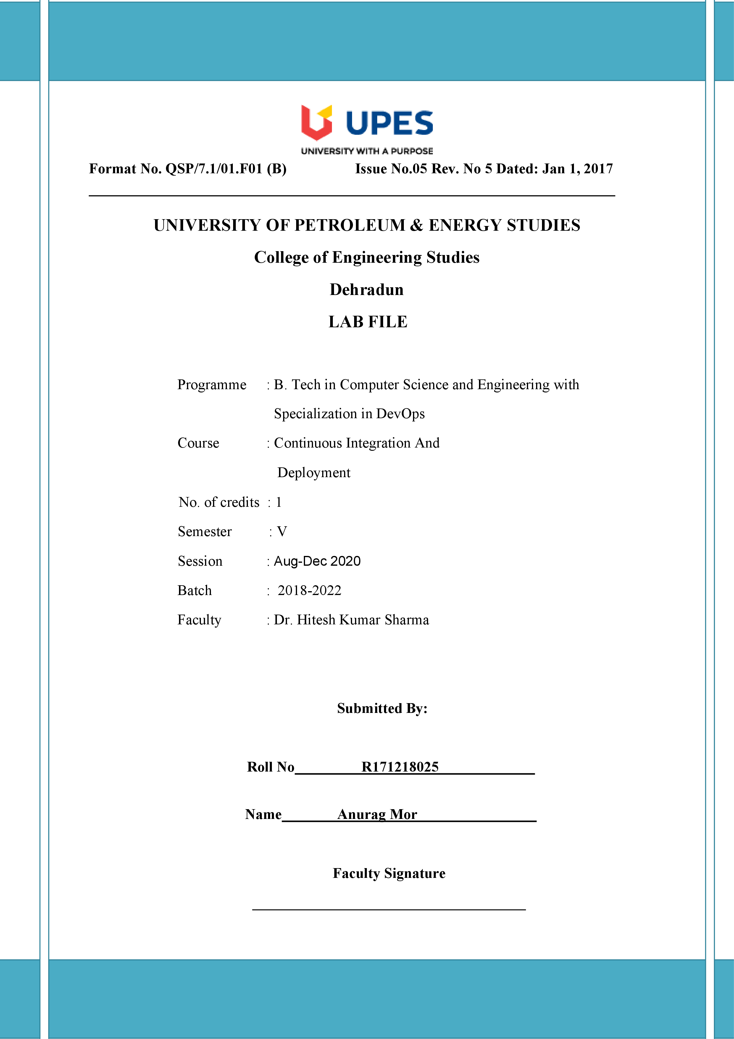

**Experiment 6 Date:- 04-09-2020**

**Aim:-** Create pipeline using Jenkinsfile.

Solutions:-

1. Open the command prompt and start the Jenkins.
2. Now go to the item and now select the pipeline project and click on make option now go to git and make a Jenkinsfile in which maven goals are written and copy the path of repo and paste the path in git link of Jenkins.

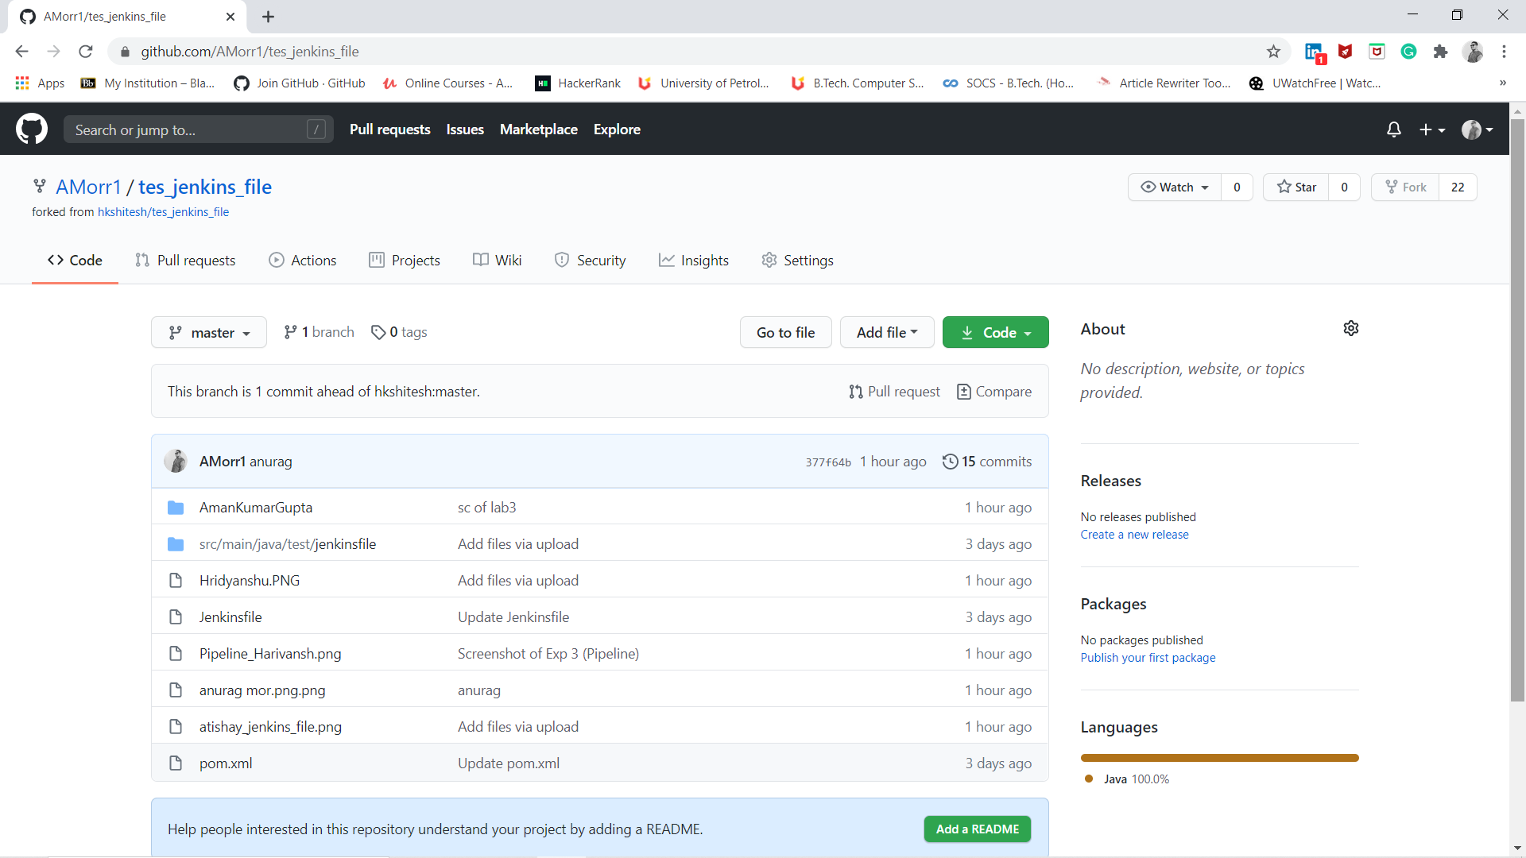

1. Now click on build option you will see the pipeline is created.

