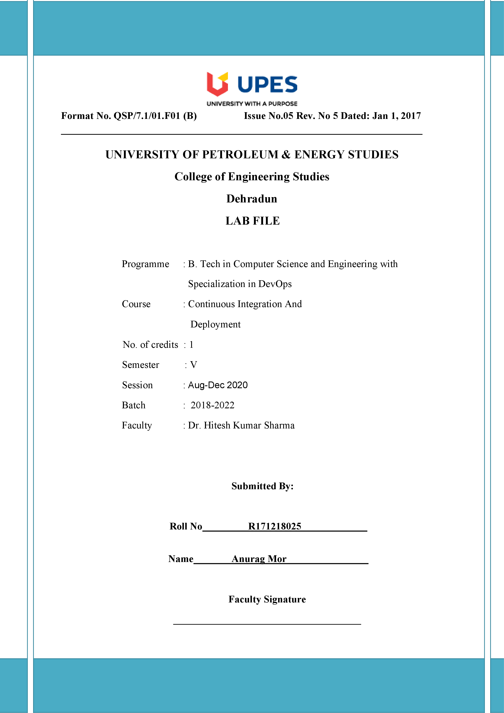

**Experiment 7 11-09-2020**

**Aim:- Create Pipeline Using Blue ocean plugin.**

Solution:-

We have created a Jenkins job to execute Maven goals like clean, compile and install on the project hosted on GitHub. Here, we create a pipeline that shows the progress of each task. For this, we use the BlueOcean pipeline plugin of Jenkins.

1. Create a Jenkinsfile (same file name and no extension) and save this file on the root of our GitHub repository.

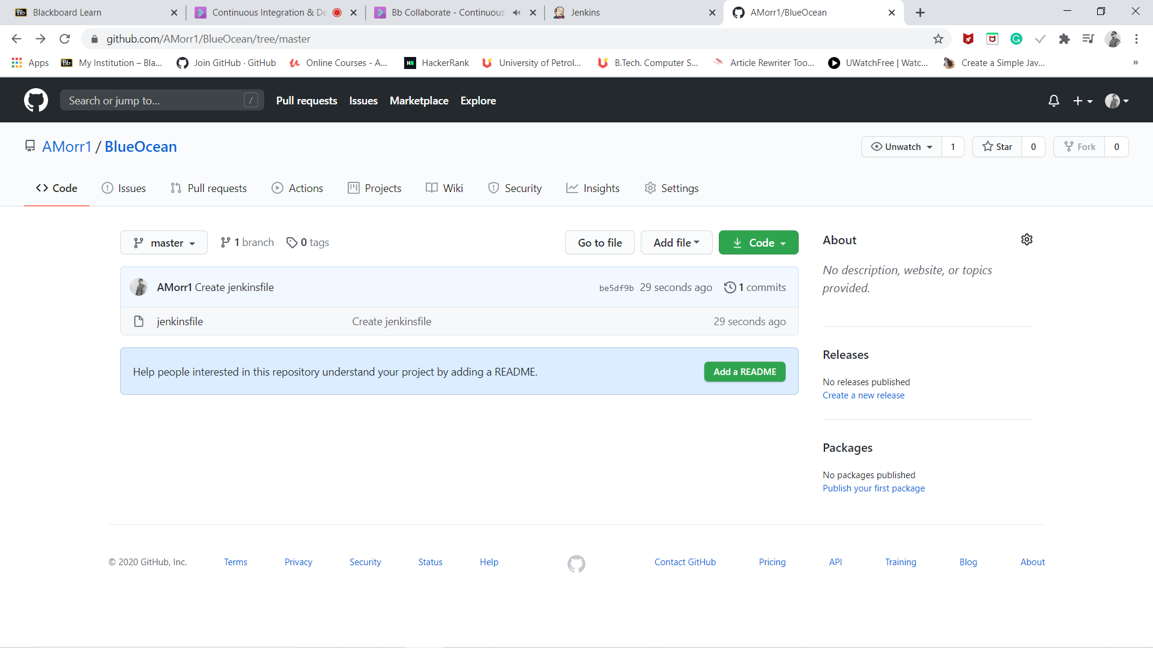

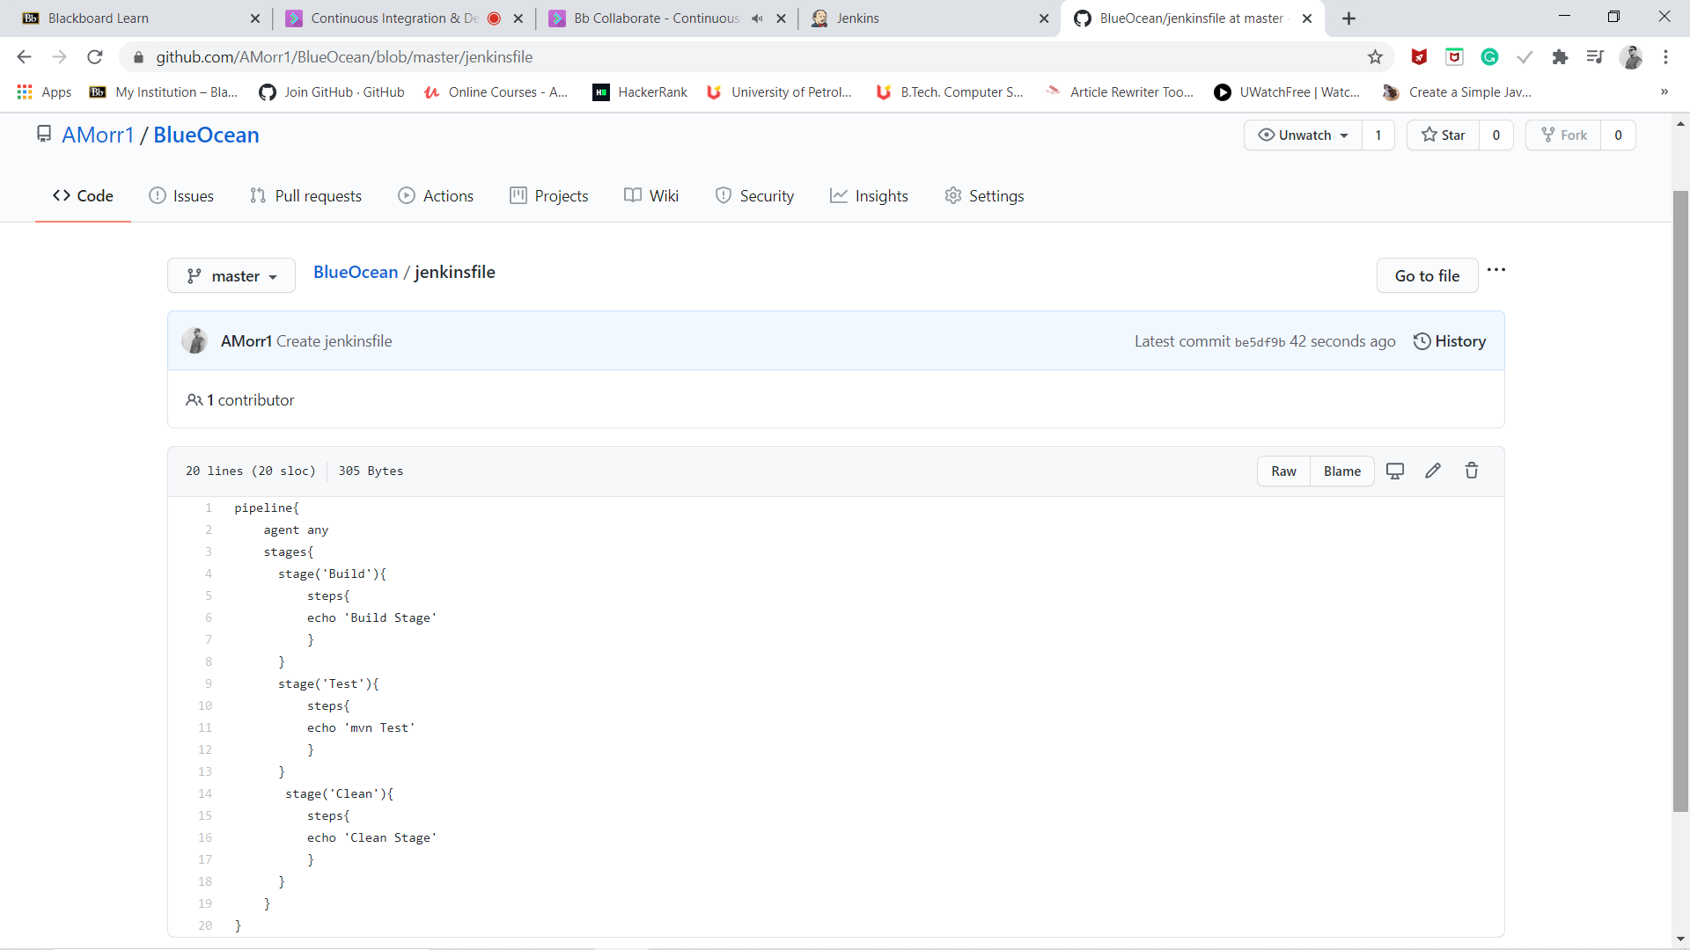

* Stages define the stages that will be seen on the pipeline.  
  Here, The pipeline will contain three stages: clean, compile and test.
* Steps define the commands that each stage will execute.
* bat is used here because the Windows Powershell will be used to execute Batch commands.  
  If Linux is used, use sh instead of bat

1. Install BlueOcean Pipeline plugin on Jenkins

Click on Manage Jenkins -> Manage Plugins -> BlueOcean Plugin

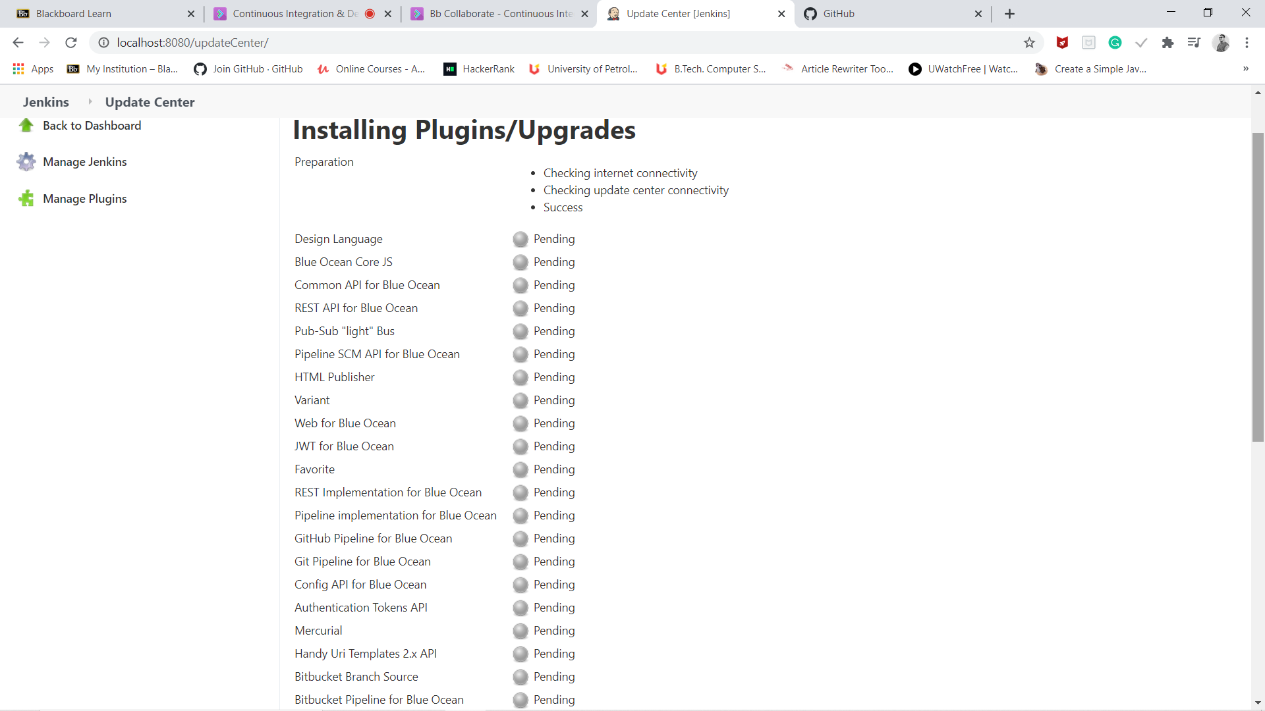

1. Click on Open Blue Ocean on the left sidebar of the Jenkins dashboard.

The BlueOcean dashboard opens up.

1. Click on New Pipeline on the top right.
2. Specify the Source Code Management tool where the project is hosted.
3. In this project, we use GitHub If your connected GitHub account is linked with multiple organizations, select the organization where your project is hosted.Once you choose you need to github account and have to give access to tokens permission.

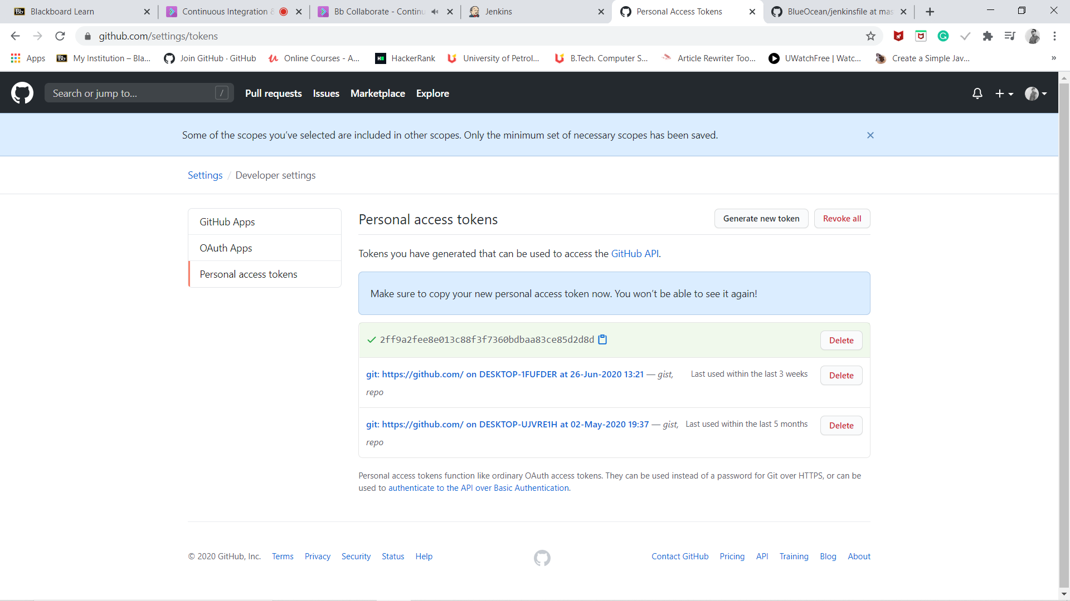

1. The pipeline is thus created and Jenkins automatically executes the pipeline whenever a change triggers it.
2. Click on the pipeline name to check its status.

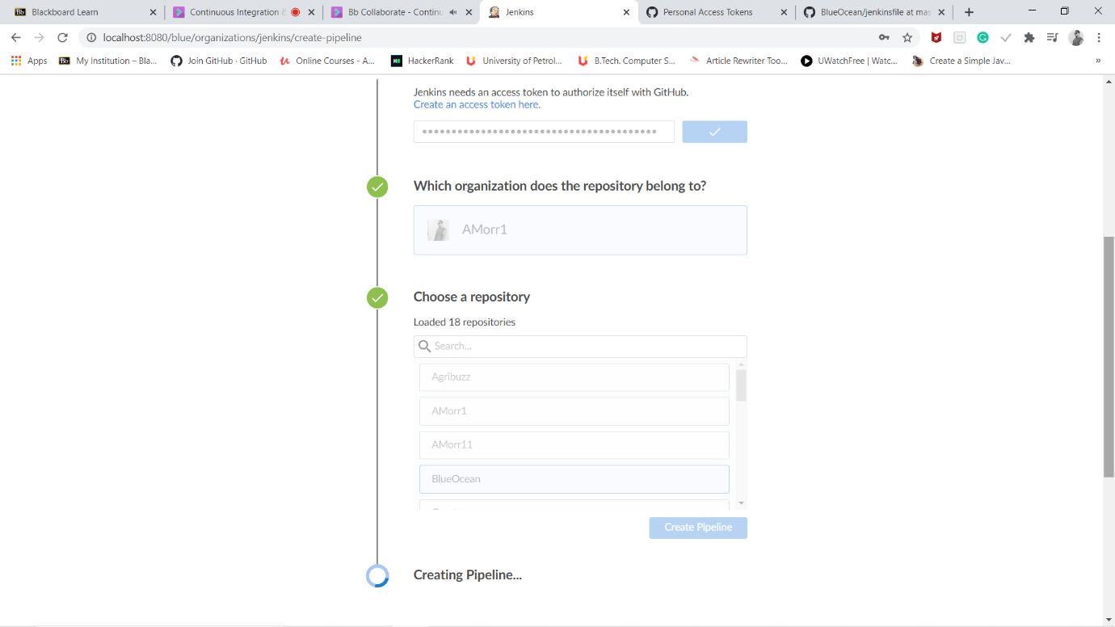

1. Here, the pipeline shows green color for all the stages which states that all the stages in the pipeline are up and running.

