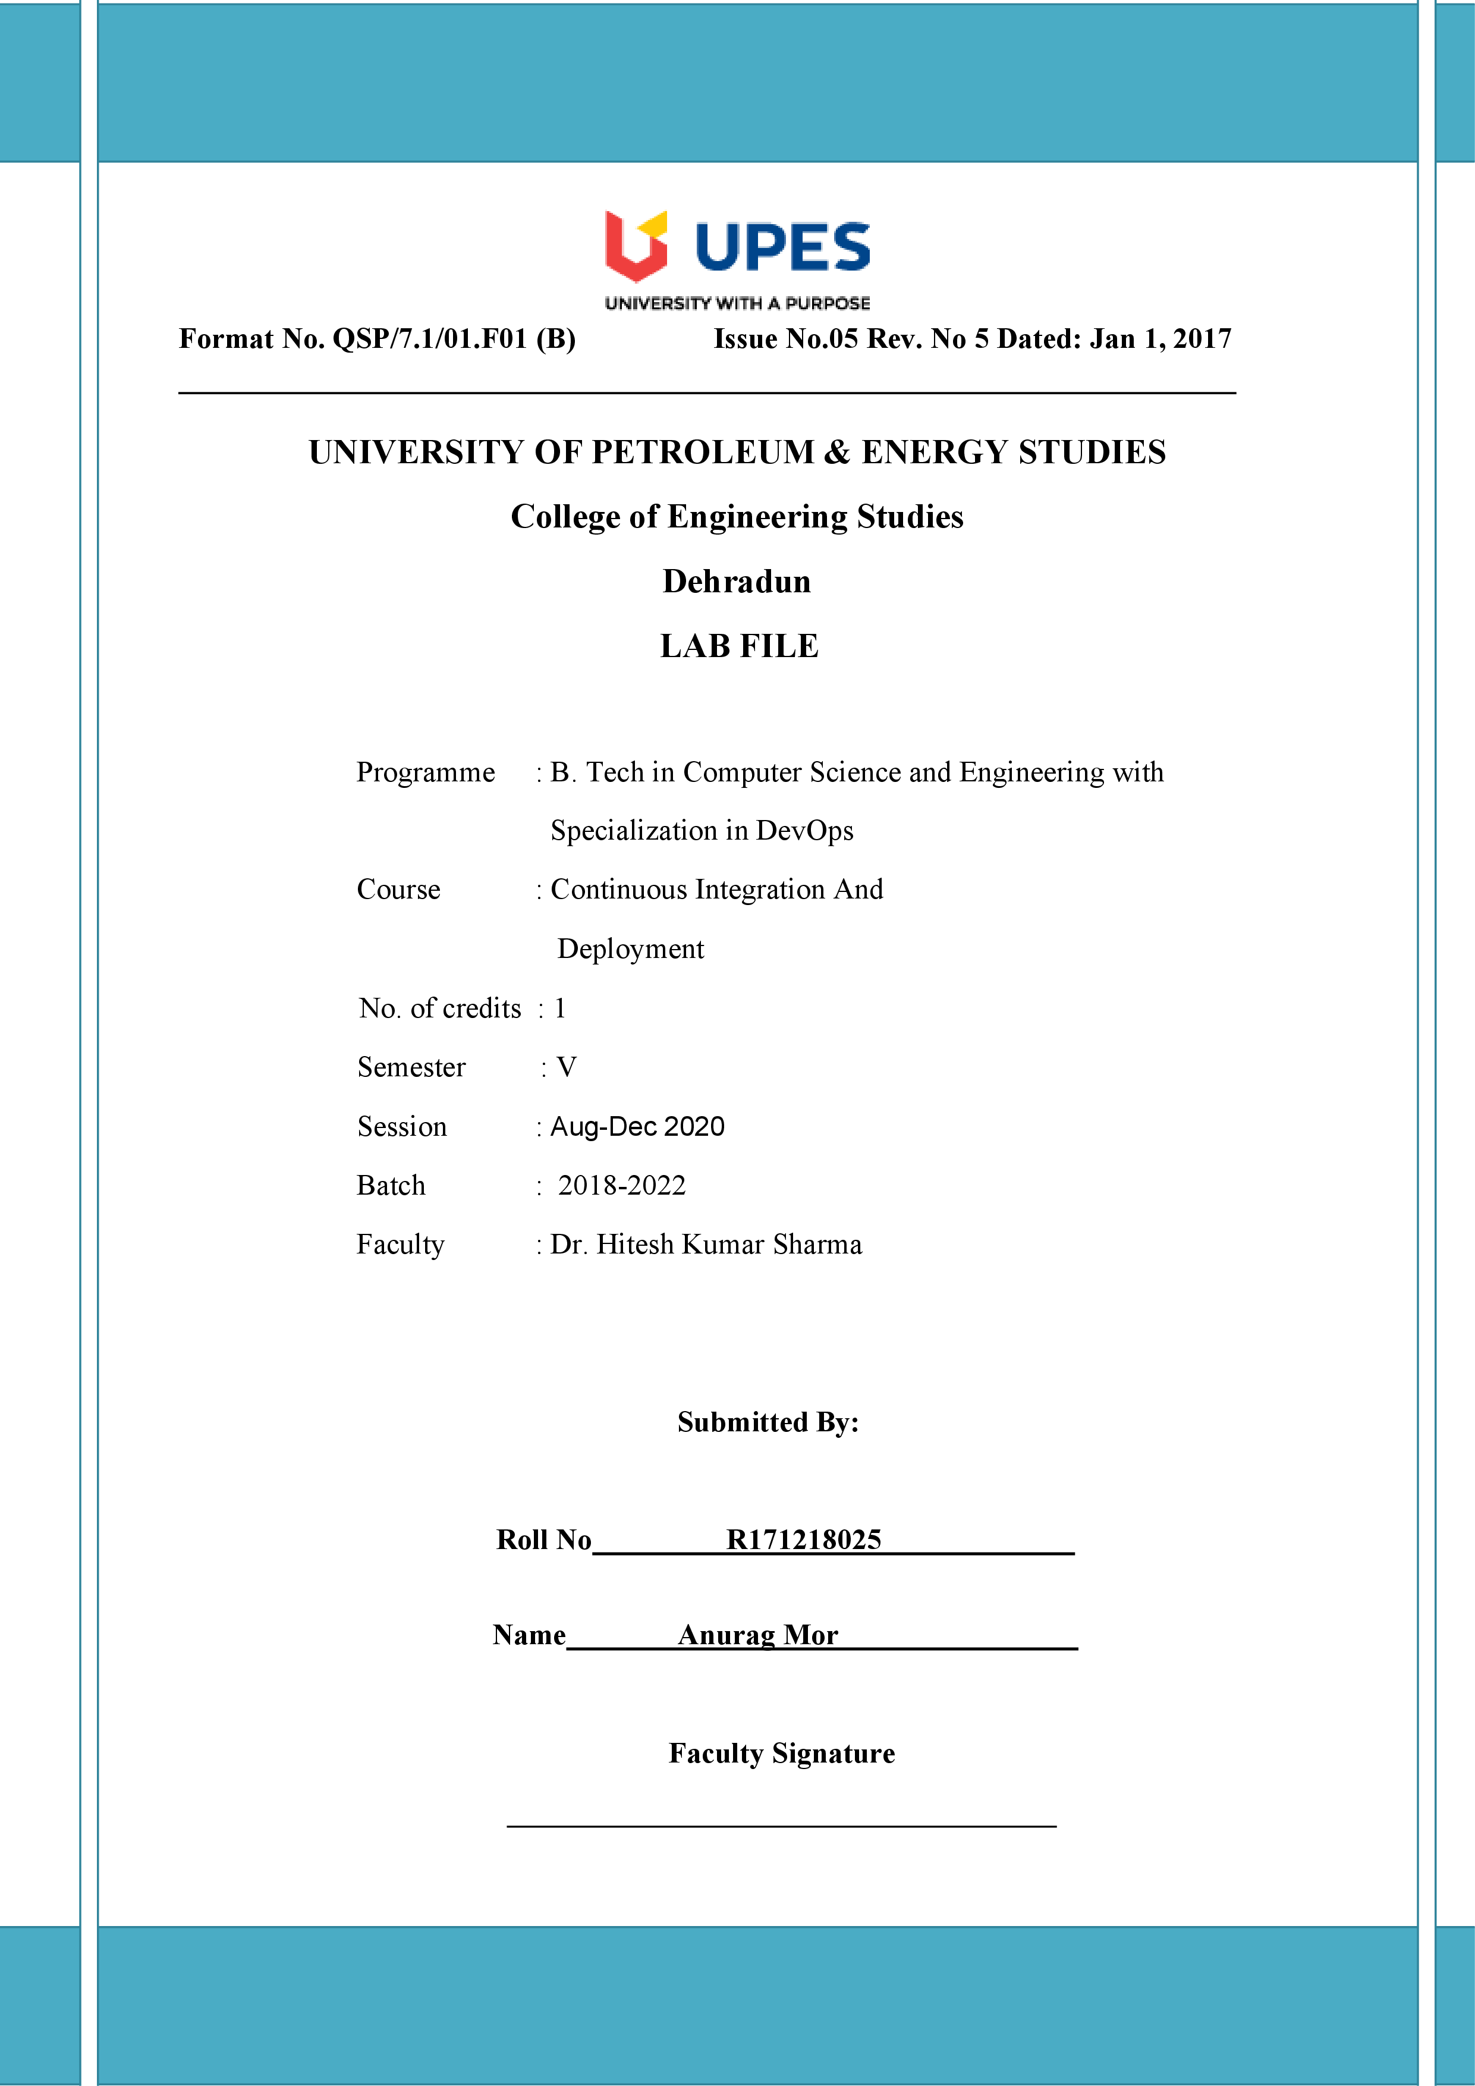

**Experiment 8 18-09-2020**

**Aim:-** Implementing Master/Slave Architecture in Jenkins

Solution:-

1) Start the Jenkins service using the java -jar jenkins.war command in the command prompt then go to the Jenkins dashboard at localhost:8080

2)Select the option of Manage Jenkins.

Then Select Manage Nodes and Cloud

Click on new Node option

3) Create a slave node.

Give a name and description to this slave node.

Create a directory for the slave node and provide the location of the directory in the ”Custom WorkDir path”

4) Open the folder created for the slave node “Slave 1”

A new jar file “agent.jar” should be created

5) Copy the location of the directory where the agent.jar file is created

Traverse to the location of agent.jar

Run the command provided for “slave 1” in its configuration settings

Initially the node “Slave 1” showed it was inactive.

It was marked by the red cross accompanying it

Now it is active.

6) Go to the configurations of an existing maven project.

Go its “General” configurations

Check the option “Restrict where this project can run”

Provide the name of the slave node “Slave 1” in the label expression

7) Click on the “Build Now” option for the project

Select the console output to see the build process

