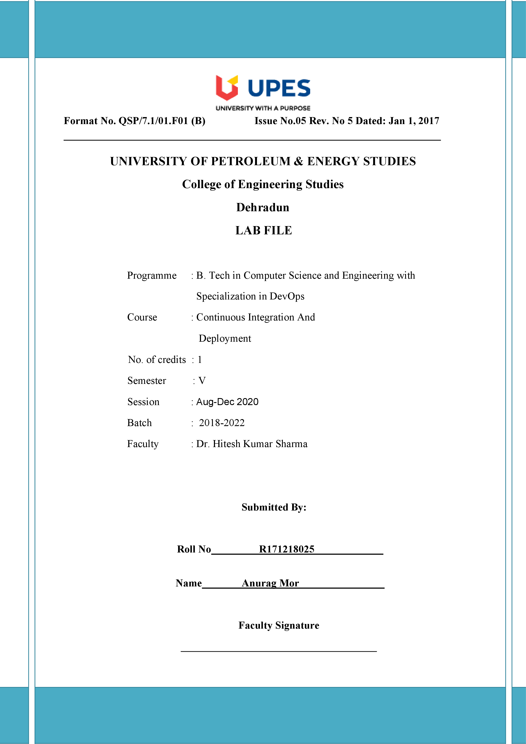

**Experiment 9 25-09-2020**

**Aim: -** Uploading Artifacts on Nexus Server using command line.

Solutions: -

1. Head over to: sonatype.com/nexus/repository-oss/download to download nexus server
2. Go to the location where nexus is installed.

Open the bin folder to find nexus.exe file

Open command prompt in the same folder and run the following command :

Nexus.exe /run

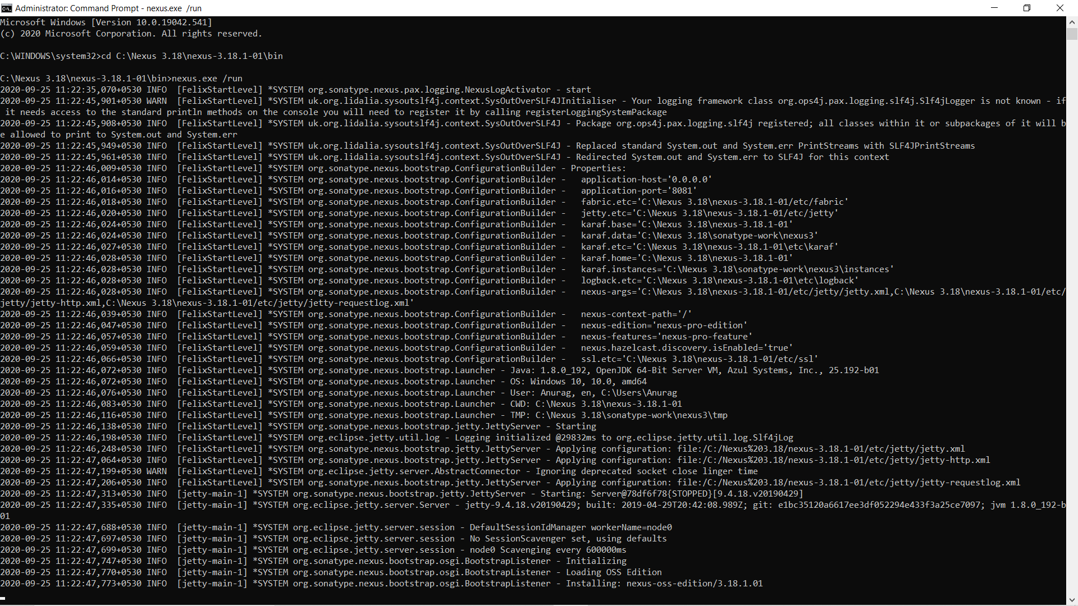

1. Once the command runs head to localhost:8081, the port where Nexus server runs

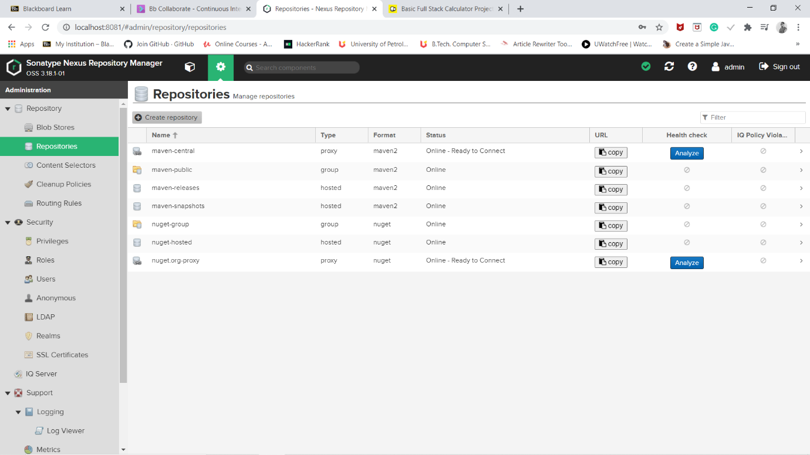

1. For the first time, nexus requests the admin password already given with the installation.

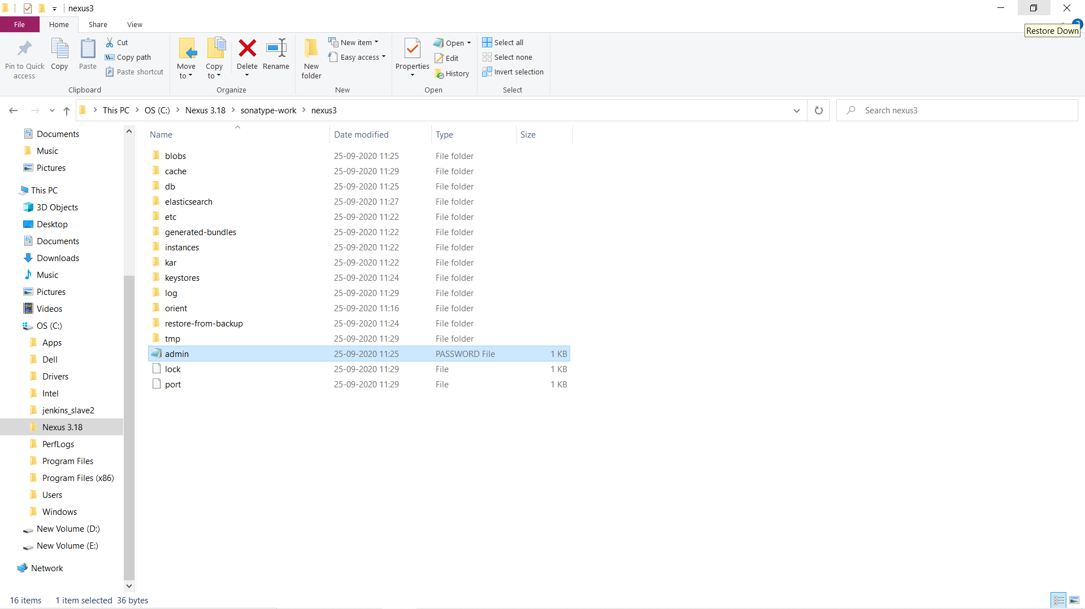

1. Find the default admin password at the sonatype-works/nexus3/ folder with the name admin.password

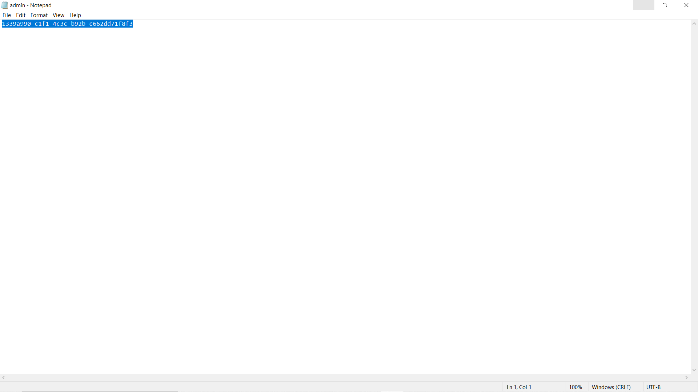

1. Complete the set-up, to create a new admin username and password and login
2. Create a new repository in Nexus (here called “nexus”) and copy its URL

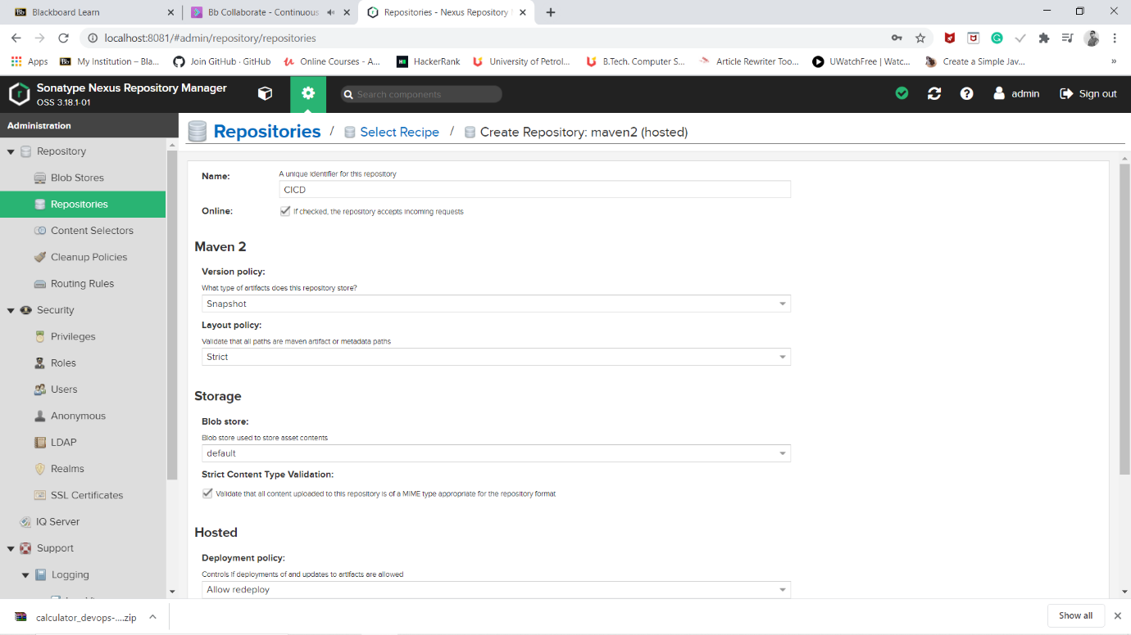

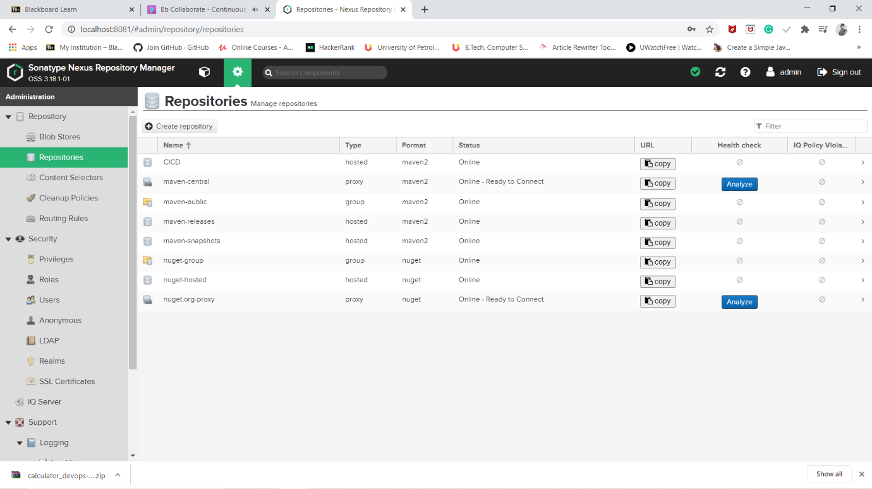

1. Open the pom.xml of the Maven project to be published to Nexus

Add the snapshotRepository tag into the pom.xml and give the URL of Nexus repository copied

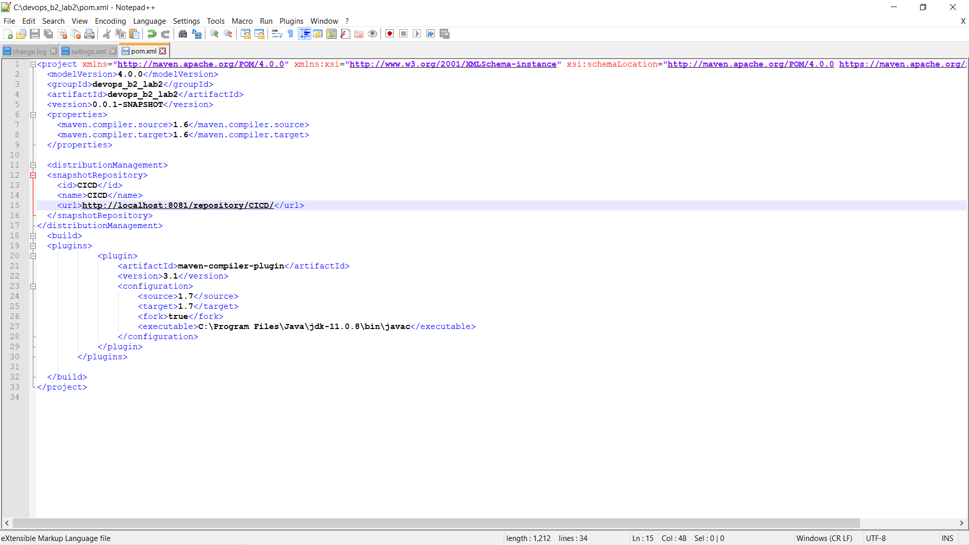

1. Now, open setting.xml in the “apache-maven-3.6.3” folder

Add the tag of server with the required credentials

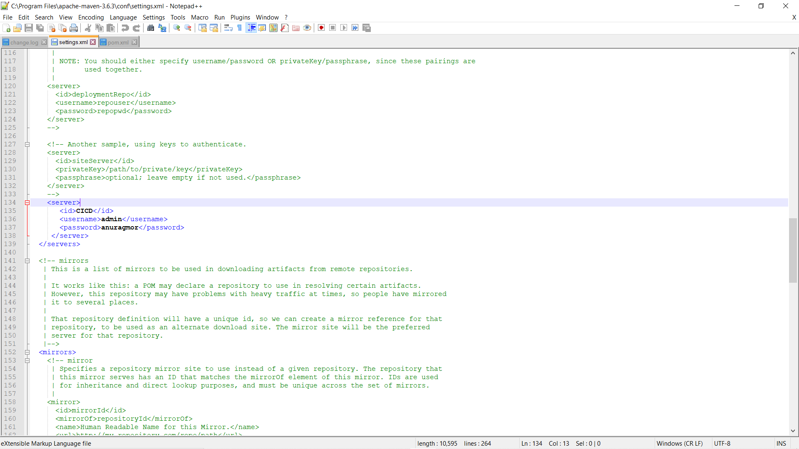

Run “mvn deploy” to deploy the built jar on the Nexus server

The command should run successfully, if no errors exist in the project.

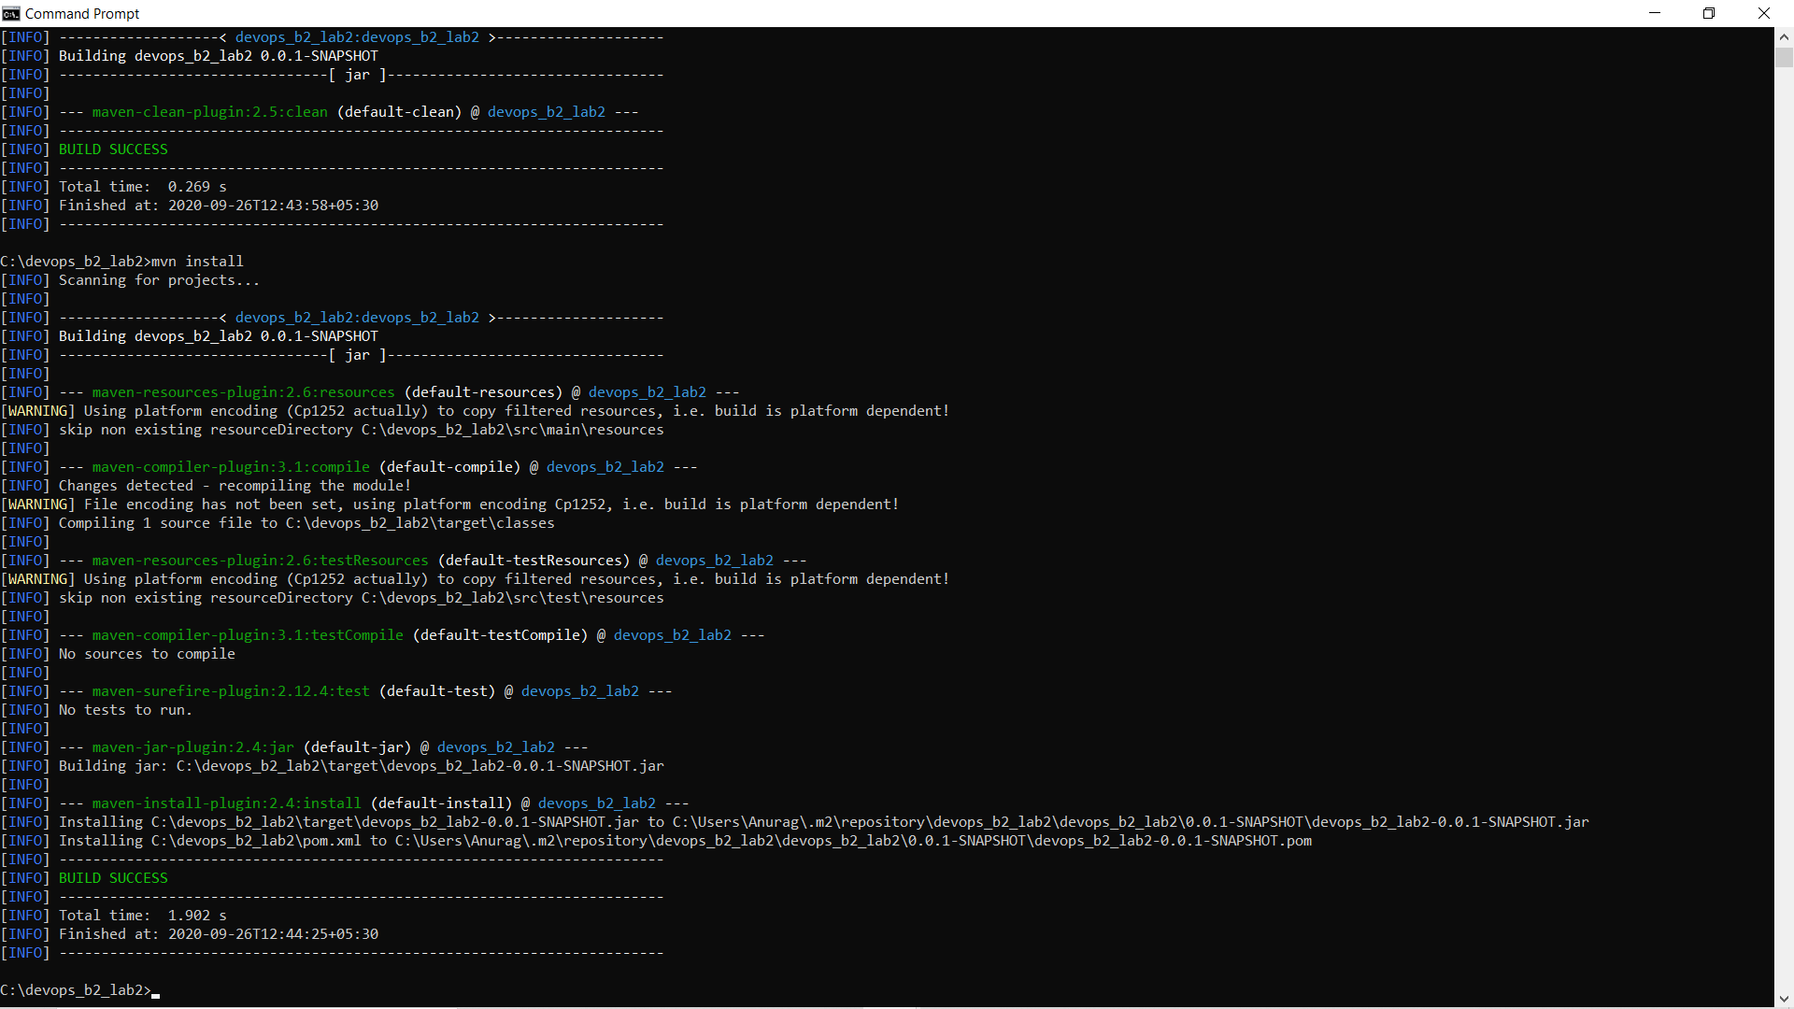

1. Browse the Nexus repository now to see the deployed jar

