**Static Code Analysis using SonarQube**

**Solution:**

Go to sonarqube.org/download to download Sonarqube

Download the community edition

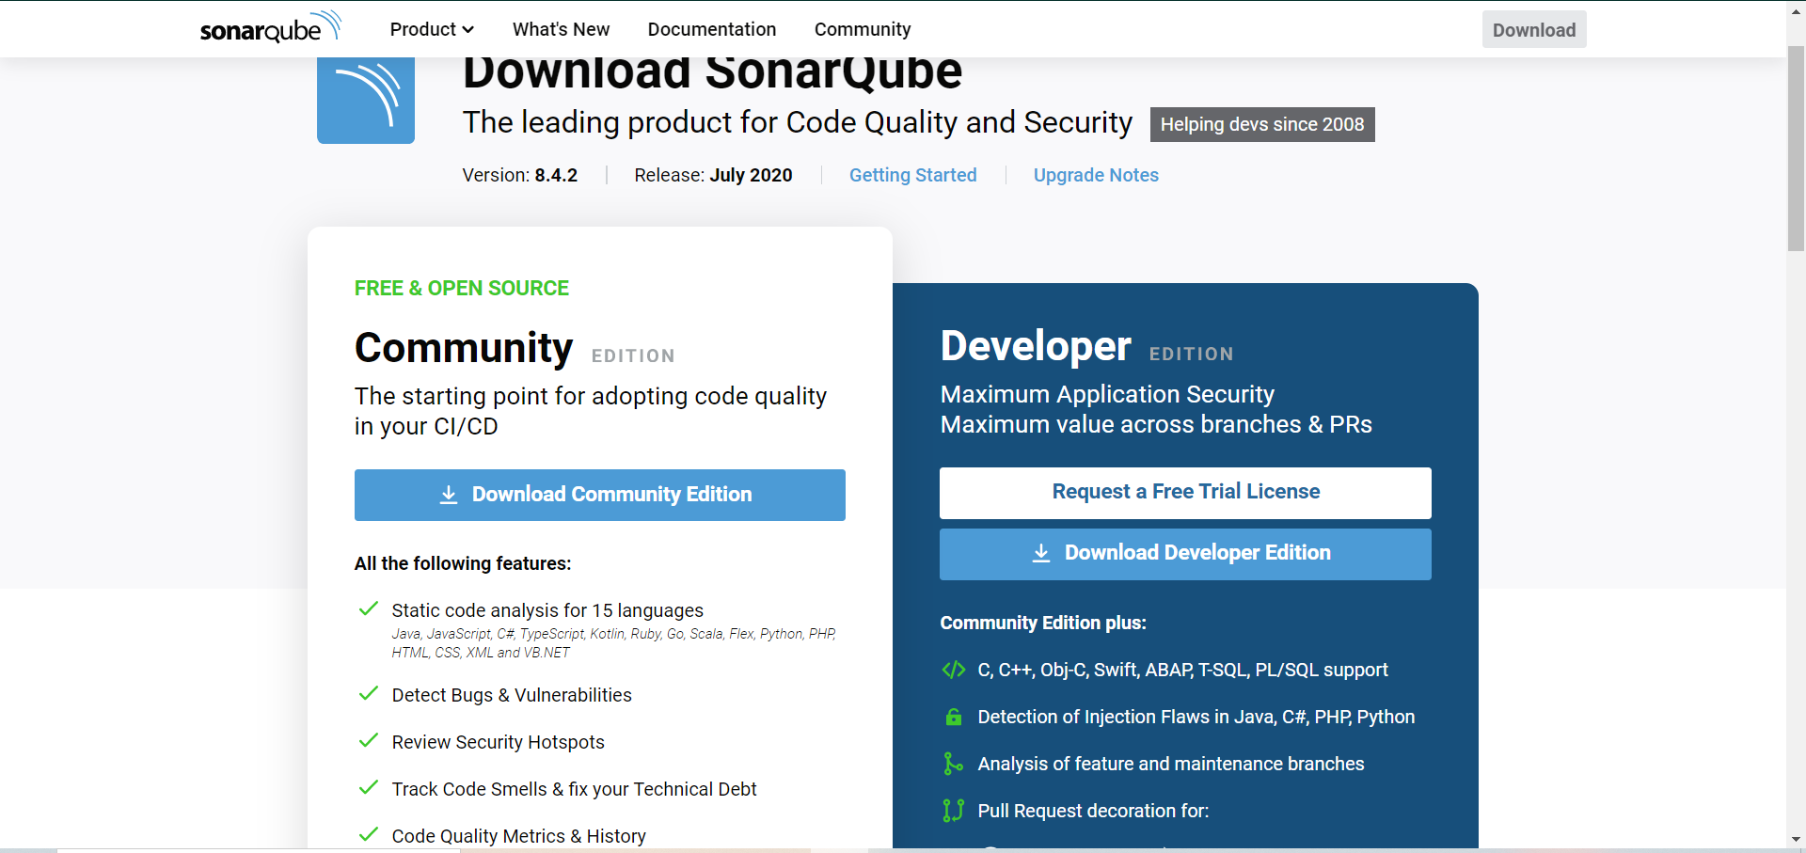

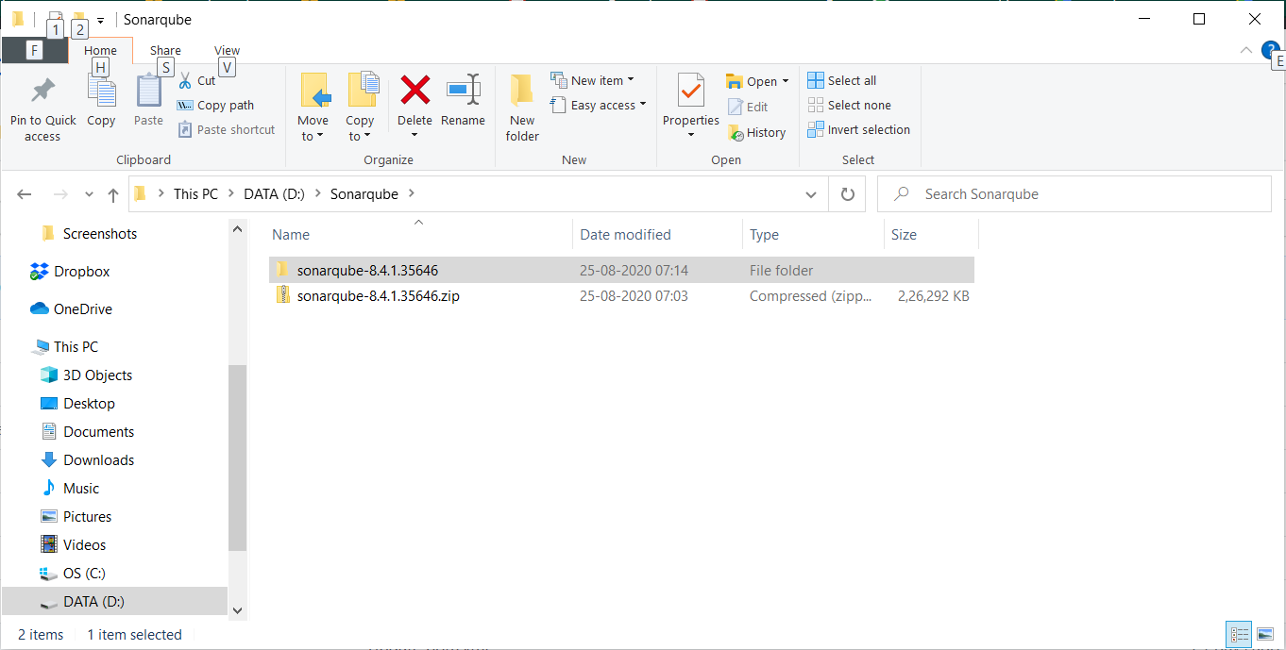

In the extracted folder go to bin, and them to Windows-x86-64 (assuming Windows OS) to find a file named StartSonar.bat

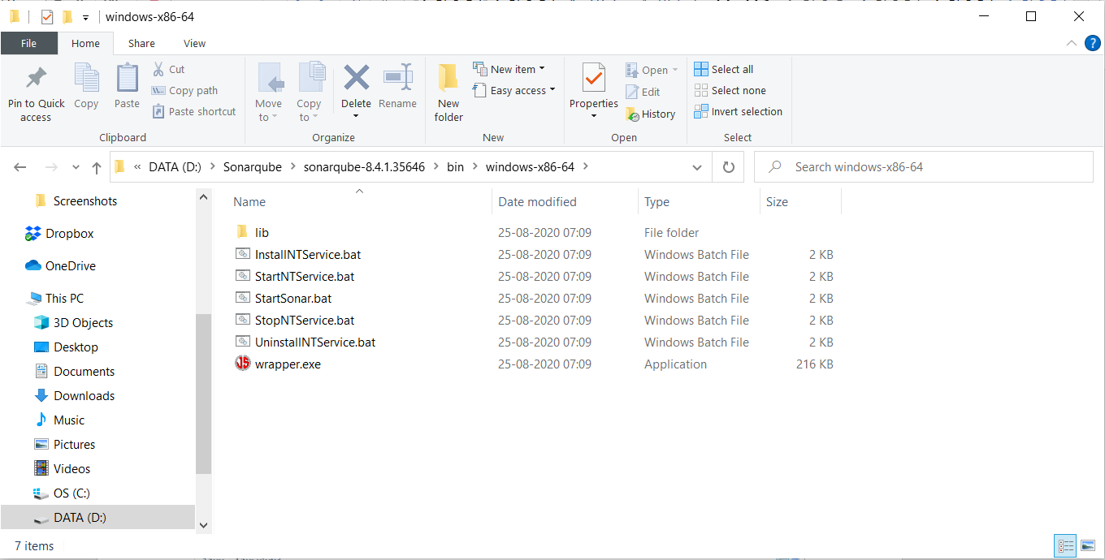

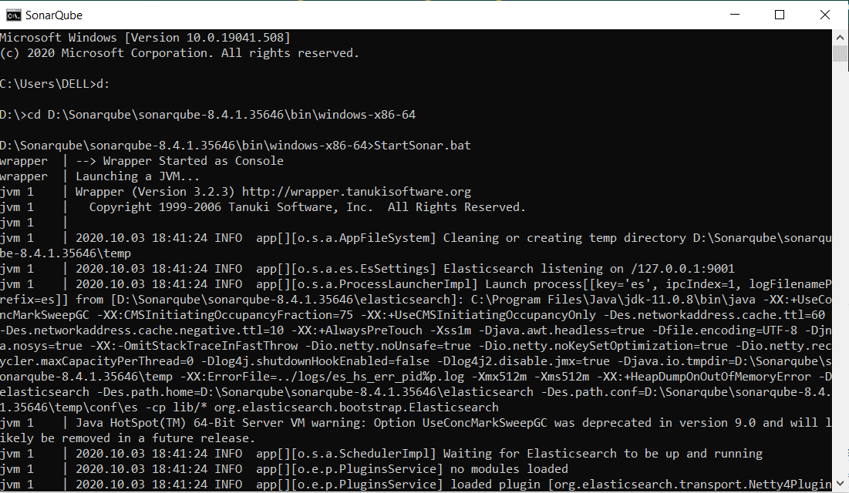

Once the command successfully runs, go to localhost:9000 (9000 is the port where sonarqube runs)

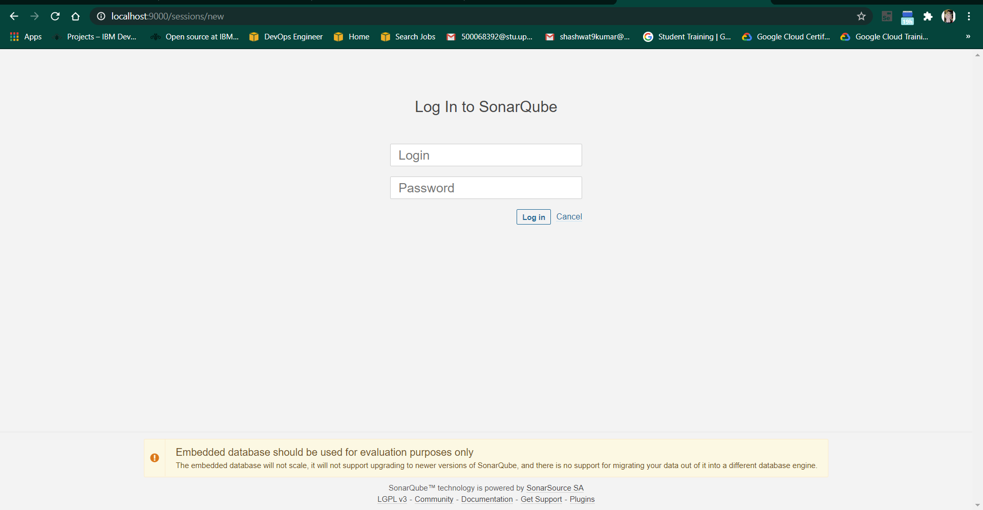

Traverse in the command line to the Maven project whose quality is to be assessed.

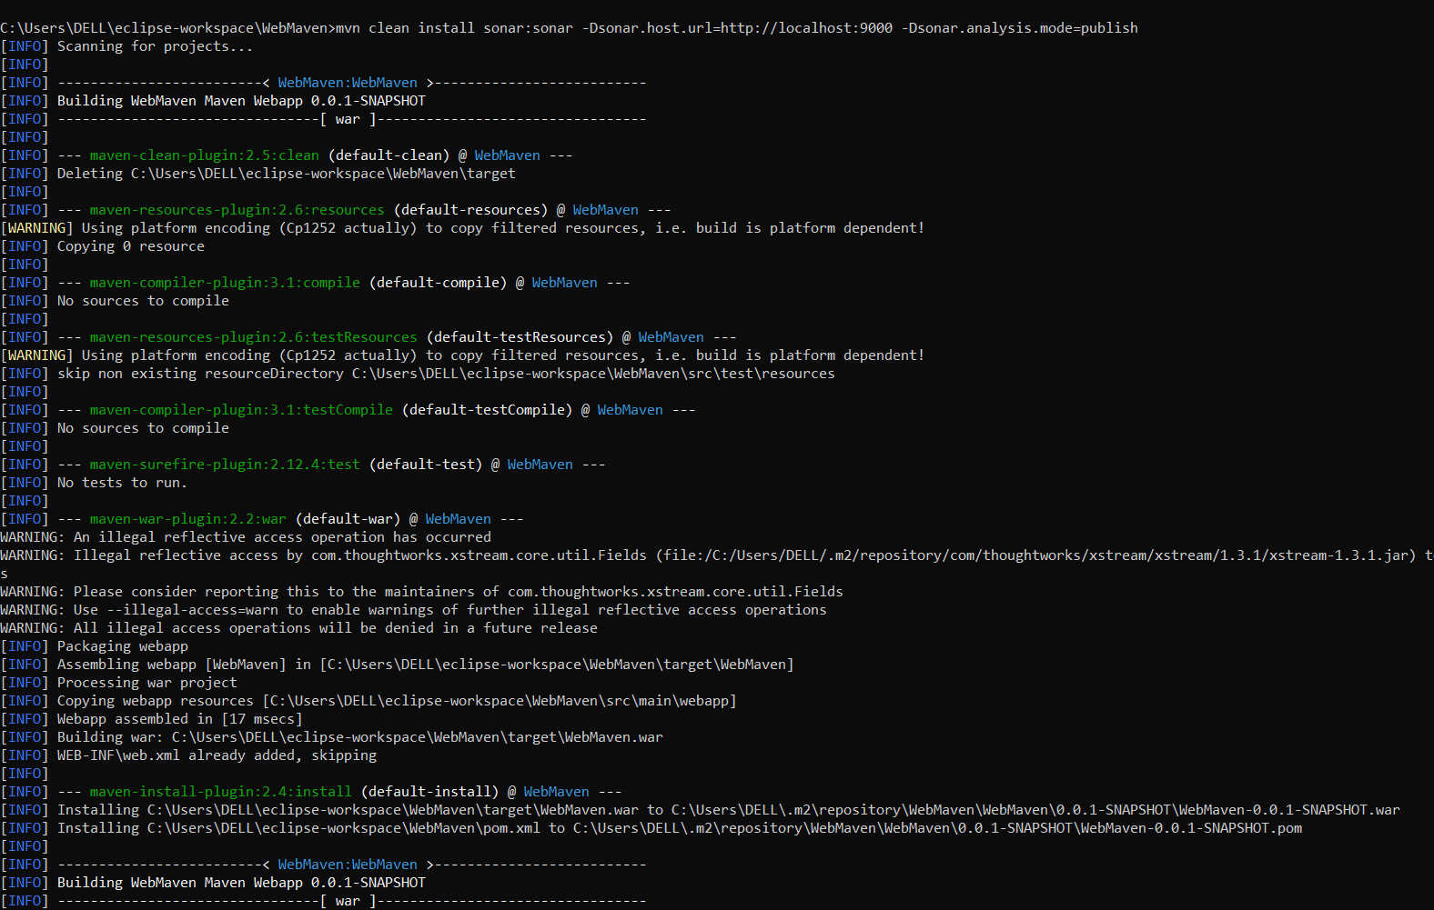

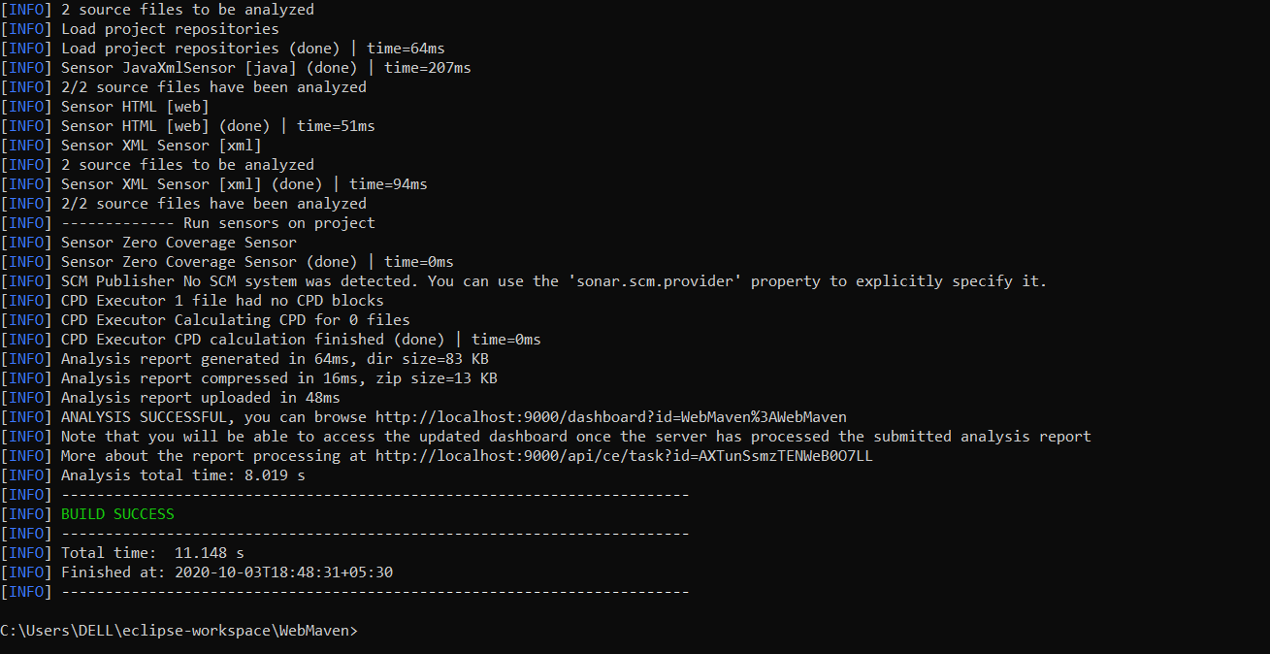

On the location: localhost:9000/projects

you will find your maven project being published and the vulnerabilities being assessed

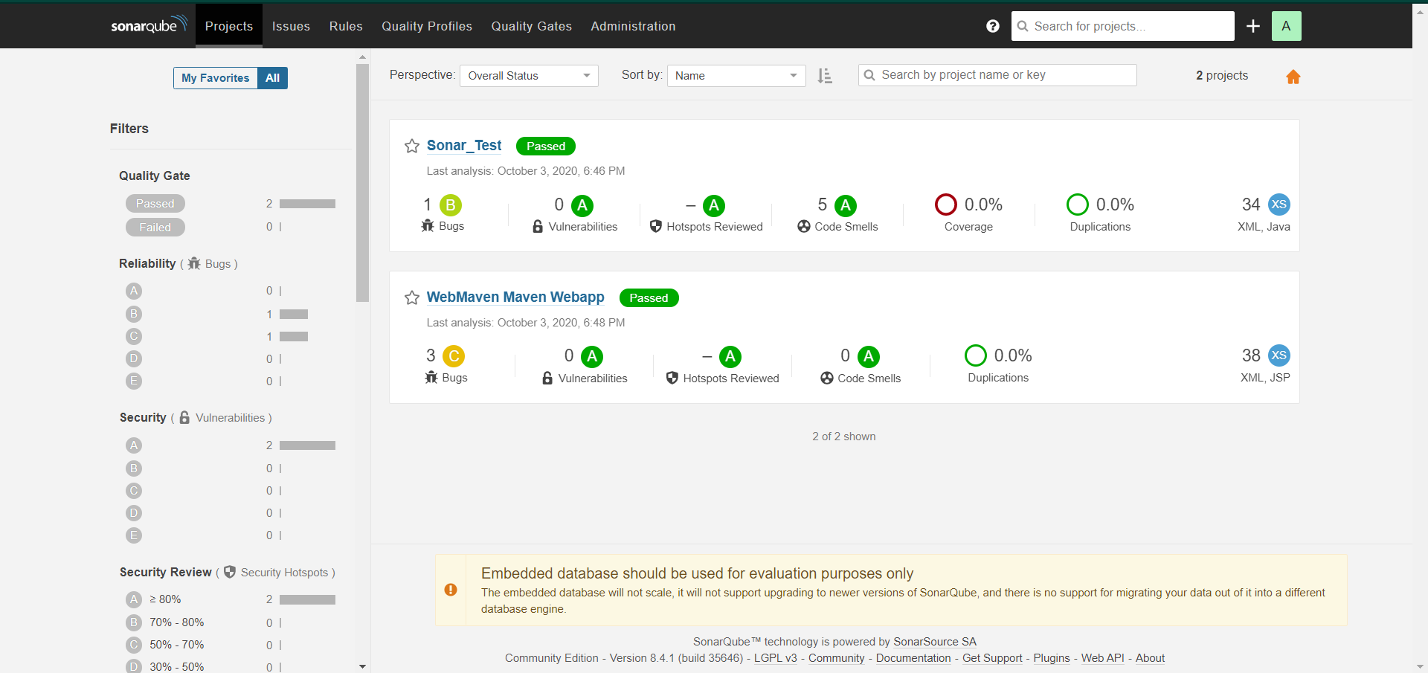

Additionally, you can further inspect the project published, by clicking directly on the project

