**Lab-1**

**Aim: JENKINS SETUP**

**STEP-1:**

* Go to Link [**https://www.jenkins.io/download/**](https://www.jenkins.io/download/)

**STEP-2**

Click on Generic Java Package (.war):- This will download a (.war) file

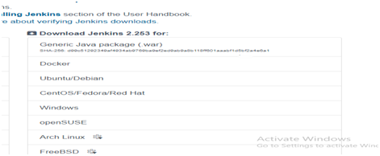

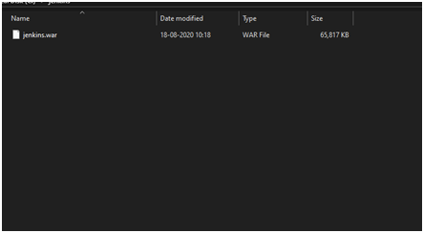

**STEP-3:**

* Open Command Prompt and go to Jenkins folder through CMD

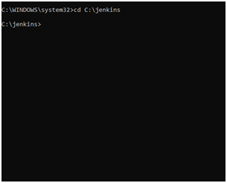

**STEP-4:**

* Now run command: — java –jar jenkins.war
* Note:- Your System should have JDK ( VERSION 8 TO 11 anyone )

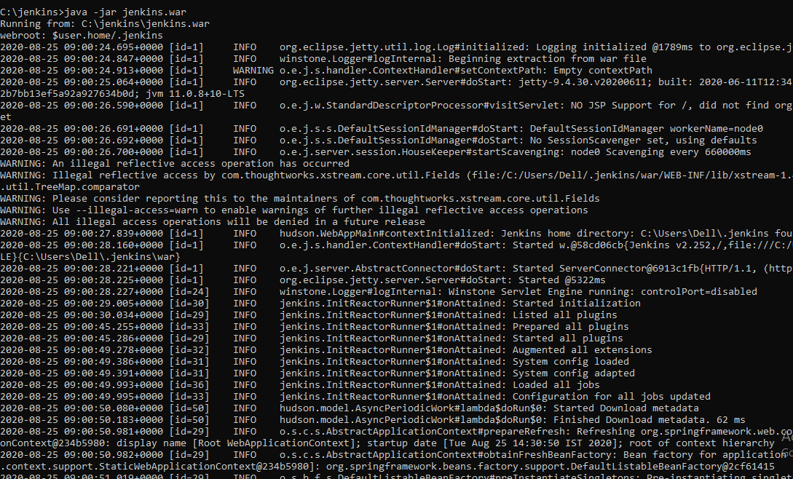

**STEP-5**

* After running the command go to chrome and type: — **localhost:8080**

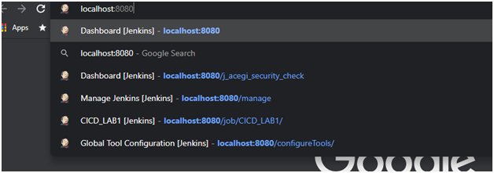

· Your login page will open.

* After Logging Your Dashboard will be visible