***LAB – 5***

Aim : Creating a pipeline

Step-1:

Create jenkinsfile script file

Jenkinsfile must not be inside any subfolder of github.

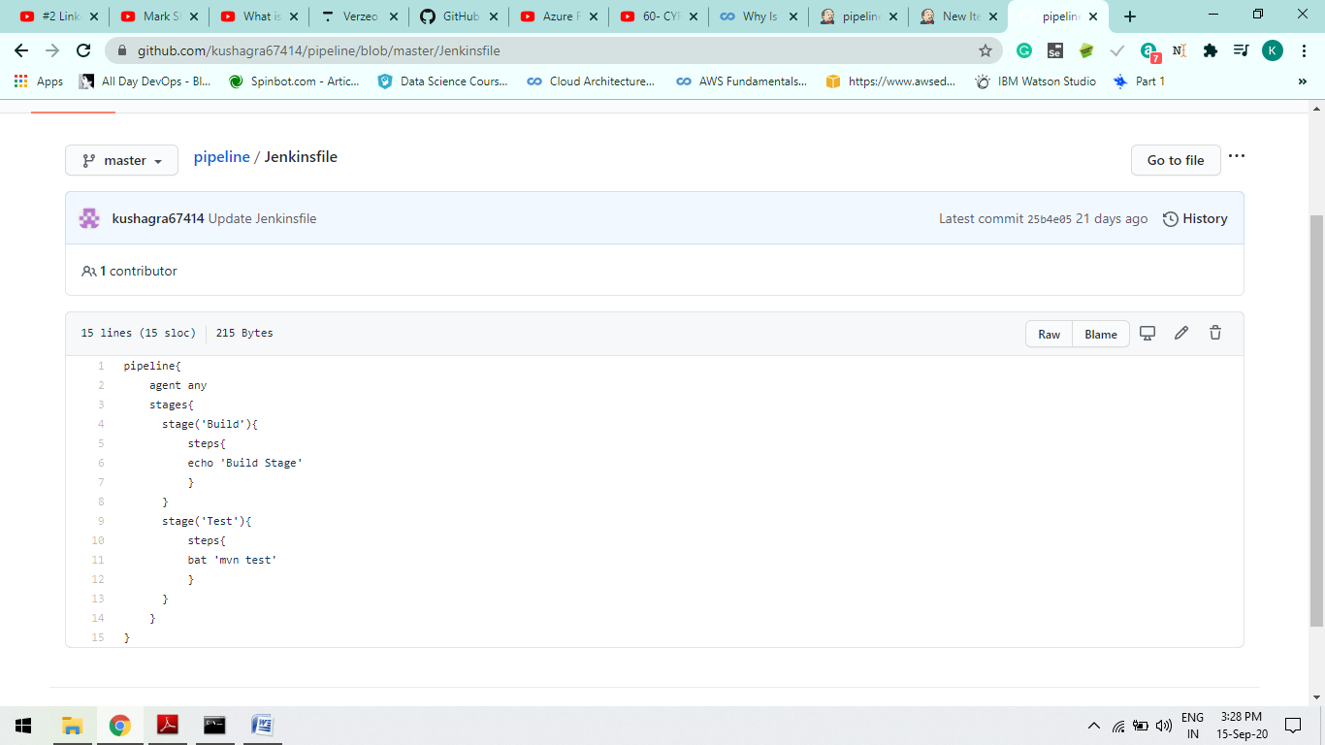

Step-2

Create a Project at Jenkins localhost and Configure it

Also while giving a github repo path in configurations must use “git” extension

If Your repo name is Pipeline then “.git ” is necessary ext at that time.

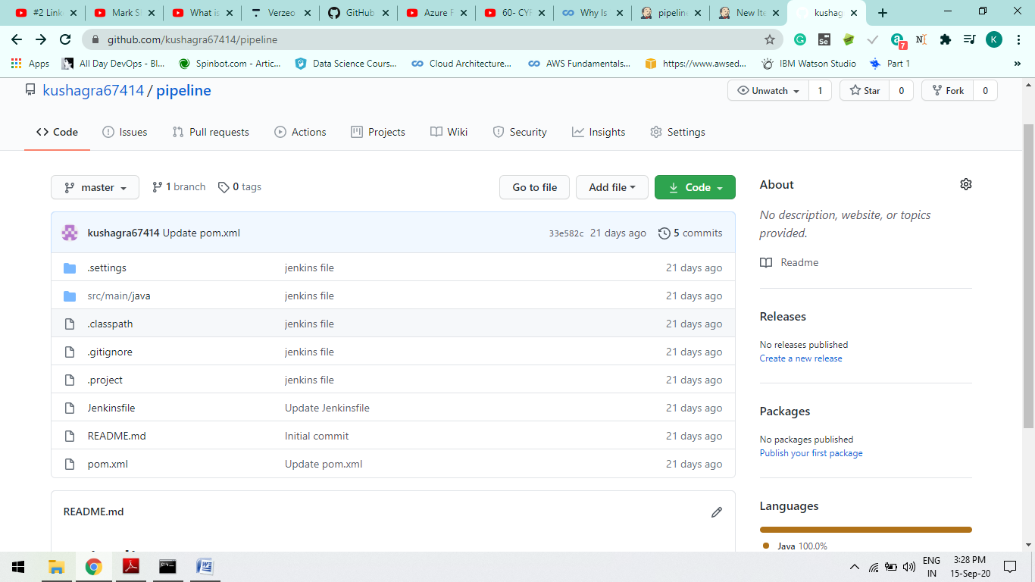

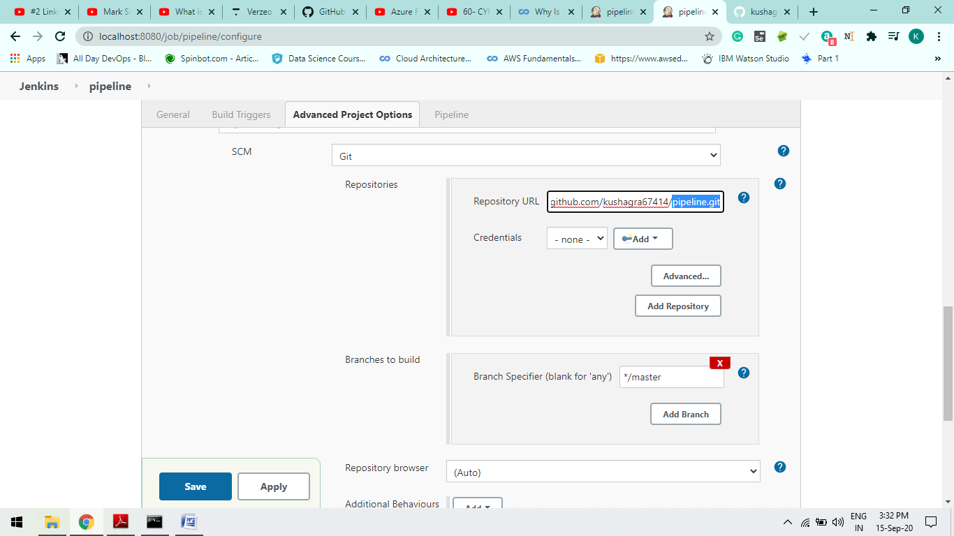

I

Step-3

Build Now and see the maven goals output define in jenkinsfile script.

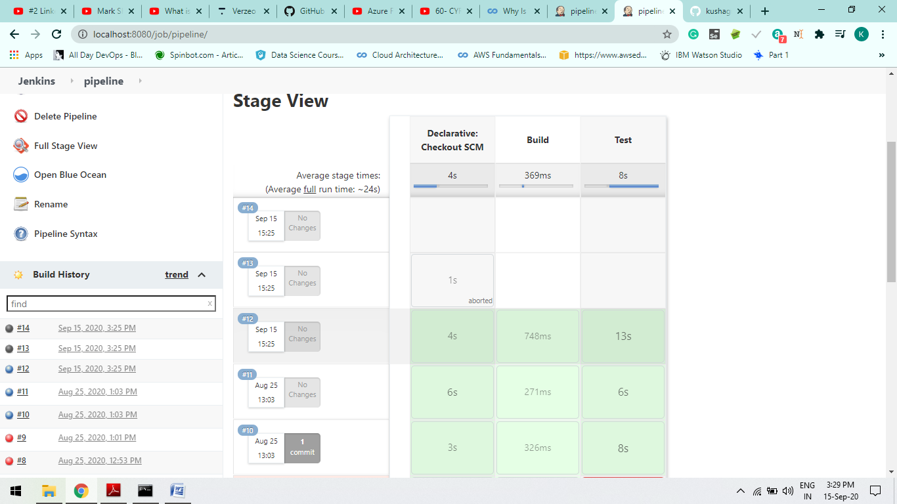

Step-4

Outputs of log Success =>

1. Build log:

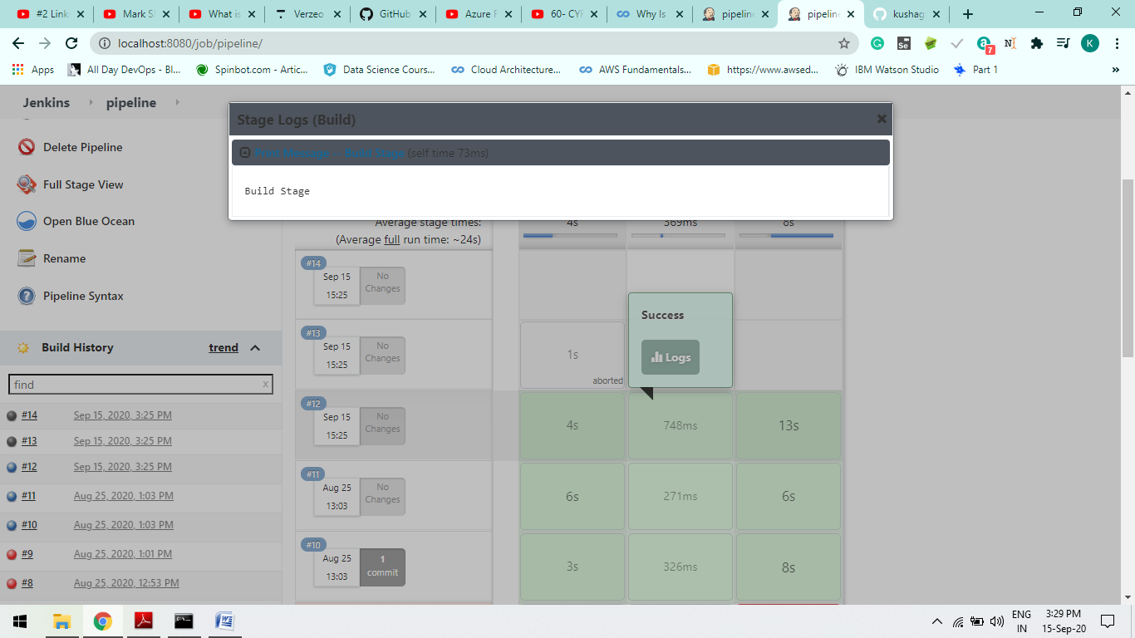

1. Test log:

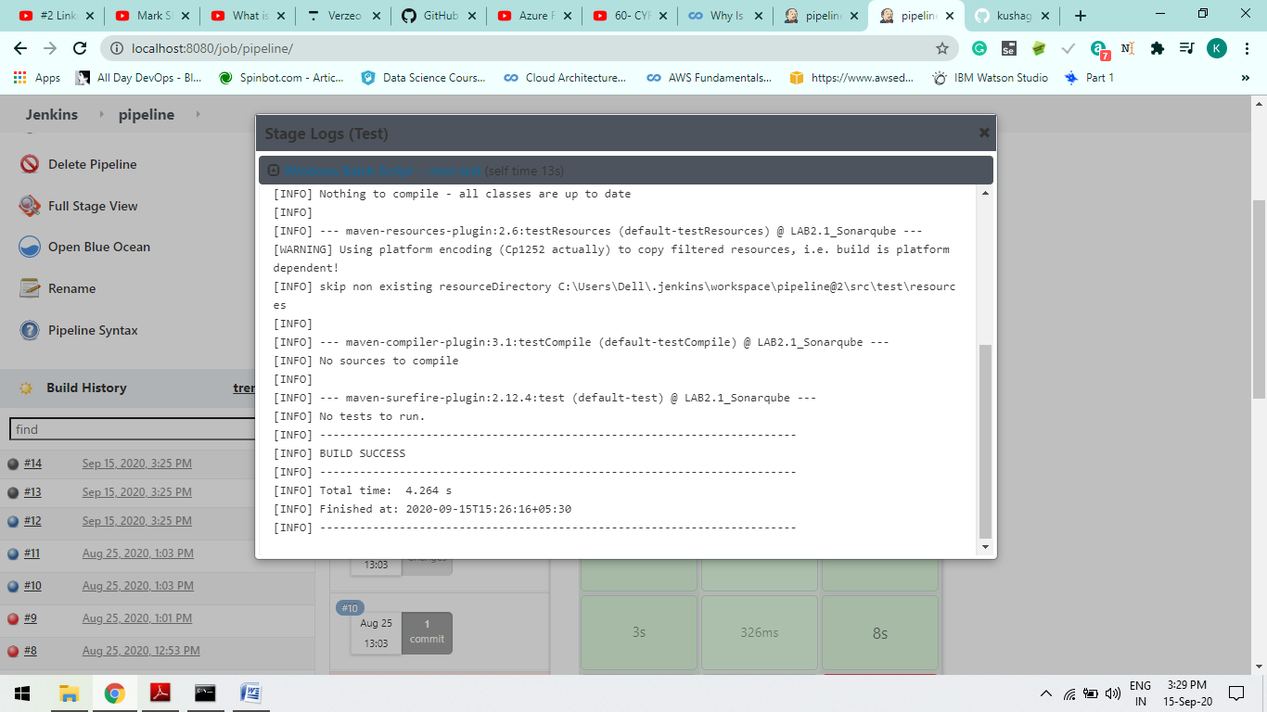

1. **Declarative: Checkout SCM**

