**CICD LAB-7 Experiment**

**Aim : Working of Slave in Jenkins :**

Note :

If Jenkins show invalid user name or not able to access.

Type : Jenkins.exe stop

It will stop all Jenkins service.

Then start your Jenkins using :

Java –jar Jenkins.war

**Step-1:**

Goto “manage Jenkins> Configure Global Security >”

Goto agent property option and select “random” option

**Step-2:**

Goto “manage Jenkins > Manage Nodes”

Create new node say “Slave_1”

Give description name (anything) say Slave_exp

Configurations we have to do :

1. Remote Root Directory : create a folder In local machine say “jenkins_slave_1” and give path of folder in it.

It will act as a workspace where our slave’s will be stored.

1. Usage option : Select “Use this nodeas much as possible”.
2. Launch method : Select “Launch agend by connecting it to the master”. This option will we occur if you have chosen “Random” option earlier in your configuration file.
3. Custom WorkDir path : path of your workspace folder. [ same as Remote Root Directory ]

Save the configurations

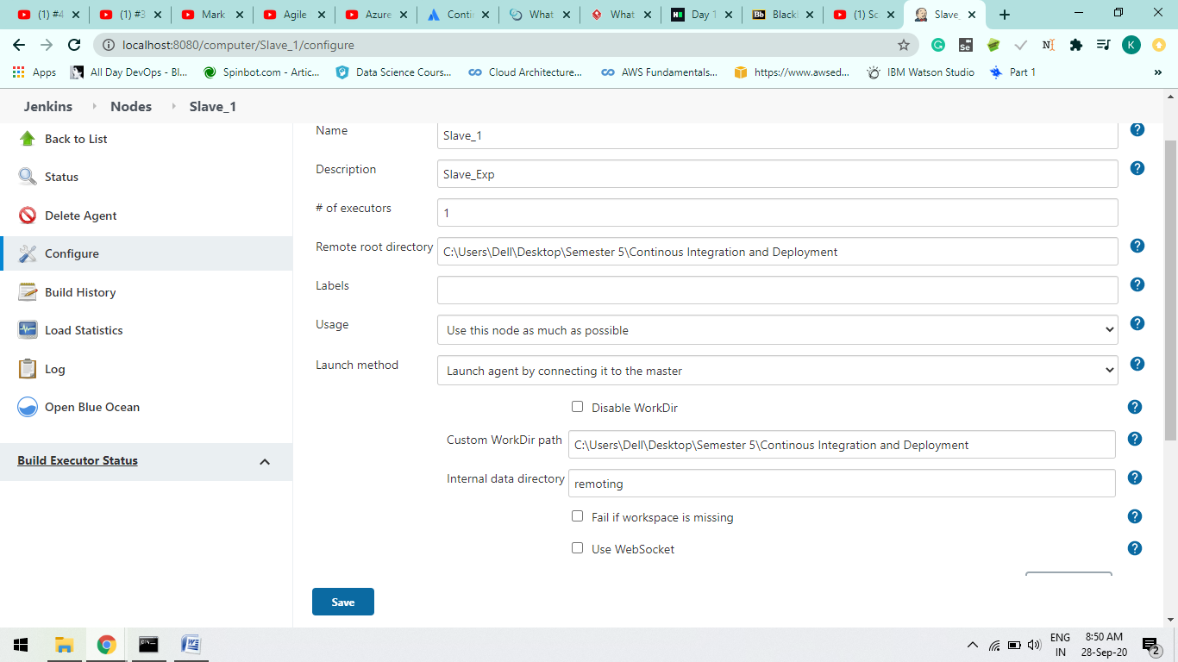

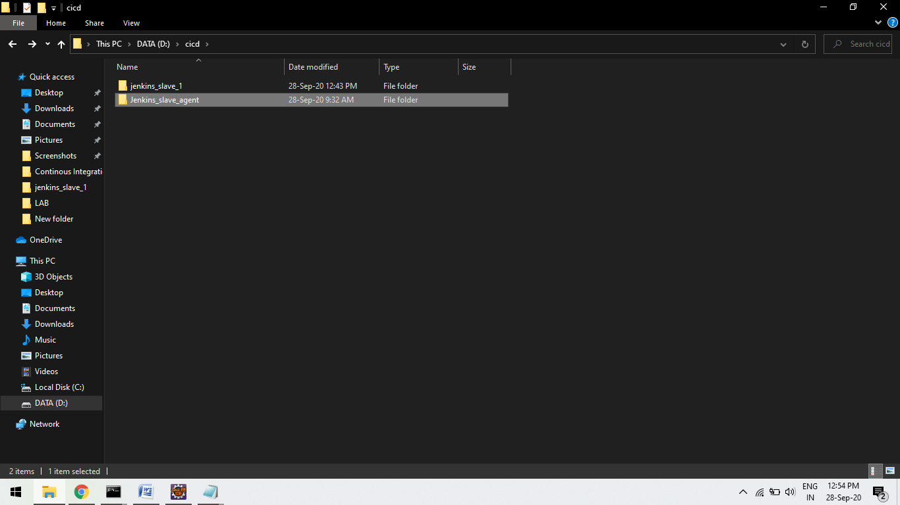

**Step-3:**

Now Slave is create but it is not connected to the master.

So click on the Slave_1

Click on the agent.jar , it will download the file as it helps to activate or launch the agent on command line.

Download it and create a folder at local machine and save it to that Folder

Folder name lets say : “Jenkins_slave_agent”

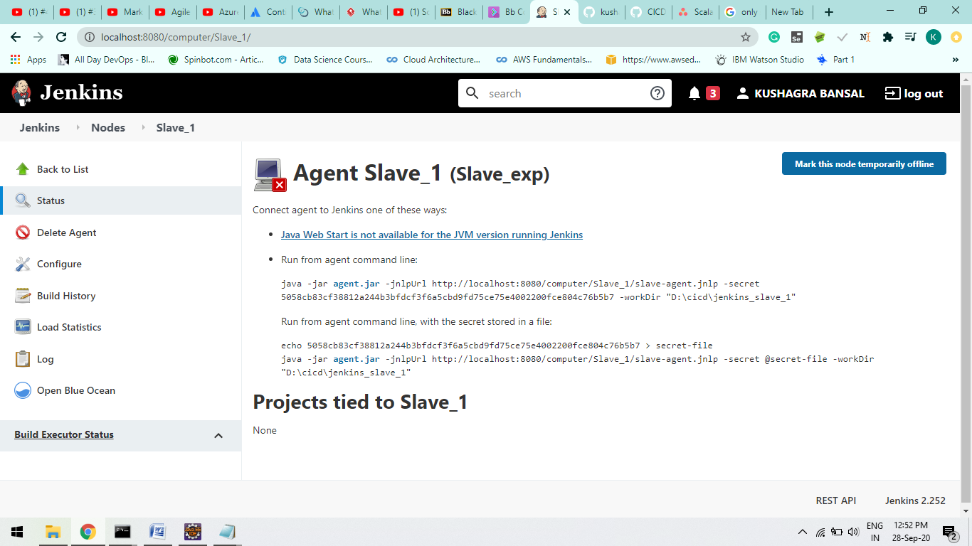



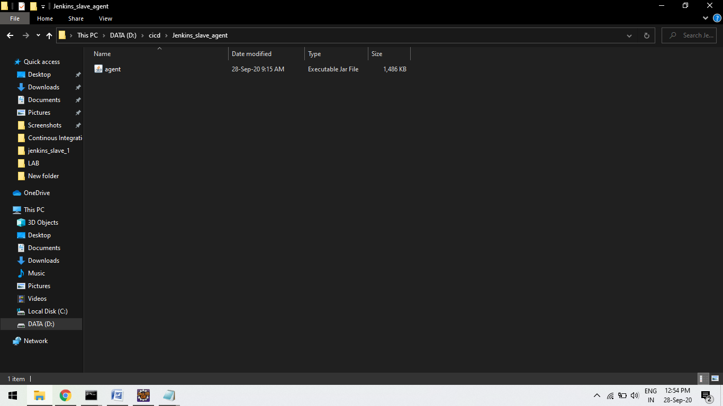

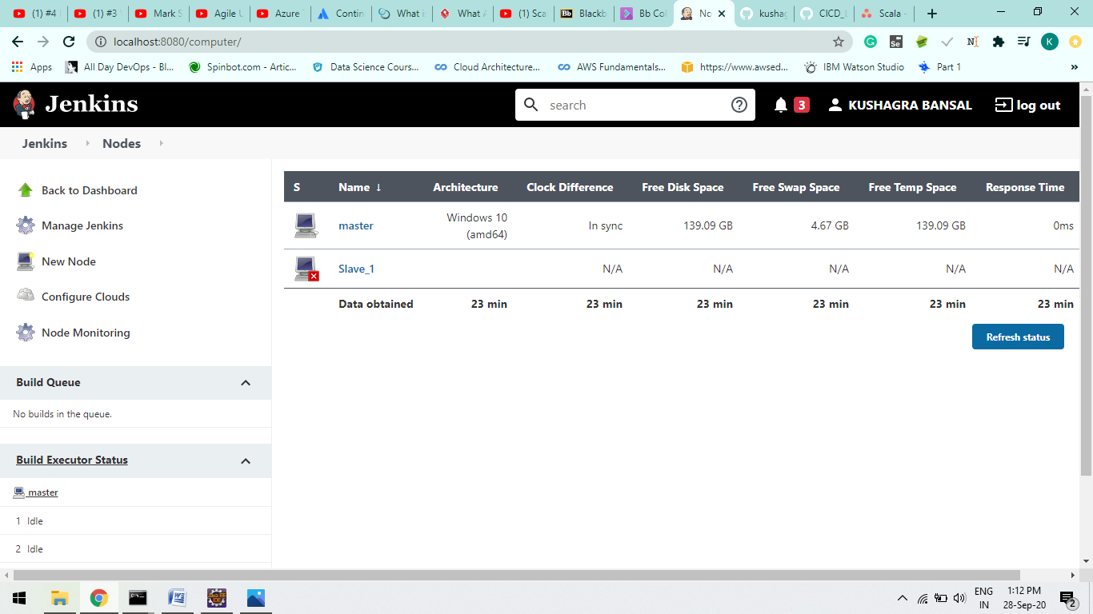

Sfrdv

**Step-4:**

java -jar D:\cicd\Jenkins_slave_agent\[agent.jar](http://localhost:8080/jnlpJars/agent.jar) -jnlpUrl http://localhost:8080/computer/Slave_1/slave-agent.jnlp -secret 5058cb83cf38812a244b3bfdcf3f6a5cbd9fd75ce75e4002200fce804c76b5b7 -workDir "D:\cicd\jenkins_slave03"

Type will connect node to its master node.

Refresh you will see slave is connected to its master node.

A



After the node is connect u will see RED CROSS LOGO is disappear.

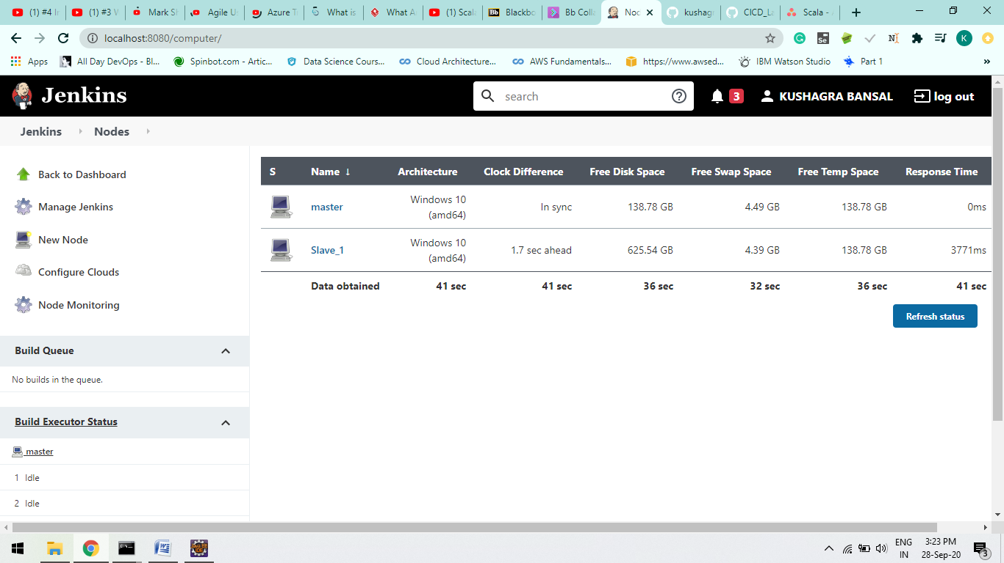

**Step-5:**

Create a Github repo and push a maven project.

Create a project in Jenkins and configure it by giving github repo path

As mentioned in Screenshots.

A

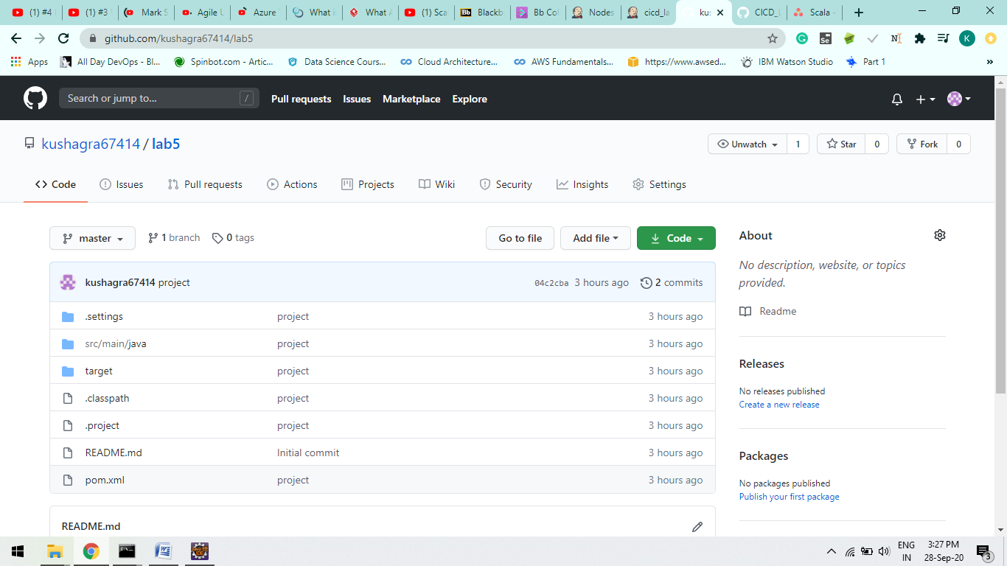

B

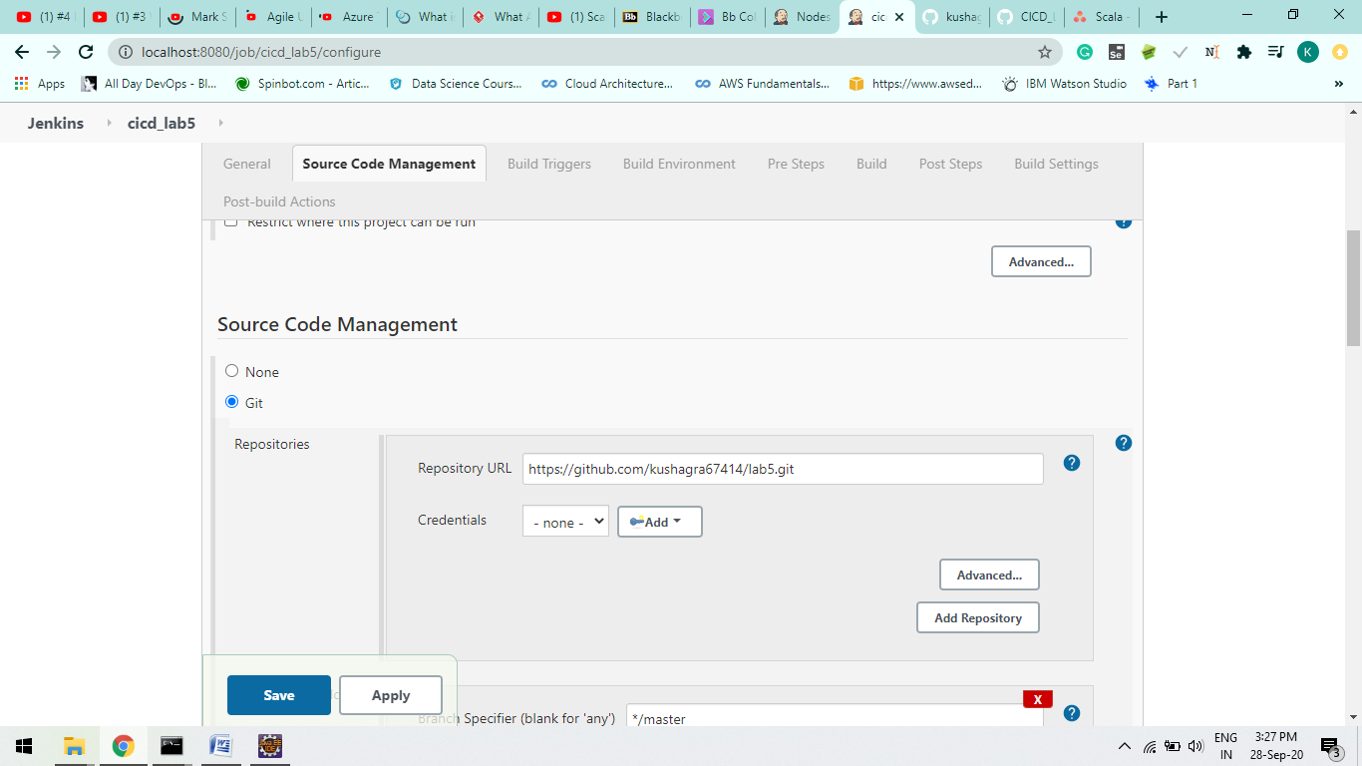

C

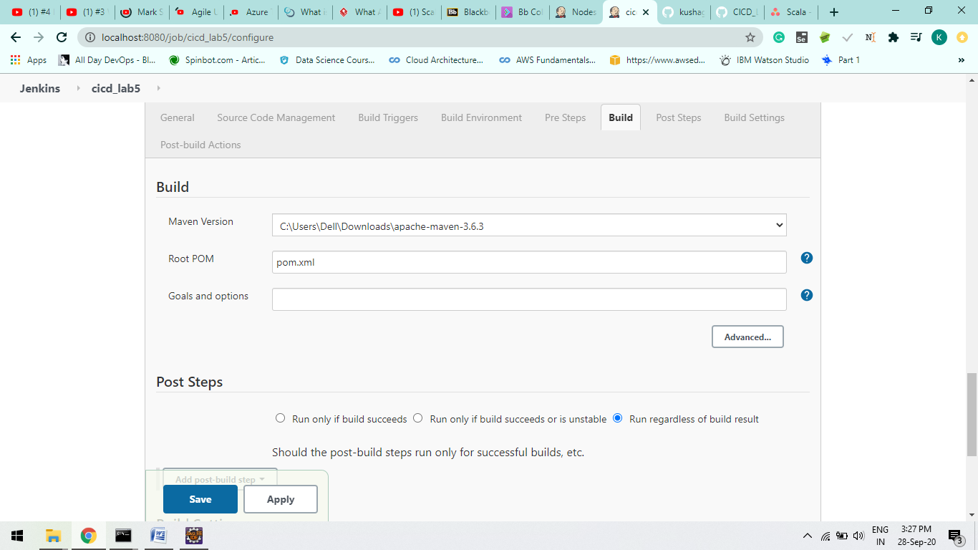

**Step-6:**

Now we have to link it with the Slave_1 we have create

Goto “general” Selects Restrict where the project can be run and type the Slave project name.

Save your all configurations and Build the project.

A.

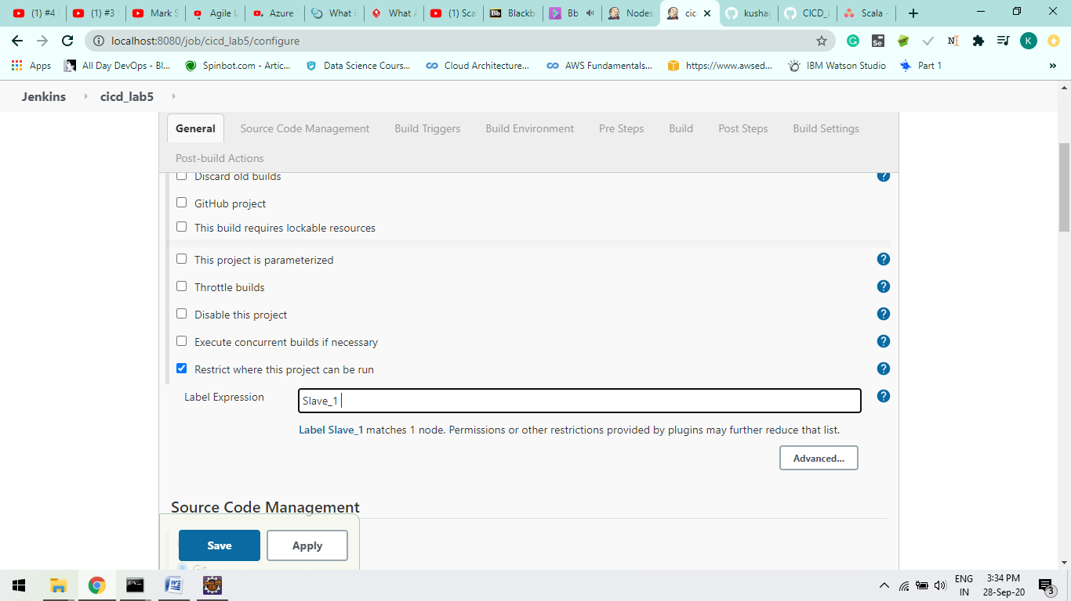

**Step-7:**

Click on Console output and check buid is successful or not.

If not check your configurations file and correct it.

Our project will save in our workspace directory in our local machine.

In our Earlier configuration we use Maven Clean Goal.

OutPut :

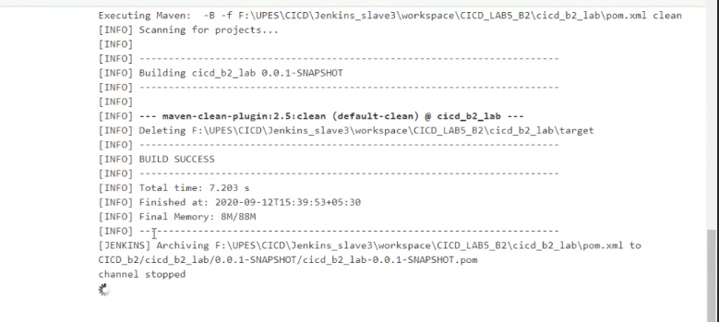

B.

Here your project get stored in Slave.

