CICD LAB-8 Experiment (Ocean Blue Plugin)

BlueOcean Plugin Install:-

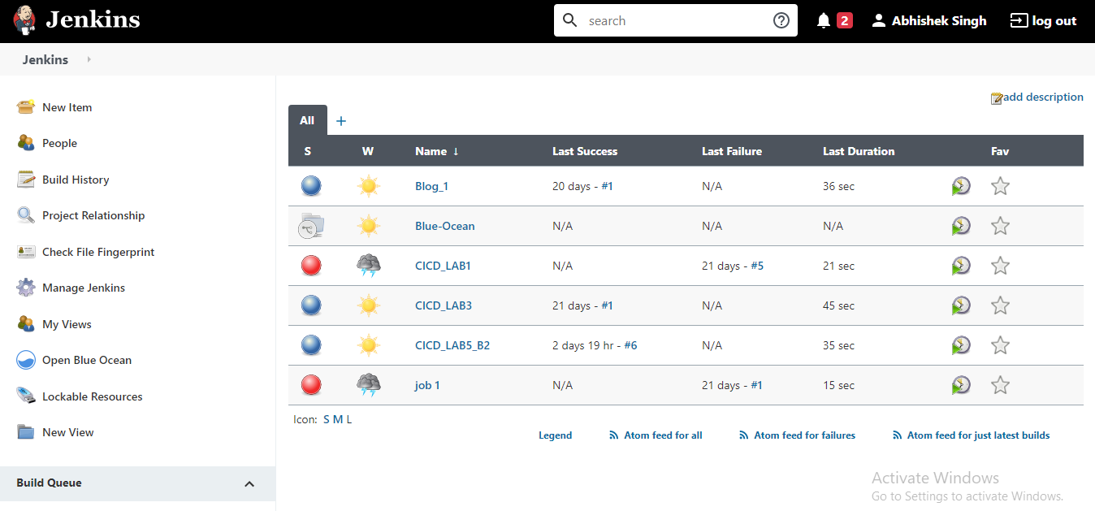

Jenkins File at GitHub:-

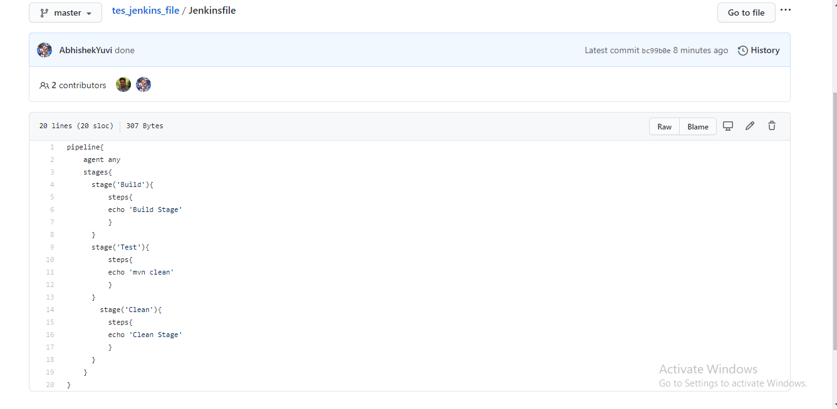

Pipeline Created:-

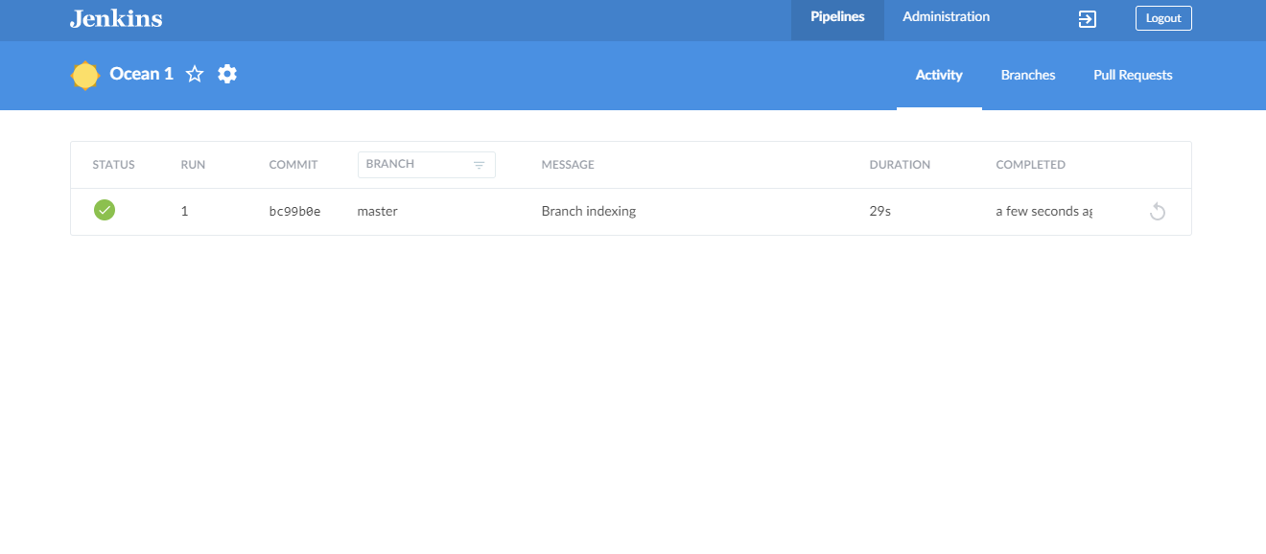

OUTPUT:-

