**Continuous Integration and Deployment Lab**

Experiment Number: 1 (Installation of Jenkins and Execution of a simple job in Jenkins)

By :-

Devansh Markan

R171218036

500069794

Batch:- 1

Download Jenkins through this website: <https://www.jenkins.io/download/>

And download the binaries for Jenkins for Windows

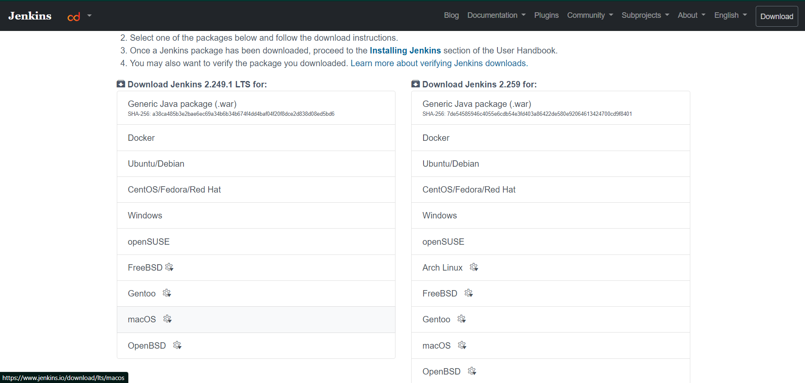

So, when you download Jenkins, it will produce a file named jenkins.war

Use this file to run Jenkins.

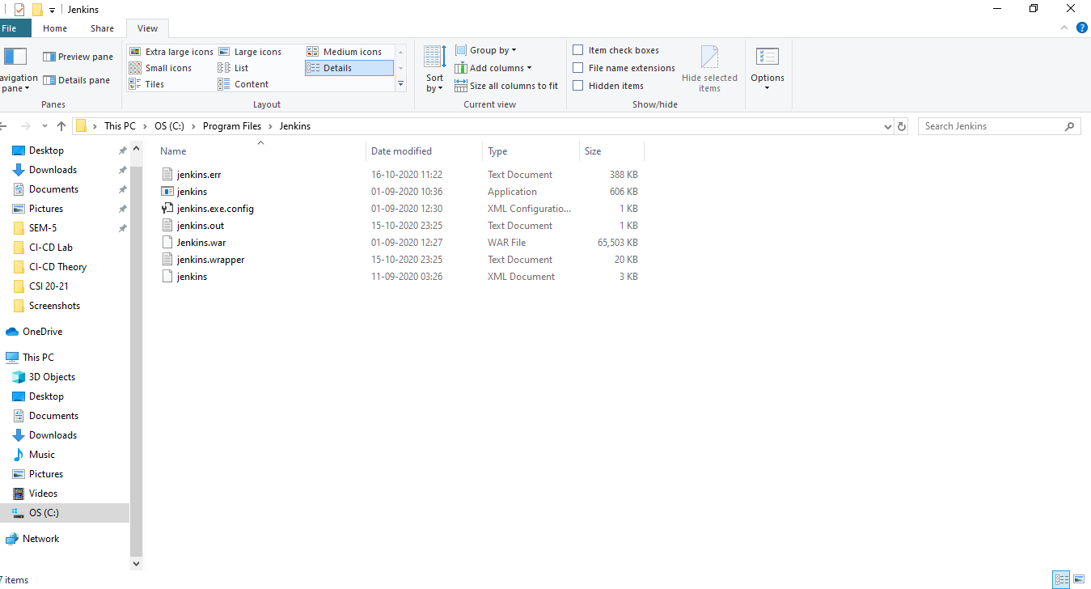

Now,

Open the command prompt in Administrator Mode.

Traverse to the directory containing the jenkins.war file

Type the command : java -jar jenkins.war

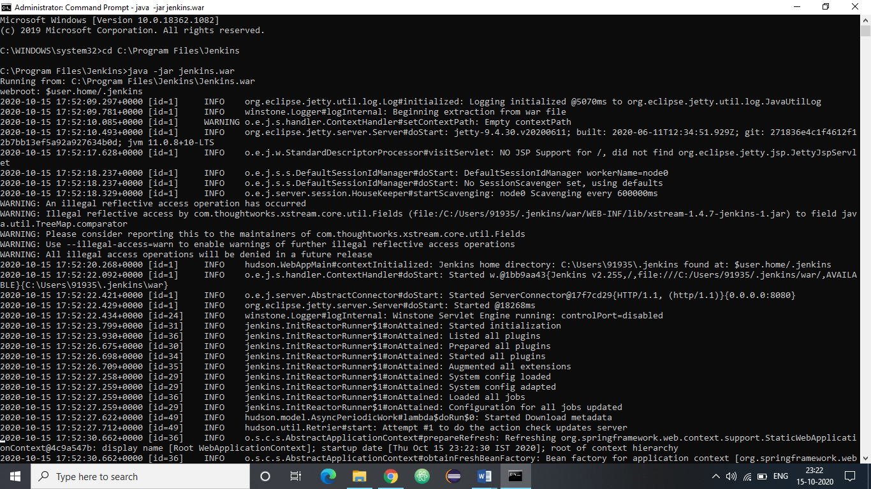

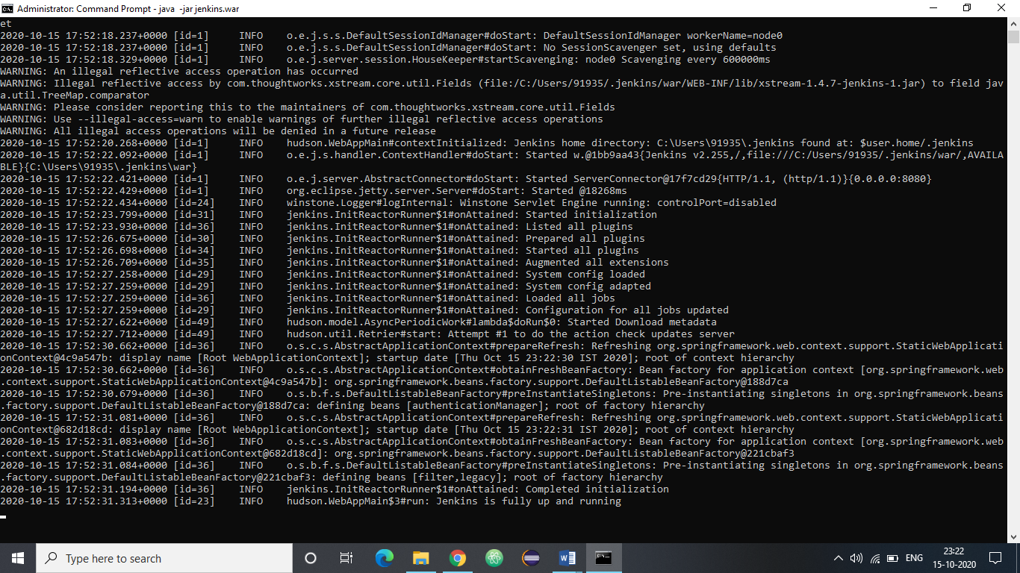

1. Open the web browser.

2. Go to localhost:8081 -> This is the port on which Jenkins run on my system

3. You would be prompted to input the administrator’s password and create a new user.

4. Log in into the Jenkins dashboard

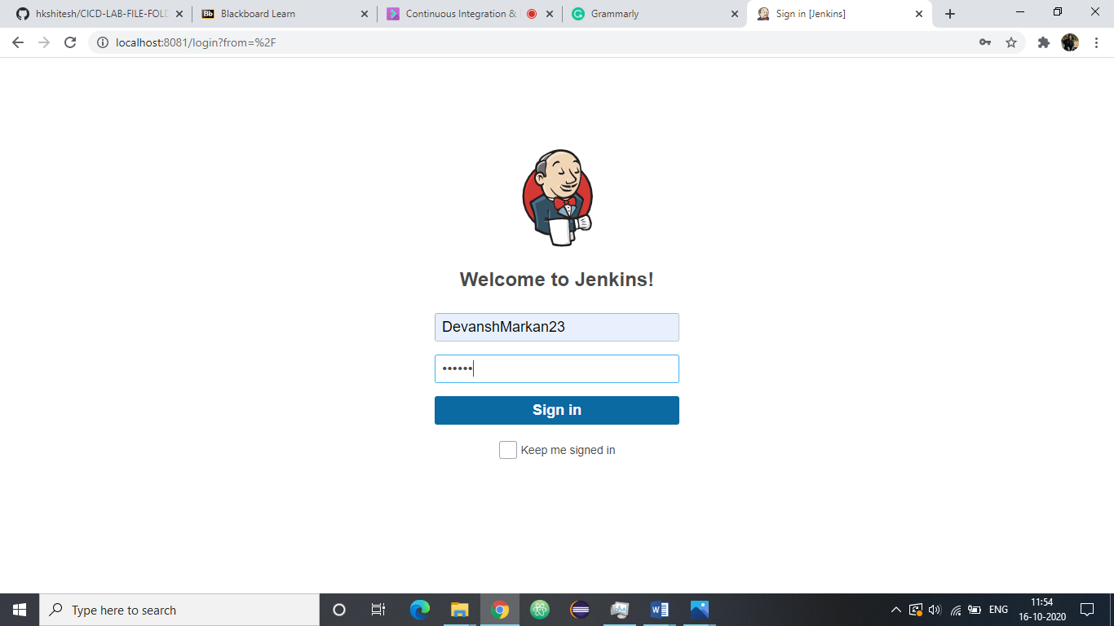

You will have to add the JDK installations and Maven installations to maven.

Go to manage Jenkins option and then, Go to global tool configuration

In the Java JDK section name the JDK and add the location of JAVA_HOME

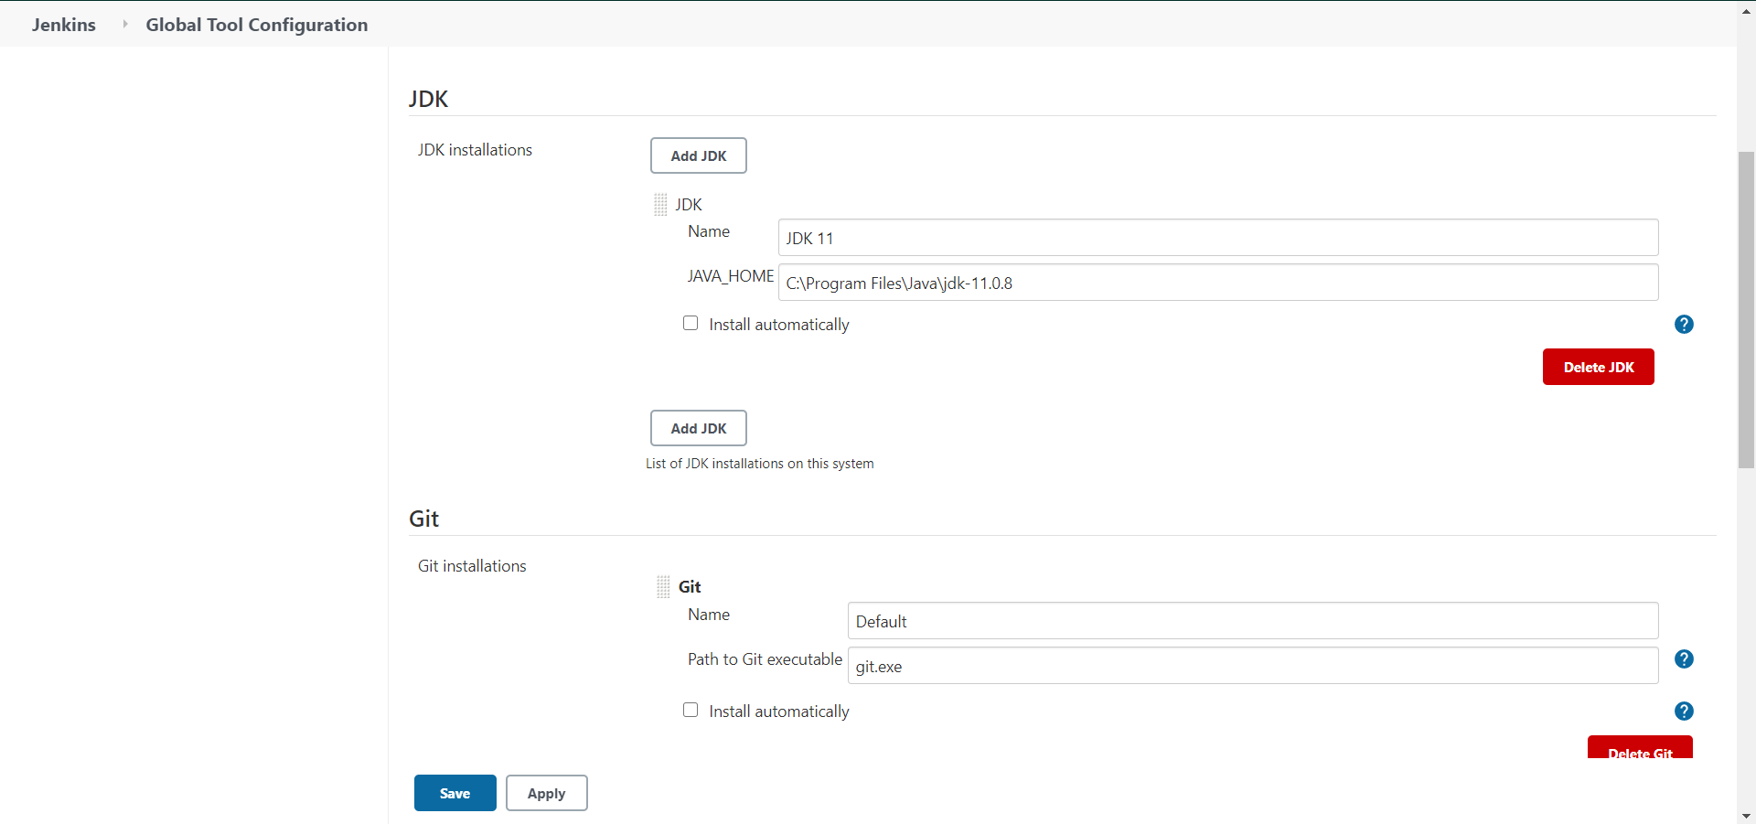

1. Now with everything set and configured, we are ready to create a Jenkins pipeline.

2. In the Jenkins dashboard, select new items option

3. Select a name for your pipeline and check the maven project option.

4. Click ok

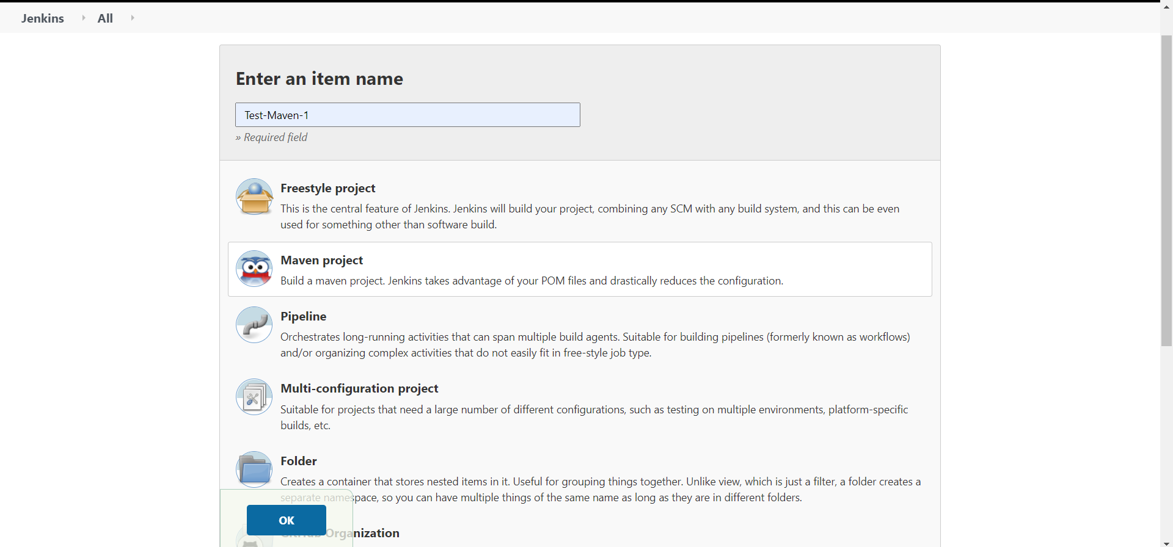

Now, after execution, we get something like this-

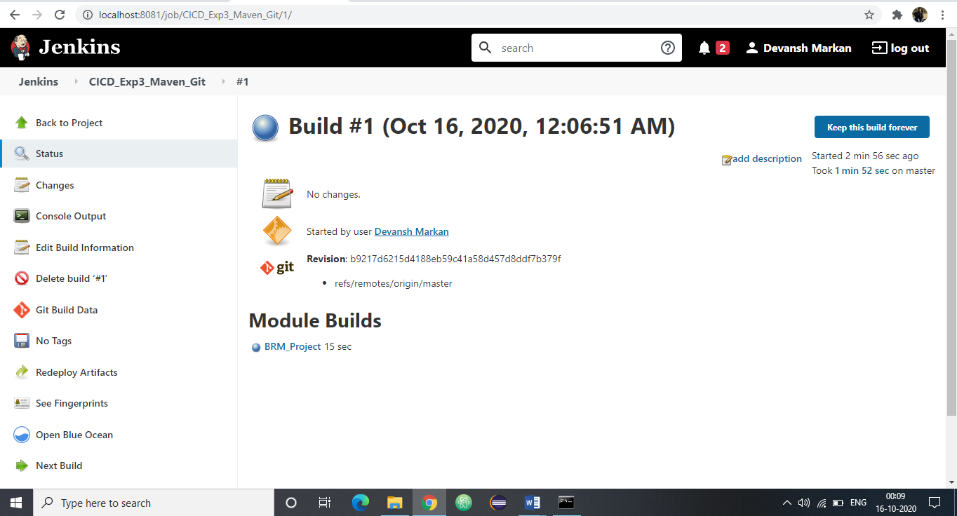

Click on Build now and check the console output for the project.

