EXPERIMENT - 12

**Installing Docker**

Steps:-

1. $ curl -fsSL https://download.docker.com/linux/ubuntu/gpg | sudo apt-key add –
2. $ sudo add-apt-repository "deb [arch=amd64] https://download.docker.com/linux/ubuntu $(lsb_release -cs) stable"
3. $ sudo apt-get update

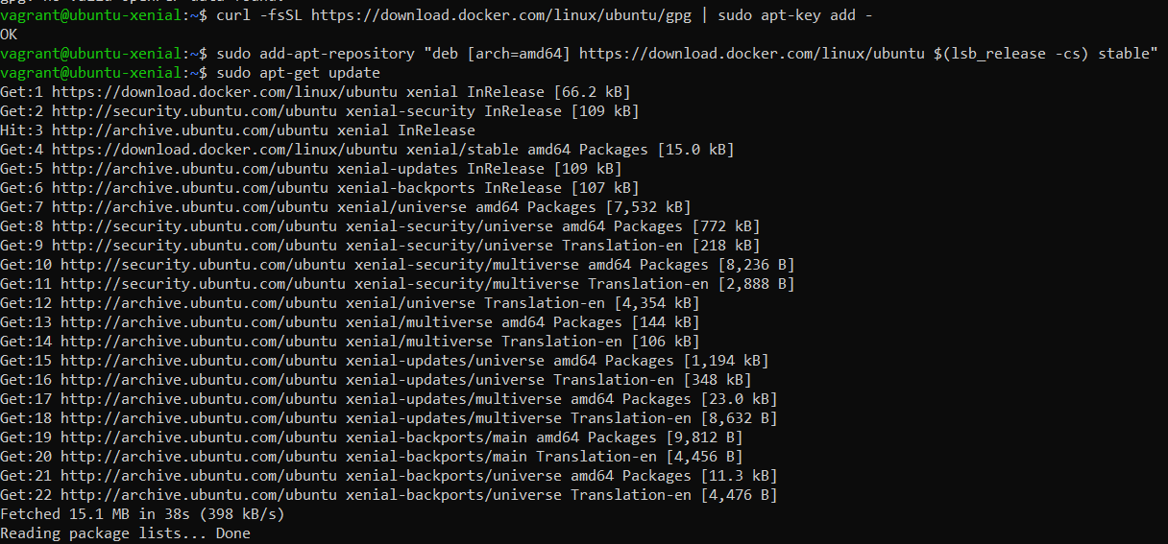

1. $ apt-cache policy docker-ce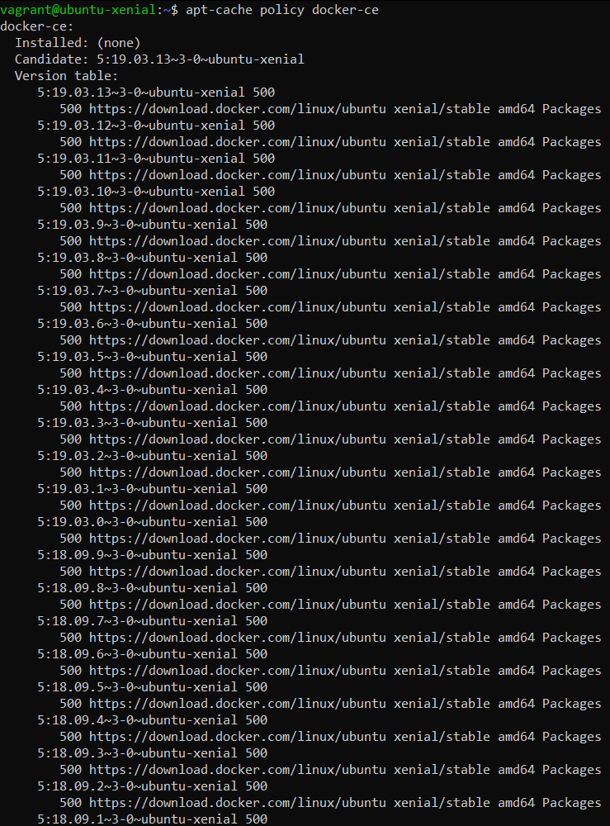
2. $ sudo apt-get install -y docker-ce

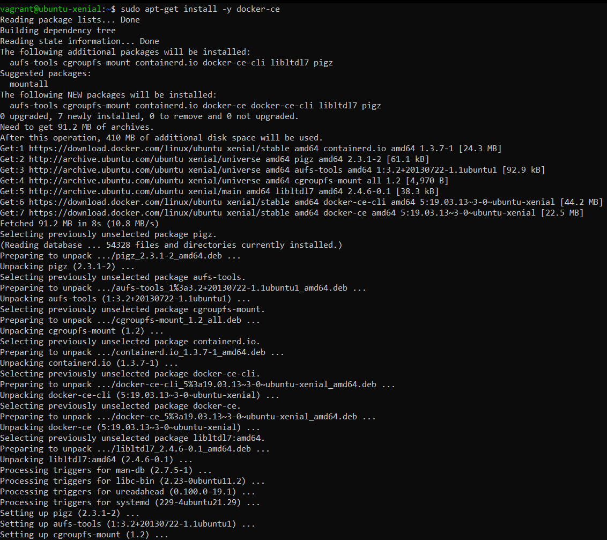

1. $ sudo systemctl status docker

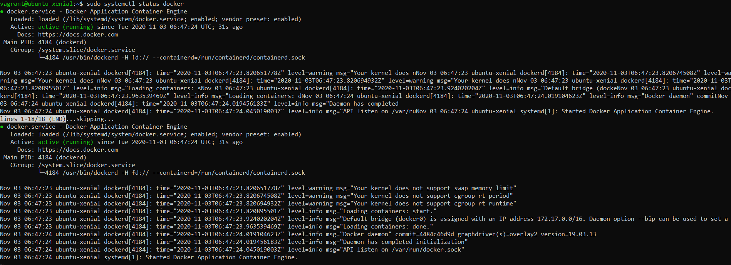

1. $ docker --version
2. $ sudo usermod -aG docker ${USER}
3. $ su - ${USER}
4. $ sudo usermod -aG docker vagrant
5. $ docker run -it ubuntu
6. $ docker ps
7. $ docker ps -a

