EXPERIMENT – 13

WORKING ON DOCKER

1. Use $docker images command to check the docker images available in your machine.

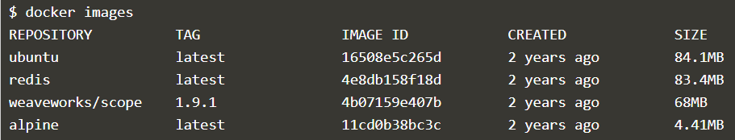

1. Use $docker search <imagename> command to search for the images available for download.

$docker search redis – For searching Redis Images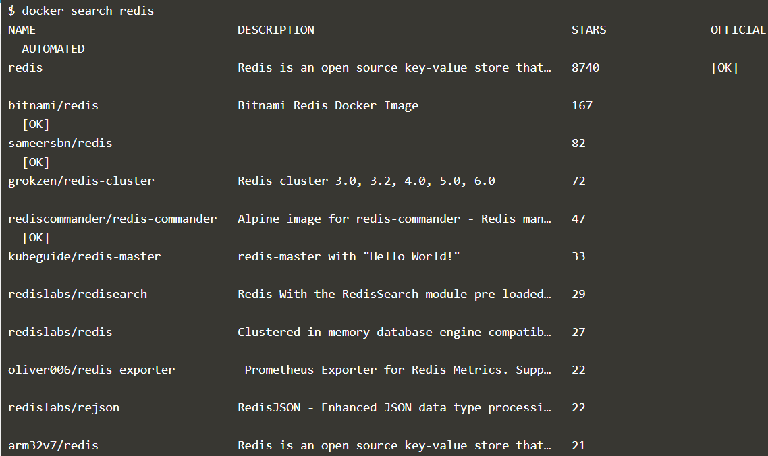

1. Use $docker pull <imagename> to download a Docker Image

$docker pull arm32v7/redis

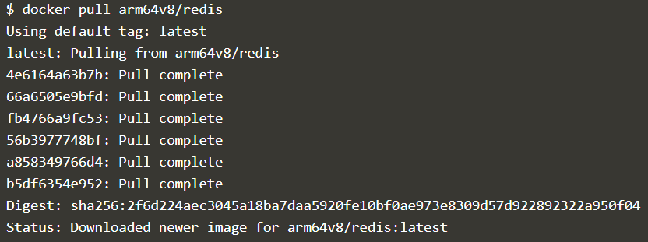

arm32v7/redis image has been downloaded

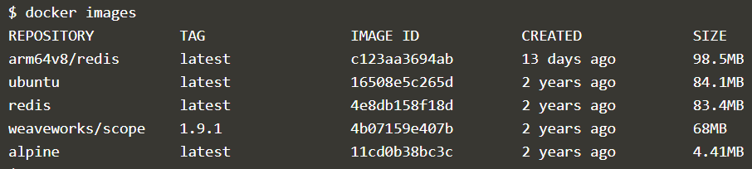

1. Use $docker run -d <imagename> to run the docker image and -d is used to keep it running in the background. Same images can also run multiple times.

$docker run -d redis



1. Use $docker ps to see all the images that are only running currently in your machine.

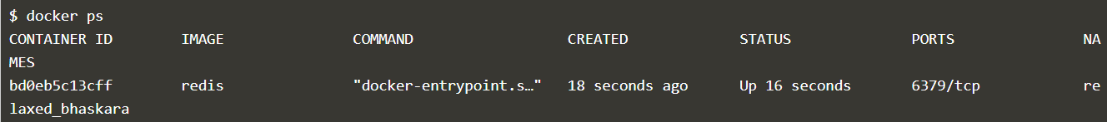

1. Use $docker ps -a to see all the images that are running and terminated.

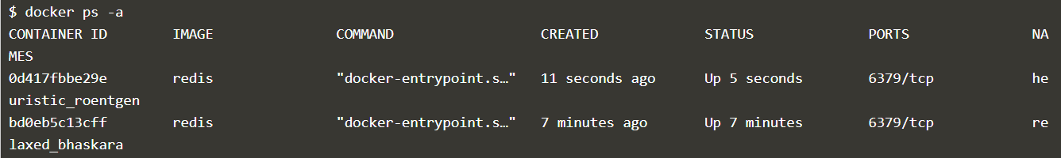

$docker inspect <container name or container id> provides more details about a running container, such as IP address.

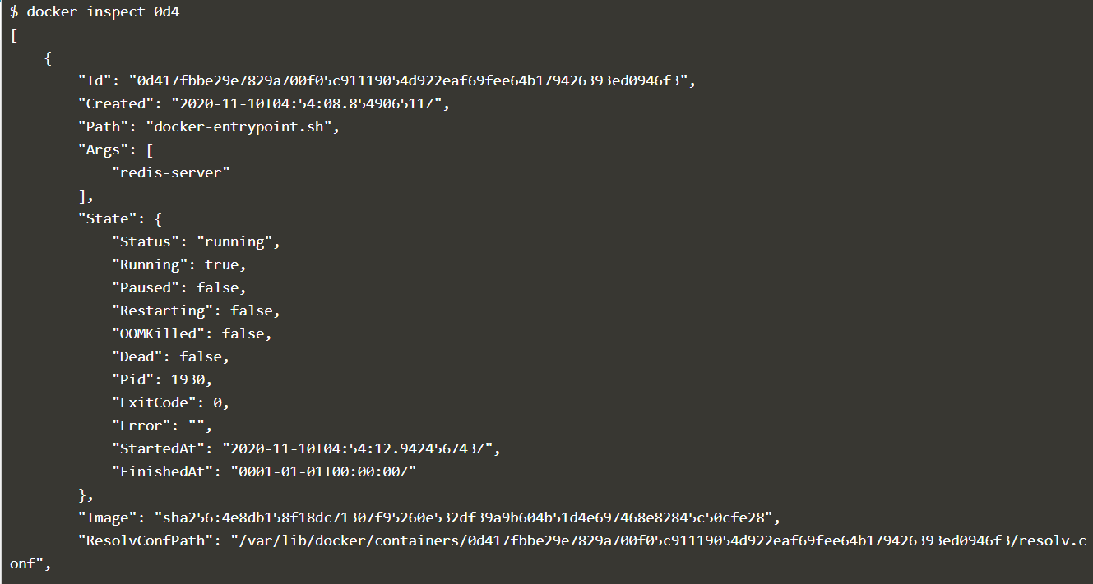

1. Use $docker run -d --name redisHostPort -p 6379:6379 redis:latestlatest to define customized docker image names and ports.



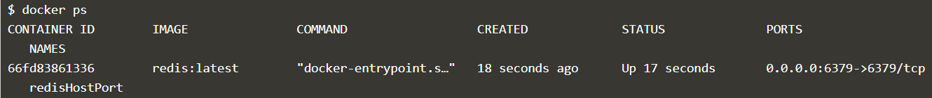

1. $docker port to see the assigned port

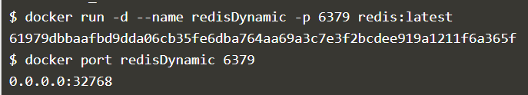

$docker ubuntu run ps command launches an Ubuntu container and executes the command ps to view all the processes running in a container.

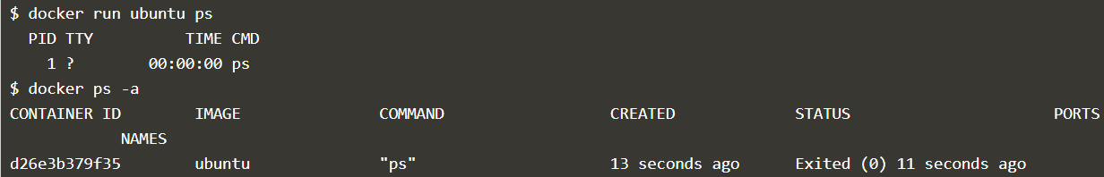

$docker run -it ubuntu command allows to get access to a bash shell inside of a ubuntu container.

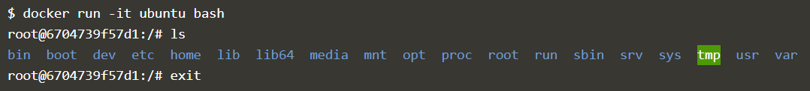

$docker stop



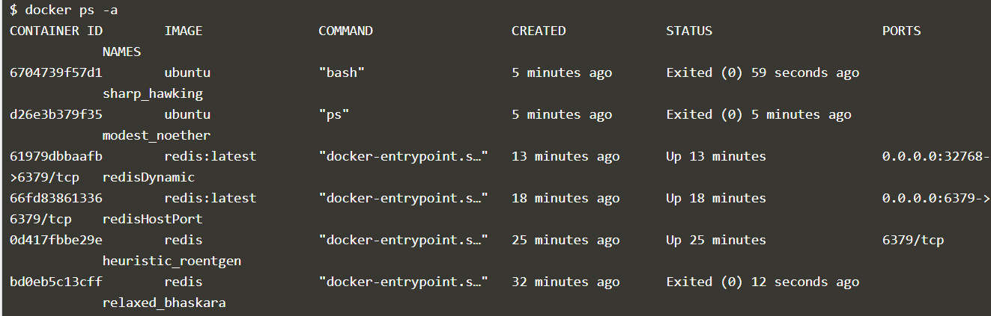

$docker start

