

**Lab Experiment – 1**

**Installation of Jenkins and Execution of a simple Job in Jenkins**

**NAME** -Divyaansh Jain

**ROLL NO** – R171218040

**SAP ID** – 500067134

**COURSE** – B. Tech CSE- DevOps Batch 1

**SUBJECT** – Continuous Integration and Deployment

**SEMESTER** – 5th semester

**Submitted To:**

Dr. Hitesh Kumar Sir

**Experiment for demonstrating the installation of Jenkins and executing a simple job**

* Go to the website <https://www.jenkins.io/download/> and download Jenkins for your preferred operating system.

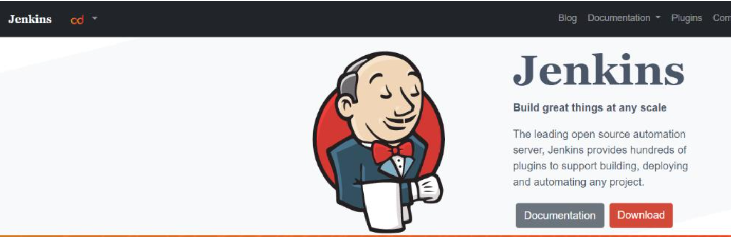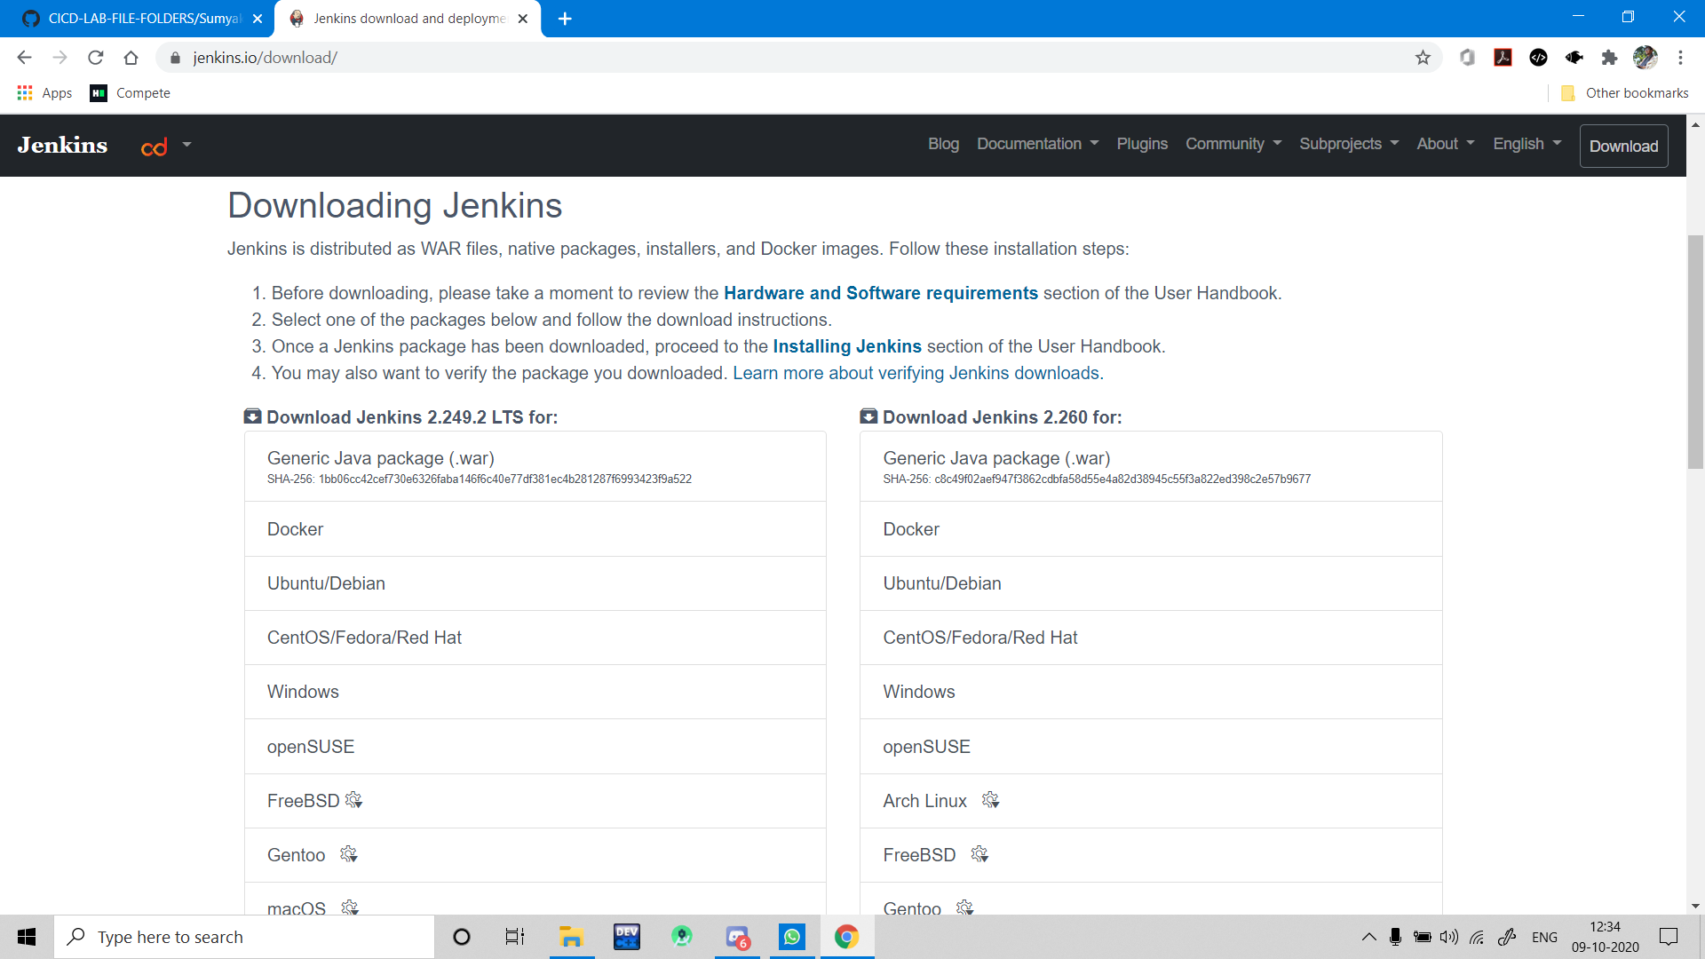

* Go to the download location of Jenkins and open command line from there.

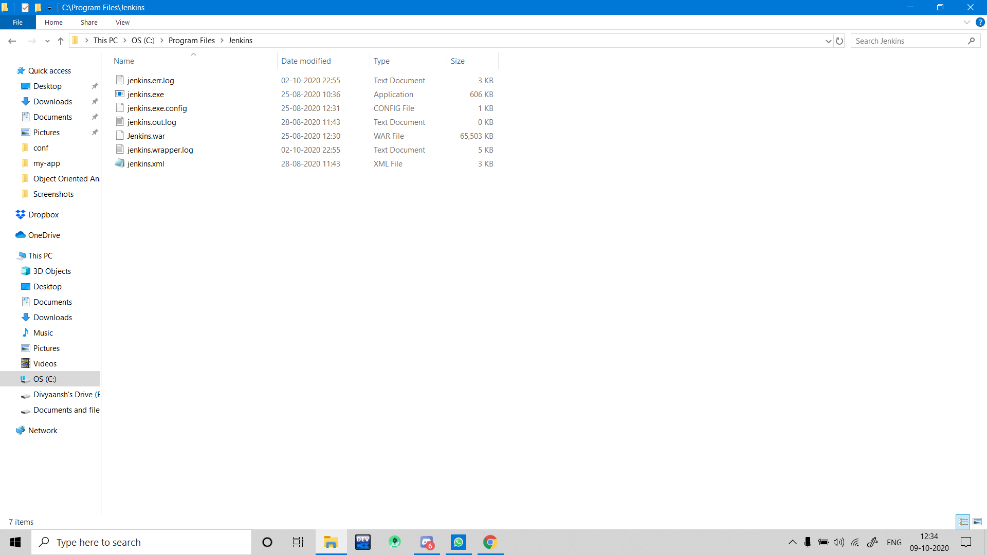

* Now open Jenkins from command line using the command “ java -jar Jenkins.war ” and by default port number is 8080.

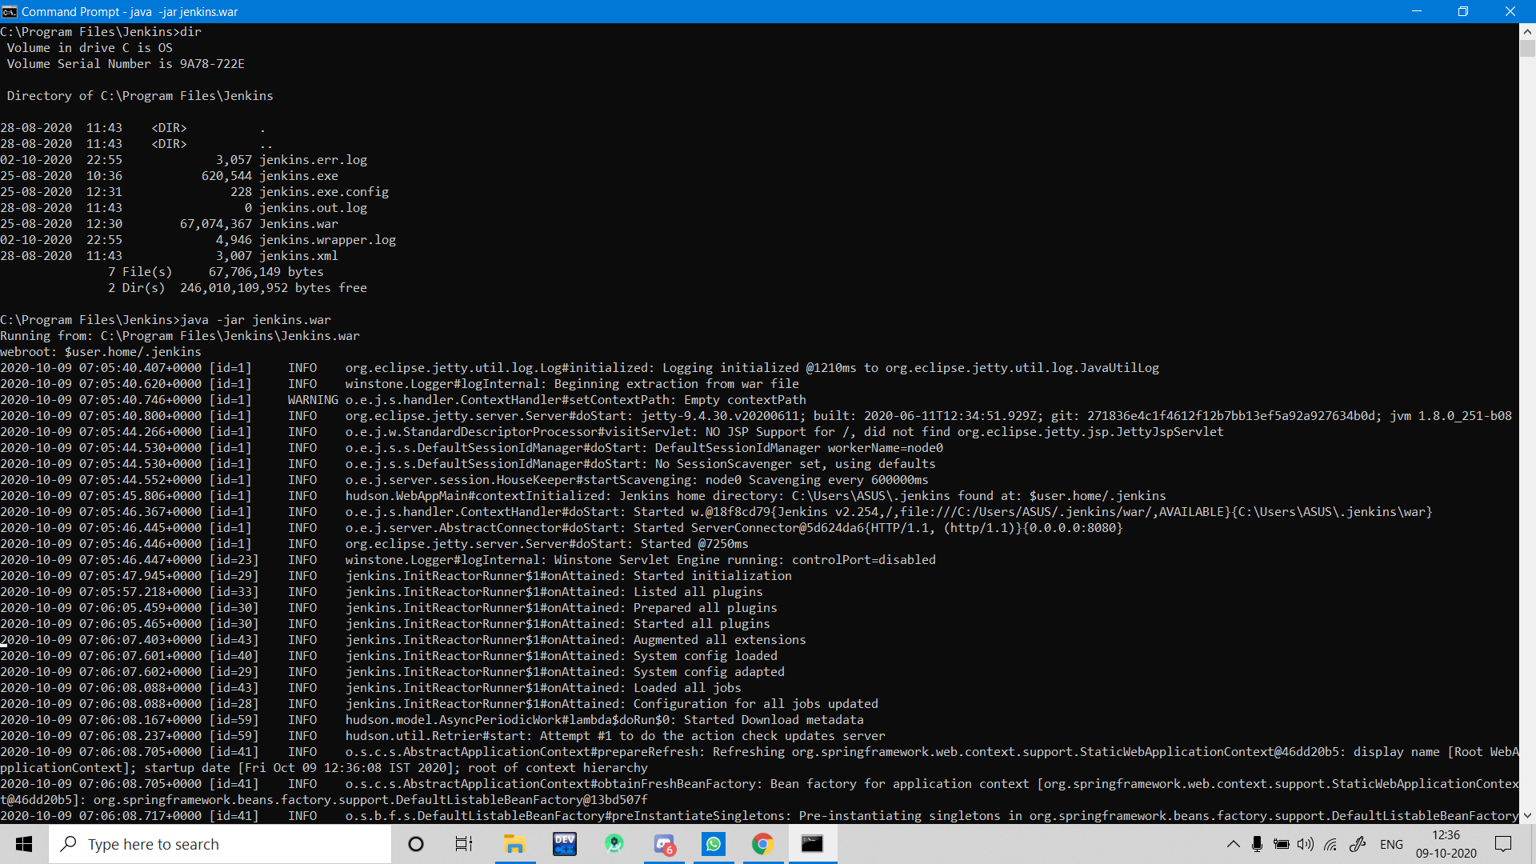

* Open Jenkins in any browser using localhost:8080 and for the first time you will see a screen which gives you a path where your password is stored initially.

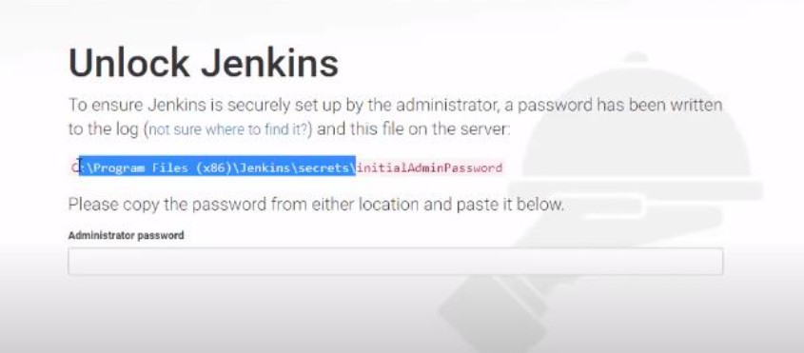

* After providing the password, you can create your own password for the user admin.

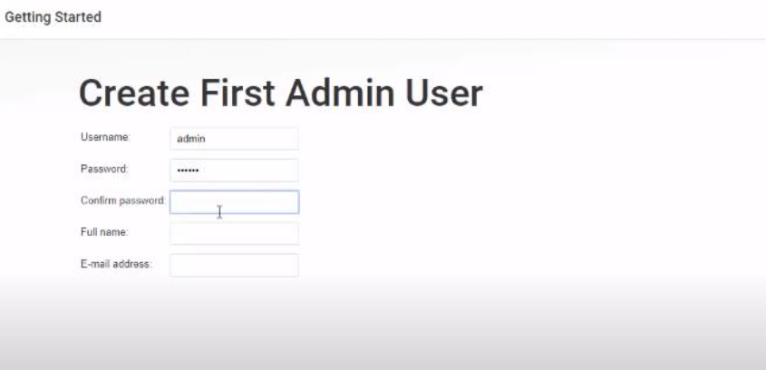

* After this, you will find a default option to download plugins.

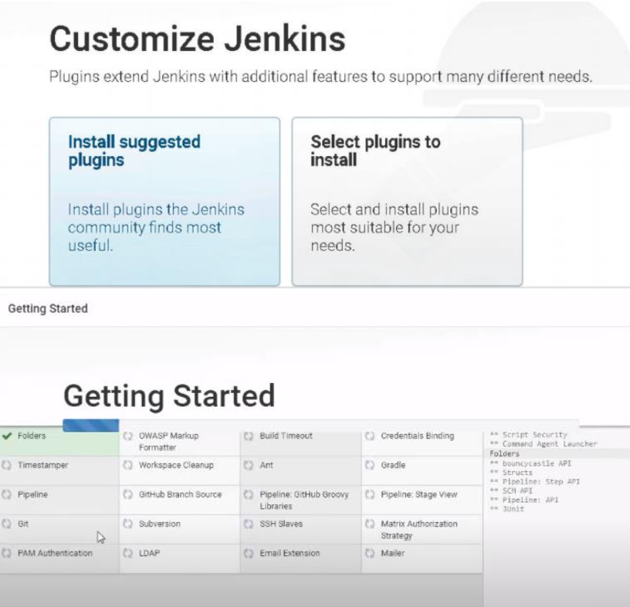

* After installation of plugins, you can login to the Jenkins using admin user.

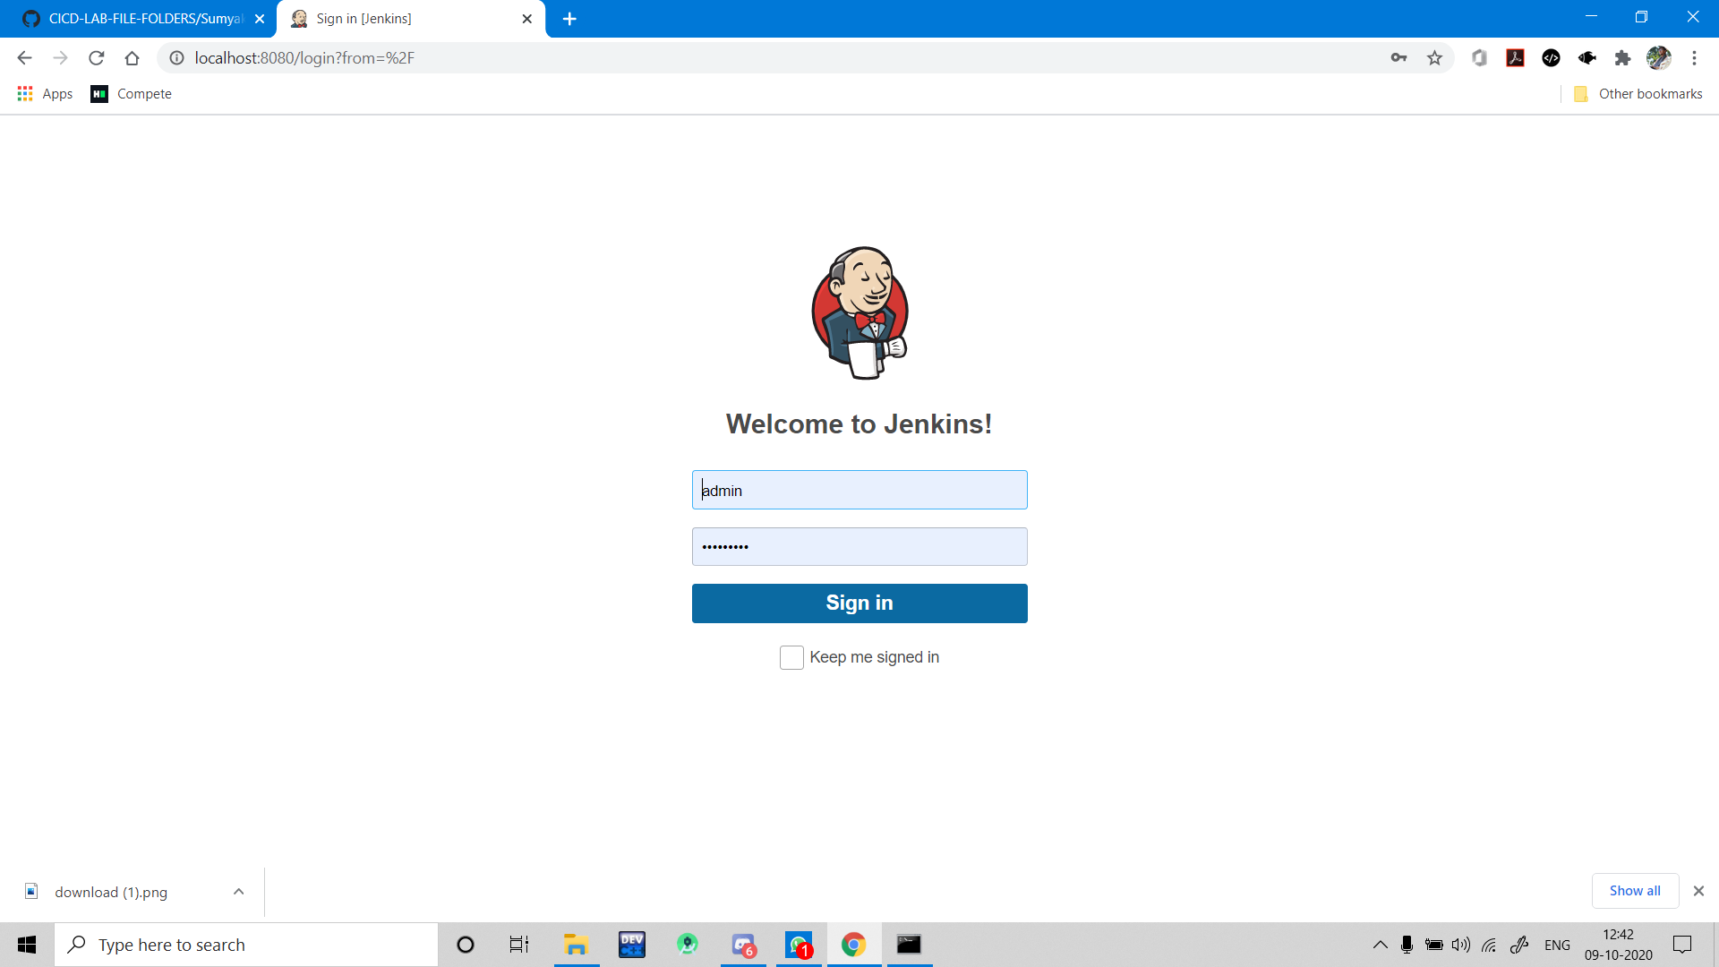

* Make a job, in this case, a freestyle job.

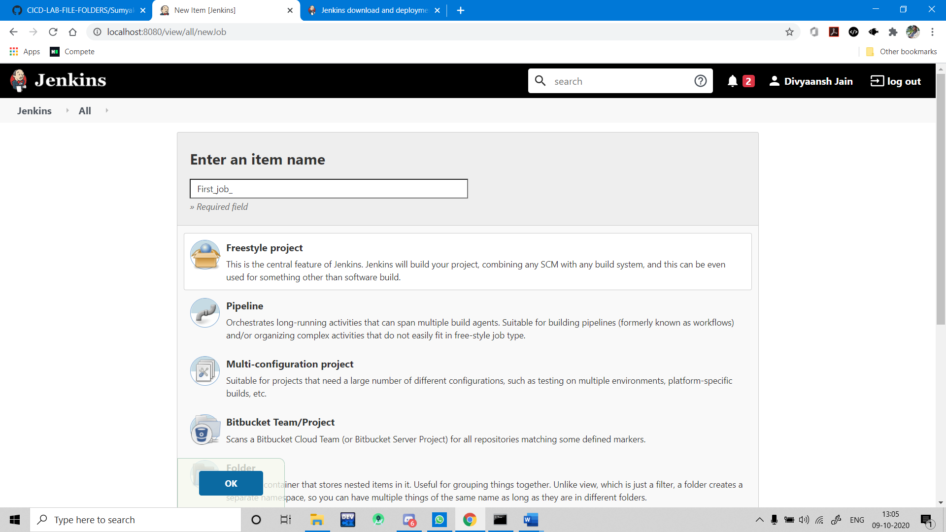

* Now in this case we are only running a simple Batch command, so in the build, we have to add a build step which is windows batch command.

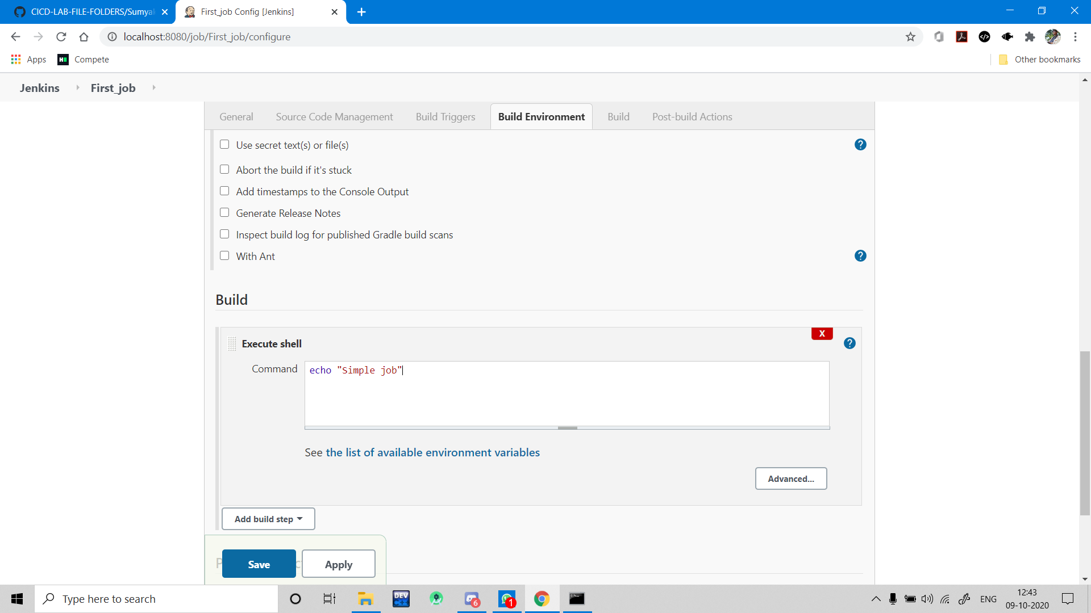

* Saving this project and running/building this project. The console output for the project is given below.

