

**Lab Experiment – 2**

**Jenkins Integration with GitHub**

**NAME** -Divyaansh Jain

**ROLL NO** – R171218040

**SAP ID** – 500067134

**COURSE** – B. Tech CSE- DevOps Batch 1

**SUBJECT** – Continuous Integration and Deployment

**SEMESTER** – 5th semester

**Submitted To:**

Dr. Hitesh Kumar Sir

**Experiment for demonstrating Jenkins Integration with GitHub**

* Make any file or a project and upload it to your GitHub account in a repository, in this case, Java file in <https://github.com/Divyaansh313/JavaTime>

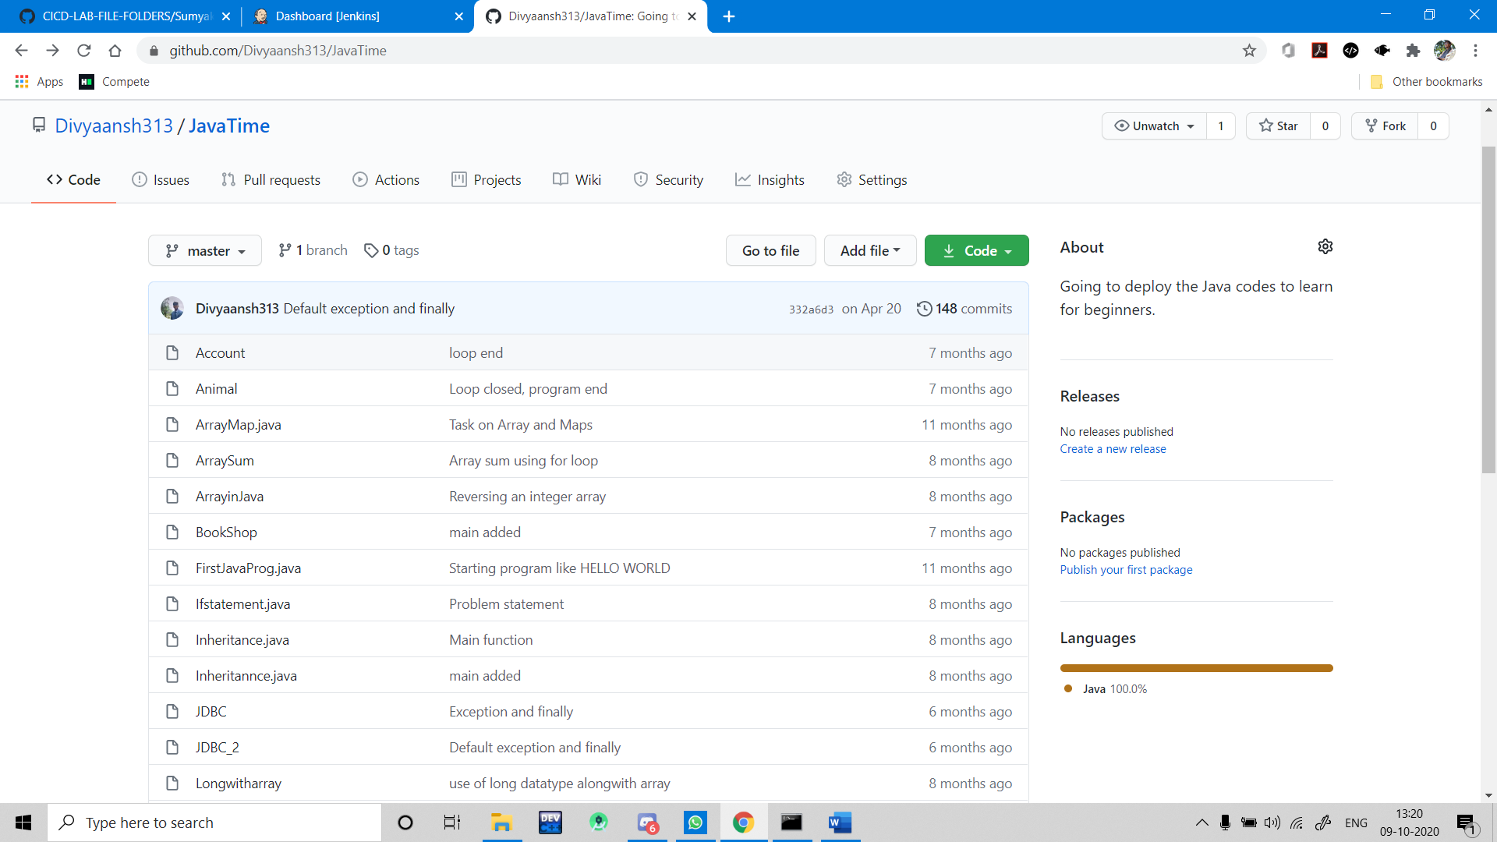

* Open the Jenkins and make a new freestyle project.

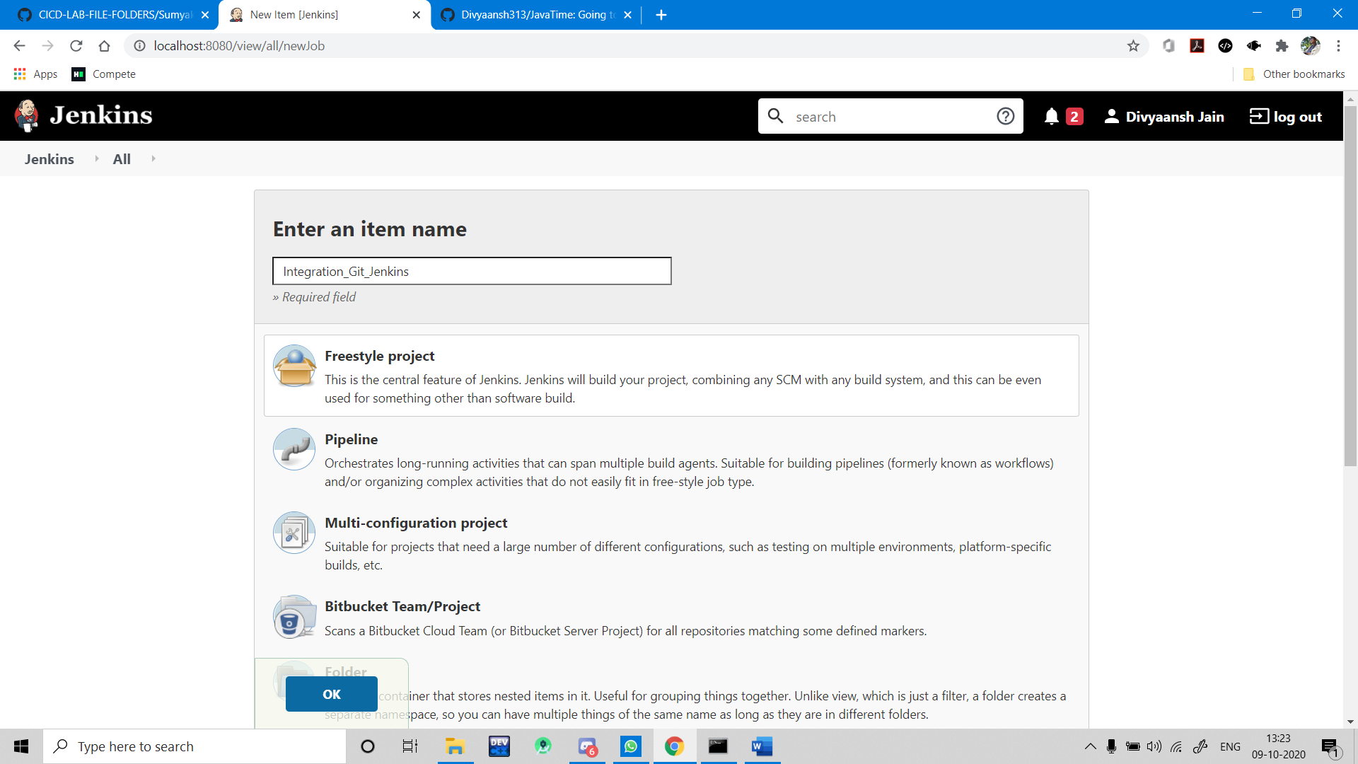

* In this project, select Git in the Source Code Management Tab and give credentials if you are working with a private repository.

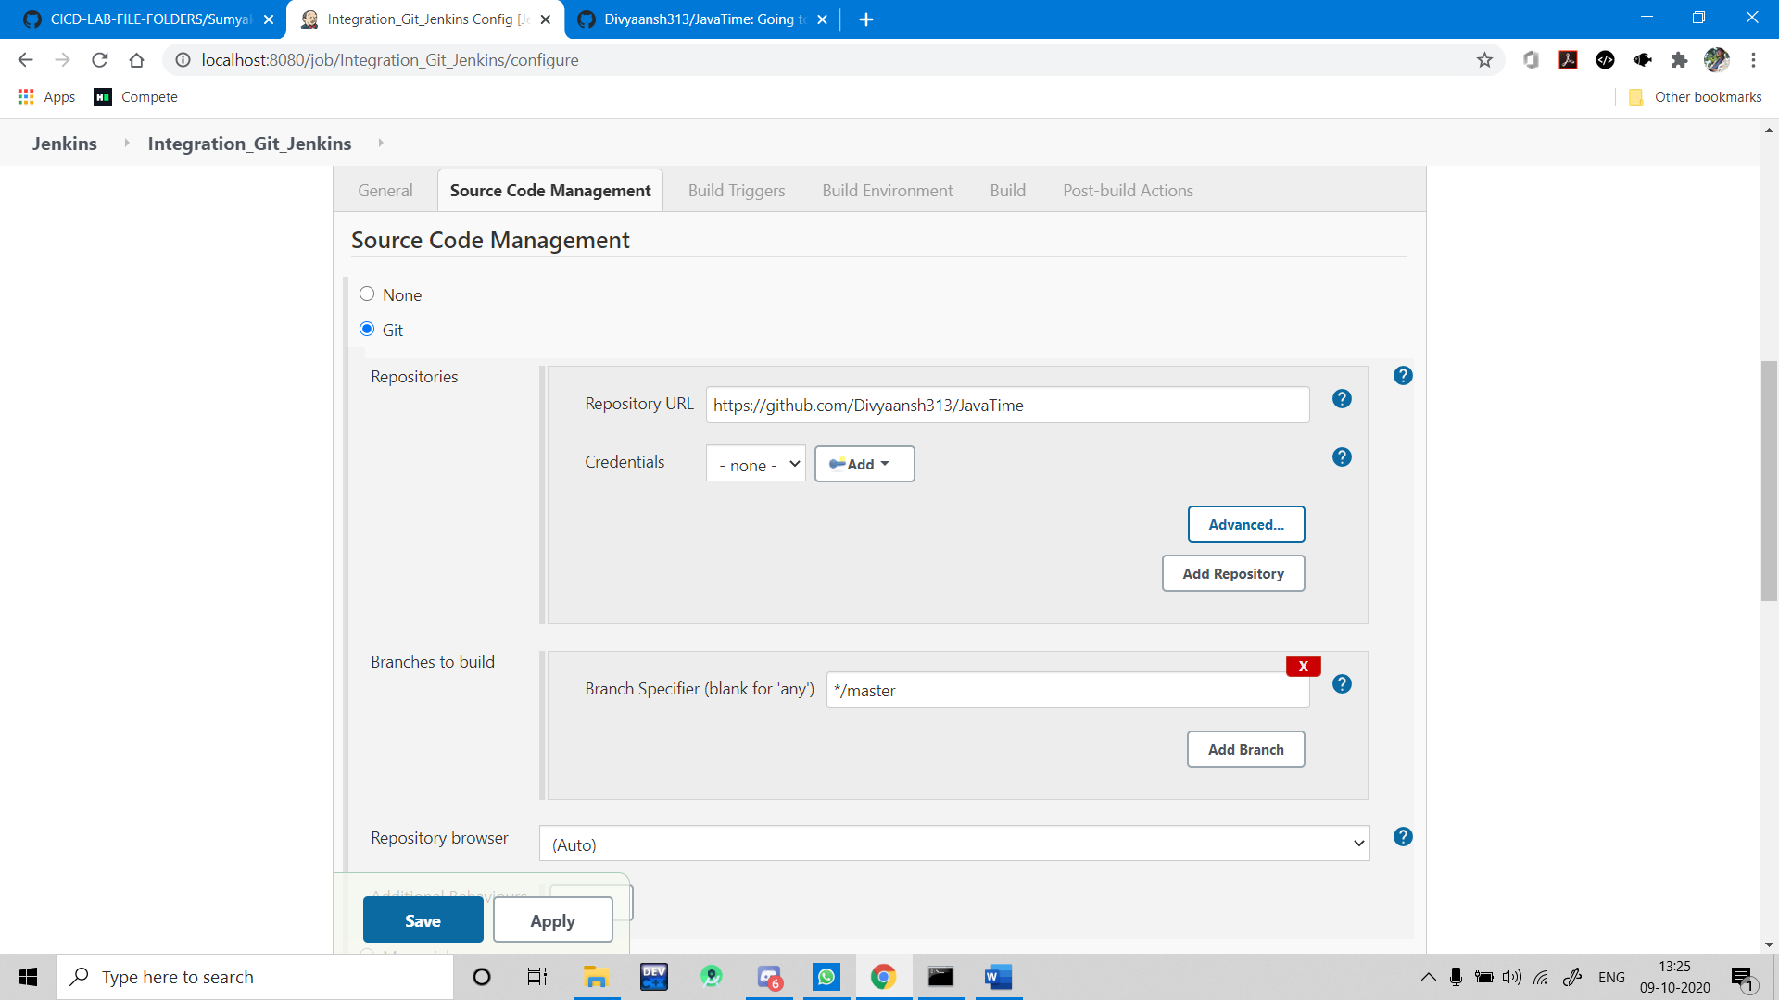

* Give appropriate batch or shell commands to run your program file, in this case Java file.

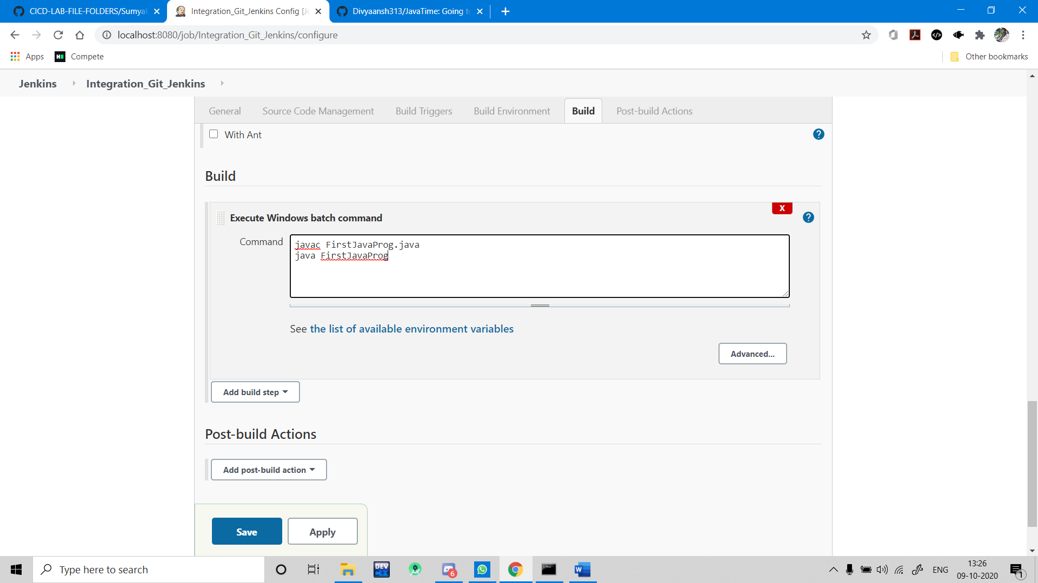

* Saving this project and running/building this project. The console output for the project is given below.

