

**Lab Experiment – 3**

**Jenkins Integration with GitHub and Maven**

**NAME** -Divyaansh Jain

**ROLL NO** – R171218040

**SAP ID** – 500067134

**COURSE** – B. Tech CSE- DevOps Batch 1

**SUBJECT** – Continuous Integration and Deployment

**SEMESTER** – 5th semester

**Submitted To:**

Dr. Hitesh Kumar Sir

**Experiment for demonstrating Jenkins Integration with GitHub and Maven**

* Make any maven project and upload it to your GitHub account in a repository, <https://github.com/Divyaansh313/Apache_Maven>

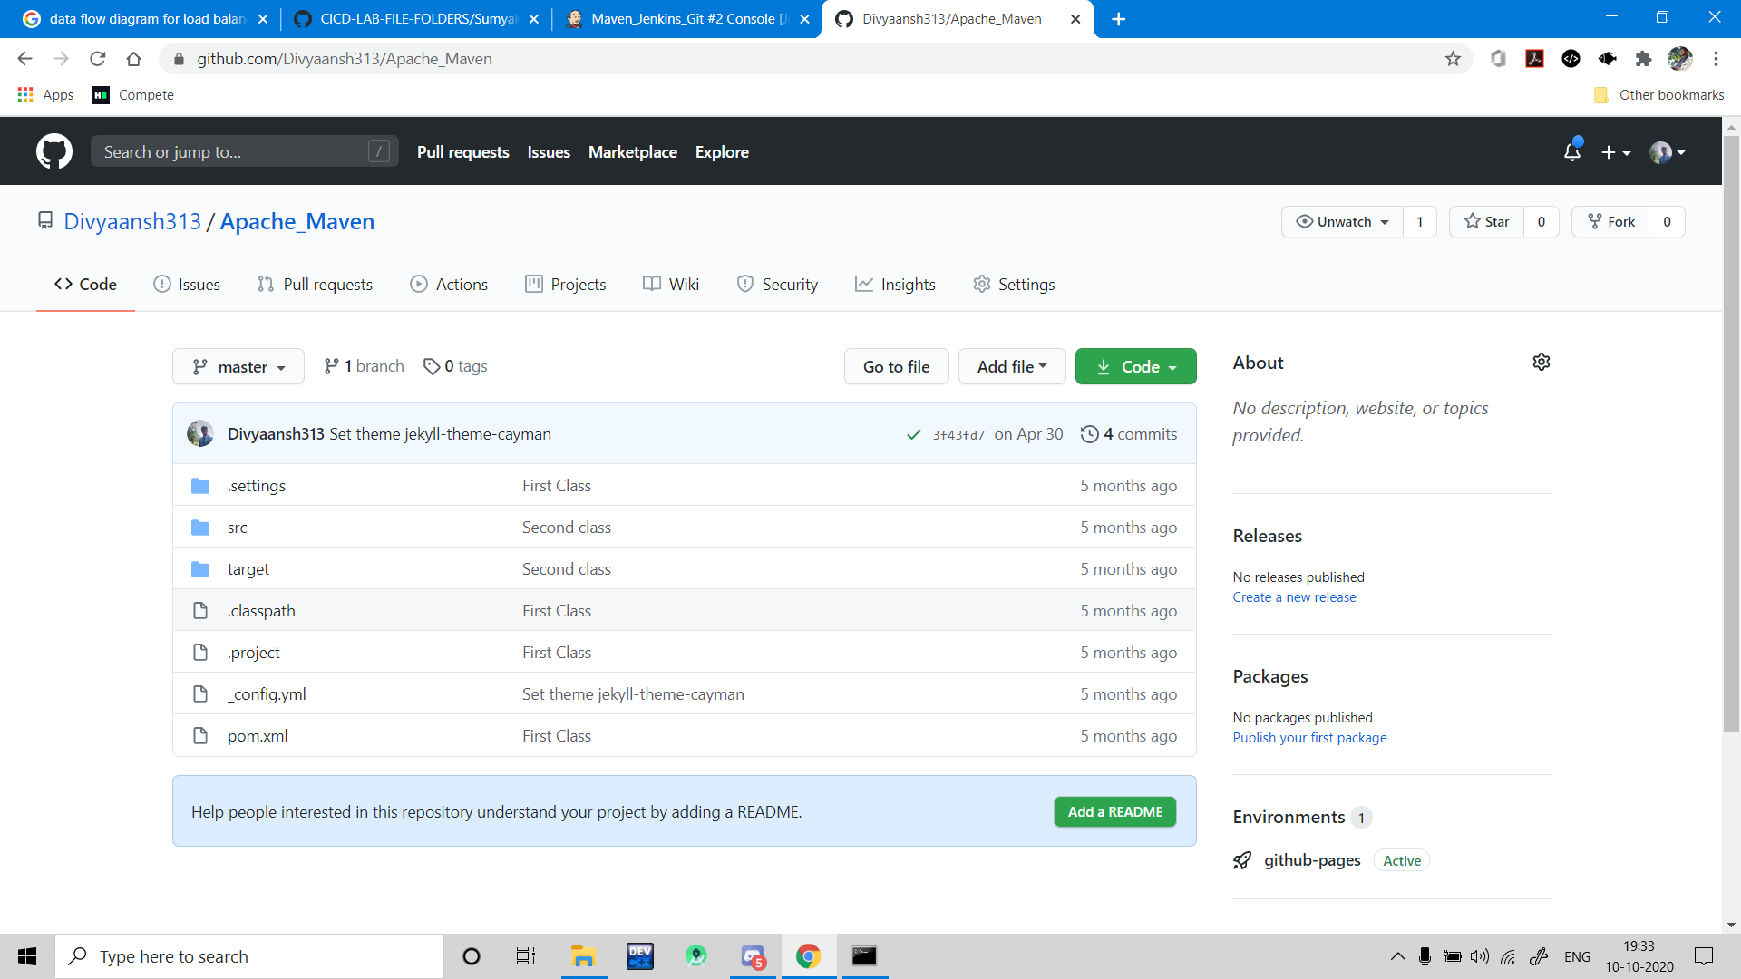

* Open Jenkins and download the Maven Integration plugin. Now in the “Manage Jenkins” and give the location of Maven.

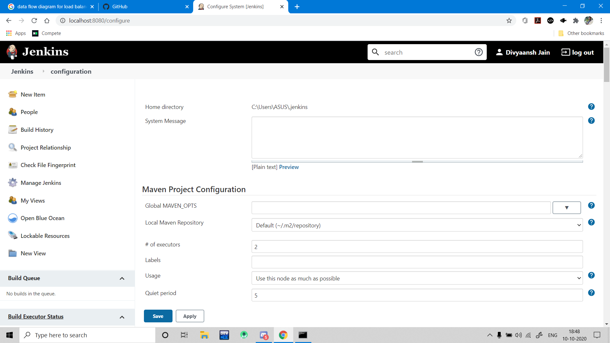

* Create a new Freestyle Project.

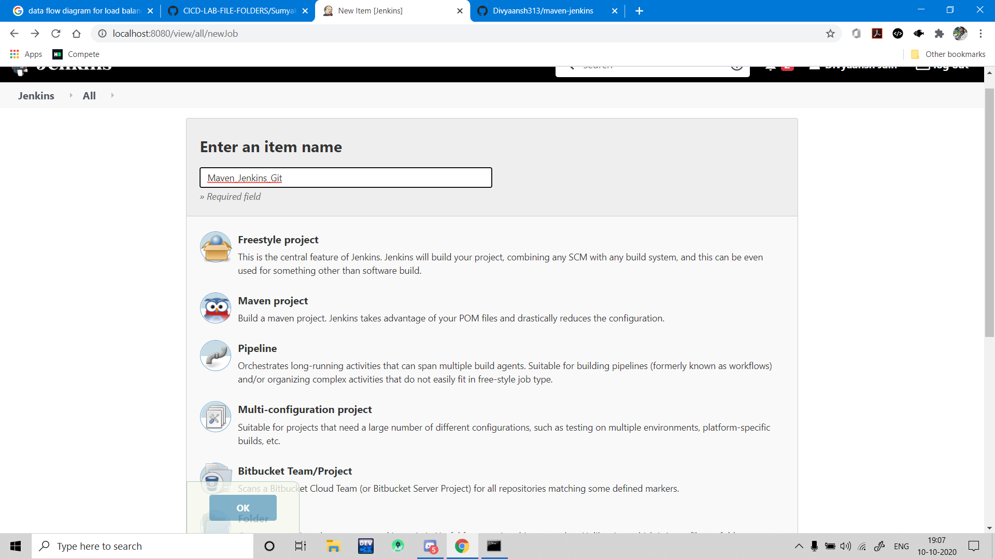

* In this project, select Git in the Source Code Management Tab and give credentials if you are working with a private repository.

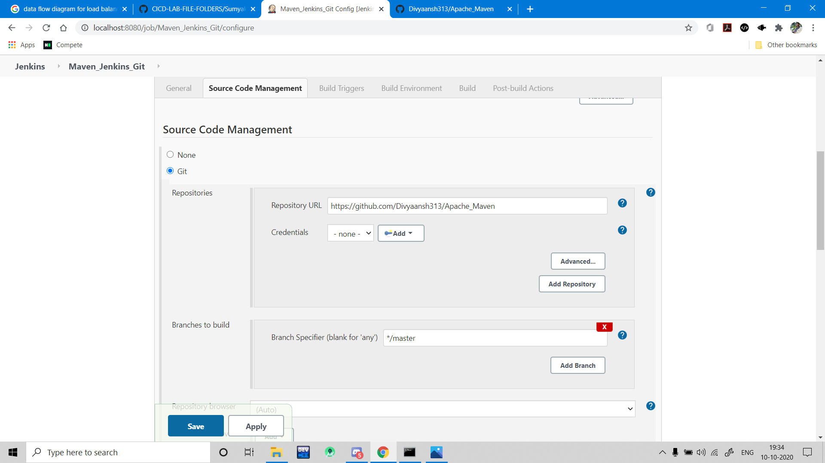

* Give appropriate batch or shell commands to execute Maven commands.

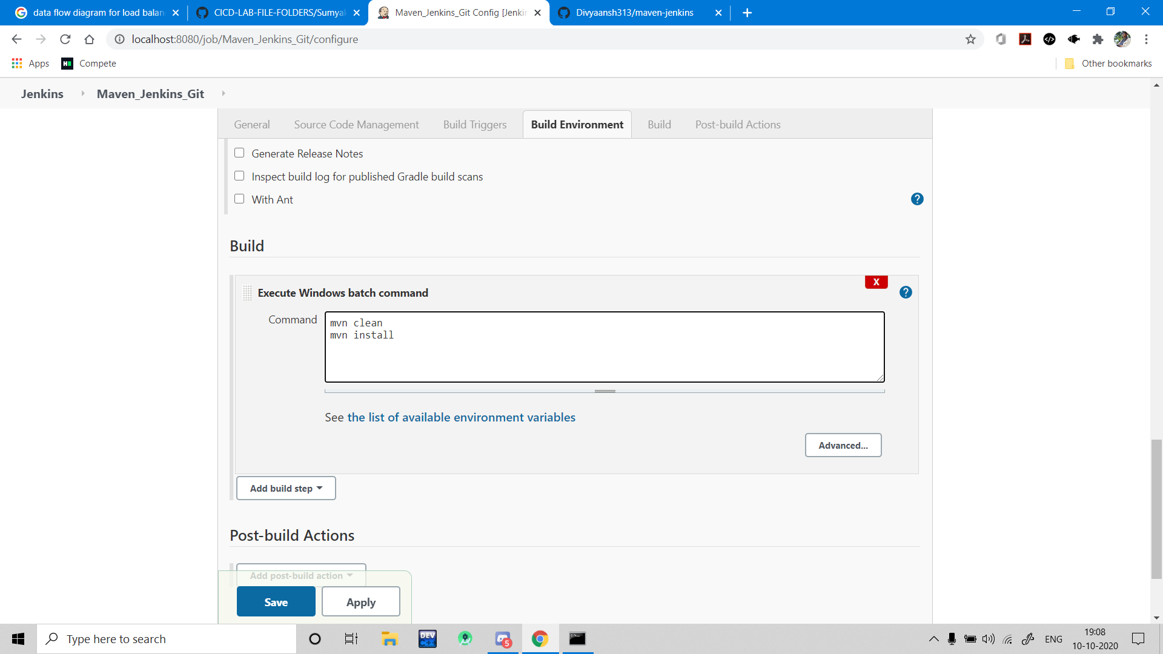

* Saving this project and running/building this project. The console output for the project is given below.

