* **Getting started with Docker**

Docker is a widely used tool which provides a set of PaaS products to deliver software in containers. These containers are isolated and have their own configurations. Although, the containers can communicate with each other.

Below given steps will lead you to the installation of Docker on Ubuntu-xenial and getting started with it.

The steps that need to be followed are:

1. Run the following command to add the GPG key that will ensure that downloads are valid.

Command: curl -fsSL https://download.docker.com/linux/ubuntu/gpg | sudo apt-key add –



2. Add Docker repository to your APT resources by using the following command.

Command: sudo add-apt-repository "deb [arch=amd64] https://download.docker.com/linux/ubuntu $(lsb_release -cs) stable"

3. Update the system.

Command: sudo apt-get update

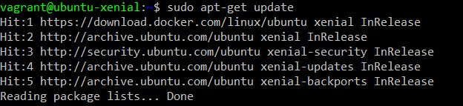

4. Ensure that official repo will be used to download Docker, rather than the default repo for Ubuntu-16.04.

Command: apt-cache policy docker-ce

You will get a similar output.

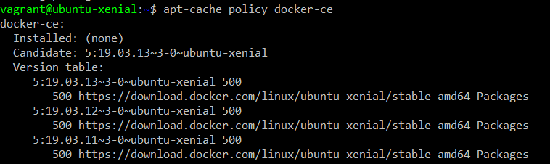

5. Now we are ready to install Docker. Run the following command to install Docker.

Command: sudo apt-get install -y docker-ce

You will get a similar output.

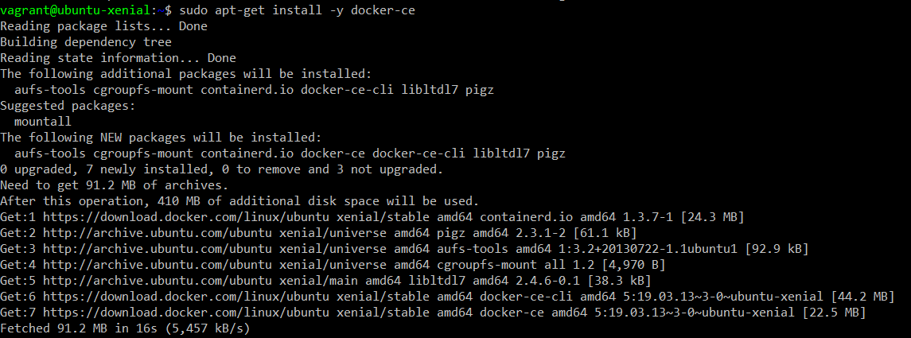

After successful completion of this command, Docker will be installed.

In the next step we will verify that its running.

6. Verify that Docker is in the running state.

Command: sudo systemctl status docker

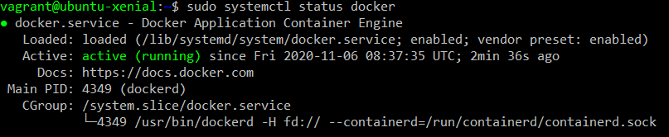

**Note:** If you want to avoid writing sudo before docker command, add your user to the docker group.

Command: sudo usermod -aG docker ${USER}

To apply the new changes, run the following command and provide the password for your user when prompted.

Command: su - ${USER}

If you want to ass a user to the group that you are not currently logged in as then use the following command.

Command: sudo usermod -aG docker username

7. Let us run Ubuntu on our newly installed docker.

Command: docker run ubuntu

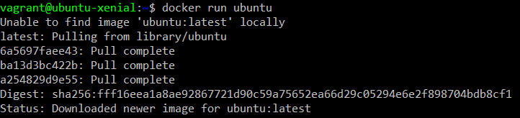

Above command will create a container with Ubuntu image and will run it. Note that the container will be exited after successful creation.

Use the following command to verify the creation of container.

Command: docker ps –a



8. Run the following command to open the interactive terminal of the newly created Ubuntu container that will let you work on it.

Command: docker run –it ubuntu



9. Create a new directory and verify that it is created.

