**Installation of Jenkins and execution of a basic job on Jenkins.**

Jenkins is a powerful tool that aids the process of Continuous Integration and Deployment. Let us get started with its installation and basic setup of Jenkins on Windows for Java development.

Note: For running Jenkins, JDK/JRE 8 to JDK/JRE 11 is required.

The steps to be followed are:

1. Go to the website <https://www.jenkins.io/download/> and download the Generic Java Package for Jenkins.

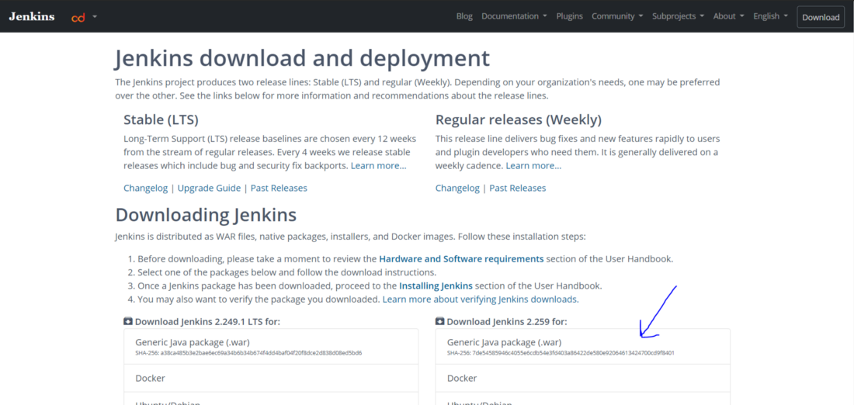

2. The above step will download a war file. Place the downloaded file at a desired location on the PC.

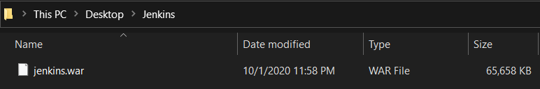

3. Open the command prompt and move to the directory where the file is stored and run the following command: java -jar jenkins.war

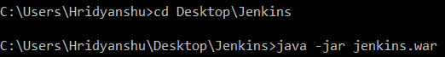

4. After the successful execution of the above command, you will get a message as below:

https://cdn-images-1.medium.com/max/1100/1*XrJXowlABRk0mPMdzwqVJQ.png

5. Now open localhost:8080 in your browser and you will get the following page:

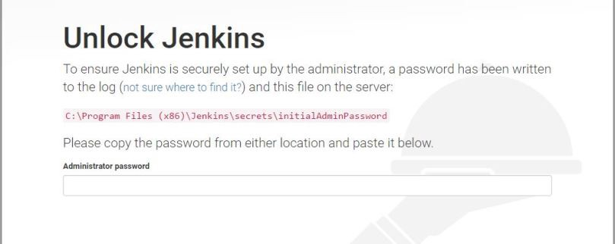

Go to the file path mentioned above and get the password (the path may be different in your case). Now you will be asked to download the suggested plugins.

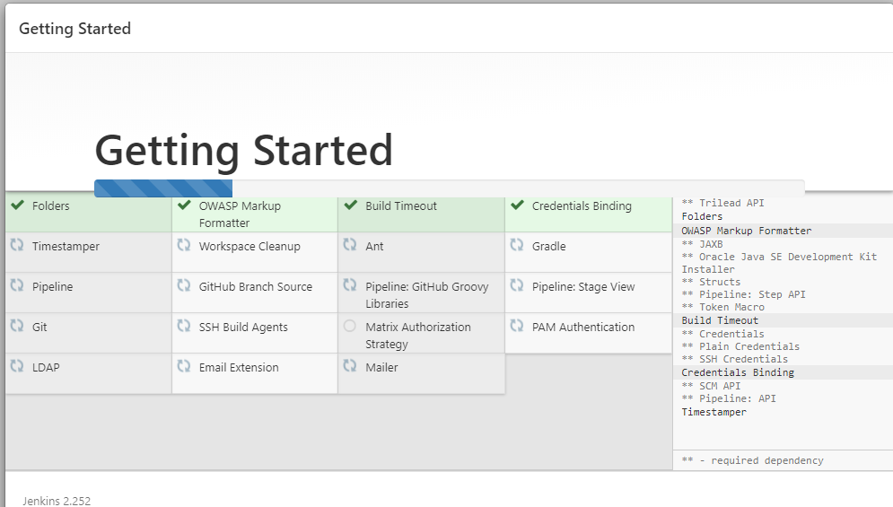

Now you are ready to get started with Jenkins. Provide your username and password and then sign in to the console.

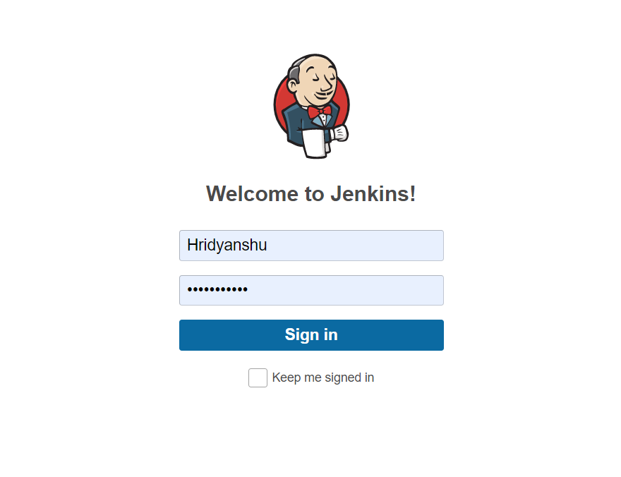

6. Now click on “New Item” on the Jenkins console.

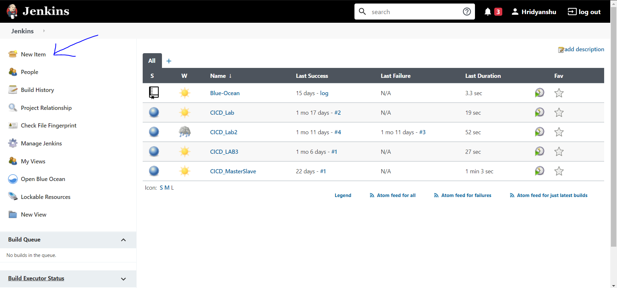

Now, create a freestyle project by providing a name and then clicking on OK.

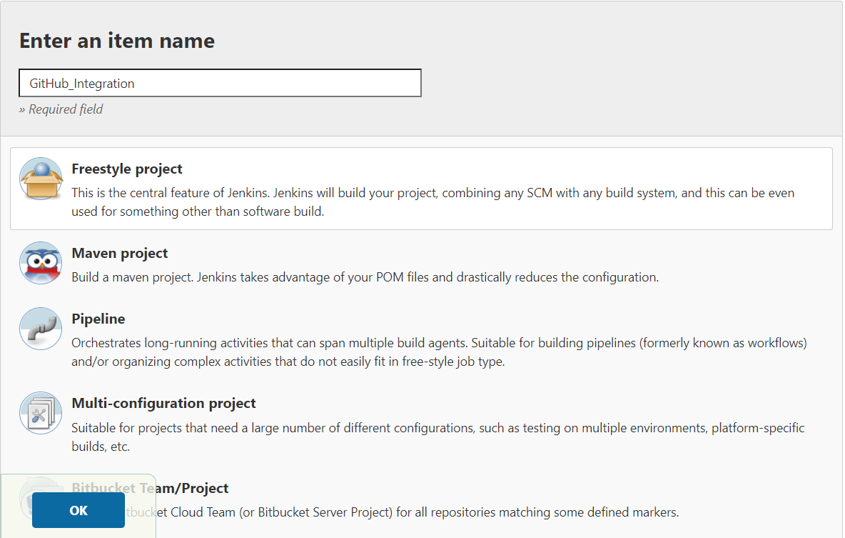

Now, project configuration console will be displayed. Select the build option there and click on add build step.

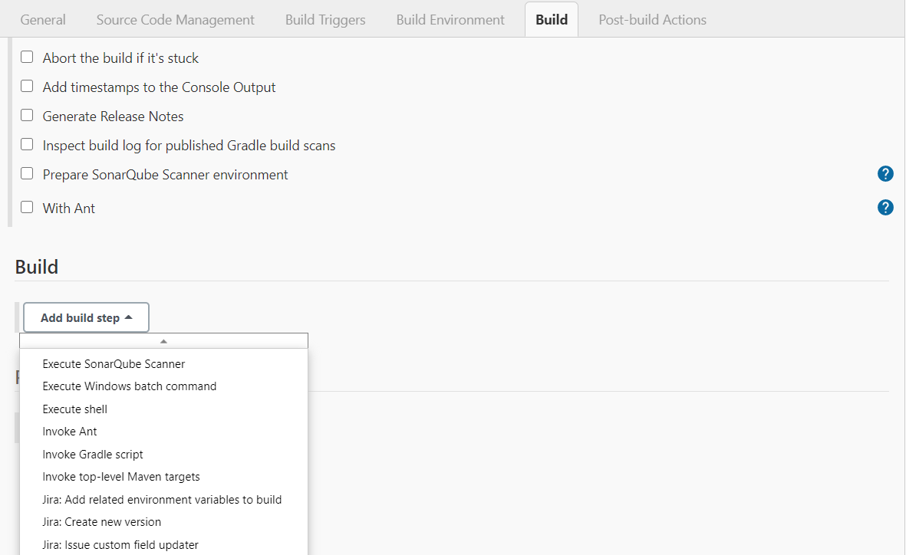

Select “Execute Windows batch command” option here and type the command you want to execute as follows:

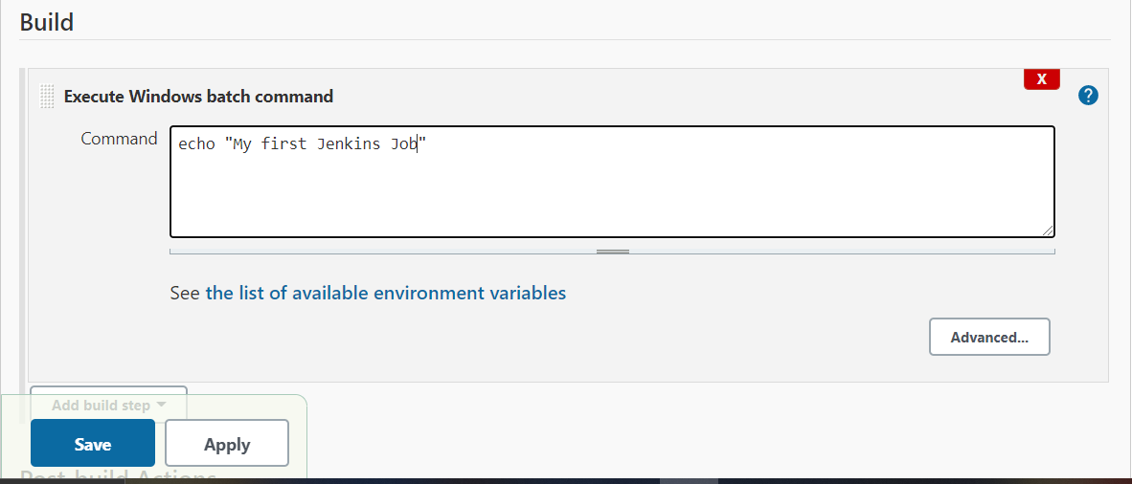

Now click on Save. You will get the project console. Click on the “Build Now” option.

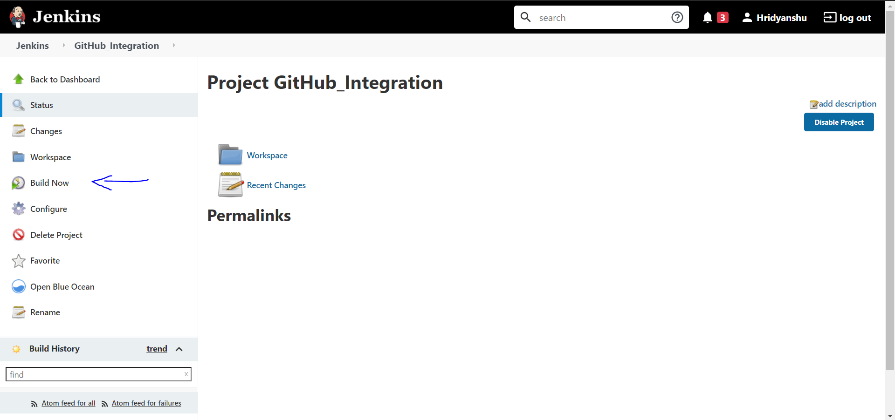

Now click on the drop down arrow next to the build number and select console output.

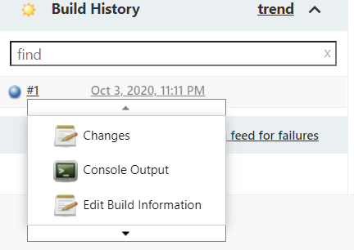

You will see your message printed in the console output.

