**Jenkins Integration with GitHub and Maven**

This article will guide you to integrate a Maven project hosted on GitHub with Jenkins.

The steps that need to be followed are:

1. Start your Jenkins and verify that the Maven plugin is installed in the Jenkins. For this, go to the Manage Jenkins console.

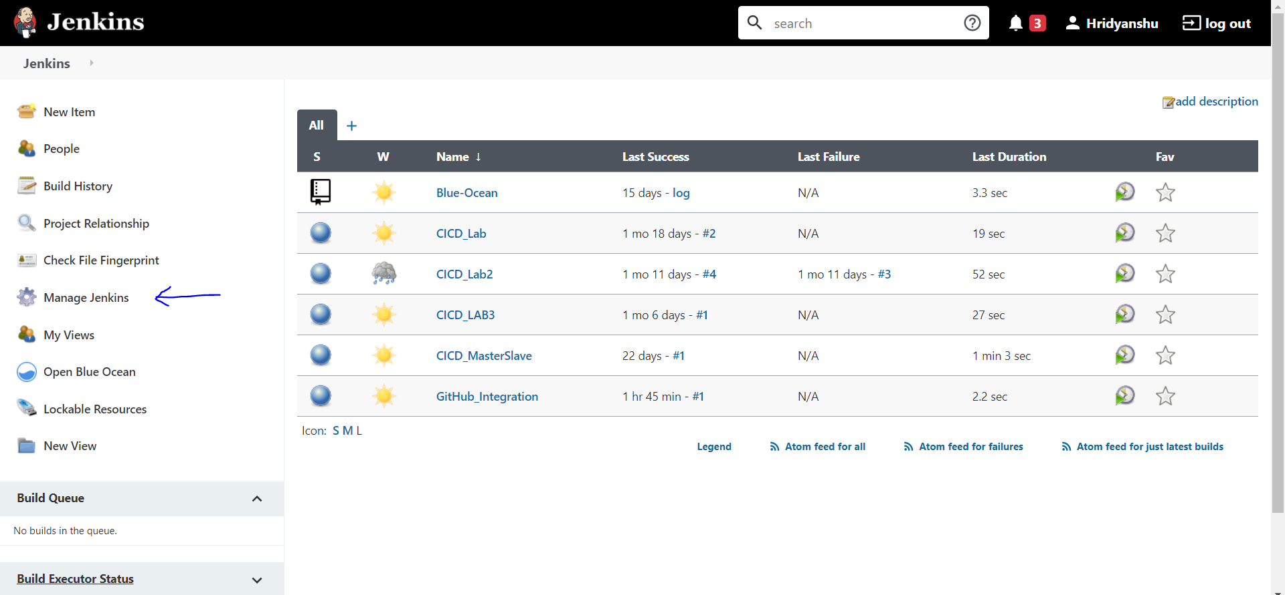

2. Now go to the Manage Plugins section.

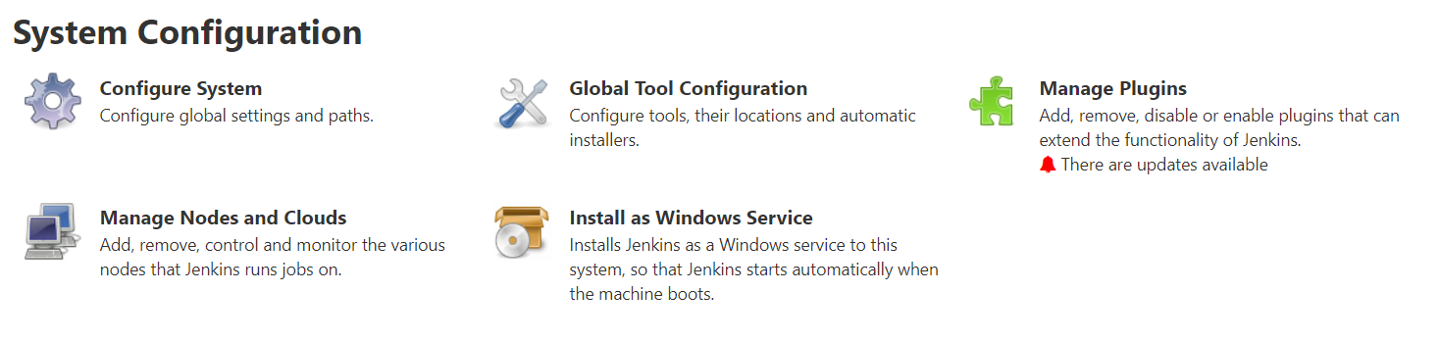

3. Make sure that you have Maven Integration Plugin in the installed list. If not, then search for it in the available plugins and install it.

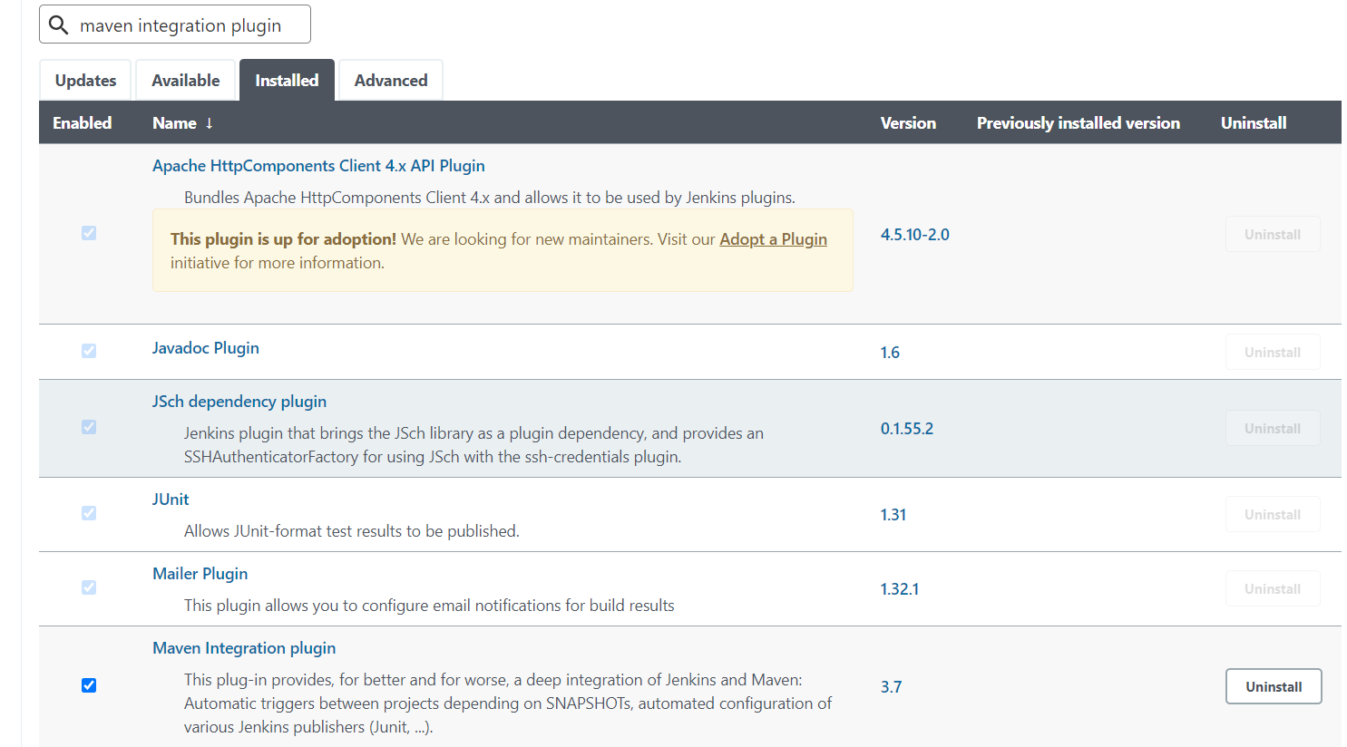

4. Now make a new Maven Project.

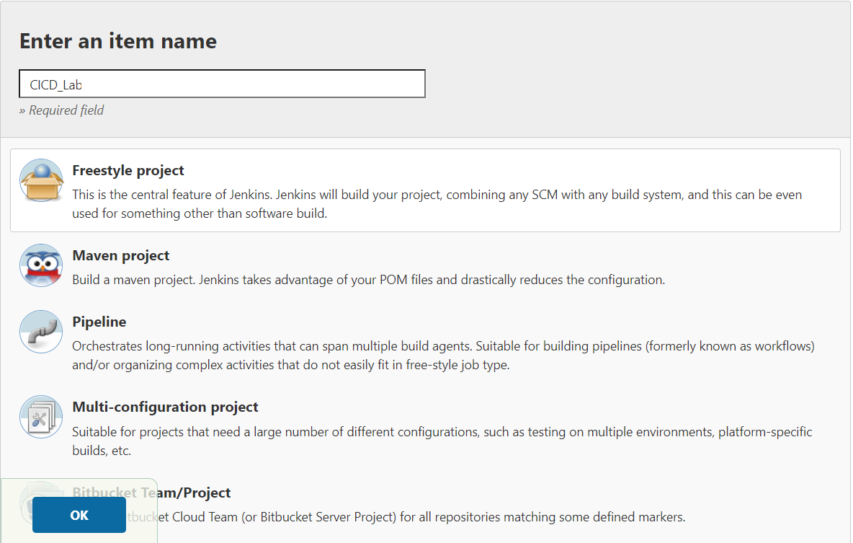

5. Go to the Source Code Management tab in the configuration settings, select Git and provide the URL of the GitHub repository where the Maven project is present.

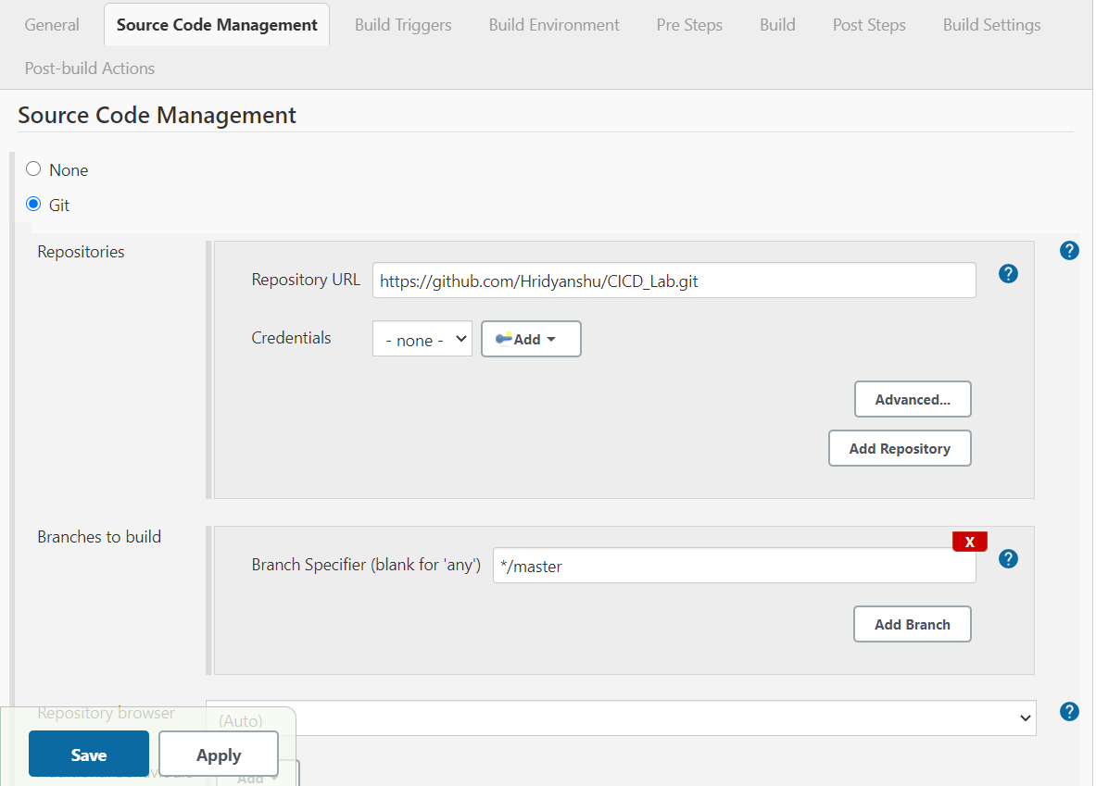

6. Now go to the Build tab in the configuration settings and add the relative path of the pom.xml file. Also specify the maven goal that needs to be run when the project is built.

The maven goal specified here is “install”.

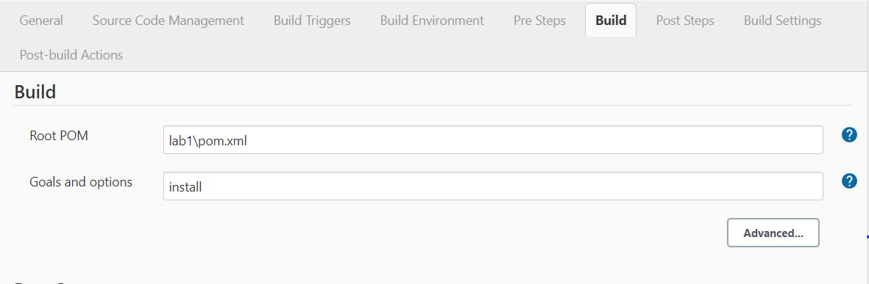

7. Now build the project. After successful build, go to the workspace folder of the project. There you will see a target folder where the newly built jar file will be stored.

