**Static Code Analysis using SonarQube**

SonarQube is an open source tool widely used for static code analysis. The below steps demonstrate how to test your project on SonarQube.

The steps to be followed are:

1. Download open source version of SonarQube (community edition) form the official website <https://www.sonarqube.org/downloads/>

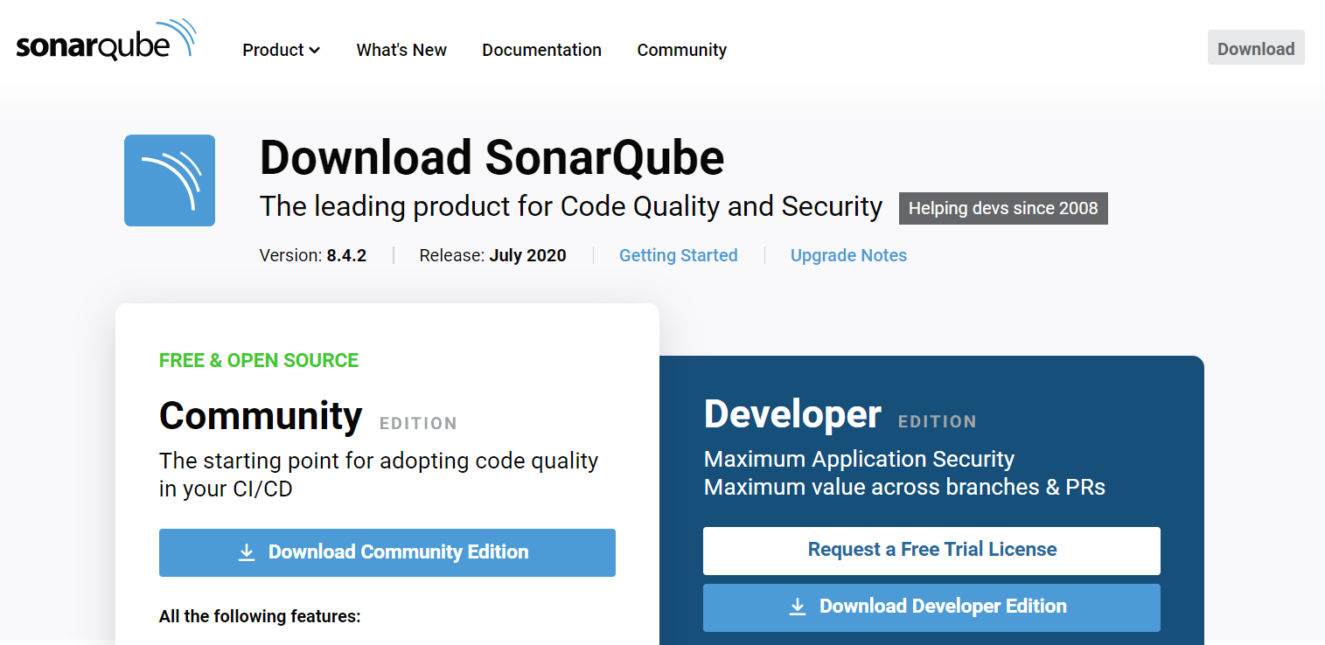

2. Extract the downloaded file at a desired place. There will be a bin folder containing folders for different operating systems.

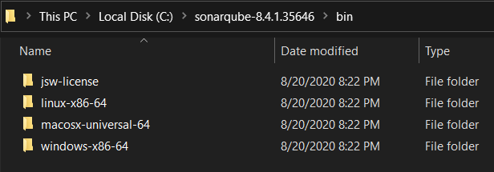

Move to the folder corresponding to your operating system.

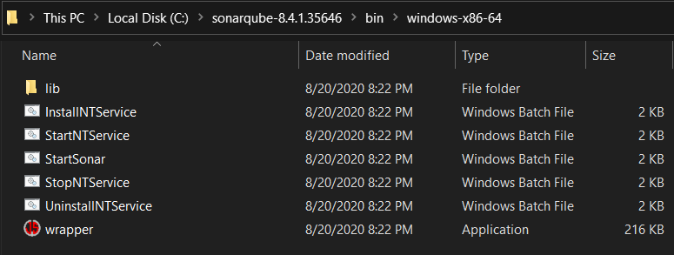

3. Now move to the above stated path using your command prompt and run the command: StartSonar.bat



This command will launch your SonarQube server. A similar output will be shown:



4. Go to the localhost:9000 in your browser. There you will be asked to enter your login credentials.

The default login credentials are:

Username: admin

Password: admin

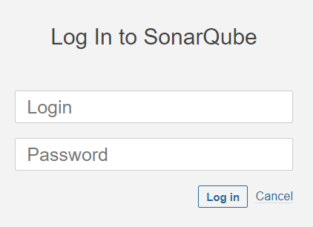

5. After successful completion of above steps, we are ready to analyze our project using SonarQube. For this, move to your project directory using command prompt and enter the following command:

Command: mvn clean install sonar:sonar -Dsonar.host.url=http://localhost:9000 -Dsonar.analysis.mode=publish

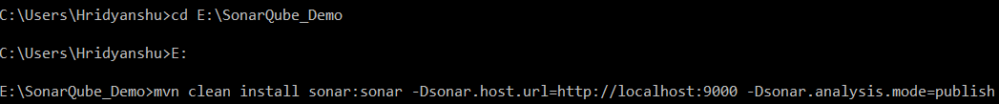

The above stated command will start building your project:

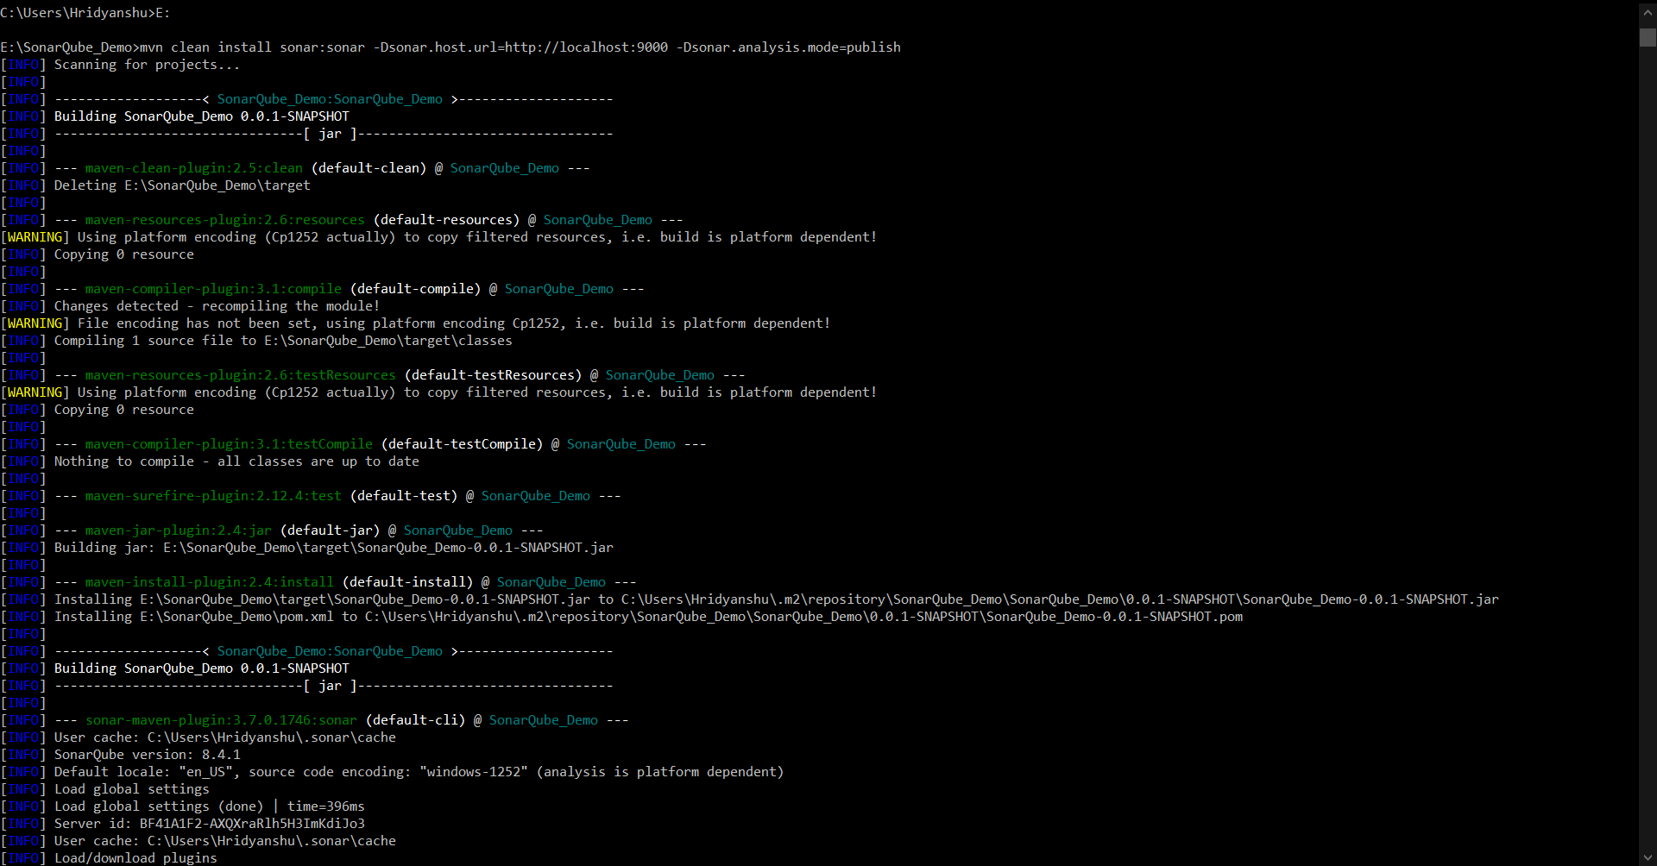

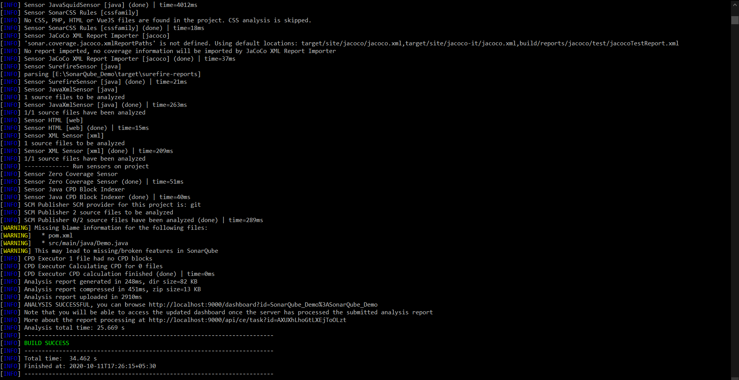

6. Now you will see that your project is vivible in the projects section of SonarQube.

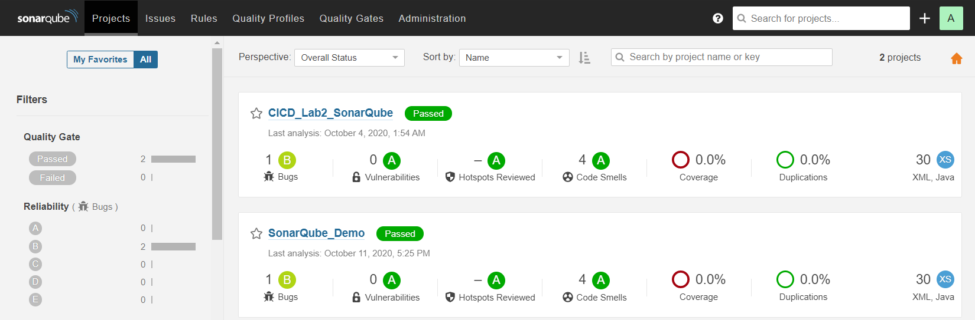

SonarQube will perform static code analysis for your project and the problems will be reported in the analysis report.

To view the analysis report, click on your project name.

The detailed analysis report will look like:

