**Jenkins integration with SonarQube.**

SonarQube is a tool widely used for static code analysis. Let us see how we can integrate SonarQube with Jenkins.

To integrate Jenkins with SonarQube, the steps that need to be followed are:

1. Start Jenkins server and go to the “Manage Jenkins” option displayed on the Jenkins dashboard.

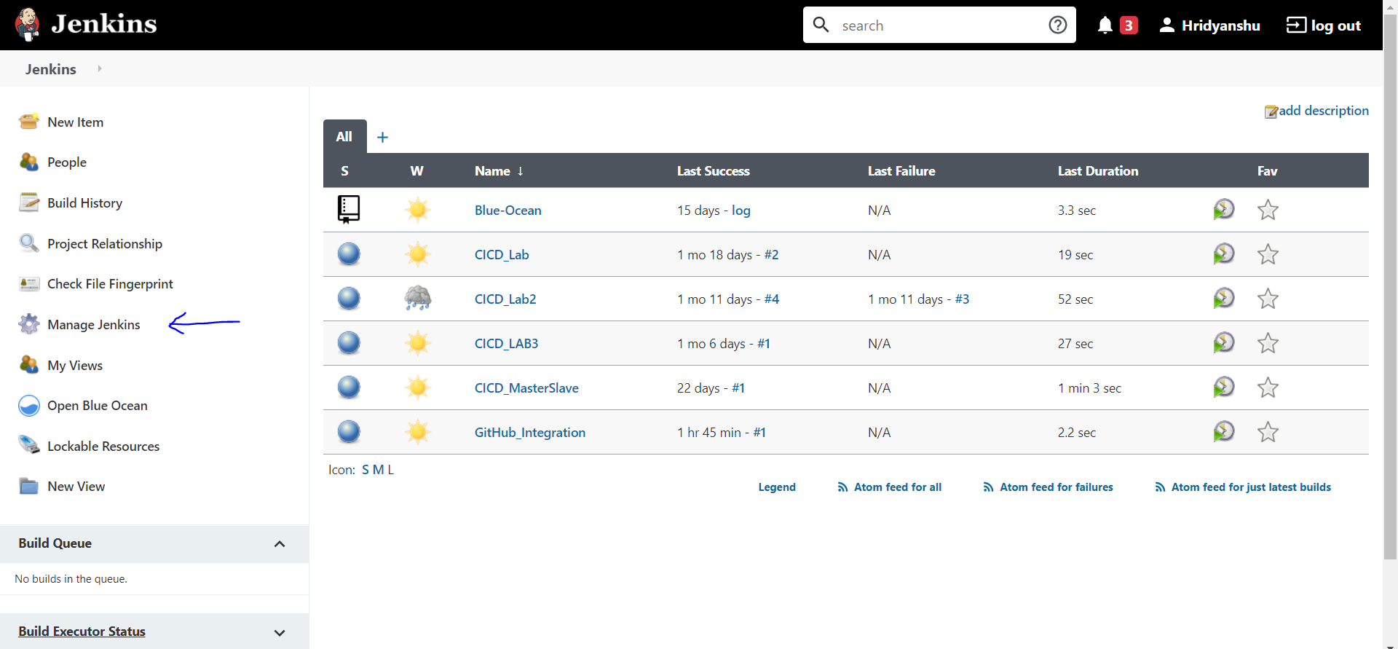

2. Now go to the Manage Plugins section.

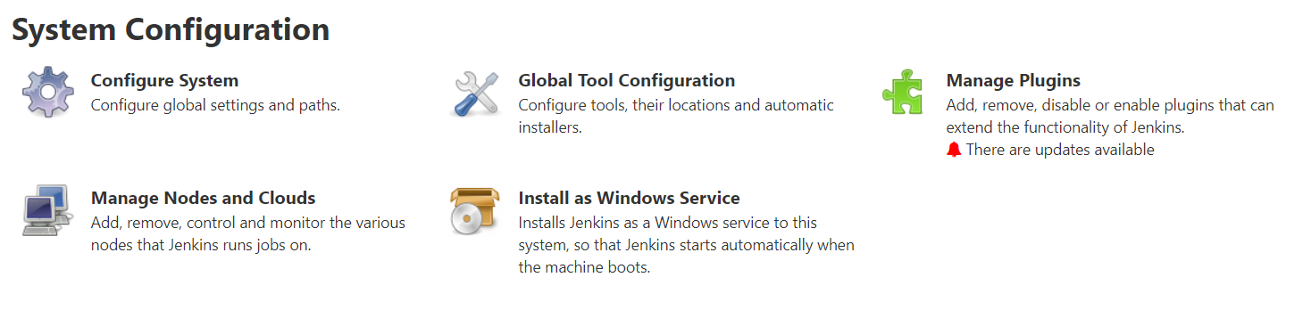

3. Here check whether “SonarQube Scanner” is in the list of installed plugins or not. If not, then install it from the available plugins section.

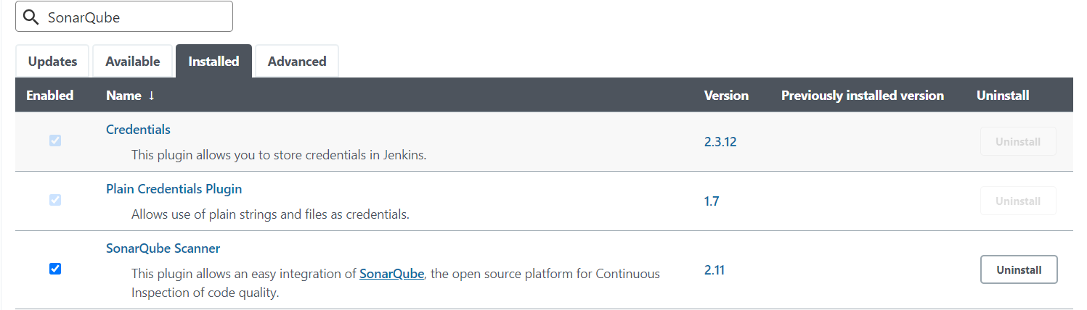

4. Now go back to the Manage Jenkins section and then go to the Configure System section.

Here, you will see a section for SonarQube Servers. Add a SonarQube server in that section by providing any name to it and its URL as follows:

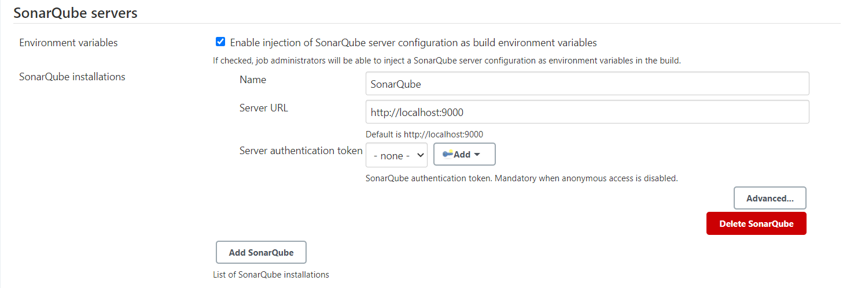

5. Now create a new Maven Project in Jenkins and configure it as follows:

a. Go to the Source Code Management and select Git. Then provide the URL of the repository where the source code is present.

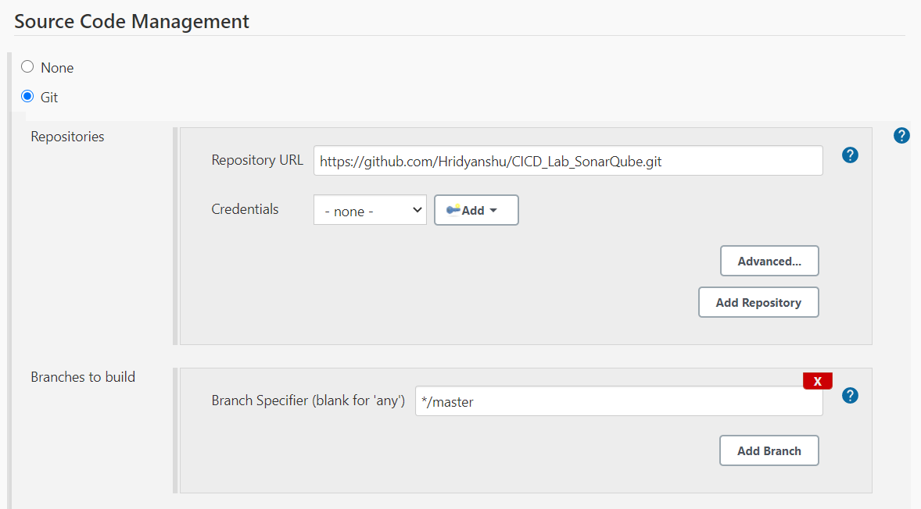

b. Go to the Build section and provide the path to the pom.xml file as on the GitHub repository. Mention the following command in goals that will be run when the project will be built.

**Command:** clean install sonar:sonar -Dsonar.host.url=http://localhost:9000 -Dsonar.analysis.mode=publish

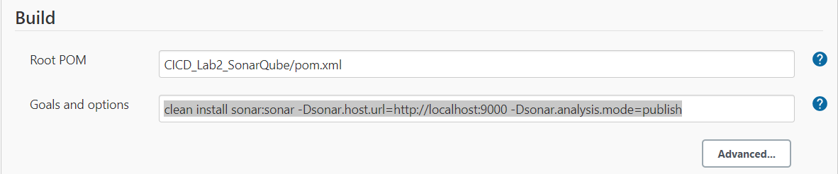

6. Save the changes and build the project using the Build Now option:

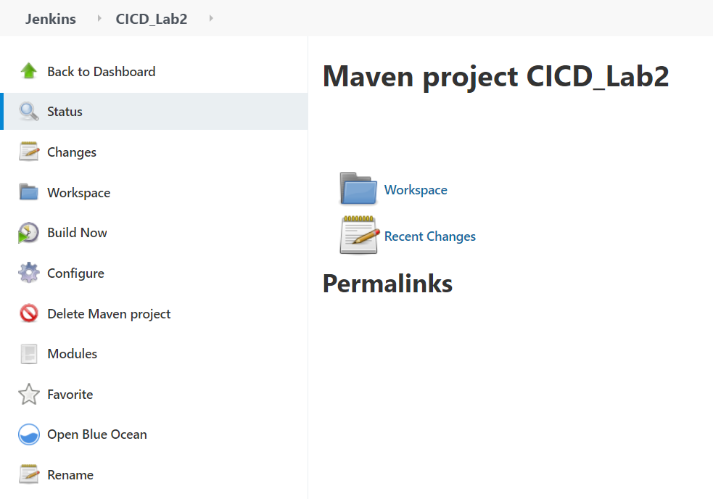

7. Now go to the console output section of the build. You will see a similar output after execution of build successfully.

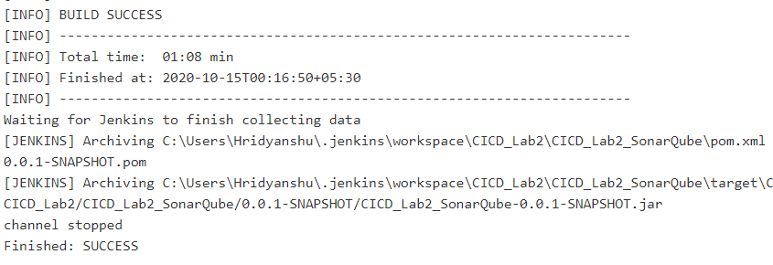

8. Login to your SonarQube server. You will see your project listed in the projects section:

