**Create Pipeline using Jenkinsfile.**

Now we will see how we can create a pipeline with a series of steps to be performed using a script written in Jenkinsfile.

To achieve this objective, the steps that needs to be followed are:

1. Create a Jenkinsfile in the project for which the pipeline is to be created:

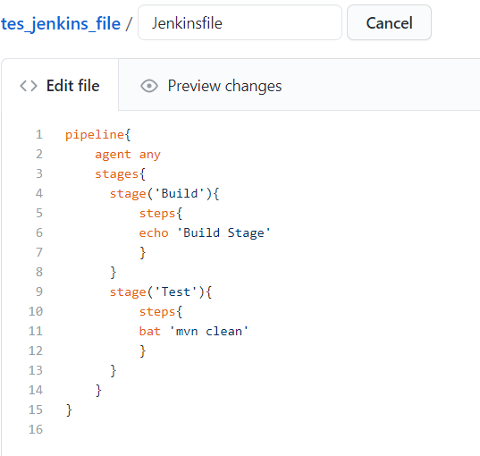

The bat command is used to execute the maven goal ‘clean’ here.

**Note:** The name of the above file must be Jenkinsfile only.

2. Go to Jenkins and create a new pipeline project.

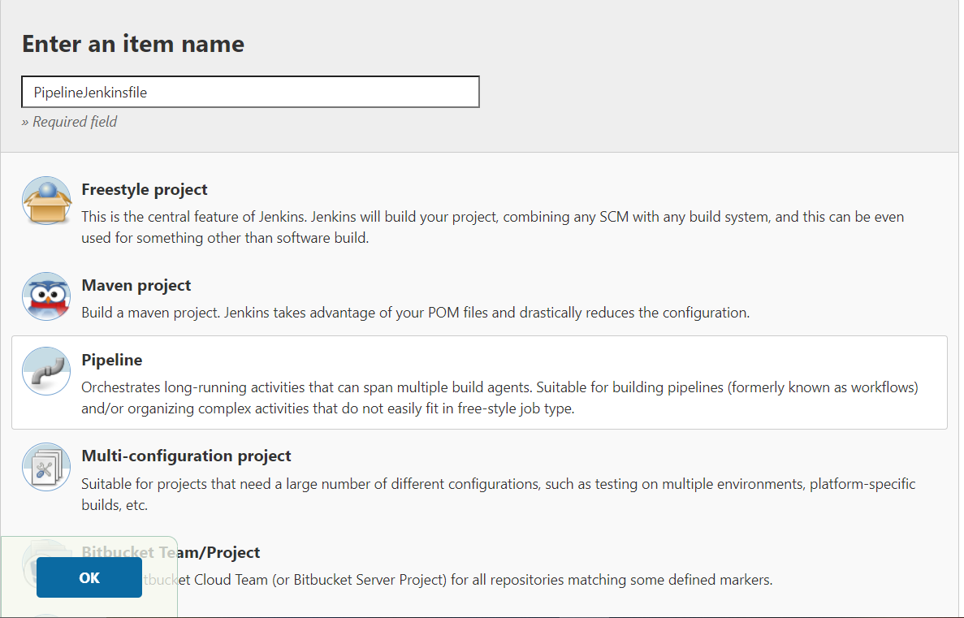

3. Now go to the Pipeline option in the project configuration and select Pipeline script form SCM.

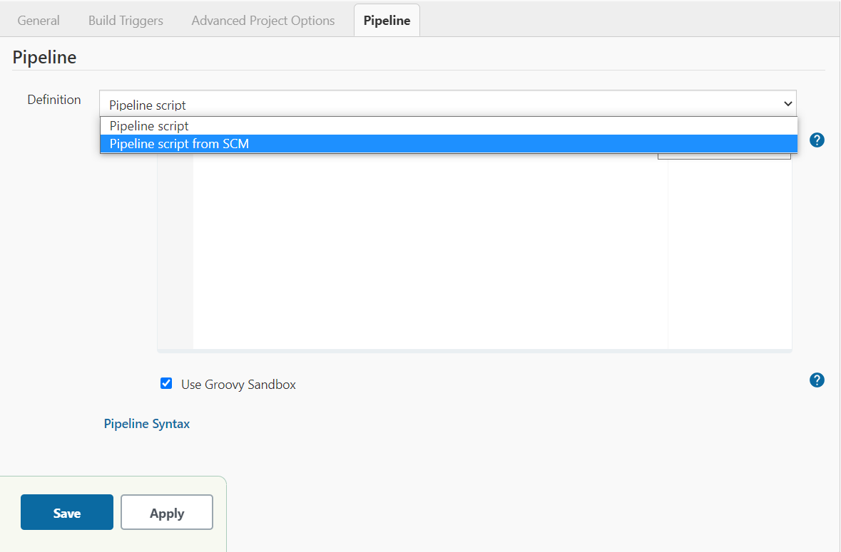

4. After choosing the above stated option, you will be asked to choose the SCM. Select Git and provide the repository URL of the project.

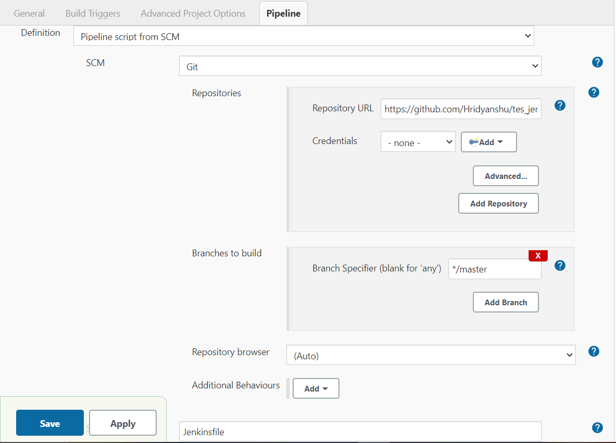

You will see a field script path just below these settings. Provide the path of Jenkinsfile in that field as on the GitHub repository.

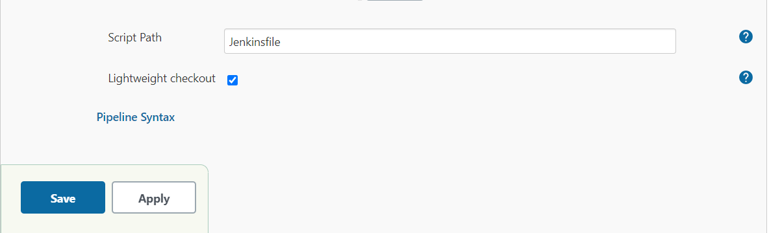

5. Save the above stated settings and build the project. You will see a pipeline being created in the project dashboard.

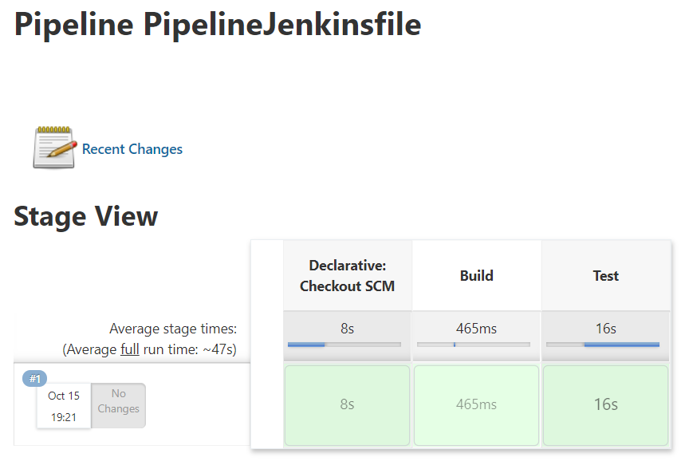

You can see the logs of each individual stage by clicking on the stage for which you want to see the logs for.

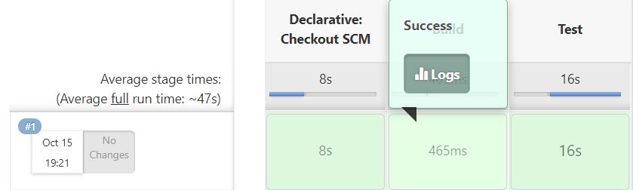

The logs will look like:

