**Create Pipeline using Blue Ocean Plugin**

Blue Ocean plugin provides an interactive way to build pipelines in Jenkins.

The steps that need to be followed to create a pipeline in Jenkins using Blue Ocean Plugin are as follows:

1. Install the Blue Ocean plugin. The steps to install Blue Ocean plugin are:

a. Go to Manage Jenkins option being displayed on the Jenkins dashboard.

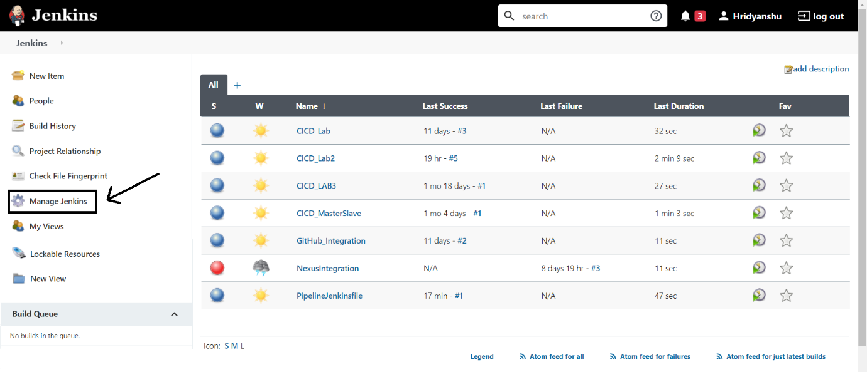

b. Now go to the manage plugins option

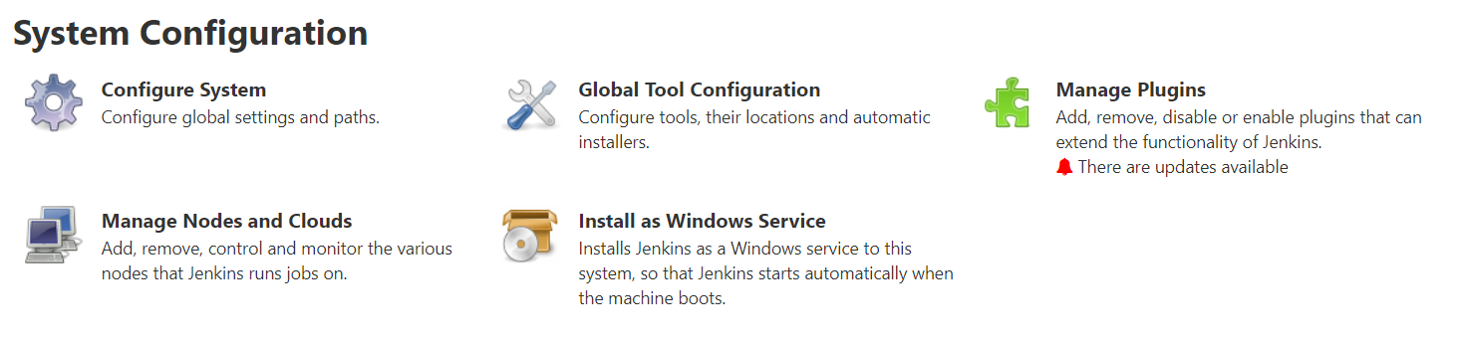

c. Search for the plugin ‘Blue Ocean Aggregator’ in the available plugins and install it.

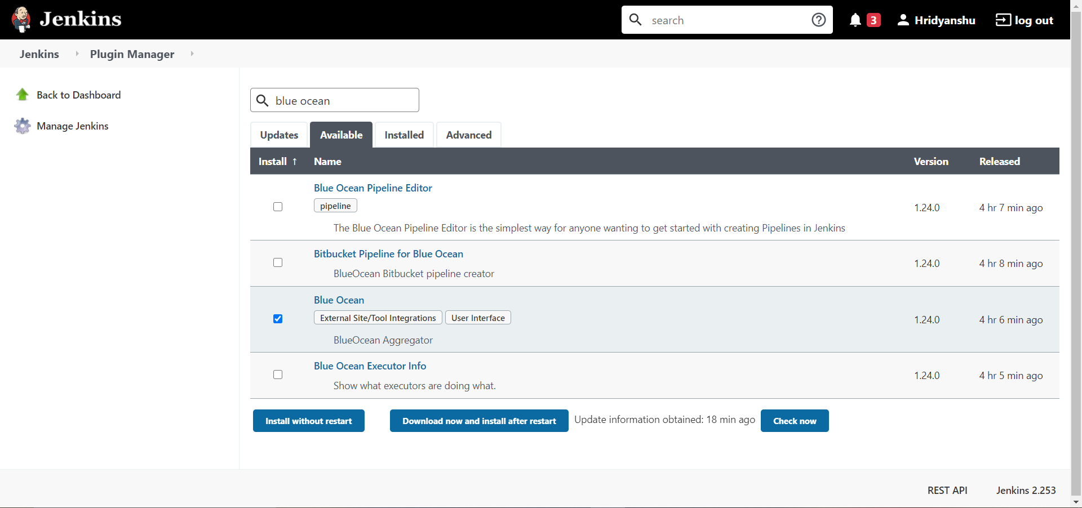

2. After successful installation of Blue Ocean plugin, you will get an option of Open Blue Ocean displayed on the Jenkins dashboard. Open your Blue Ocean dashboard using that option.

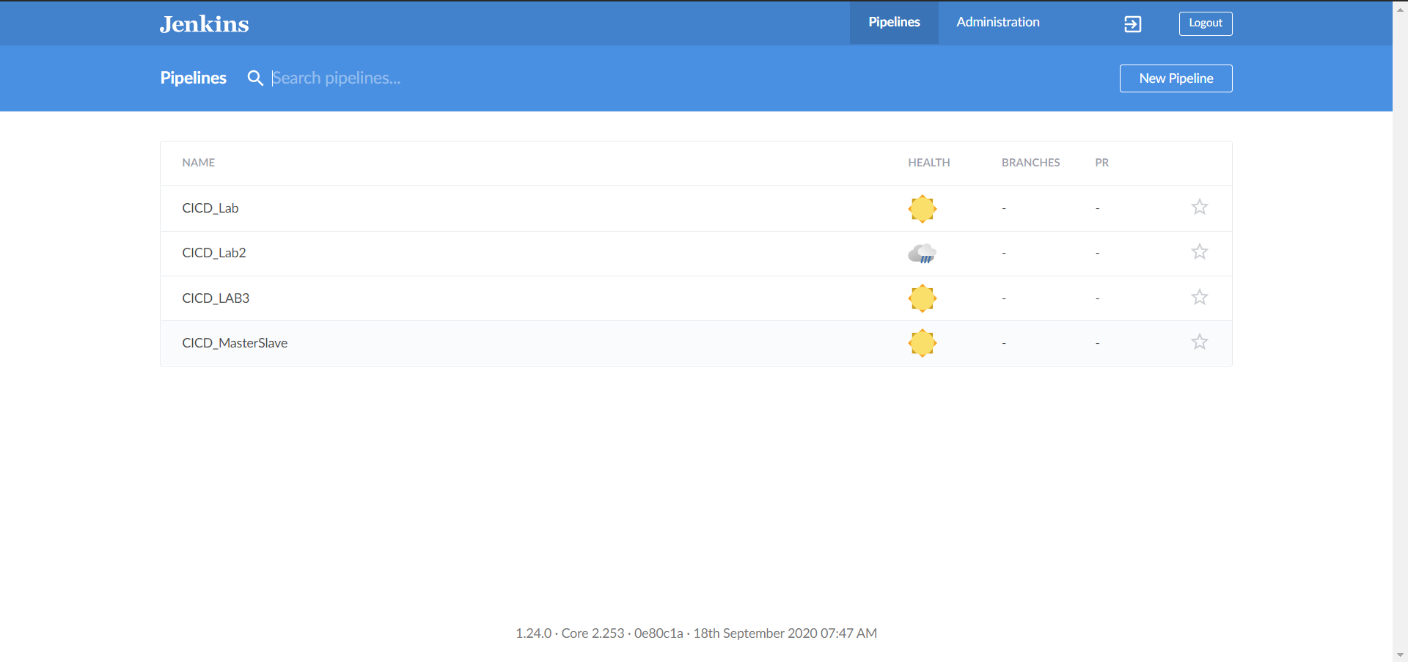

Note: You will get a similar dashboard but you will not see any project listed in the Blue Ocean dashboard.

3. Now click on the New Pipeline option being displayed at the right corner of the dashboard. You will see a similar window. Select your version control system.

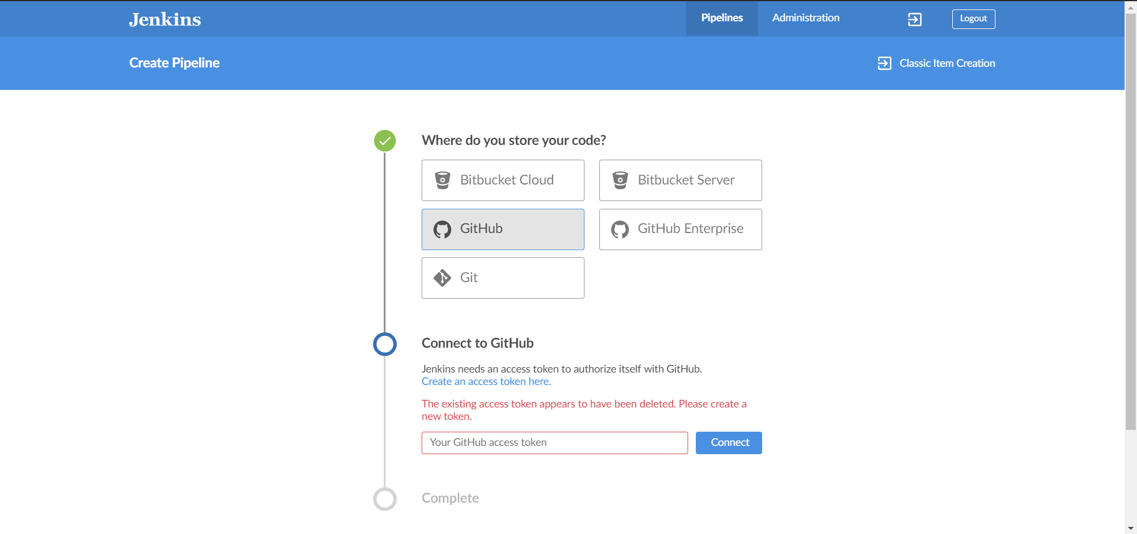

4. Now to connect with GitHub, we need to create access token. For this, create on the Create an access token link then you will be redirected to your GitHub. Create an access token as follows:

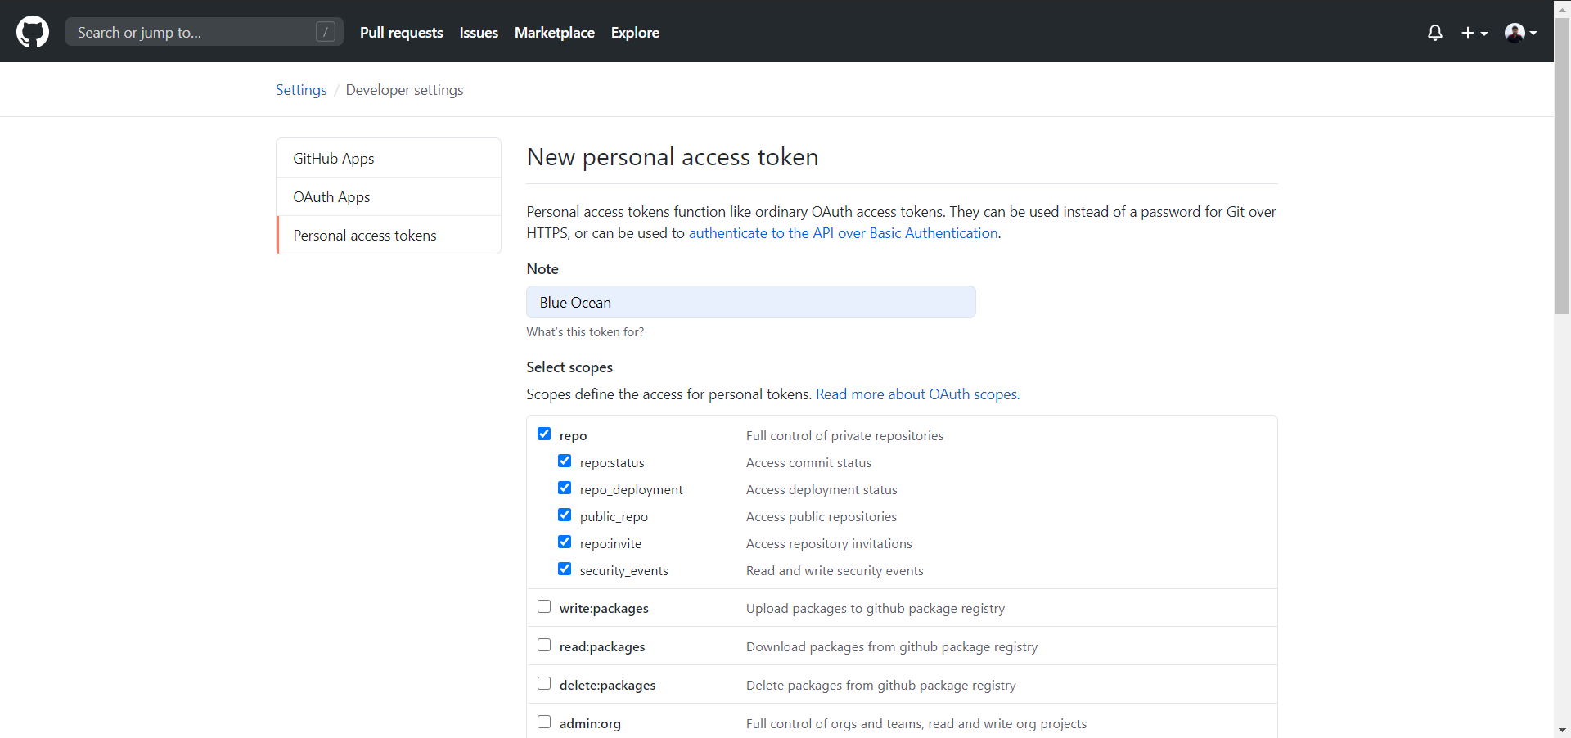

5. After successful completion of above step, you will get an access token code. Paste it in the Blue Ocean to successfully connect your Blue Ocean to GitHub.

Now you will get a list of available organizations on the linked GitHub account. Select the organization to which the project repo belongs for which the pipeline is to be created.

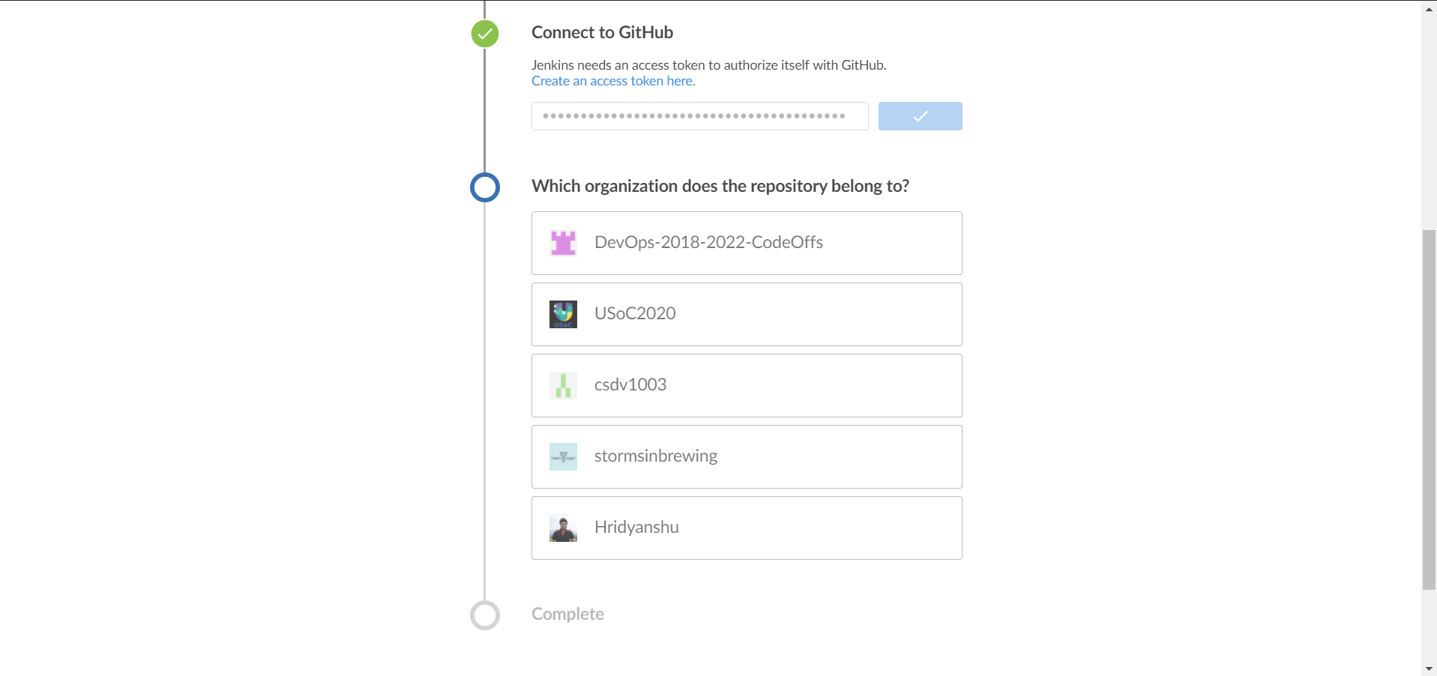

6. Now you will get a list of available repositories. Select your project repository form this list and click on the create pipeline option.

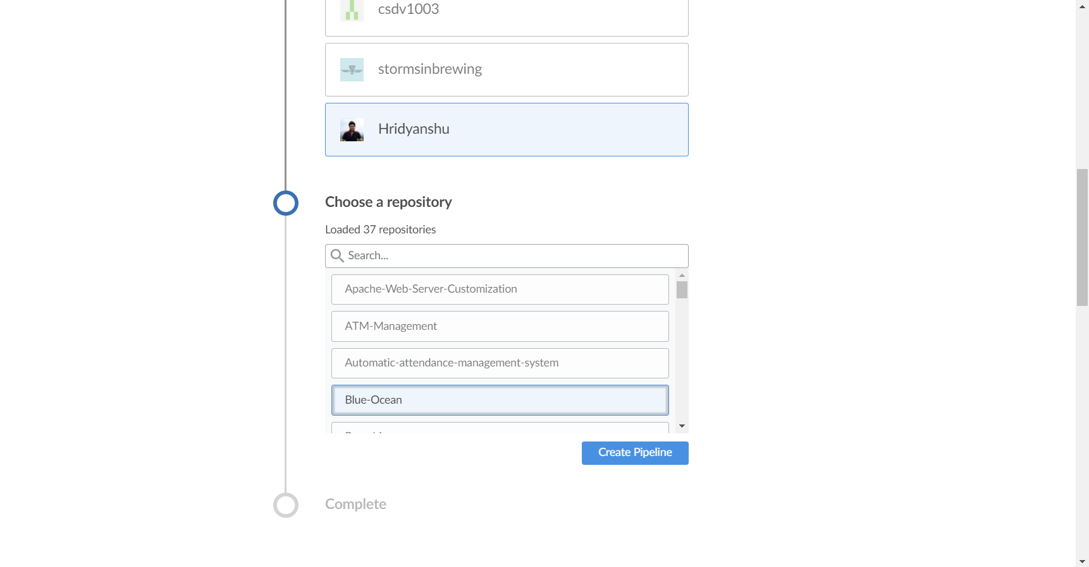

7. After successful creation of the pipeline, you will get an output as follows:

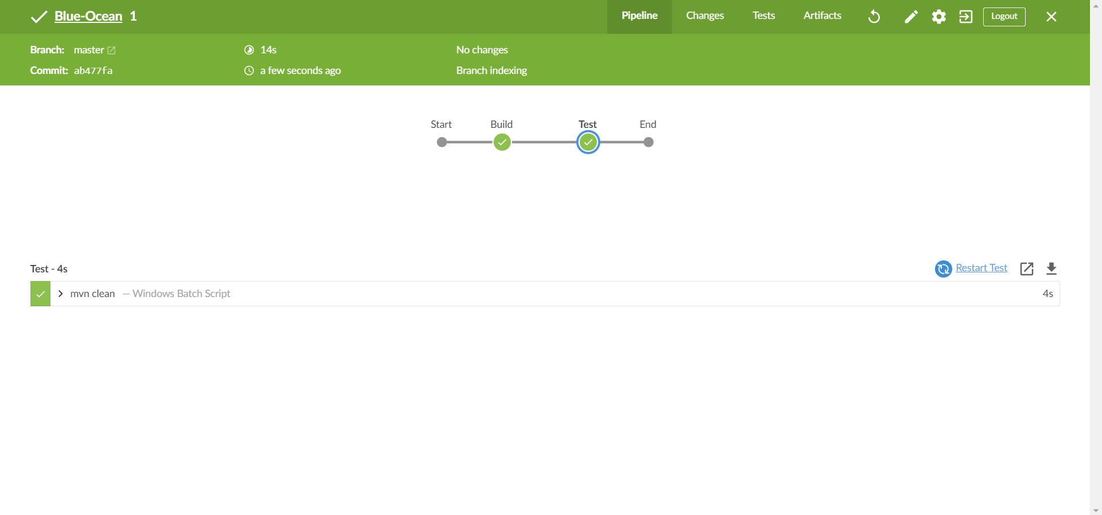

**Note:** The final output may vary depending on the script that is used in the project for which the pipeline is created.