**Implementing Master/Slave Architecture in Jenkins.**

Jenkins support a master slave architecture where a master can execute the builds on the slave machines.

In this article we are going to create a slave and execute our tasks on it.

The steps that need to be followed are:

1. Go to Manage Jenkins option being displayed on the Jenkins dashboard.

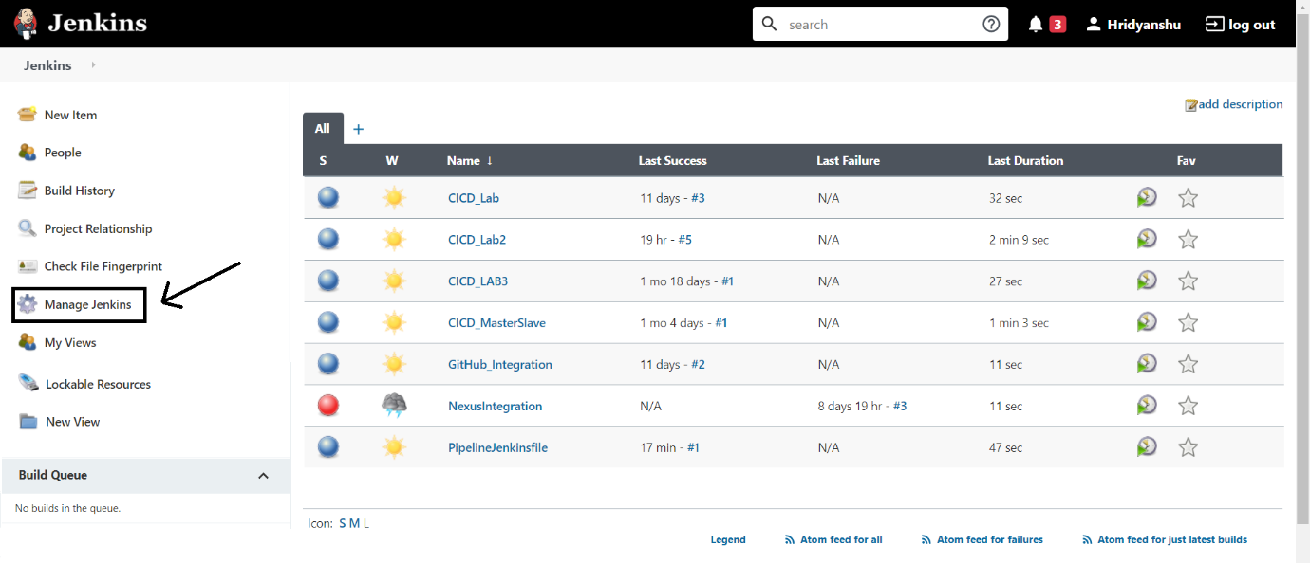

Now go to the Global Tool Configuration section:

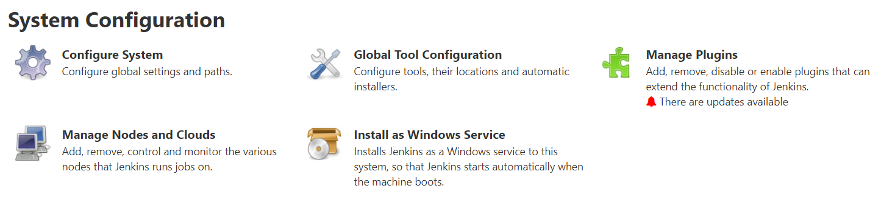

2. In global configuration settings of Jenkins, do the following settings. Ensure that the TCP port for inbound agents is set as random and the Enable API Token usage statistics option is checked.

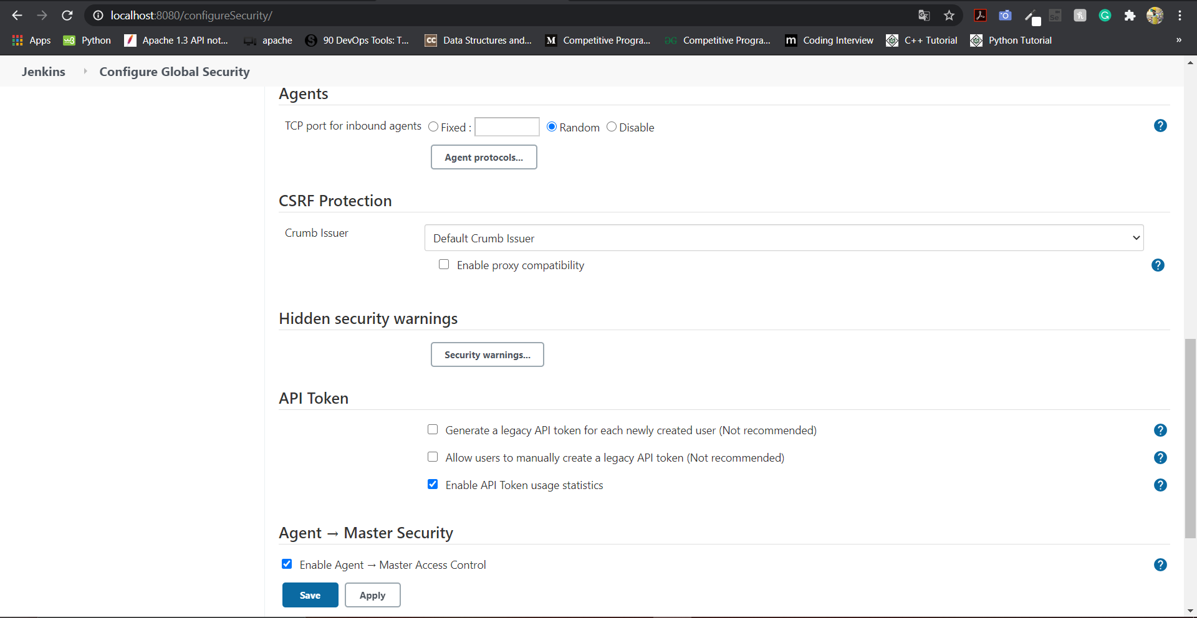

3. Now, go to the Manage Jenkins section. There you will find an option for manage nodes and clouds.



4. Make a new node and mark is at permanent agent.

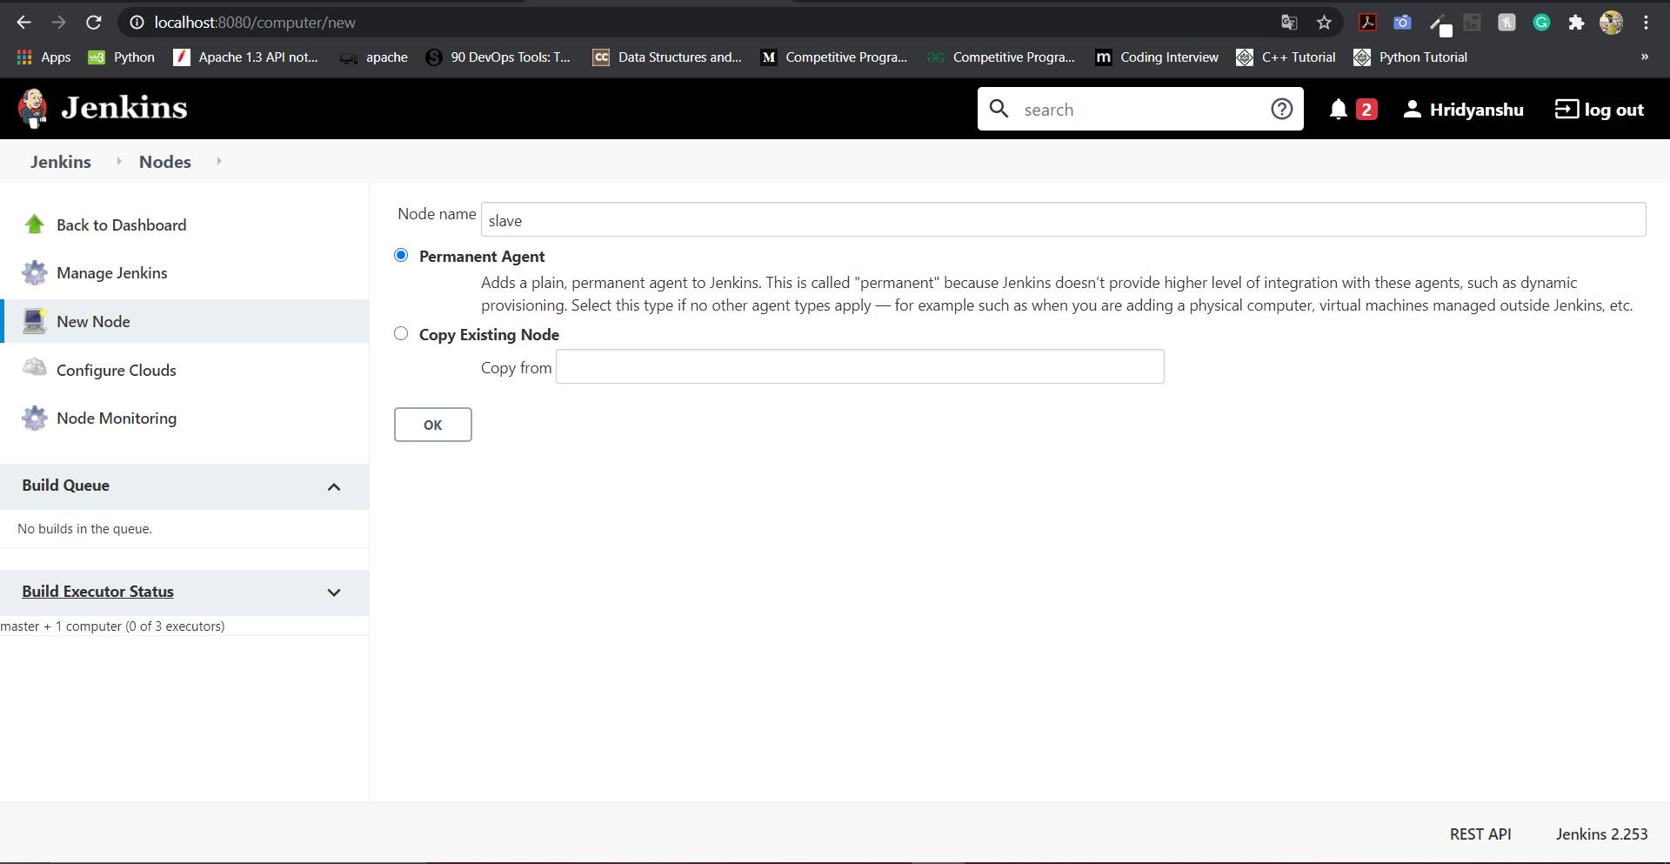

We have to make a new folder for this slave on the machine where it will reside. In our case, the slave will reside on the same machine.

So we will make a new folder on our local machine which will be dedicated to this slave.

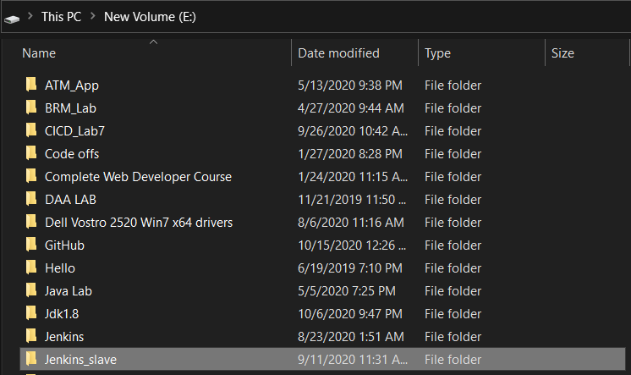

In configuration of node, provide the path of the folder created on local machine for the node in the root directory and working directory. The configuration of the node will look like:

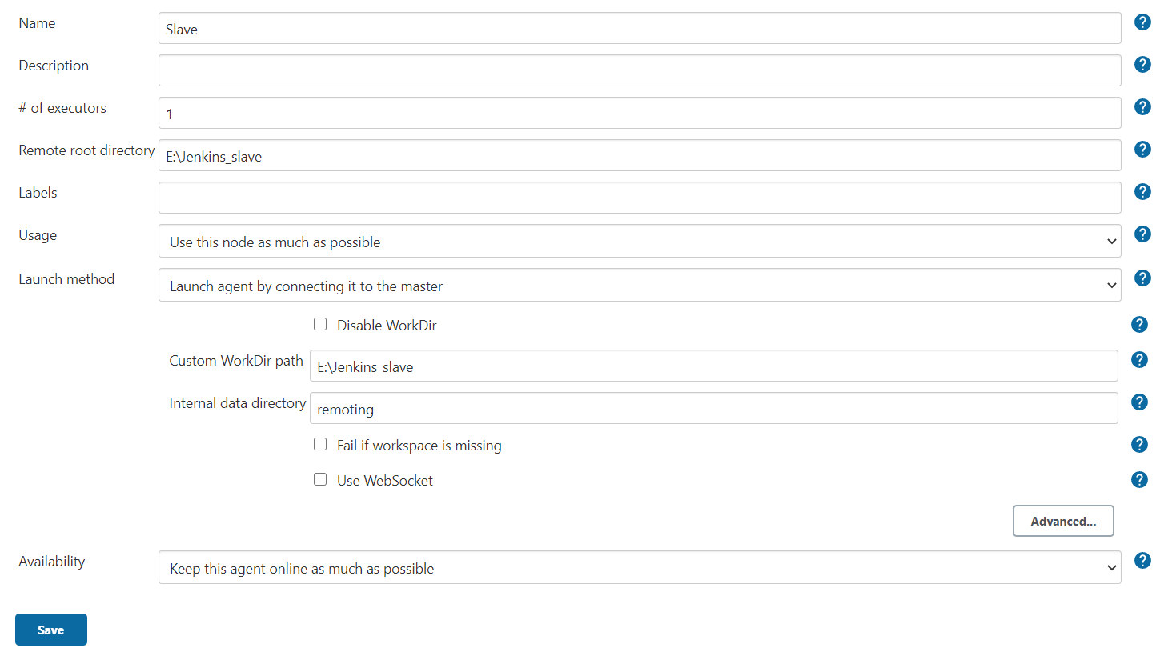

5. Go to the newly created slave and download the jar file agent.jar and place this file in the slave repository on the machine.

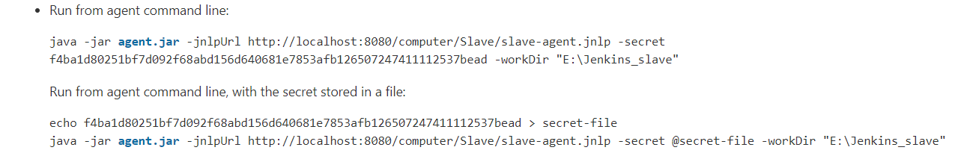

6. Now go to the folder created for the slave and run the command specified in the above step to start the slave.

The command that needs to be run is highlighted in the screenshot below:

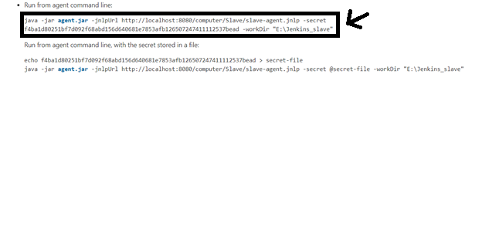

The output of the above command will look like:

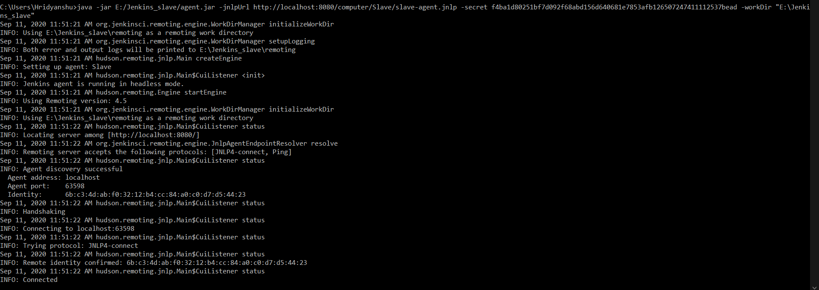

The INFO: Connected specifies that the successful connection is established to the node and the newly created node is up.

7. After completion of above steps, our slave node is set up.

Now, we are ready to make a new project and we will build that project on our newly created slave node.

Make a new Maven Project and tick the checkbox specifying “Restrict where the project can be run”. Then provide the name of the slave node in the label expression.

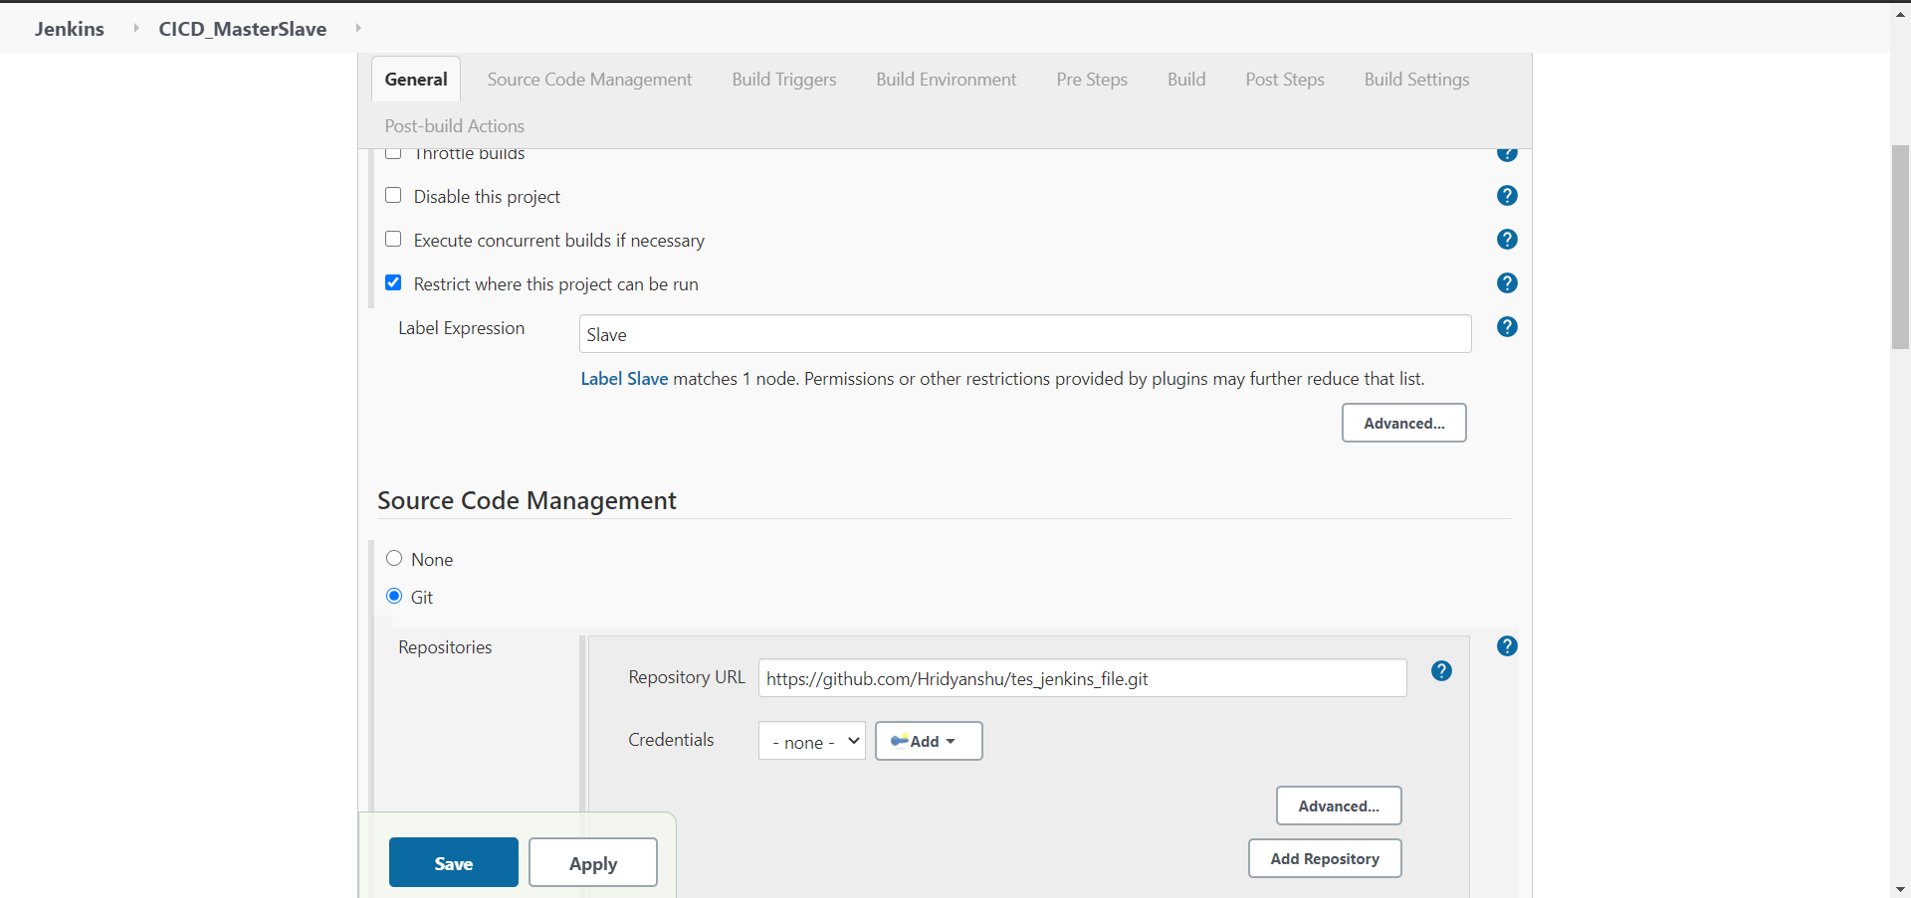

After above configuration, the build will be executed on the specified node.

The goal that is specified in the project configuration of this project is ‘install’.

8. Now build the project.

The final output in the console will look like:

