**Uploading Artifacts on Nexus Server using Command Line.**

Nexus is a tool used for management of project artifacts.

Using below specified steps, we are going to install nexus and upload our maven project artifacts on it.

The steps that need to be followed are:

1. Go to the given URL to download Nexus:

<https://help.sonatype.com/repomanager3/download/download-archives---repository-manager-3>

We are downloading Nexus 3.18.1-01 in this experiment.

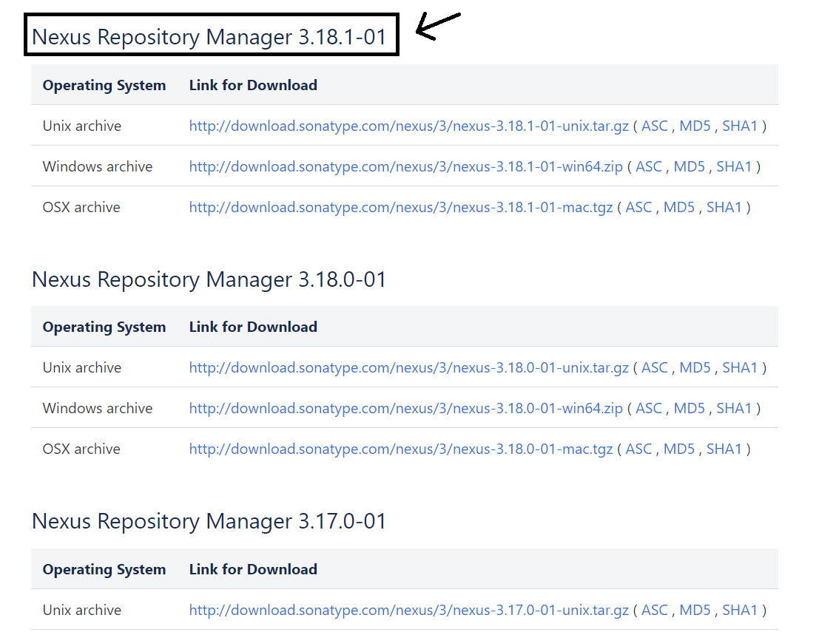

Click on the link corresponding to your operating system and a zip file will be downloaded.

2. Now extract the file at the desired location on your machine. After extracting files, there will be a bin folder inside the main folder:

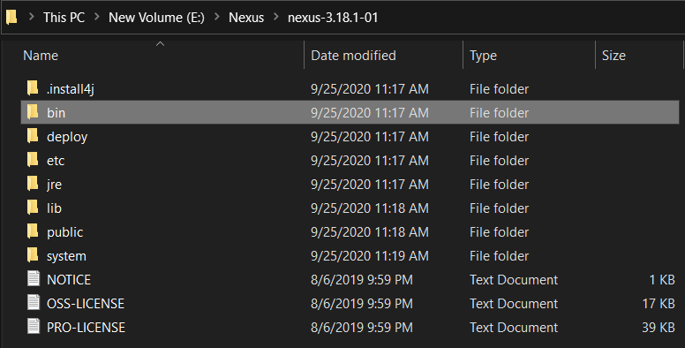

Move inside the bin folder and copy the path.

3. Open the above path using command prompt and run the below command. Command: nexus.exe /run

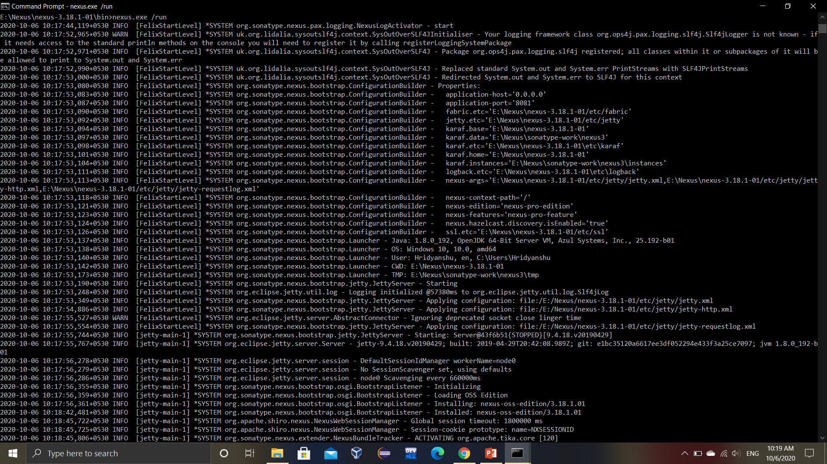

After successful execution of the above stated command, you will get the following output:

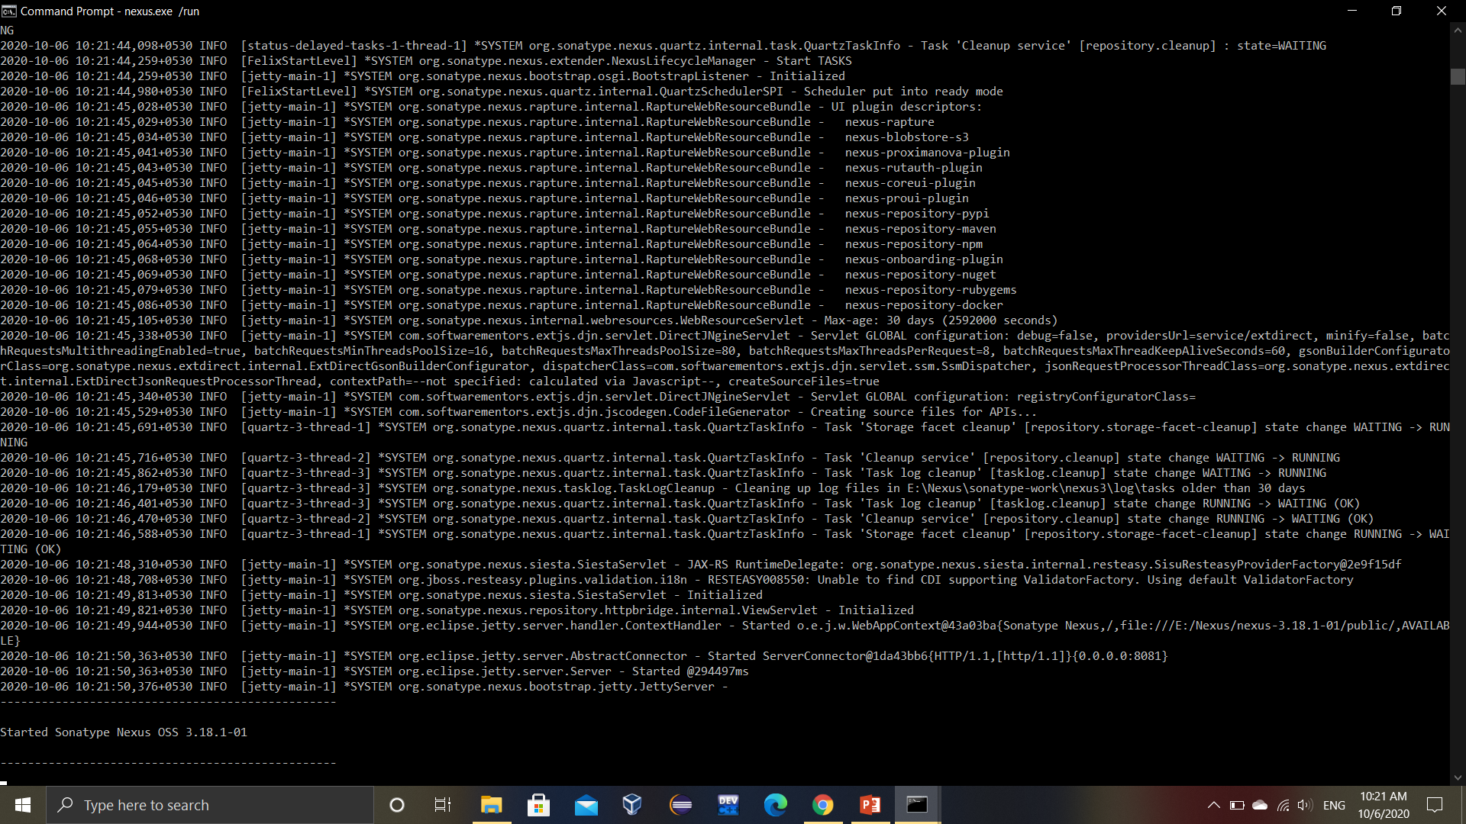

4. Go to the URL localhost:8081 (8081 is the default port number on which Nexus server runs).

You will get a similar window when you will log in for the first time. Provide the password given in the specified file.

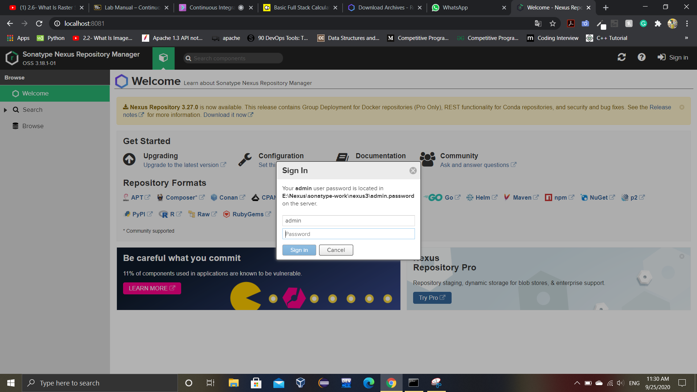

Complete the setup and then you are ready to get started.

5. After Sign in, go to the settings option and then go to repositories.

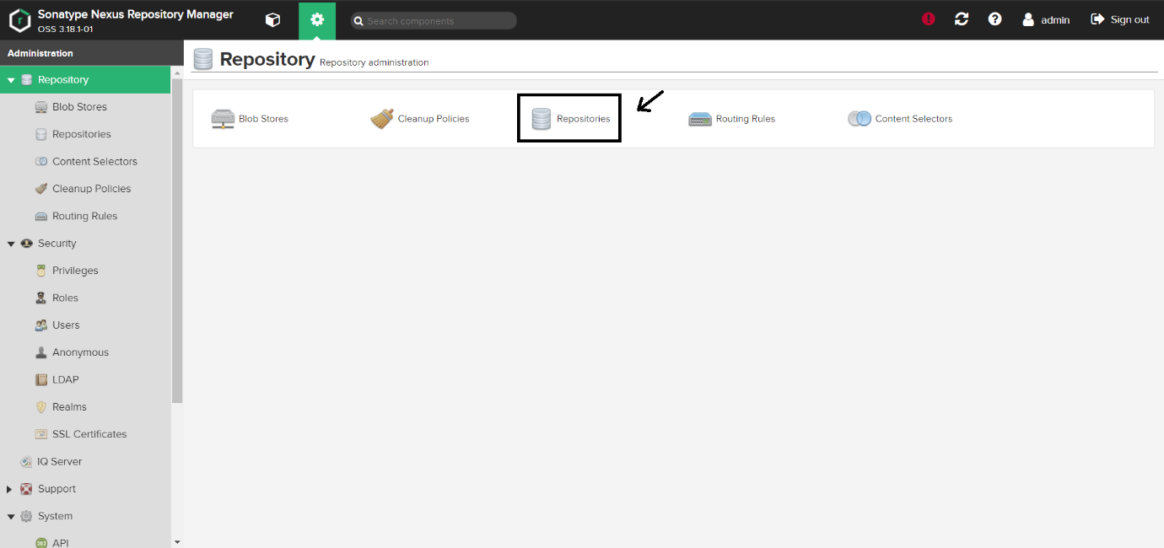

6. You will get a similar window. Click on Create Repository to create a new repository.

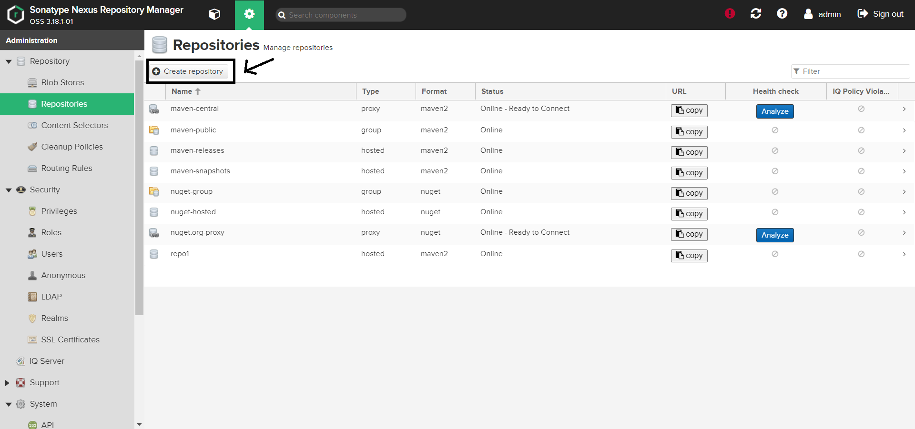

7. Select maven2 hosted repository.

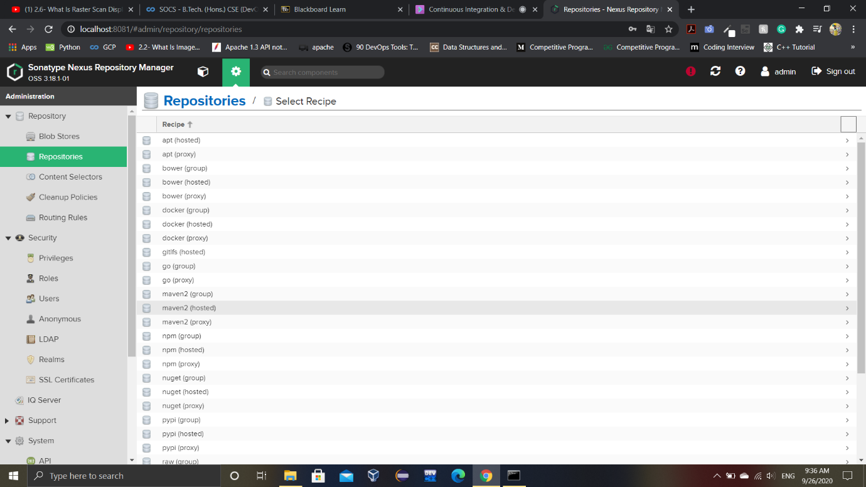

Name the repository, set version policy to snapshot and allow redeploy. Leave all other settings unchanged.

The final settings will look like.

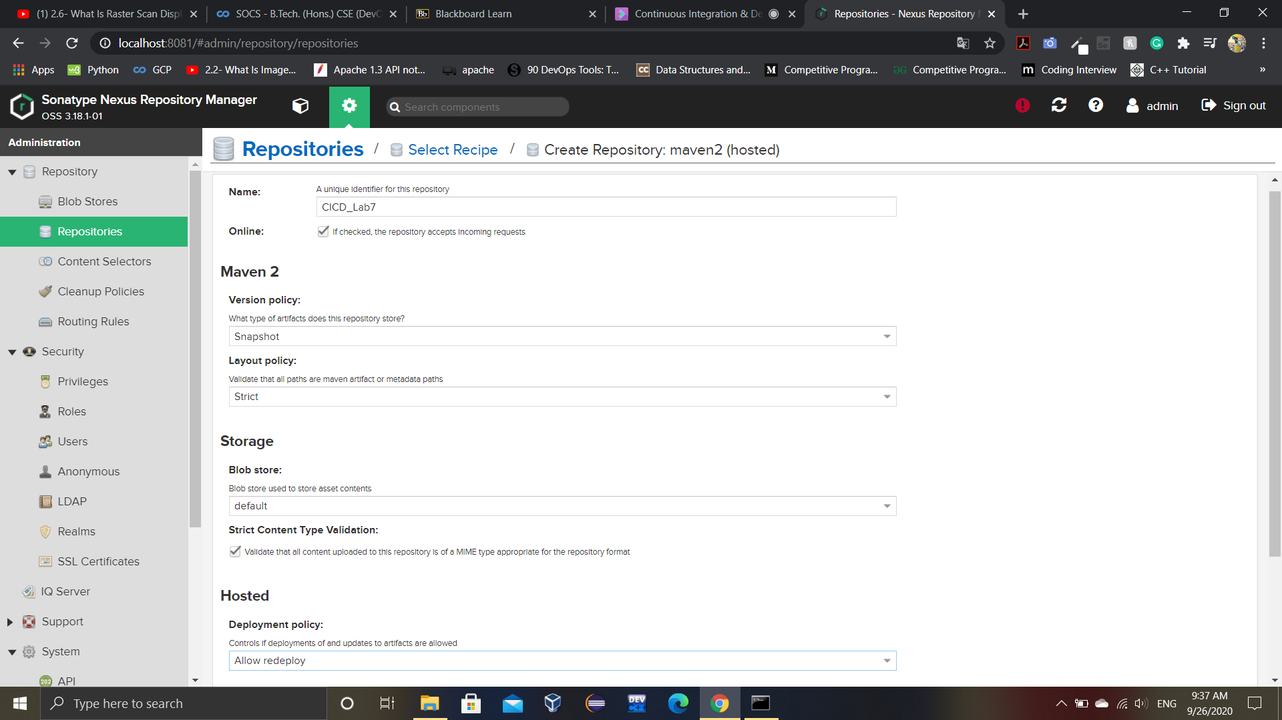

8. Copy the URL of the repository.

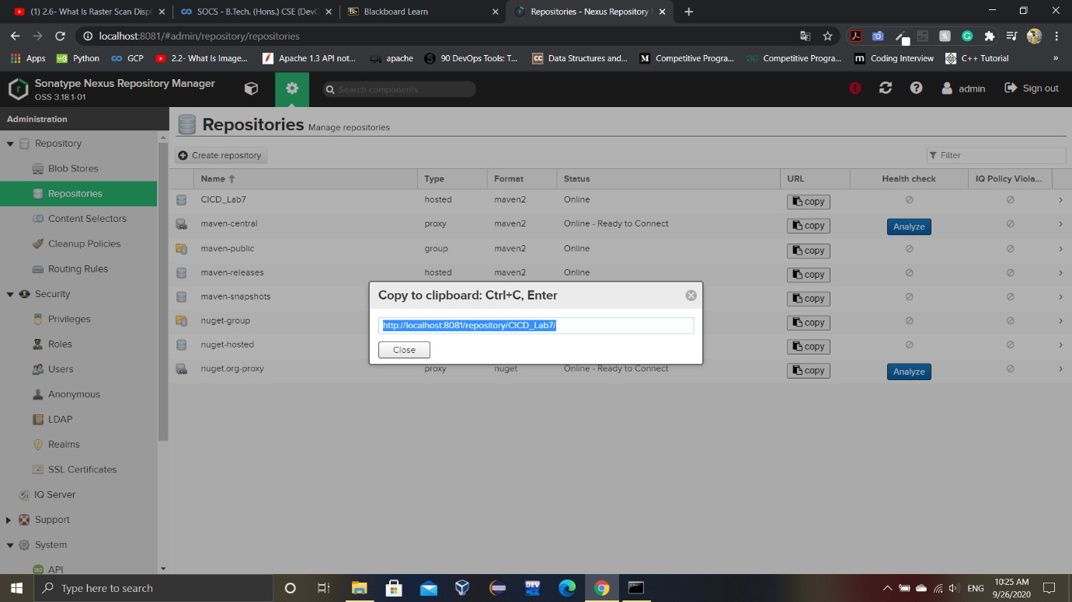

9. Add the following code in the settings.xml file located in the apache maven conf folder. The id will be the name of your nexus repo and username and password will be the same as that of nexus server.

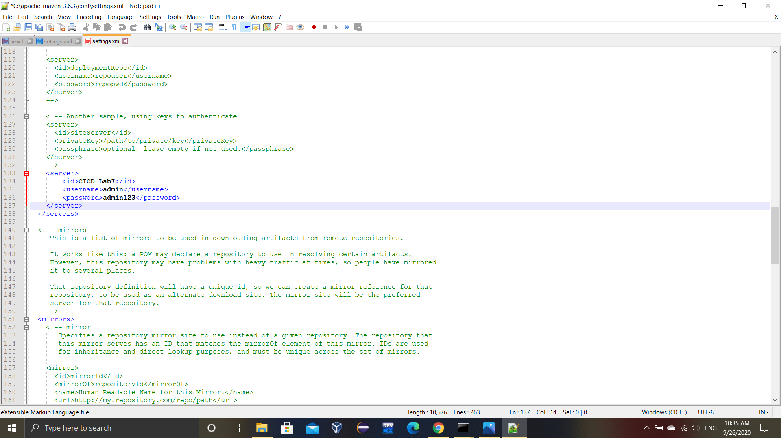

10. Create a new maven project.

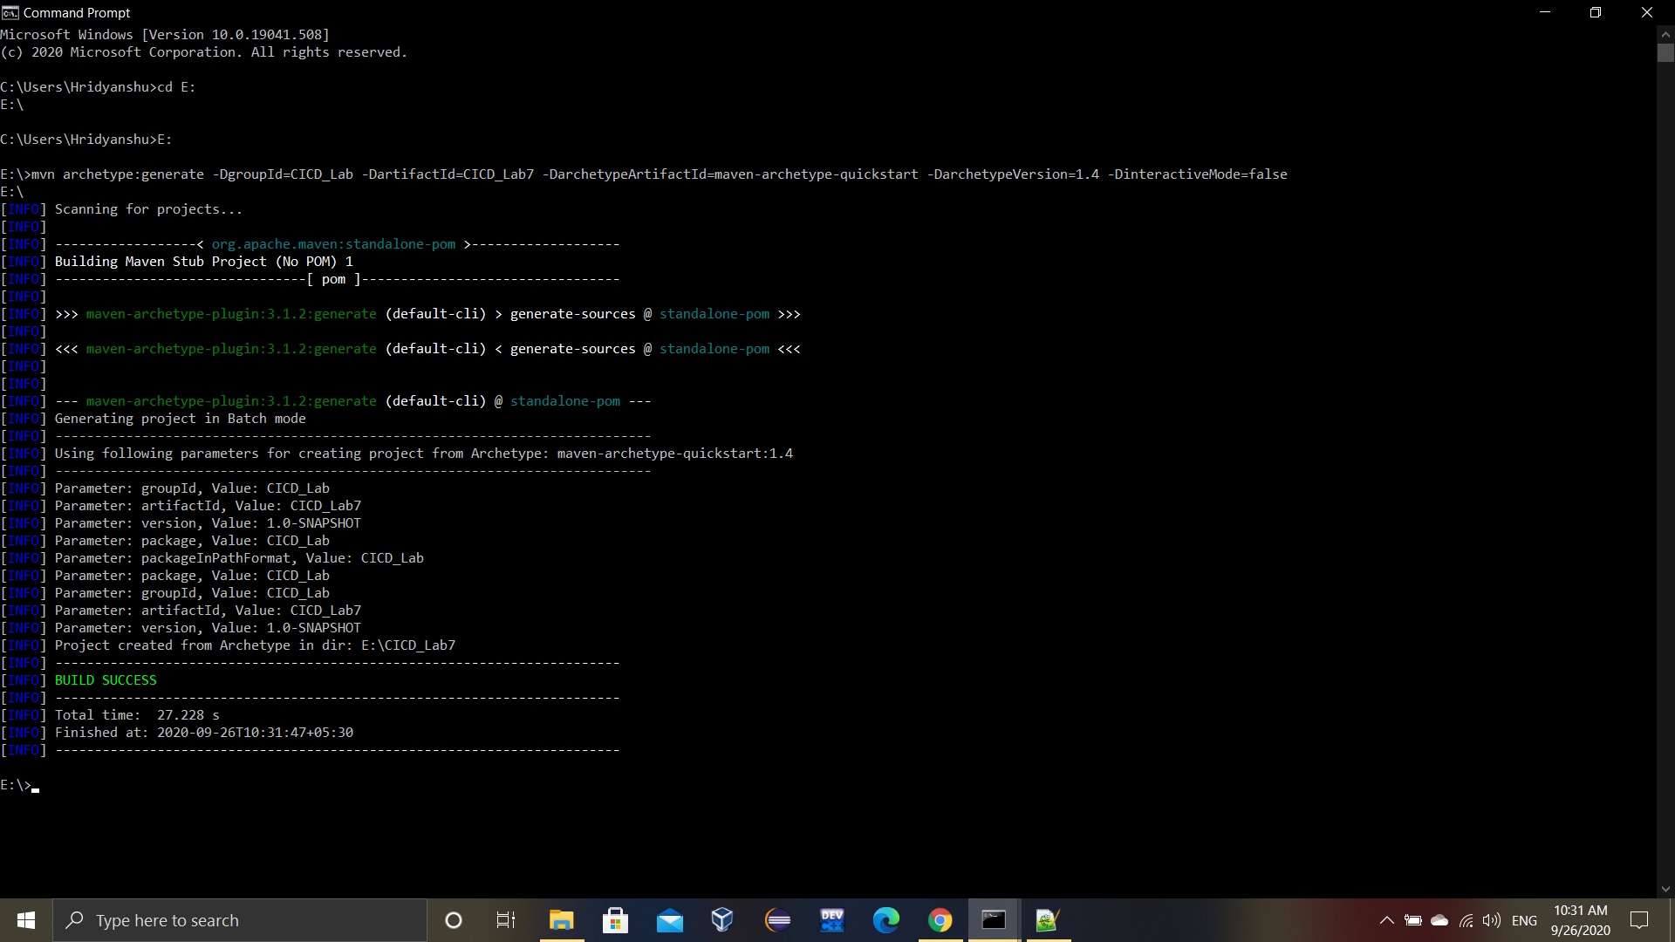

Add the following code inside the <project> tag of pom.xml file of the newly created maven project.

The URL tag will specify the URL that you copied in one of the previous steps.

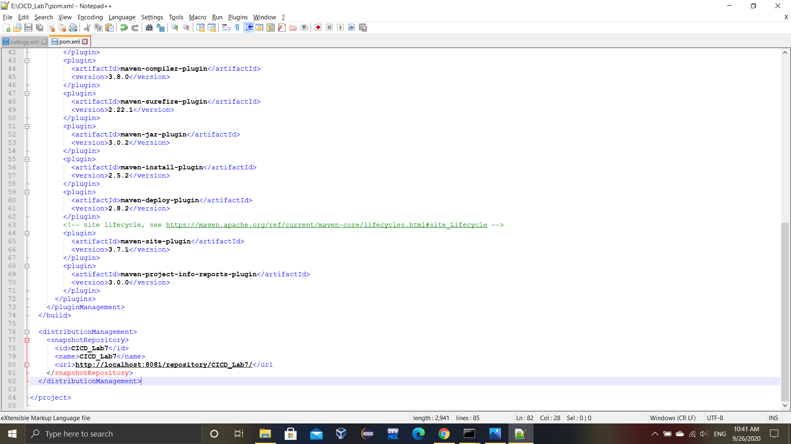

11. Let us verify that our Maven project is working fine by running a couple of maven goals.

Commads Used:

i) mvn clean

ii) mvn install

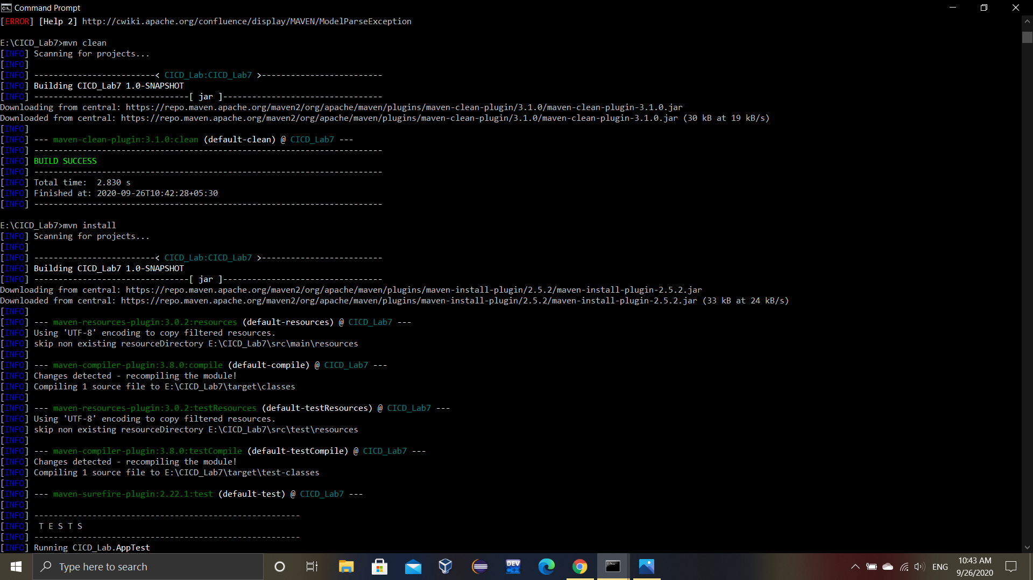

The build success for the above maven goals verify that our maven project is working fine.

Now we are ready to deploy our project on the nexus server.

12. Run the following command to deploy the maven project on nexus server.

Command: mvn deploy

You will get similar outputs:

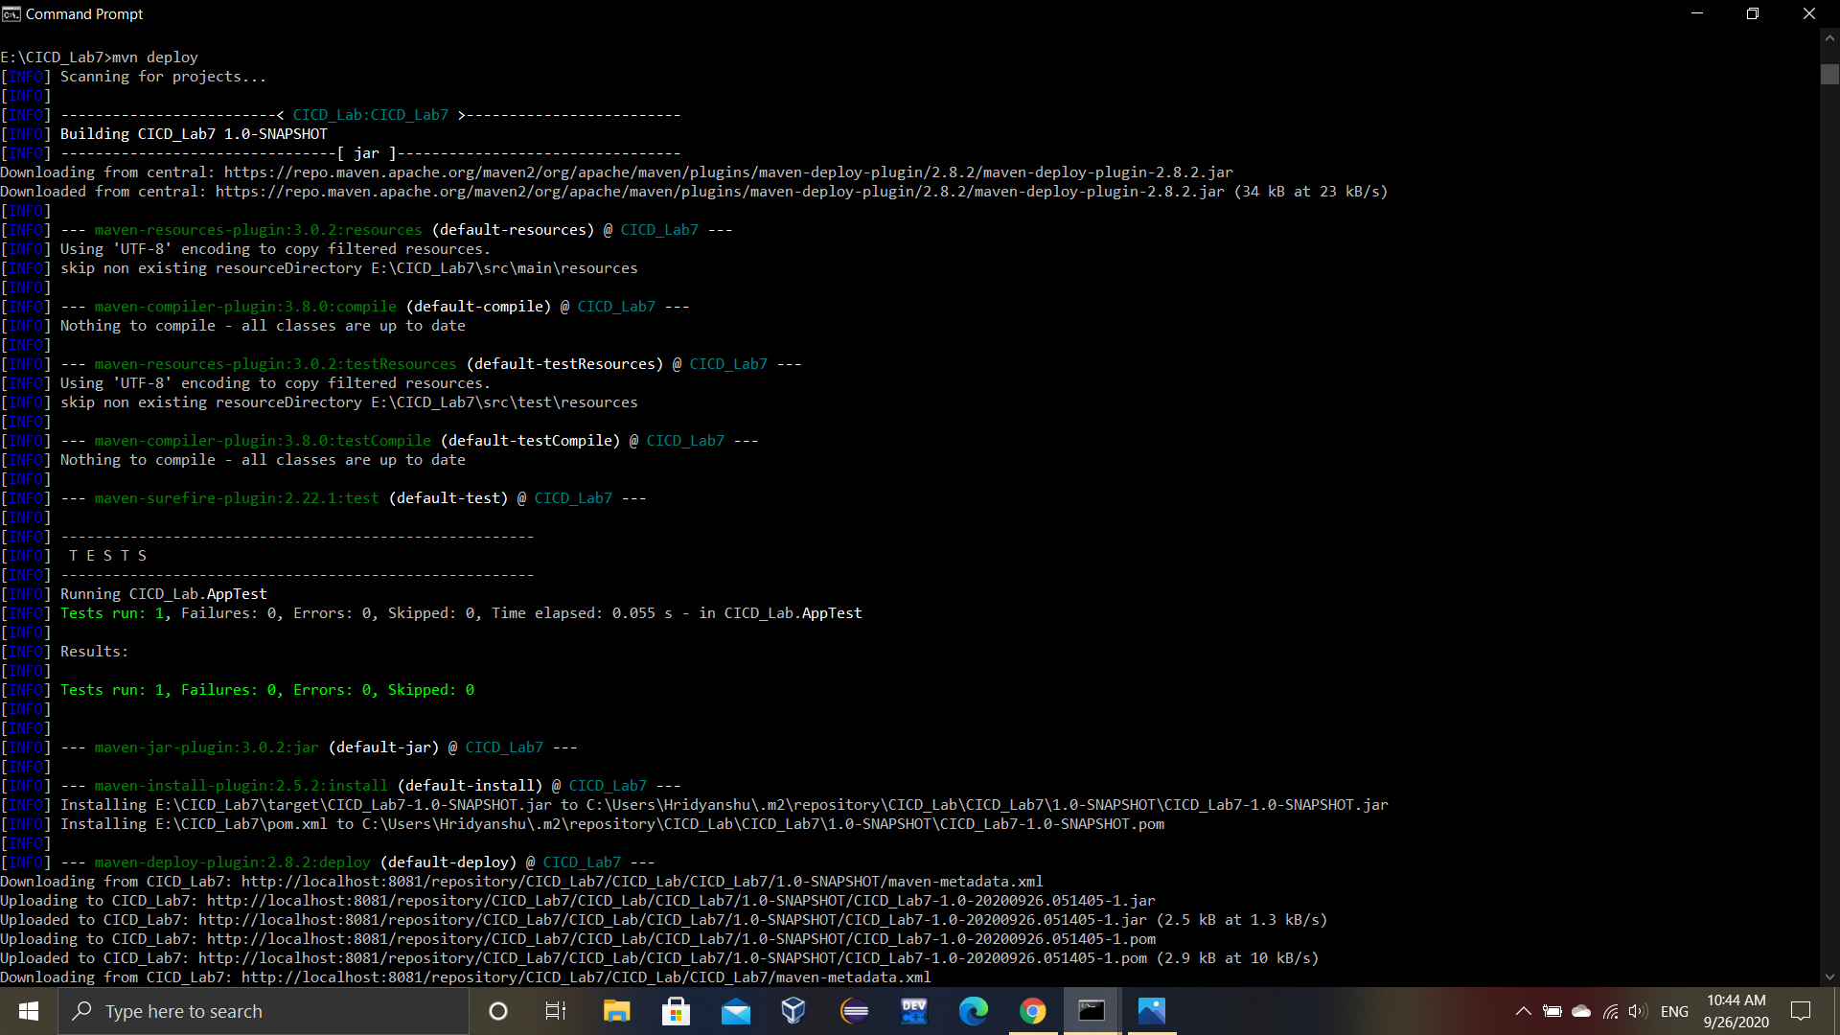

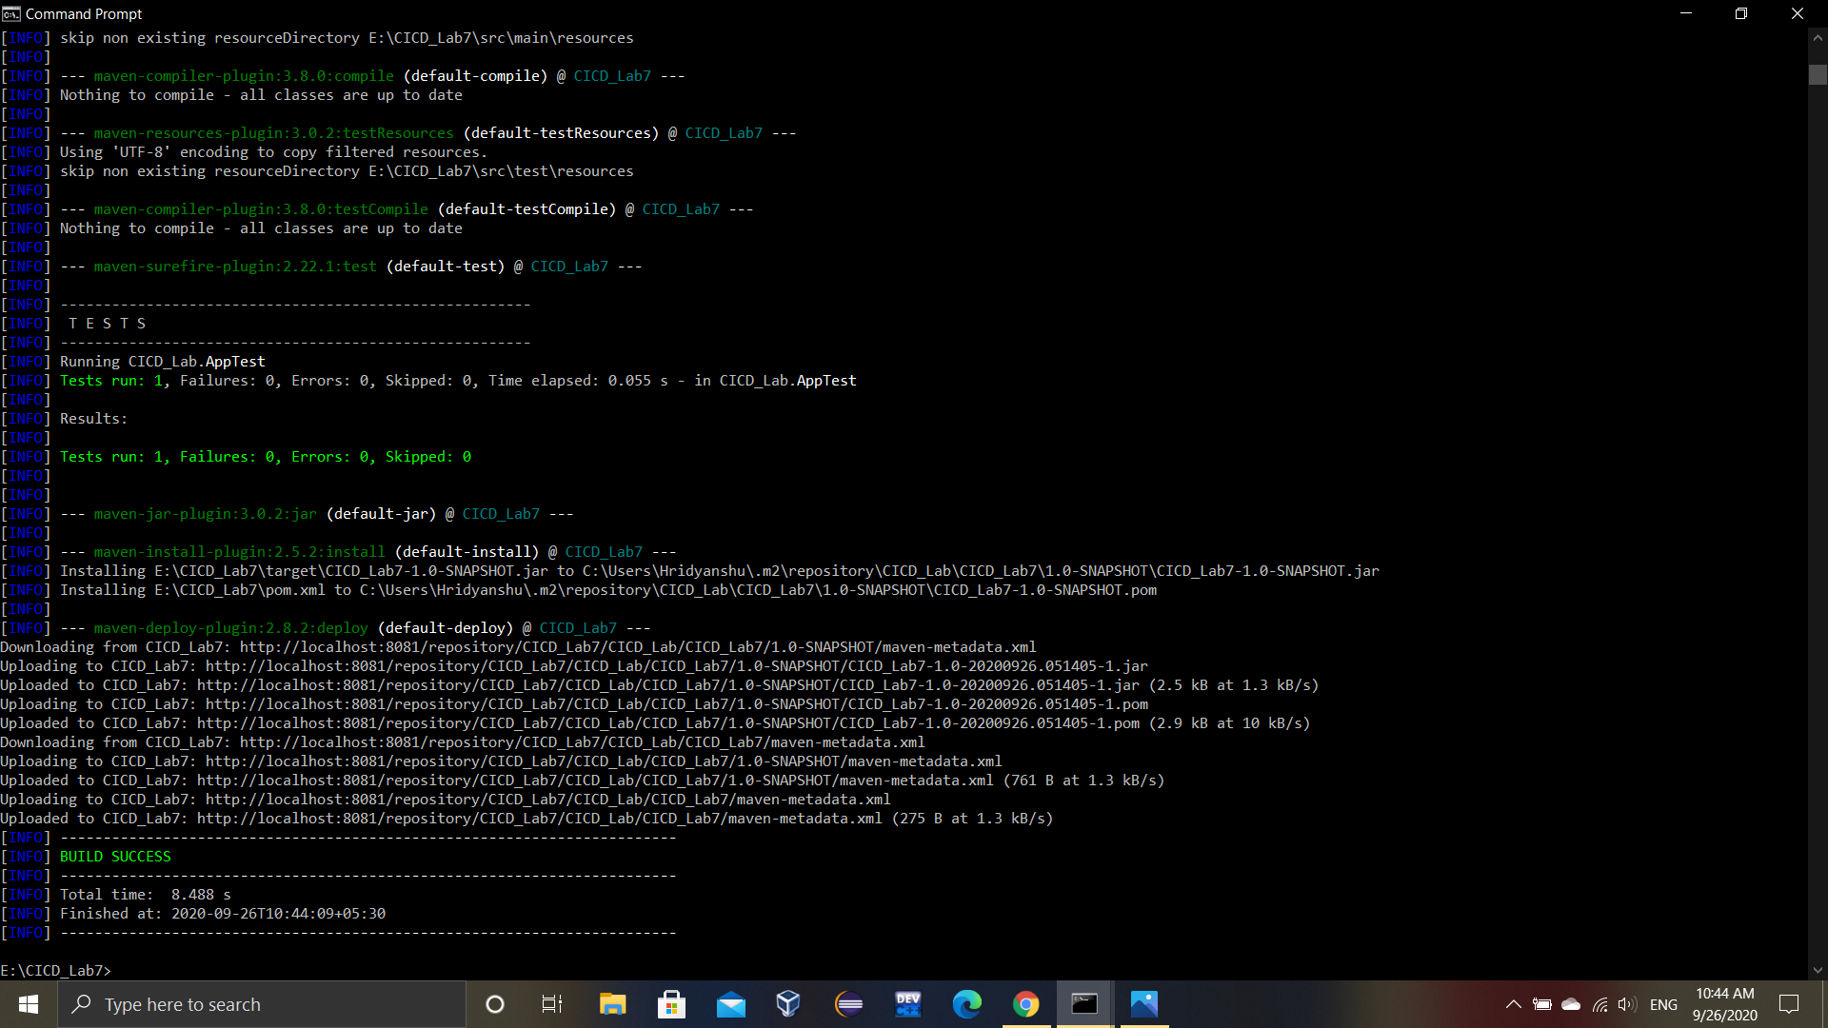

You will see that your Maven repository is deployed at the specified nexus server URL.

