Experiment 1 (Installing Jenkins)

1. Visit Jenkins.io/download/ and click on Download generic java package (.war) for your appropriate OS.

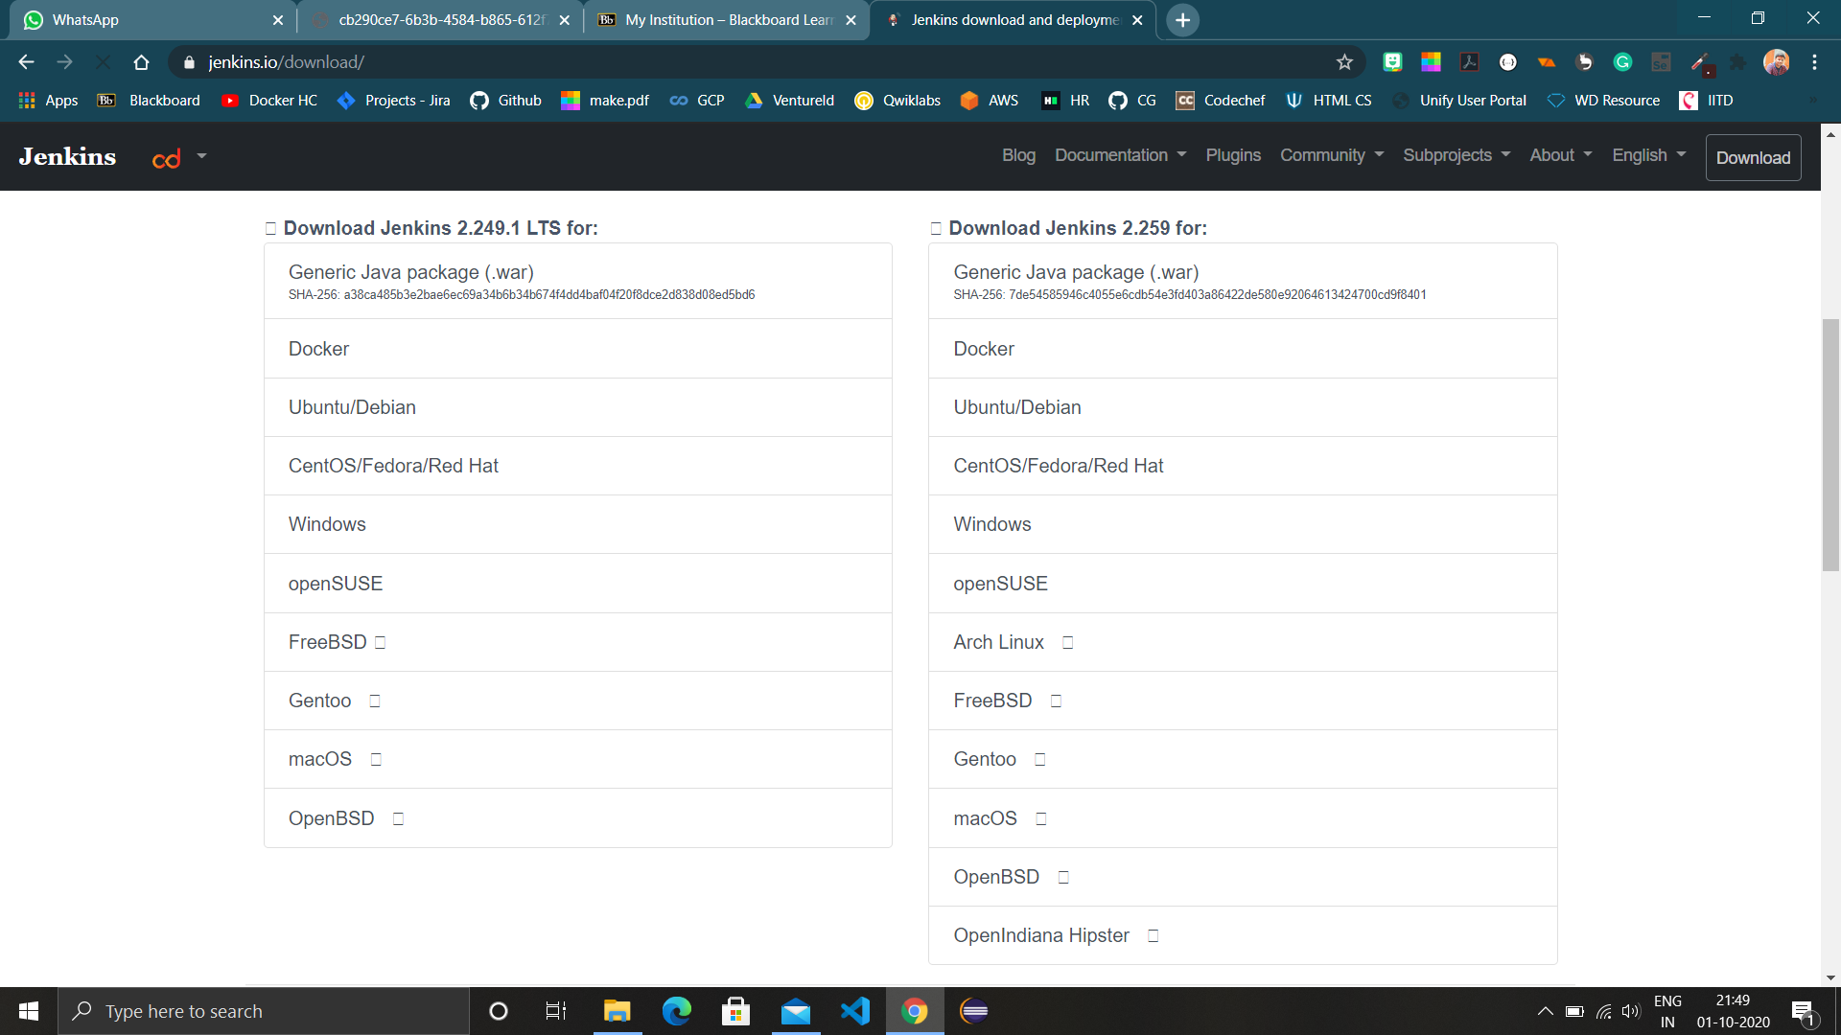

1. After download is complete , store the war file where you want it to recide. Open command prompt and visit to the file location in it and run “java -jar jenkins.war”.

After some initializations, “Jenkins is fully up and running will be shown on the command prompt.”

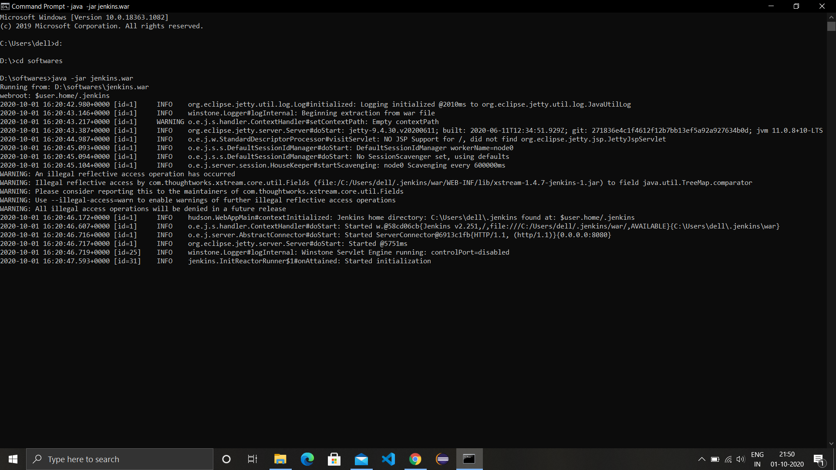

1. Now open web browser and visit localhost with port number 8080 to open the login window of Jenkins, apply default username and password (admin), install required plugins.

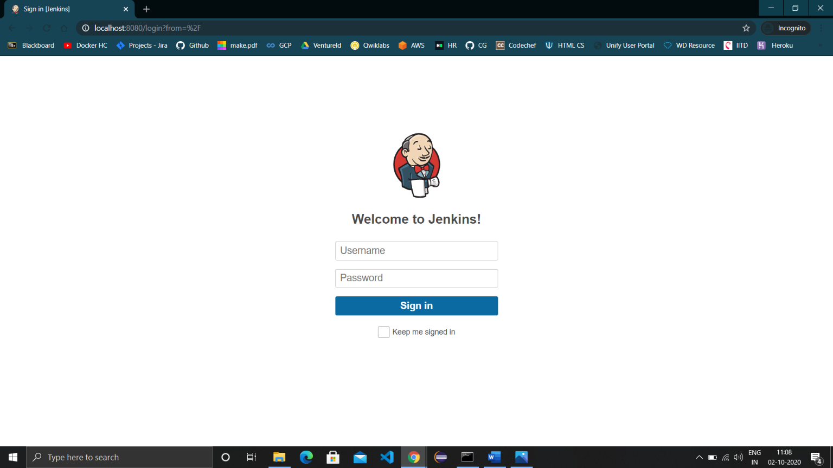

1. The dashboard of Jenkins will appear, click on New Item.

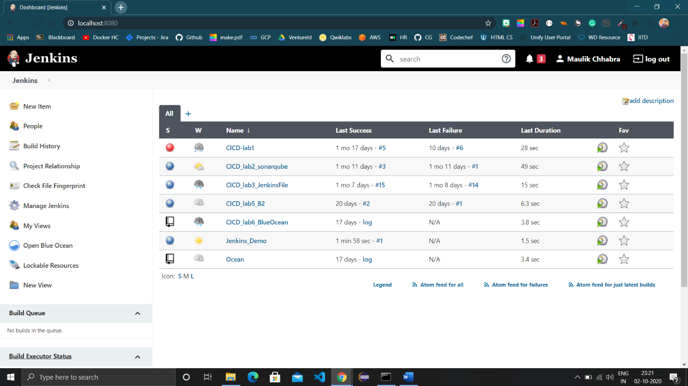

1. Provide a name to the project and choose the type of project to make.

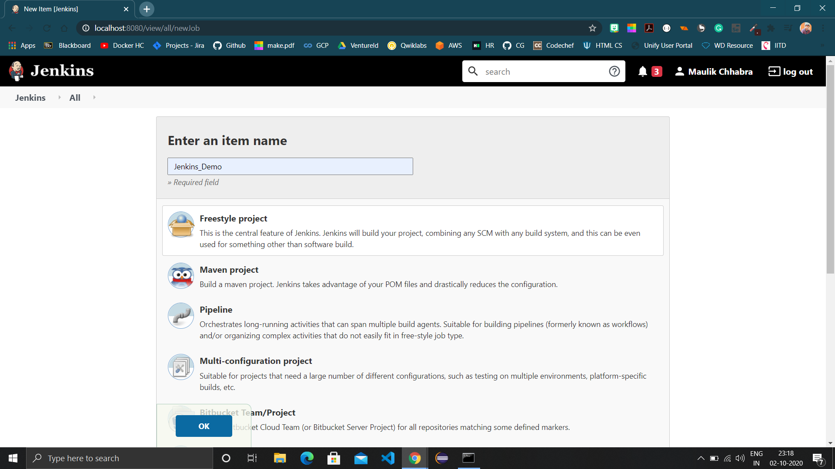

1. In build , choose “Execute Windows batch command” and enter the command to run and save the project.

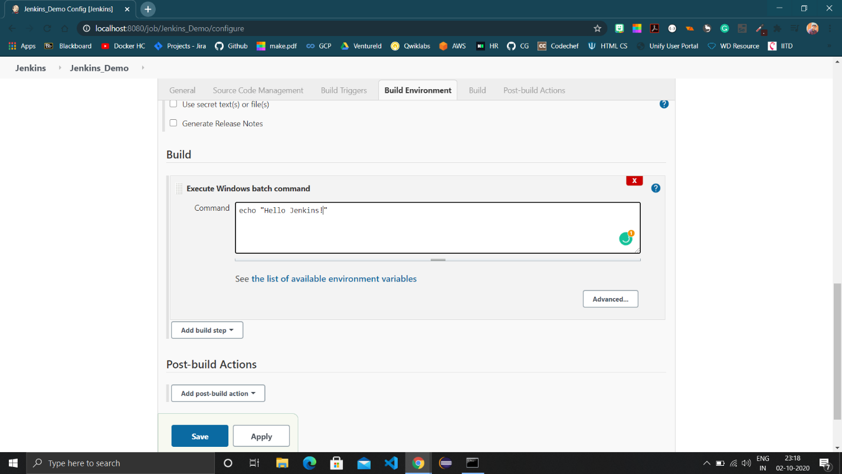

1. Click on “Build now” then click on “#1” and choose console output.

