Experiment 10 (Nexus Integration with Jenkins)

1. Login to the Jenkins dashboard and head to ‘Manage plugins’ in the ‘Manage Jenkins’ tab.
2. Install nexus repository plugins and head back to ‘Manage Jenkins’.

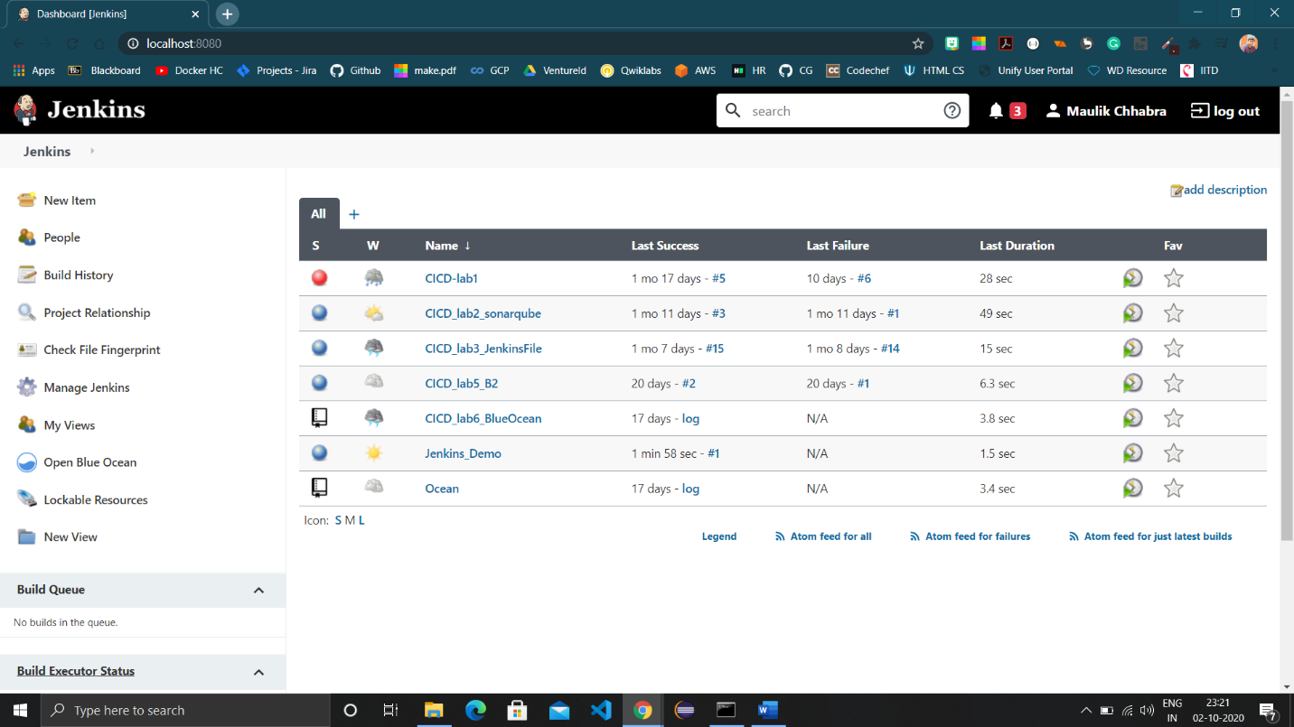

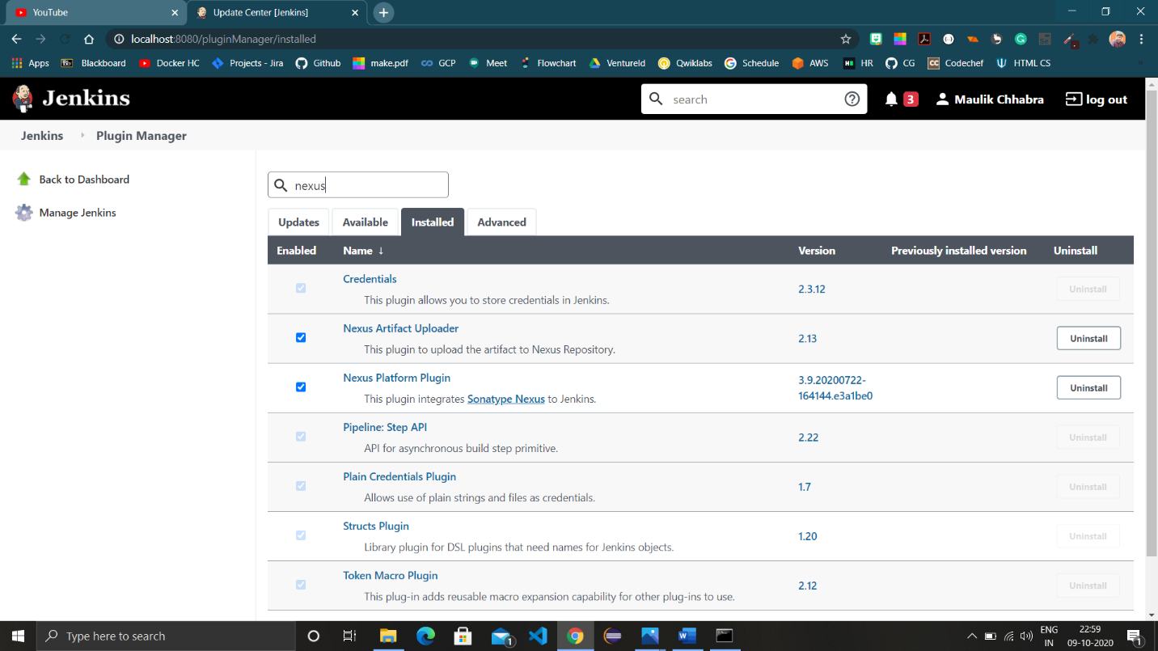

1. Choose ‘Configure system’ and scroll to ‘Sonatype Nexus’ and provide hosting URL and credentials.

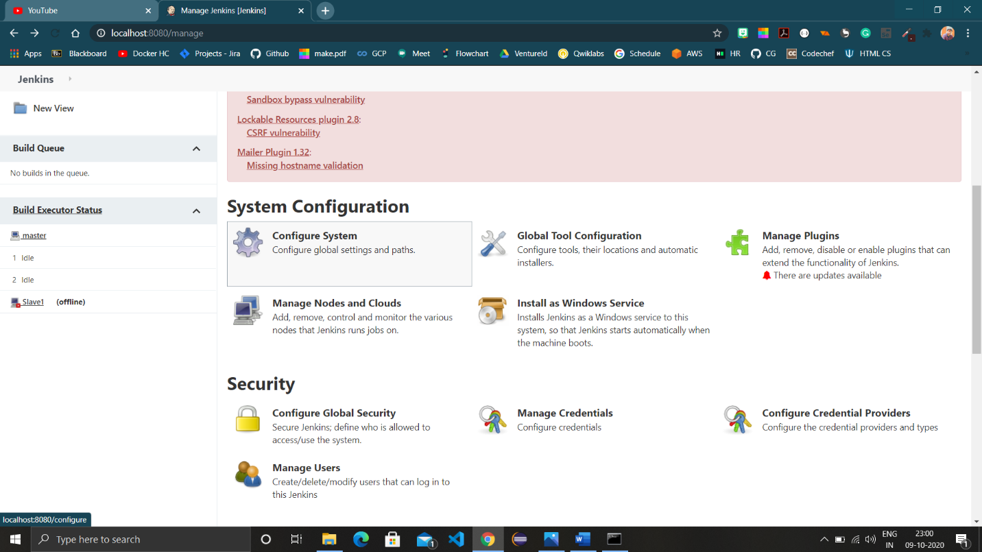

1. Click on “Test Connection” to check connection connectivity.

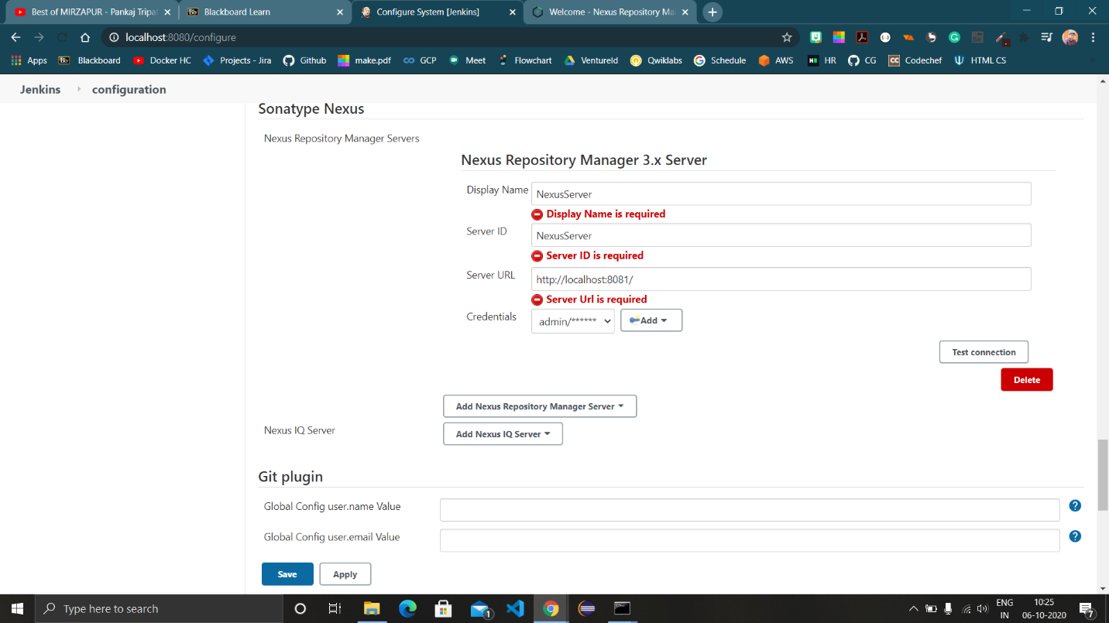

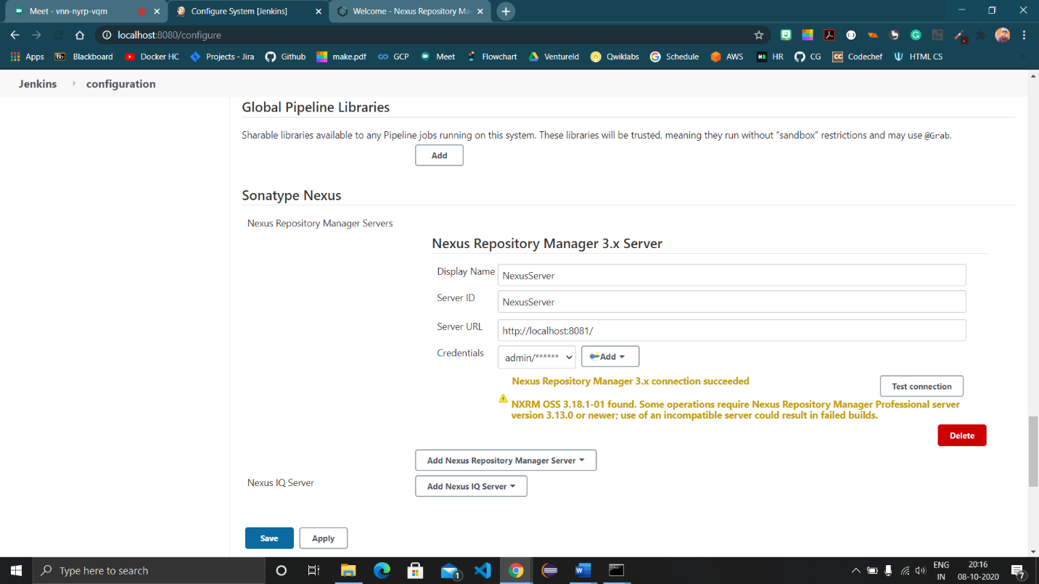

1. Head to ‘Global Tool Configuration’ and set the jdk according to the nexus compatibility. Note that the same jdk should be active on local device also. [Changed jdk 11 to 8]

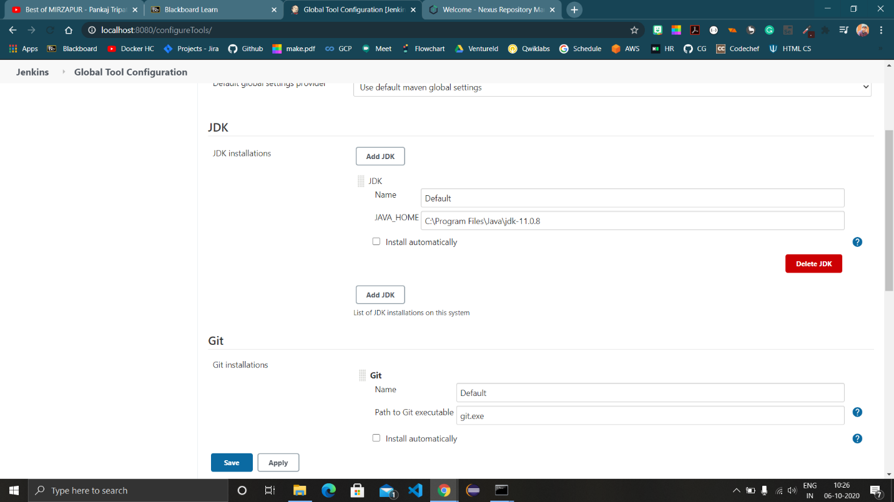

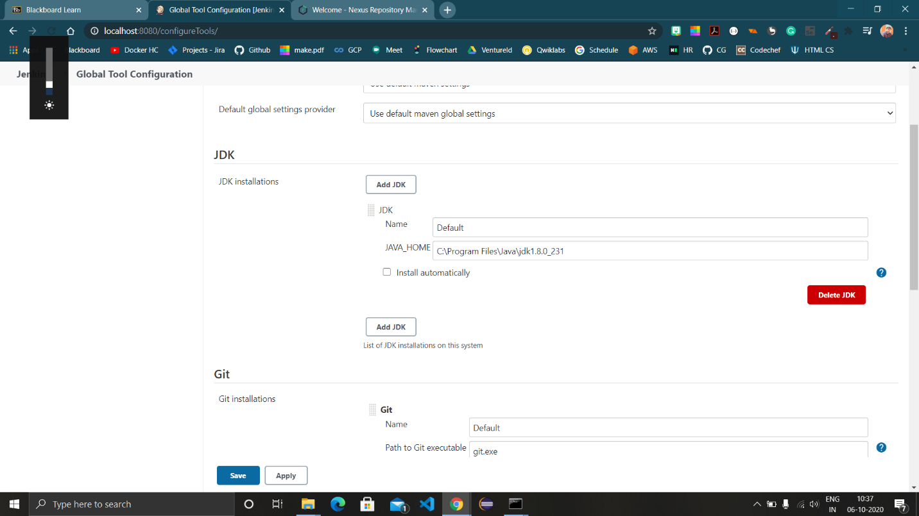

1. Login to the nexus repository manager and create a new repository in it.
2. Copy the repository URL in the pom.xml of the maven folder.

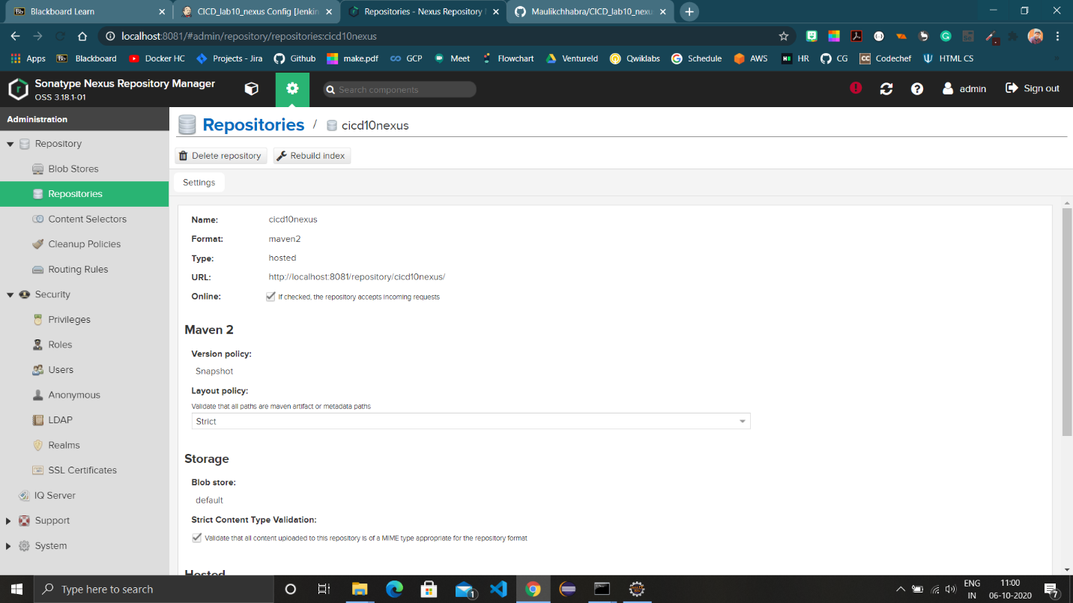

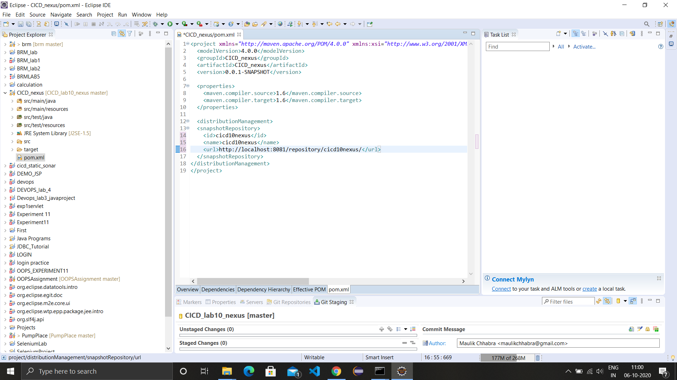

1. Push the project to github and Create a maven project in Jenkins and configure it with the URL of github repo and pom.xml file path.

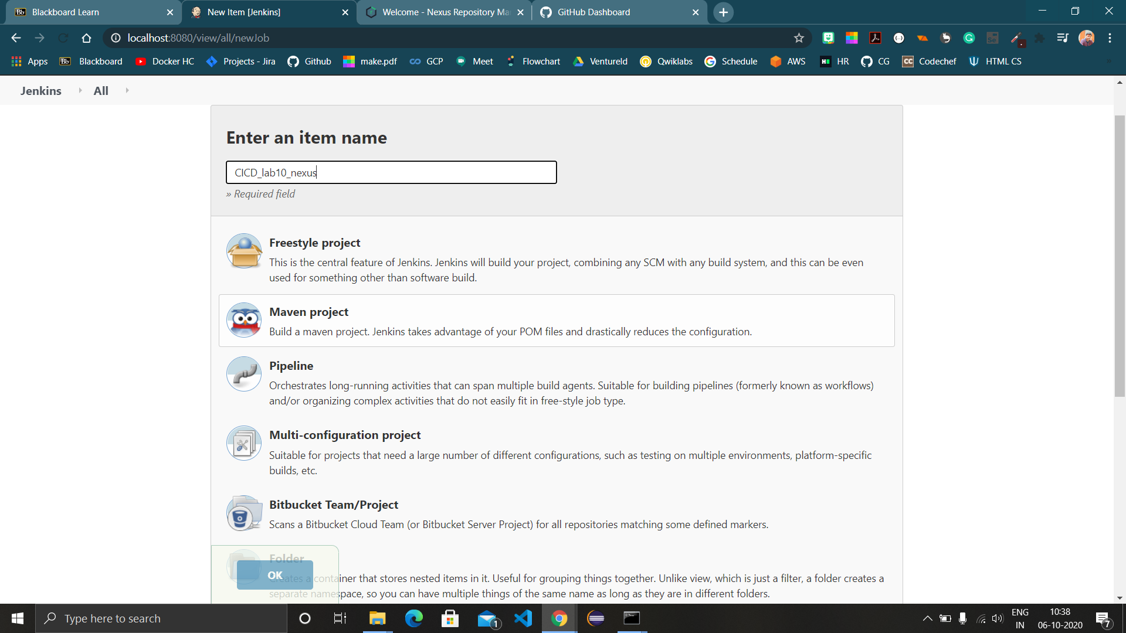

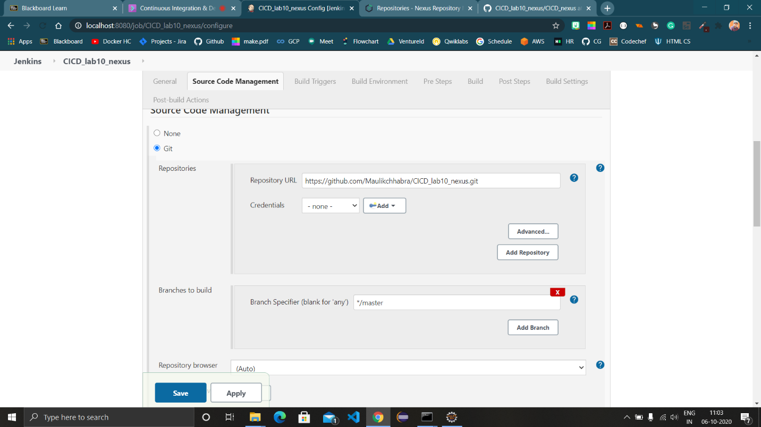

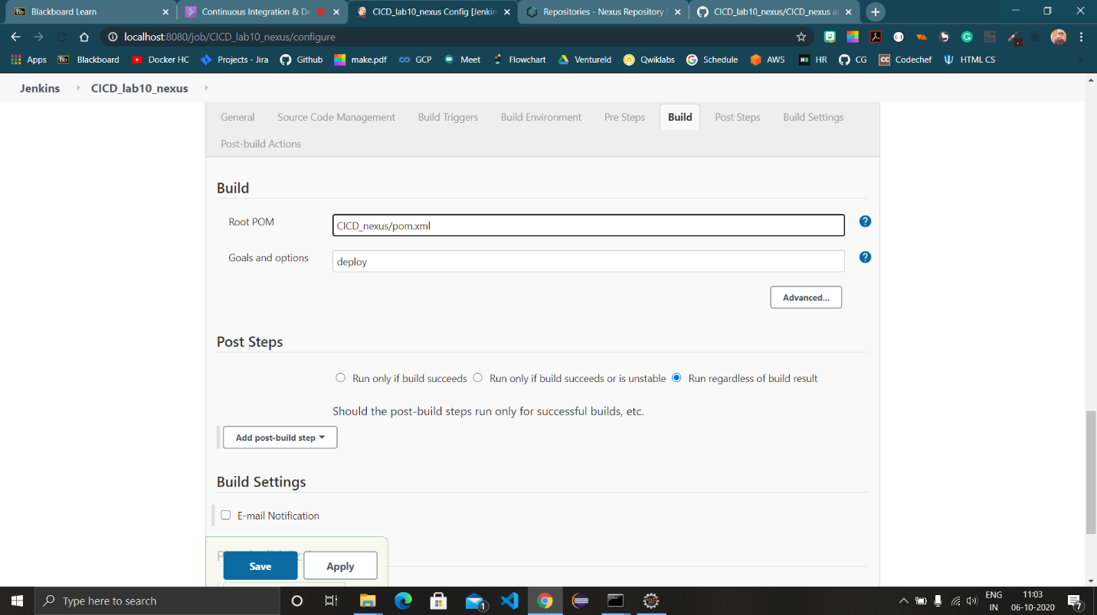

1. Build the project by clicking on ‘Build now’.

