Experiment 13 (Deploy Docker Container)

1. First log on to the vagrant vm by starting the vm using “vagrant up” and opening its terminal using “vagrant ssh”.

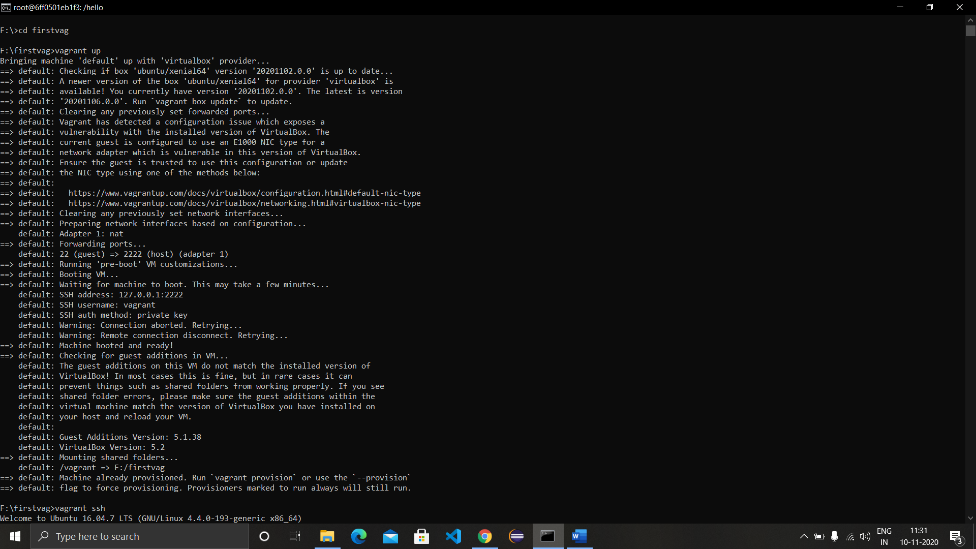

1. Now search for a docker image ‘redis’ using the command “docker search redis”.

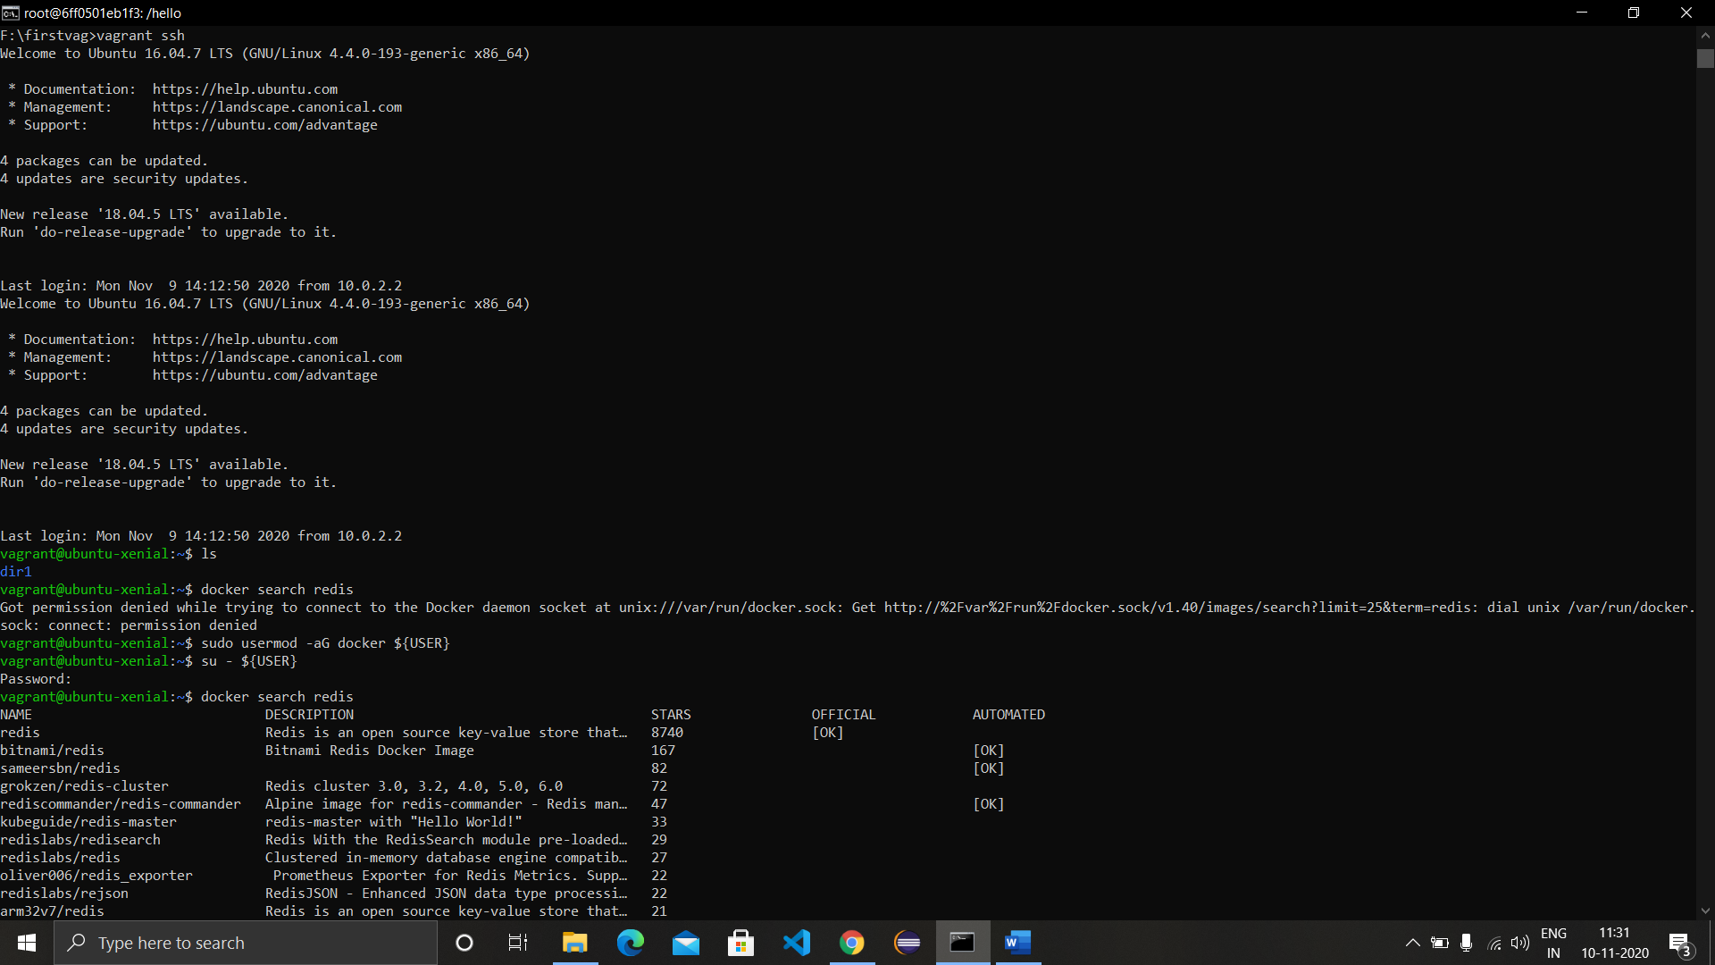

1. Pull the image to the local repository using ‘docker pull redis’.

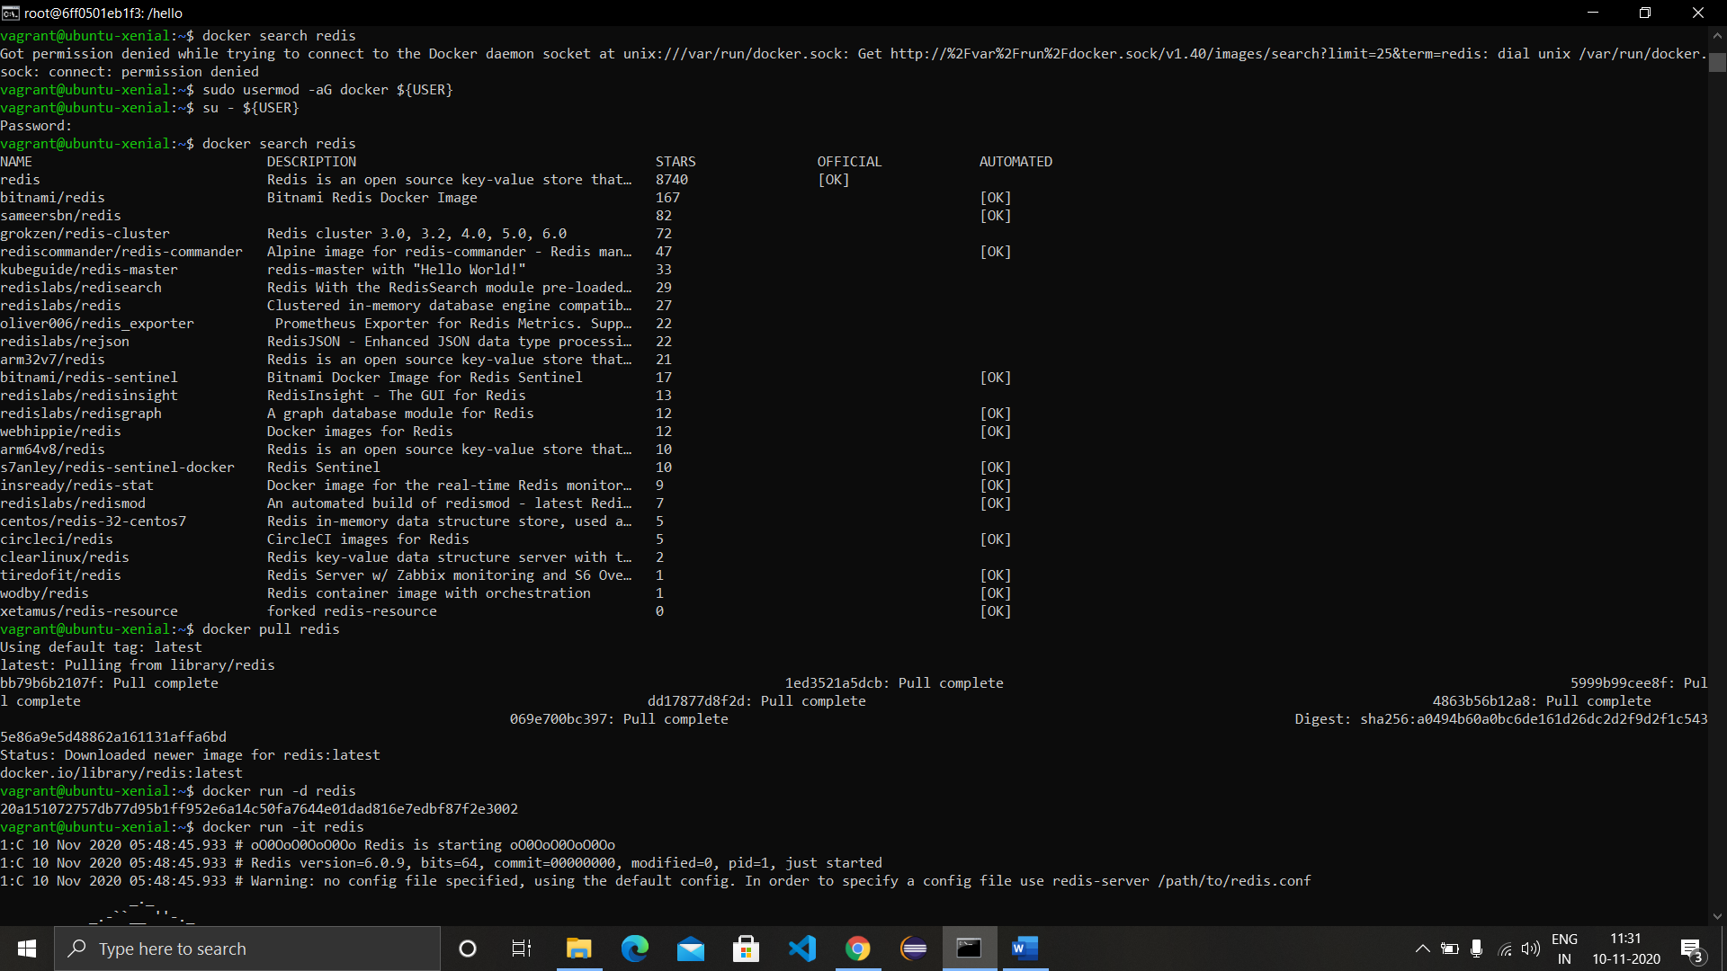

1. Run the image using the command ‘docker run -d redis’.
2. Run the terminal of the redis image using the command ‘docker run-it redis’. Come out of the terminal using ctrl+c.

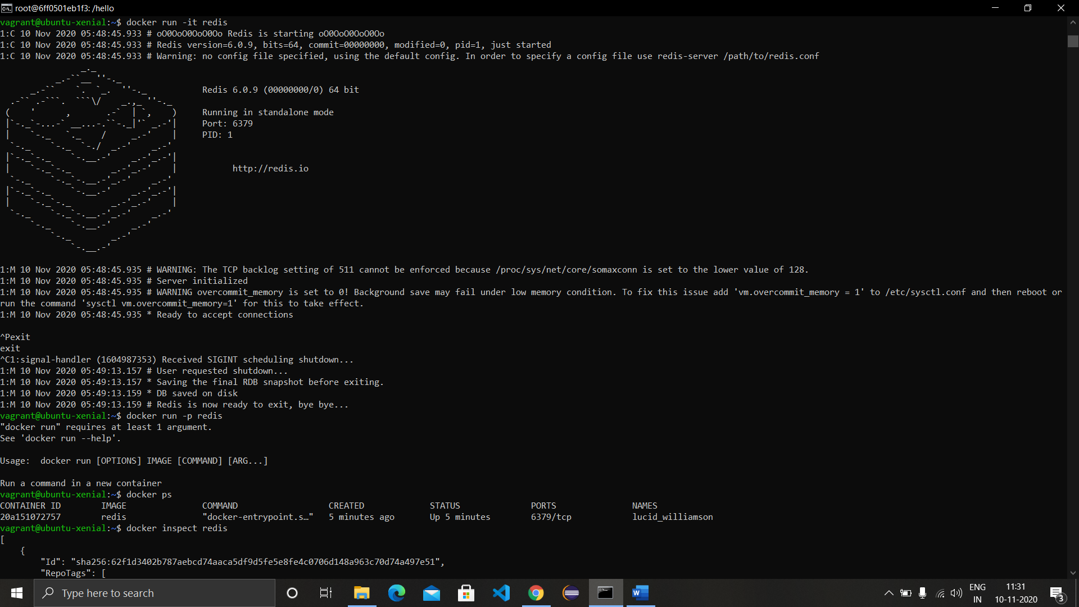

1. Inspect the redis image using the command ‘docker inspect redis’ or with container id of redis as ‘docker inspect CONT_ID’.

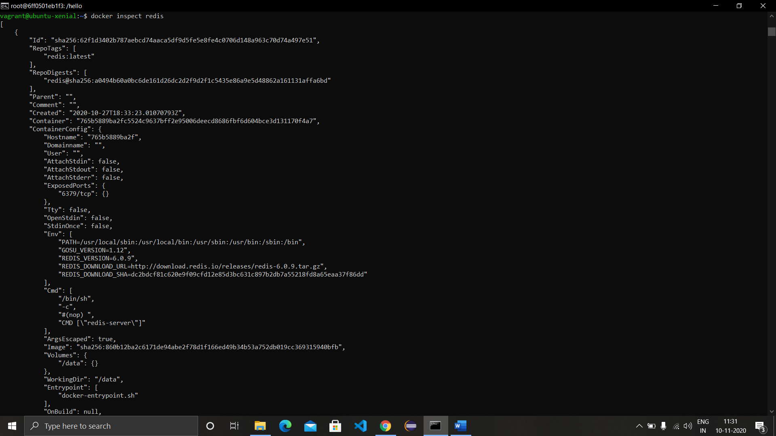

1. Run the redis image in background with the name and port specified.
2. See all the active images using the command ‘docker ps’ and all images (active or not) using ‘docker ps -a’.
3. Run an ubuntu image bash using the command ‘docker run -it ubuntu bash’.

