Experiment 2 (Jenkins Integration with github)

1. Login to the Jenkins dashboard and click ‘Manage Jenkins’ and choose ‘Manage plugins’ and install github plugins.

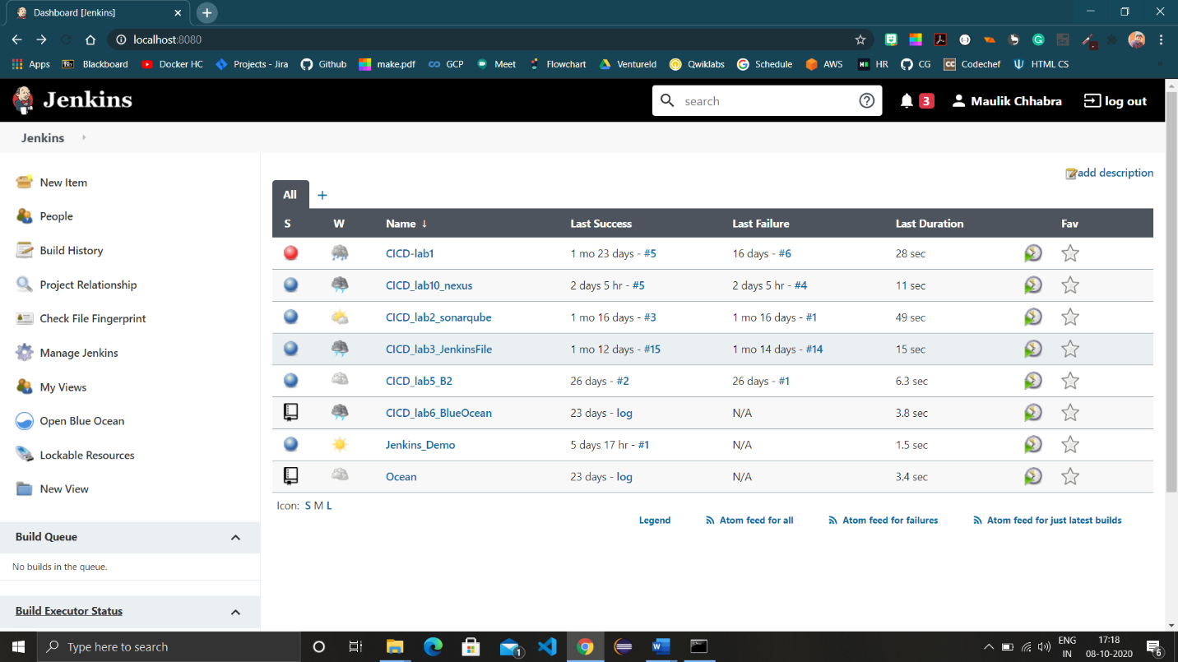

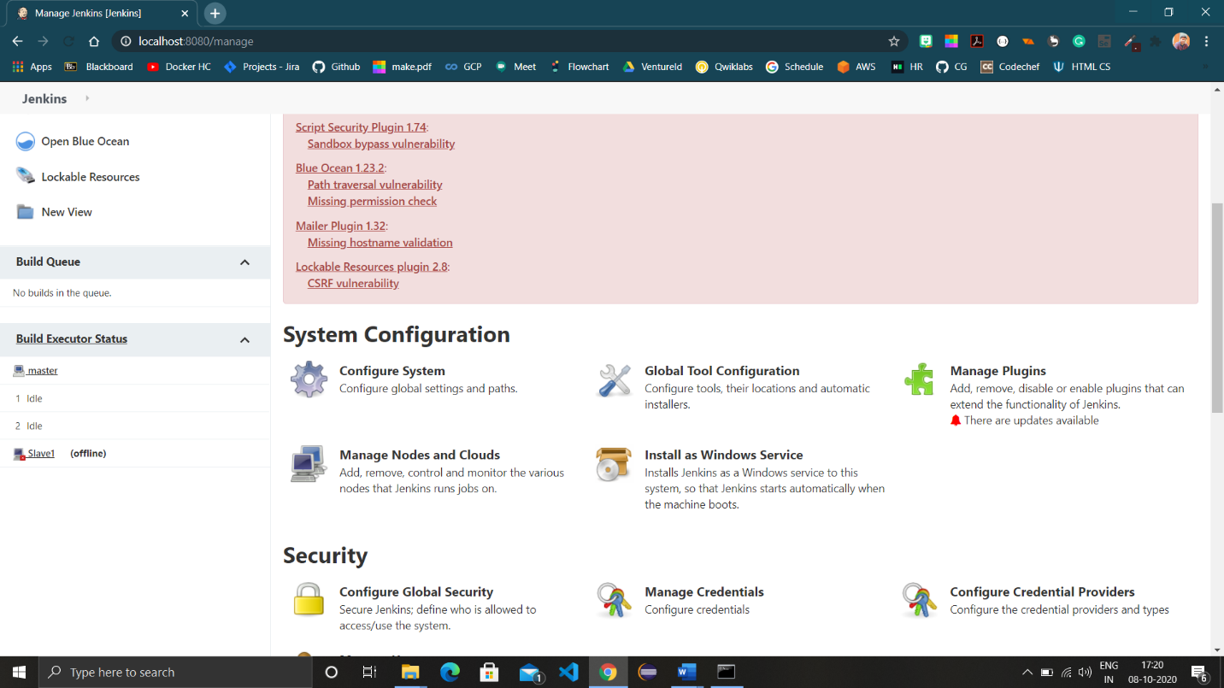

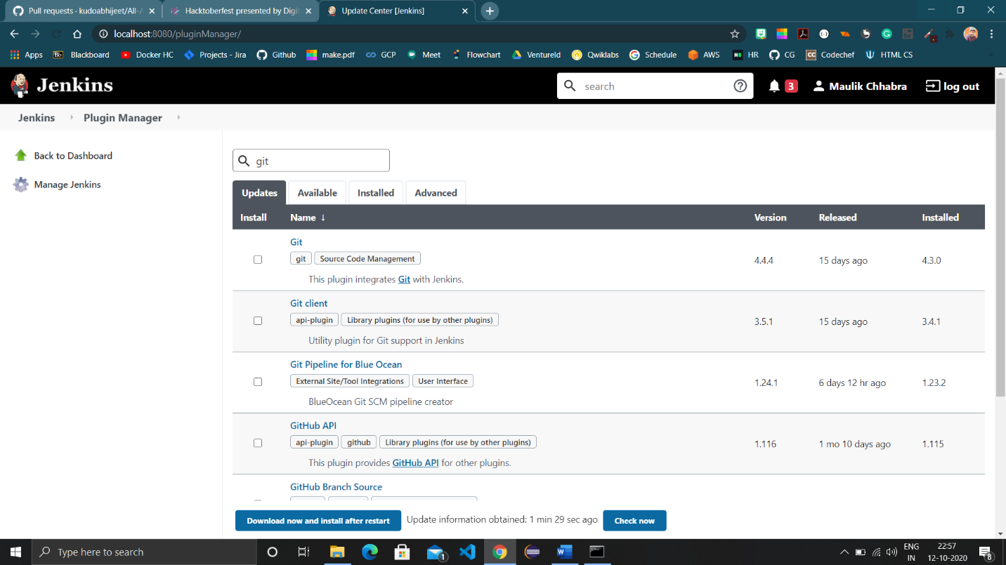

1. Now move to Global Configuration in Manage Jenkins and check Git tab.



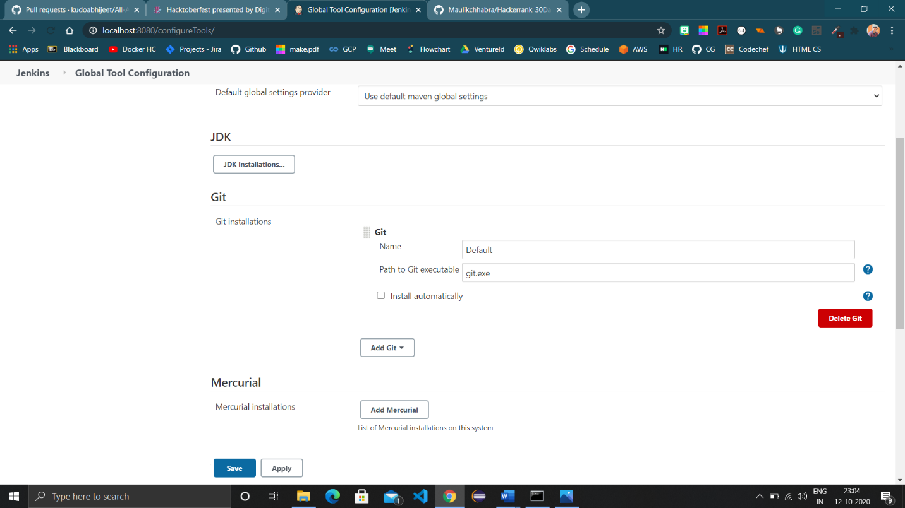

1. Create a project (free style project) and provide github url in repositories menu after selecting git in SCM tool.

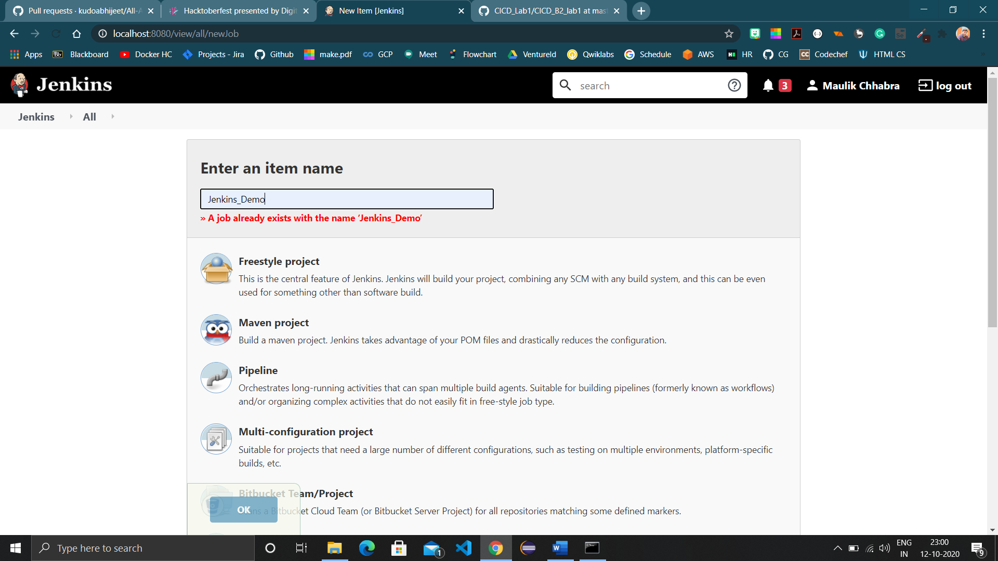

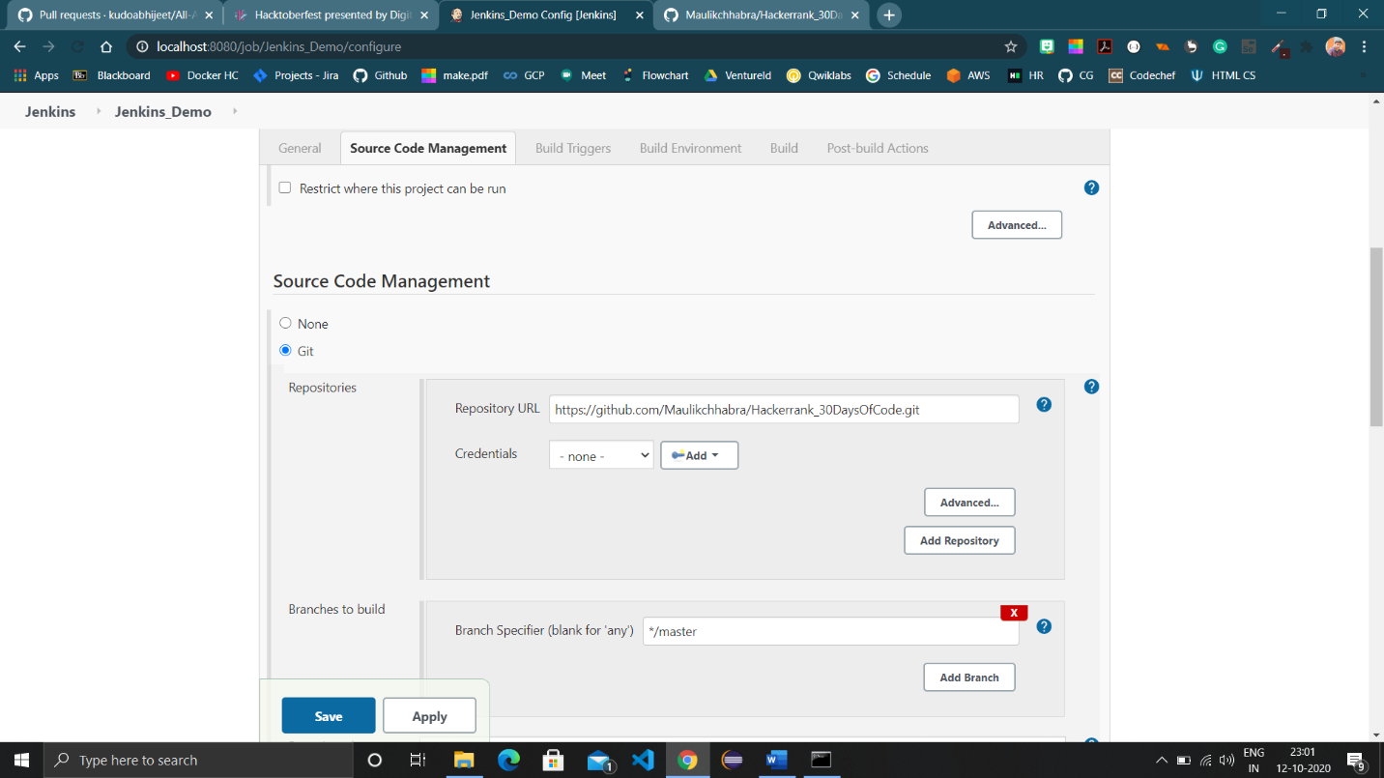

1. Save and Build the project using Build now option.

