Experiment 3 (Jenkins integration with Github and Maven)

1. Login to the dashboard and move to ‘Manage plugins’ in ‘Manage Jenkins ’ tab and install Maven build plugin along with github plugins.

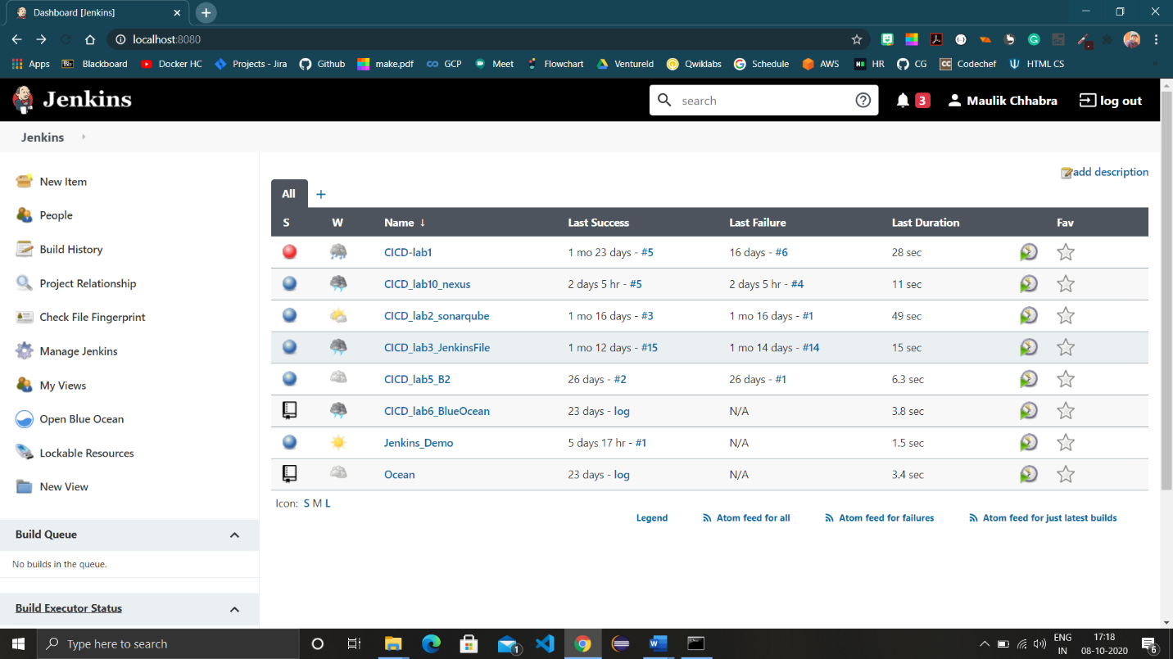

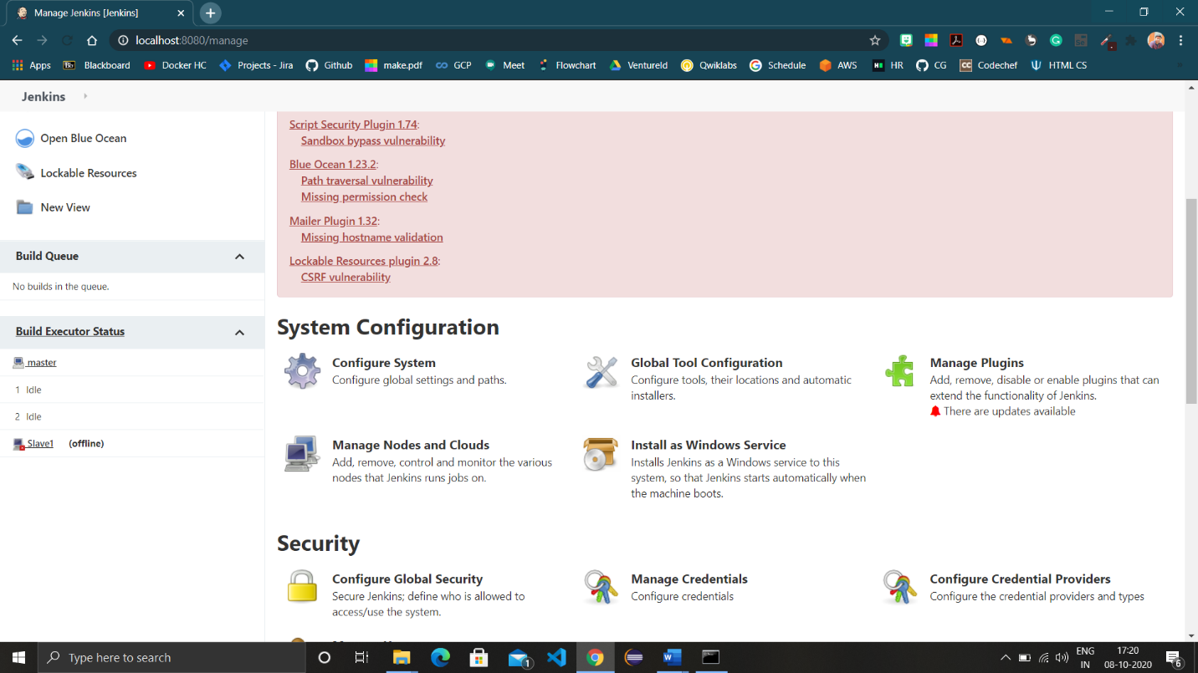

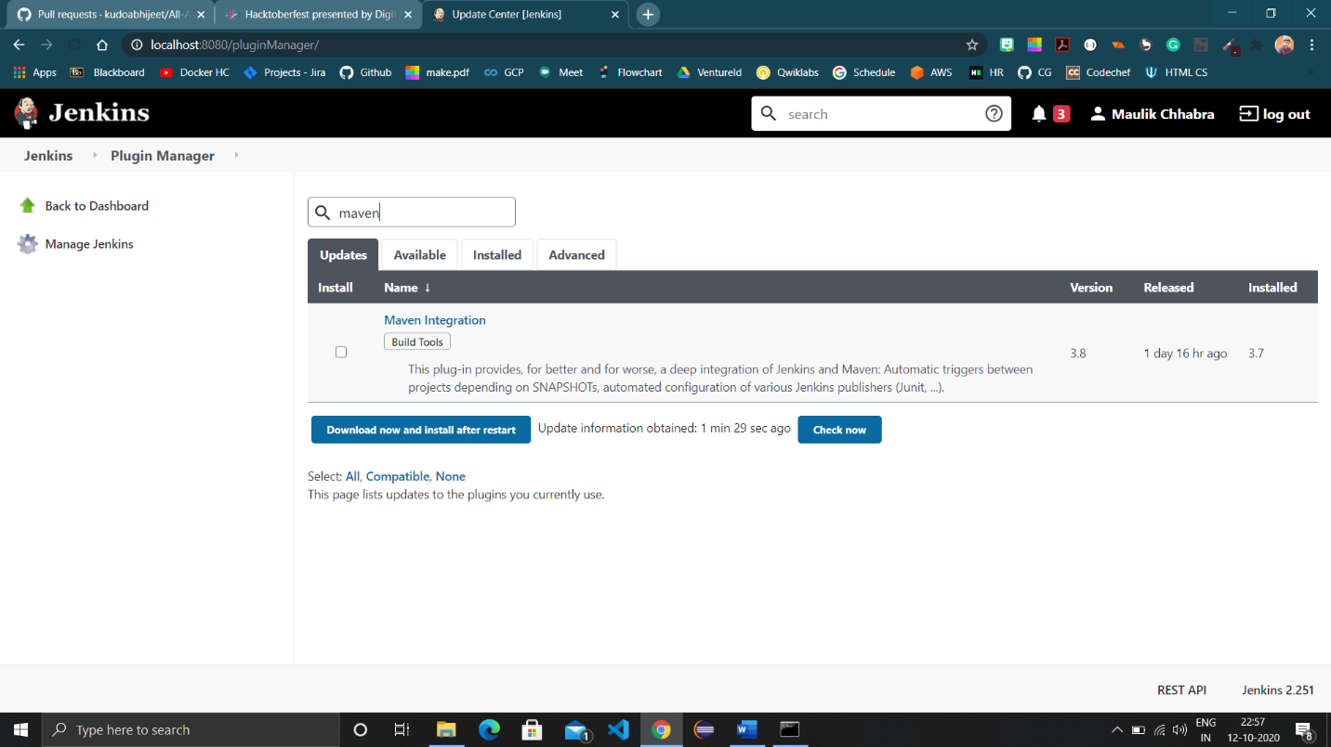

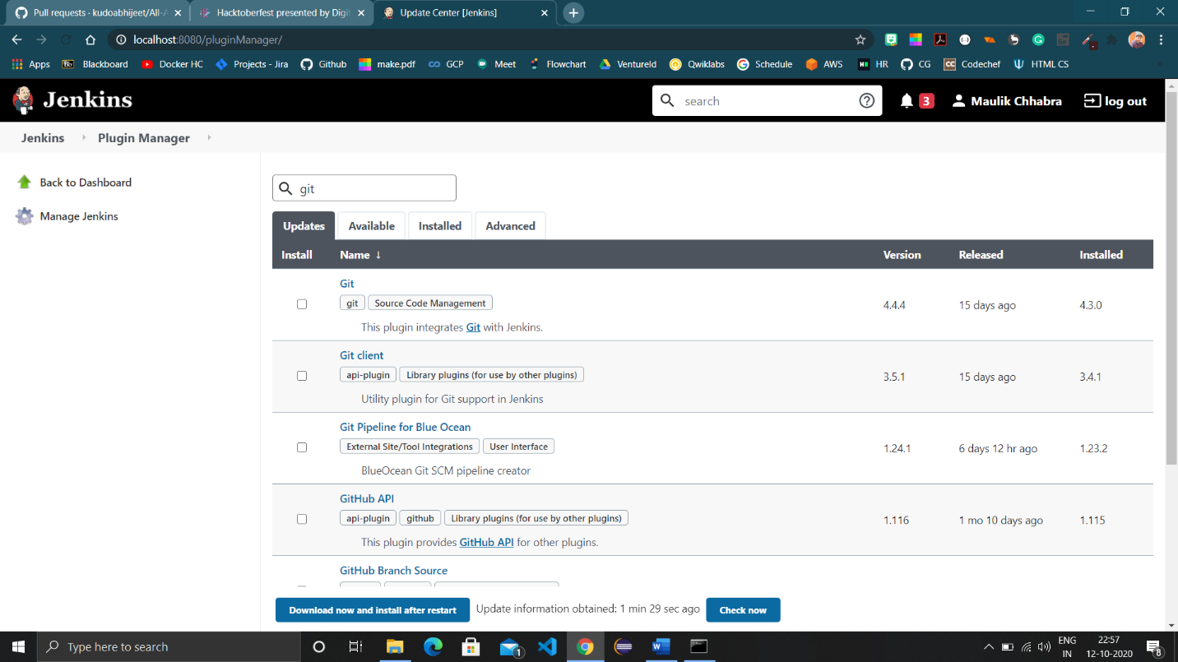

1. Move to ‘Global tool configuration’ to check Git tab and to provide Maven path in Maven tab.



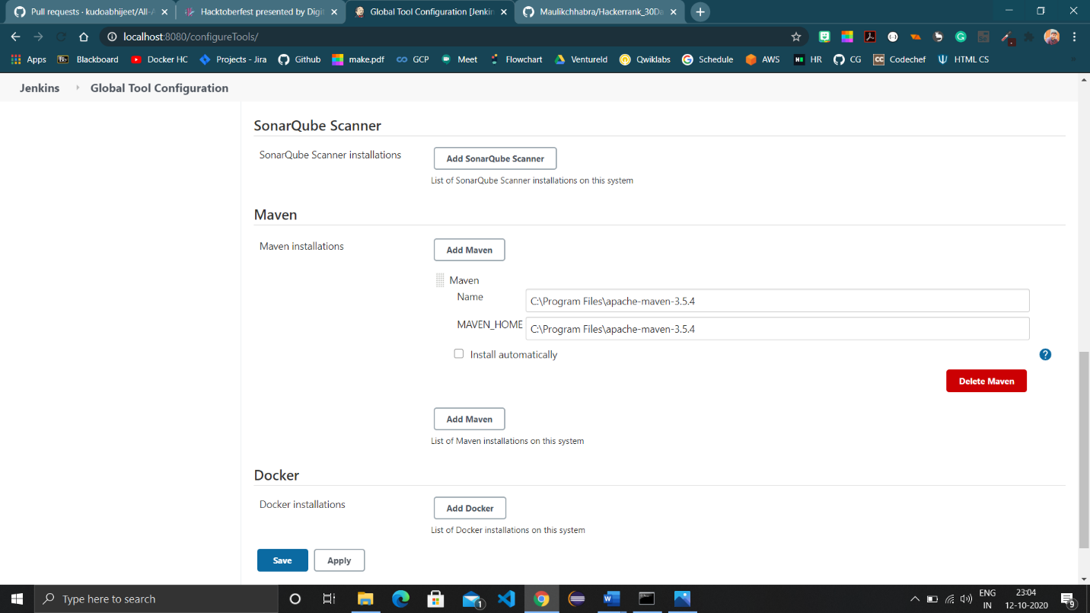

1. Move back to the dashboard to create a Maven project. Click on ‘new item’ ,select Maven project and provide name.

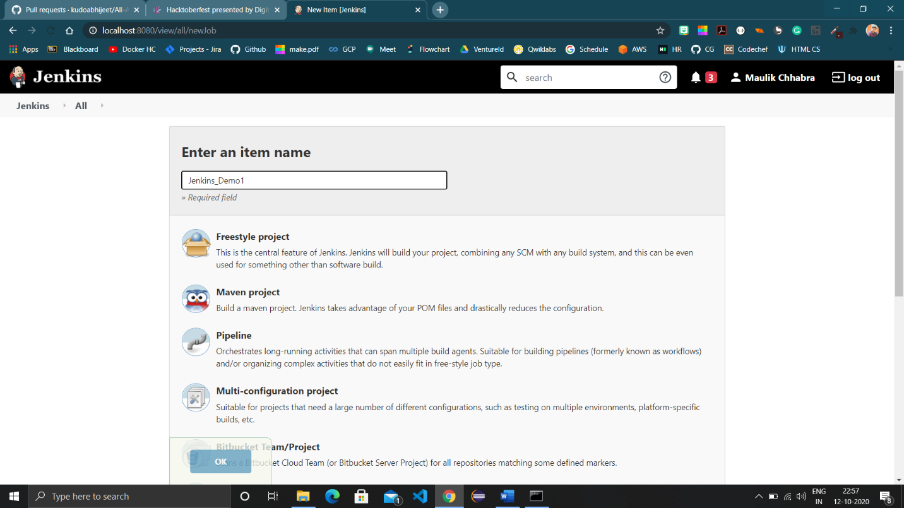

1. Provide configuration of the project (like URL of repo and path to pom.xml along with the goal to run).

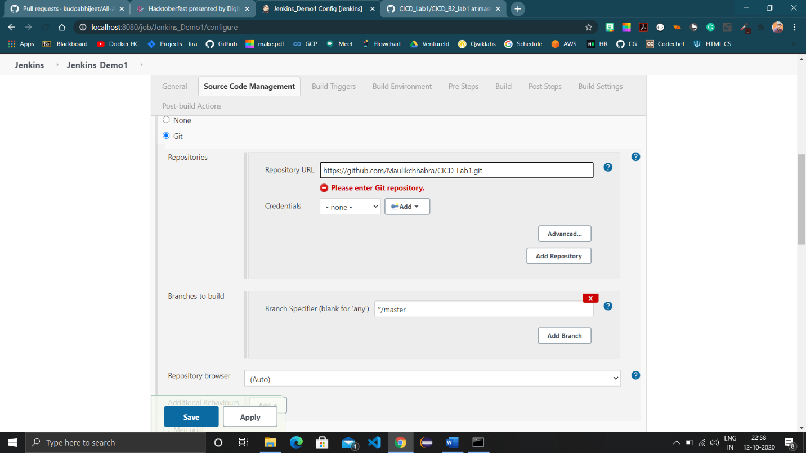

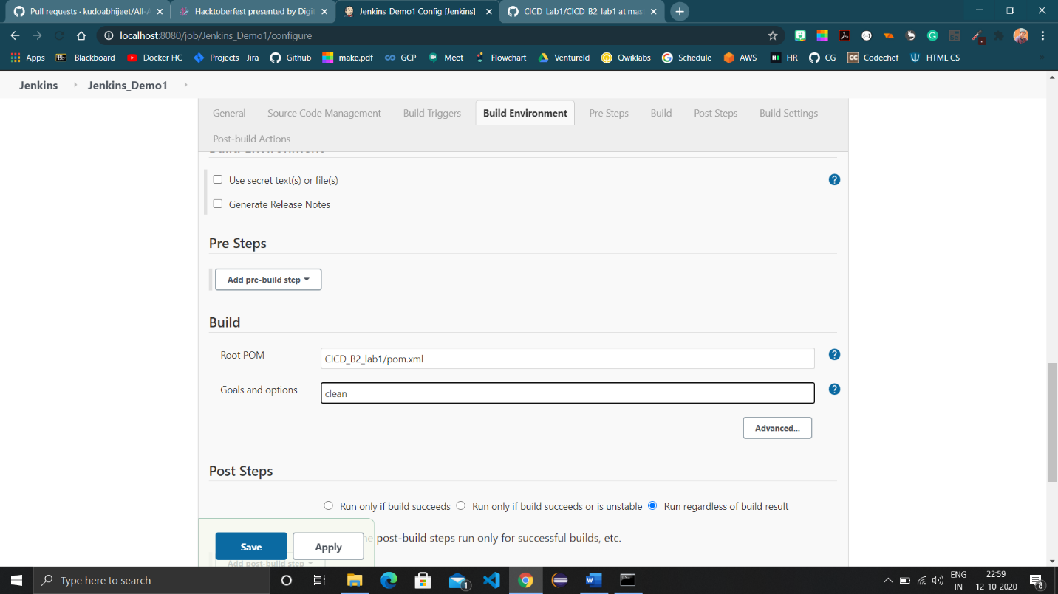

1. Click save and then build the project using ‘Build now’ button.

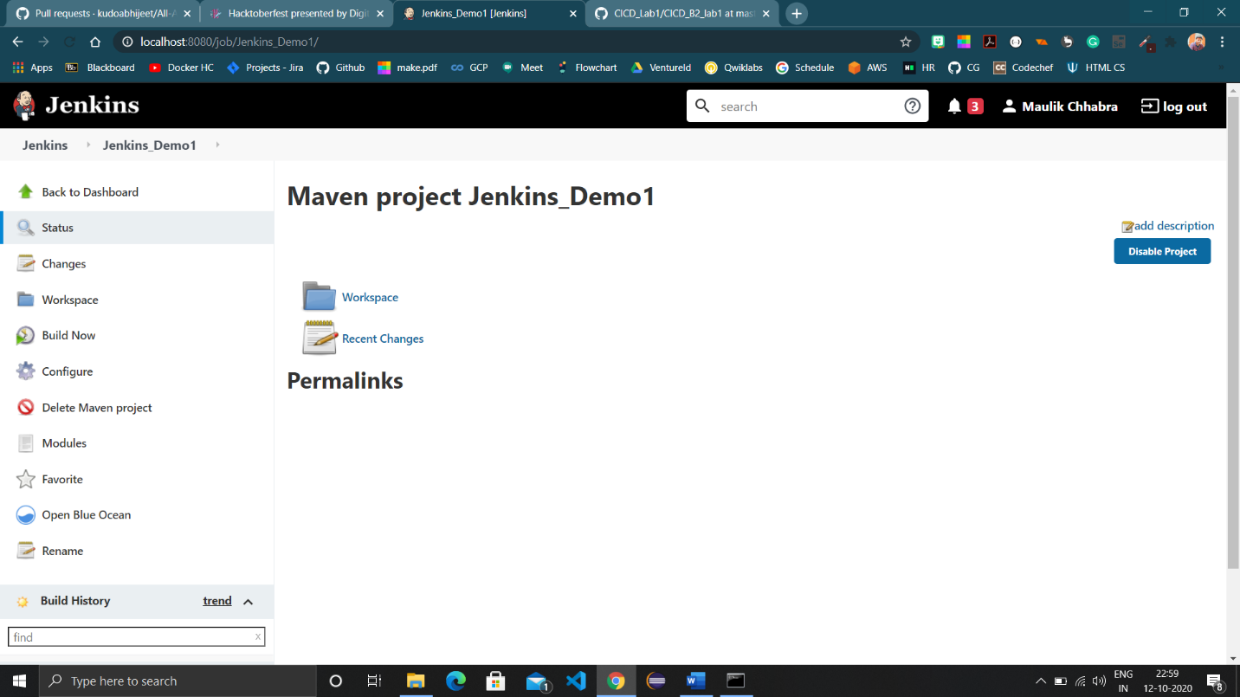

1. Following is the console output of the project build.

