Experiment 4 (Static code analysis with Sonarqube)

1. Download sonarqube and extract it to the desired folder, iterate to the folder in command prompt in which it is present and reach to StartSonar.bat in bin folder.
2. Run “StartSonar.bat” in the prompt and wait till all the initializations.

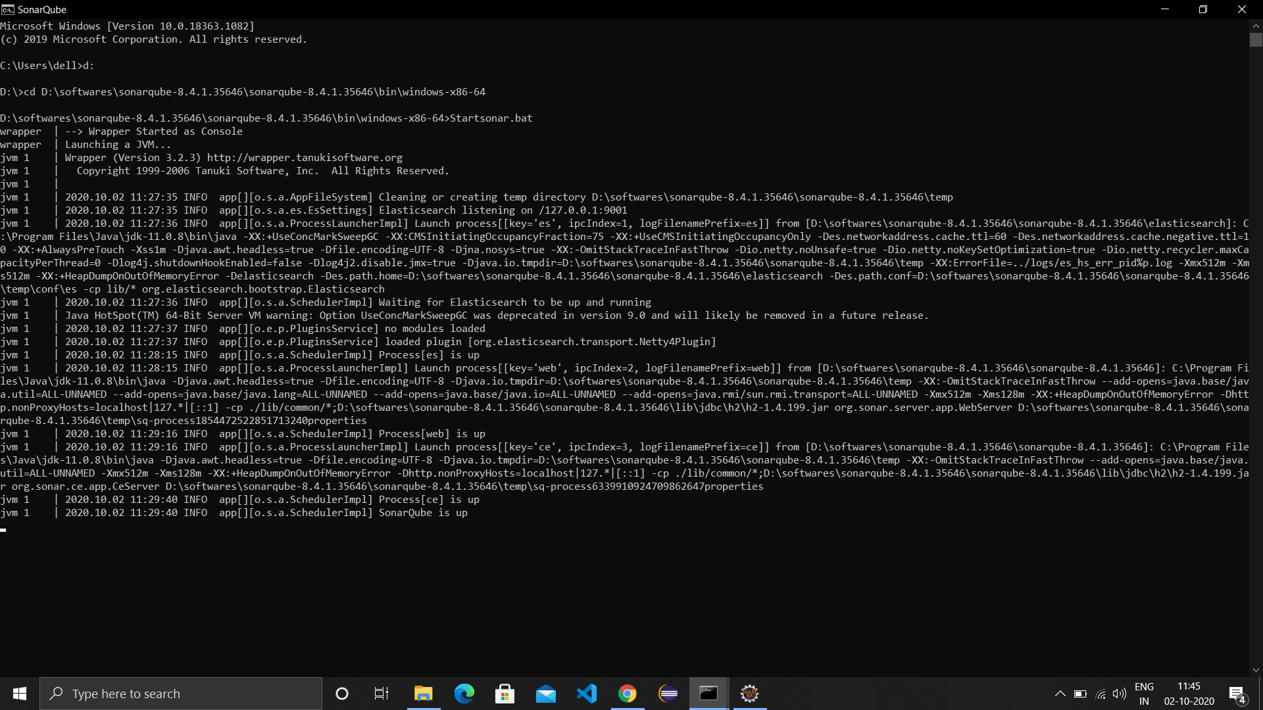

1. Open web browser and visit localhost with port number 9000 and login to sonarqube with default credentials (admin).

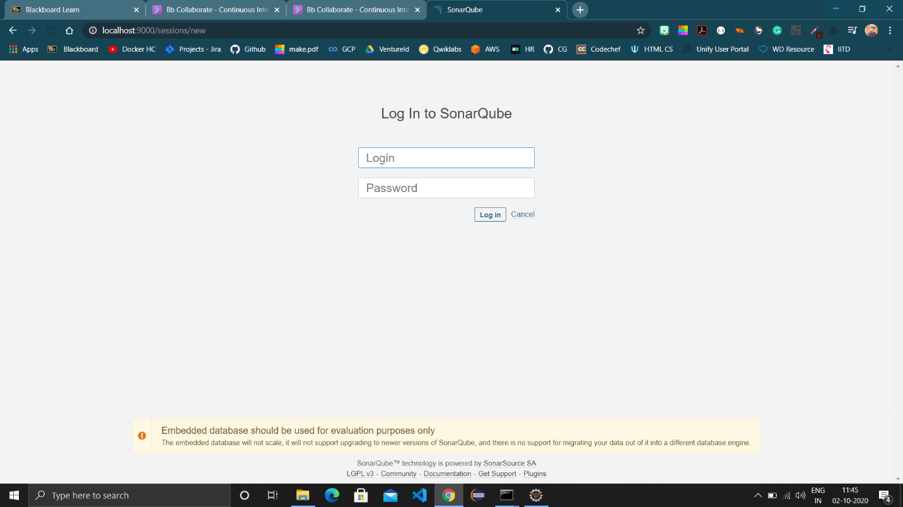

1. Create a maven project in eclipse with a code with some bugs.

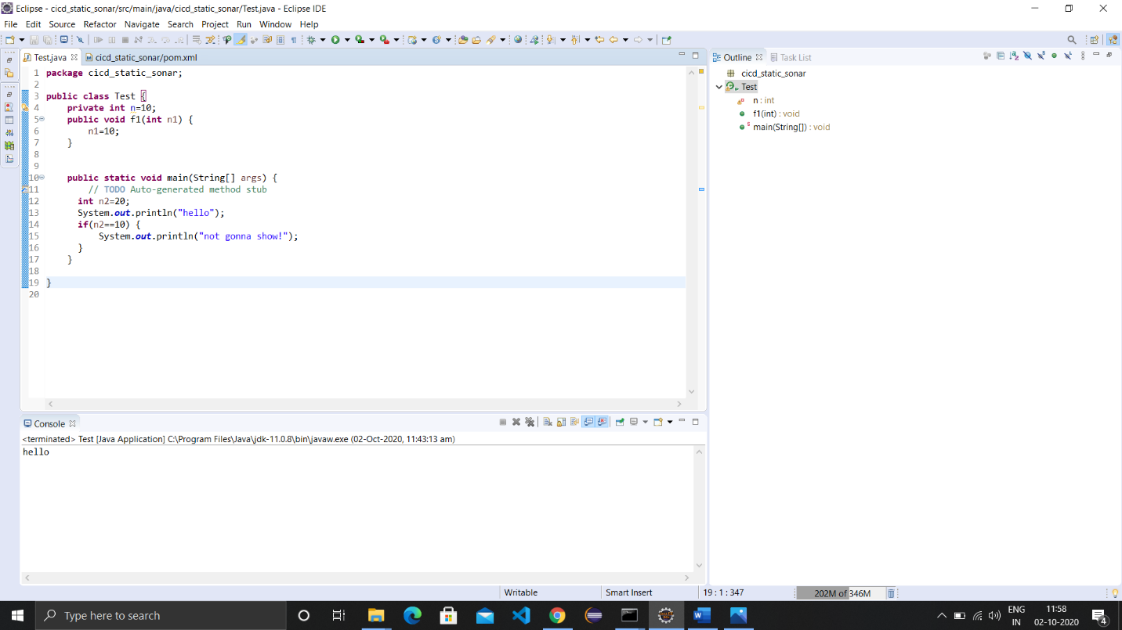

1. Iterate to the project folder in command prompt and run following command

“mvn clean install sonar:sonar -Dsonar.host.url=http://localhost:9000 -Dsonar.analysis.mode=publish”

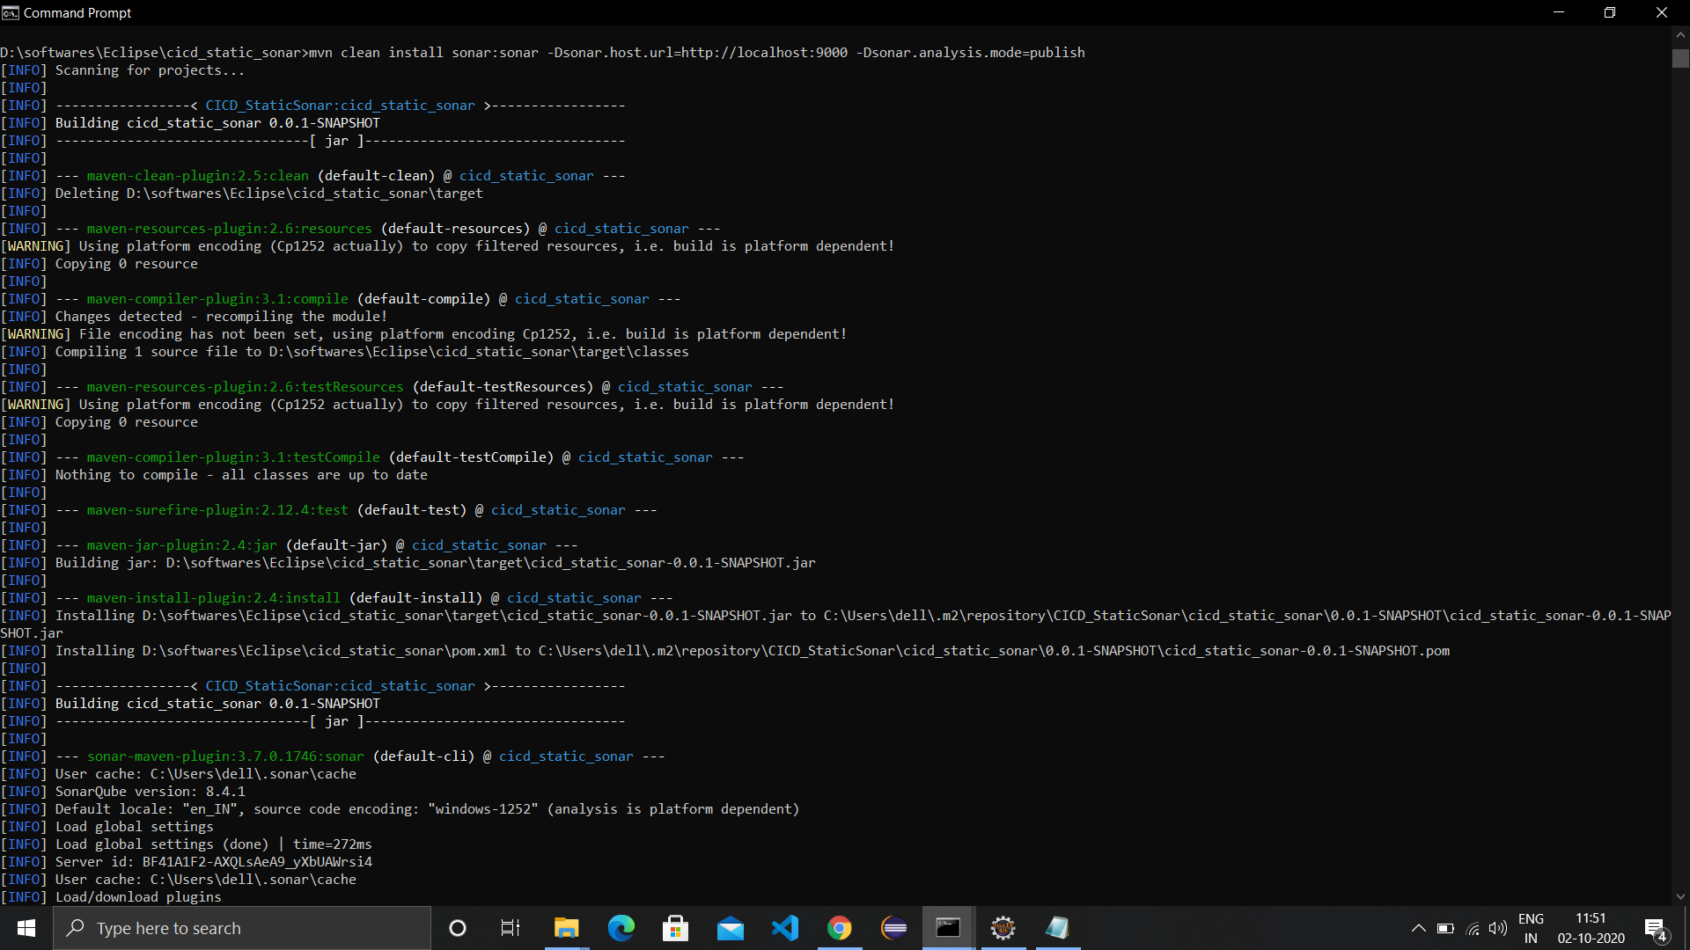

1. Once the build is successful , visit sonarqube dashboard and refresh and find the project.

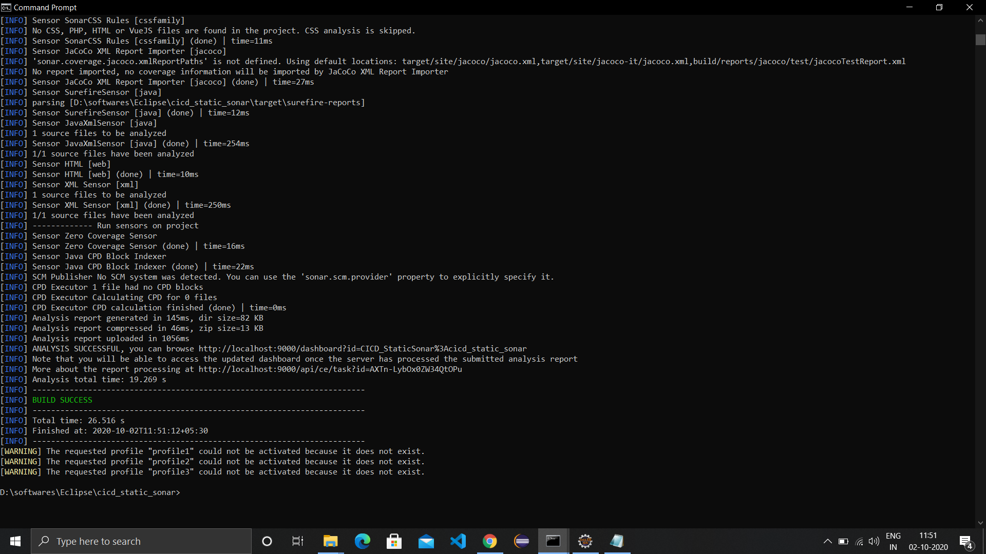

1. Generated report of the project by sonarqube

