Experiment 5 (Jenkins Integration with sonarqube)

1. Open command prompt and run “java -jar Jenkins.war” where Jenkins file is stored.

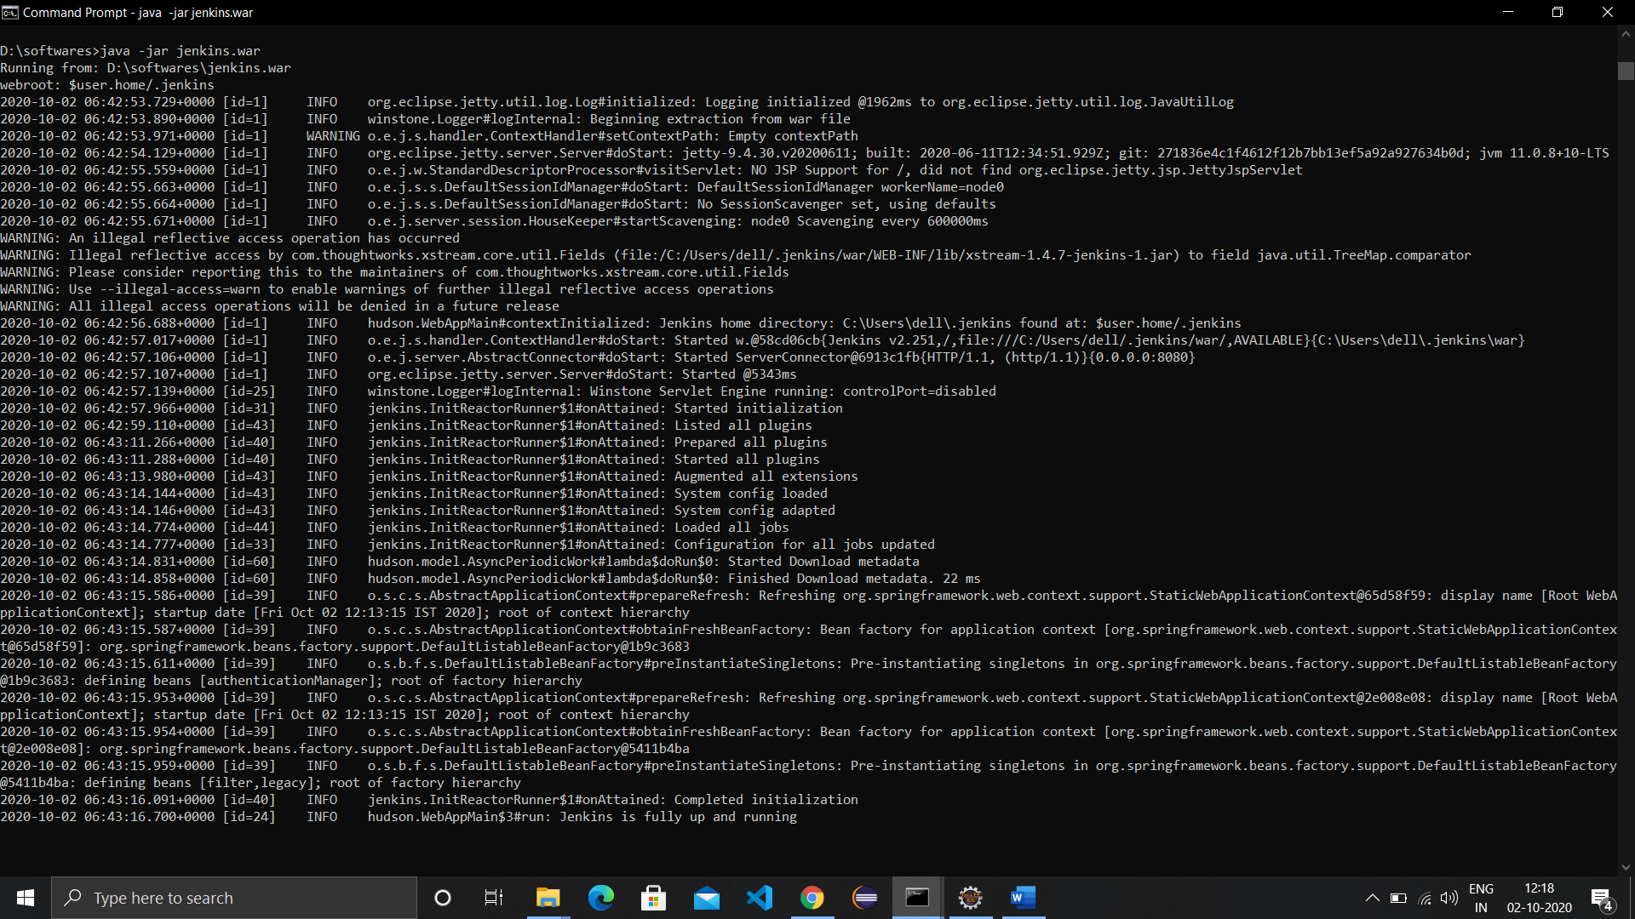

1. Push the maven project on github.
2. Go to localhost with port no 8080 and create a new maven project in Jenkins and provide link to repository in the configure. Also install sonarqube plugins required.
3. On a new command prompt, run sonarqube and open sonarqube dashboard.

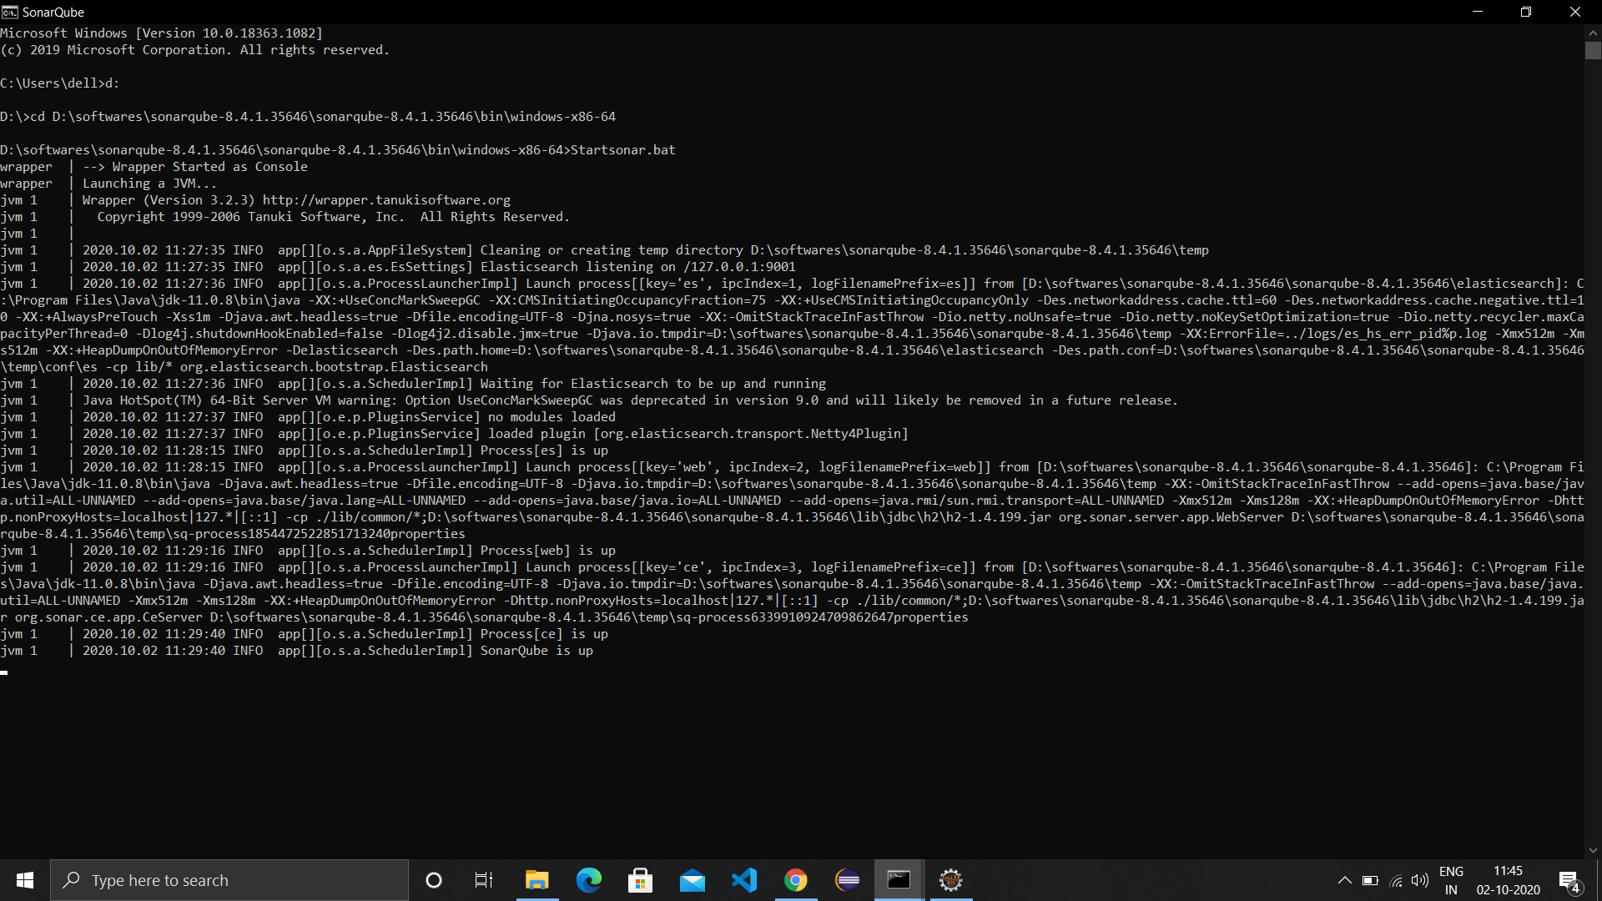

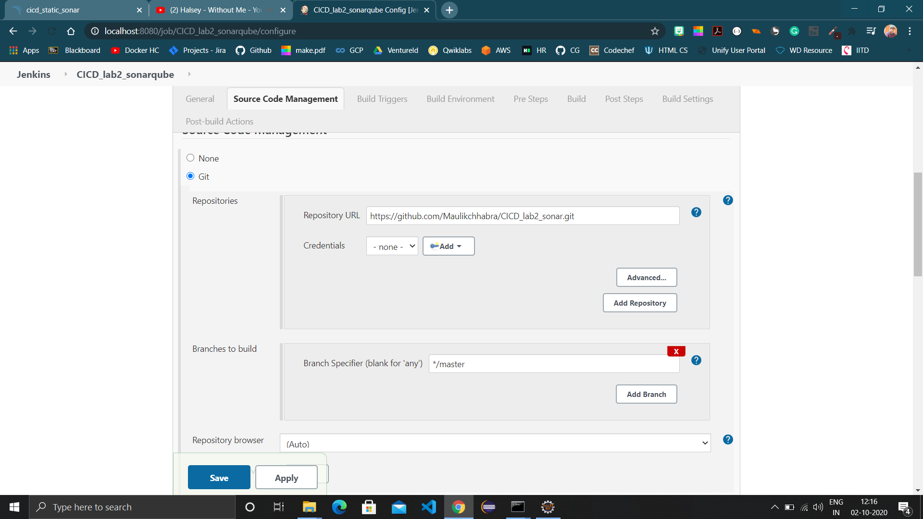

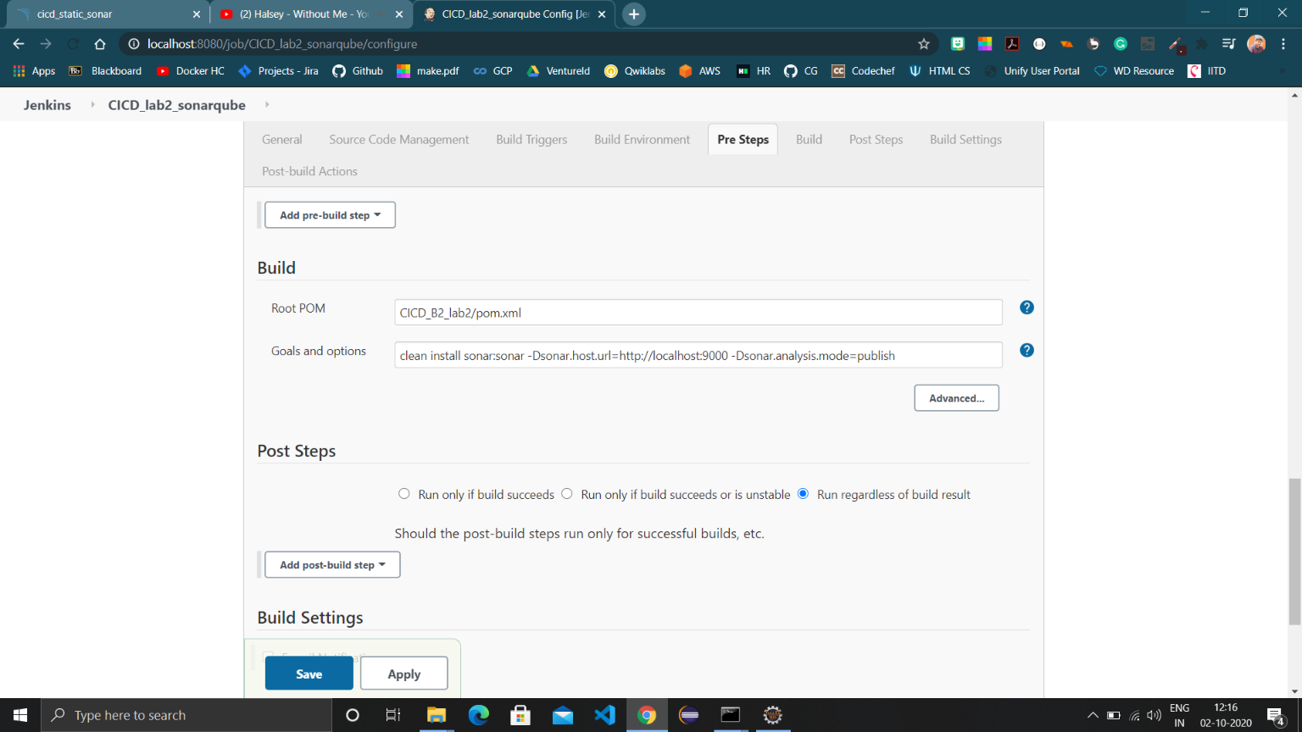

1. Code provided in the repository

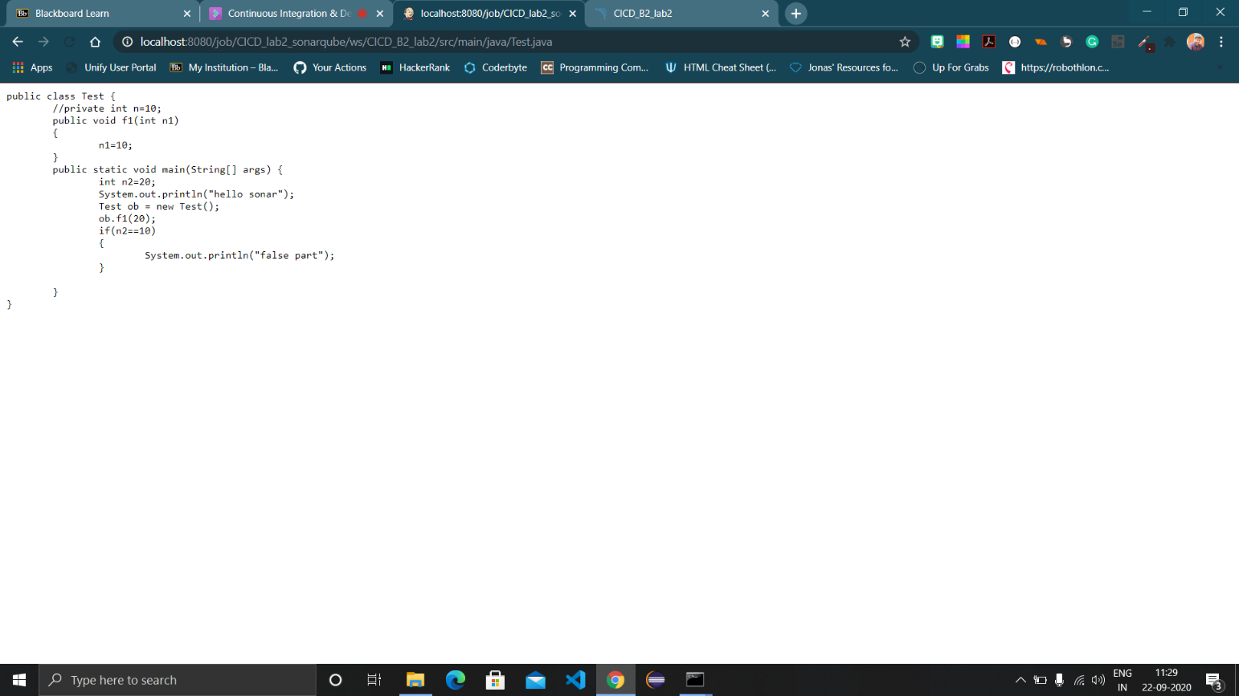

1. Click “build now” and when build happens successfully, refresh sonarqube dashboard and find the project.

