Experiment 6 (Pipeline formation using Jenkins)

1. Create a maven project and deploy it on github.

The code inside the project is given below.

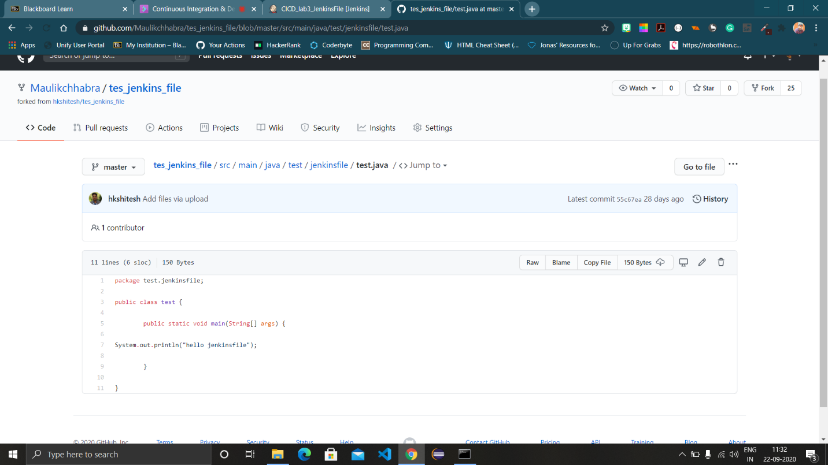

1. Create a ‘Jenkinsfile’ in the project and add following pipeline in the file.

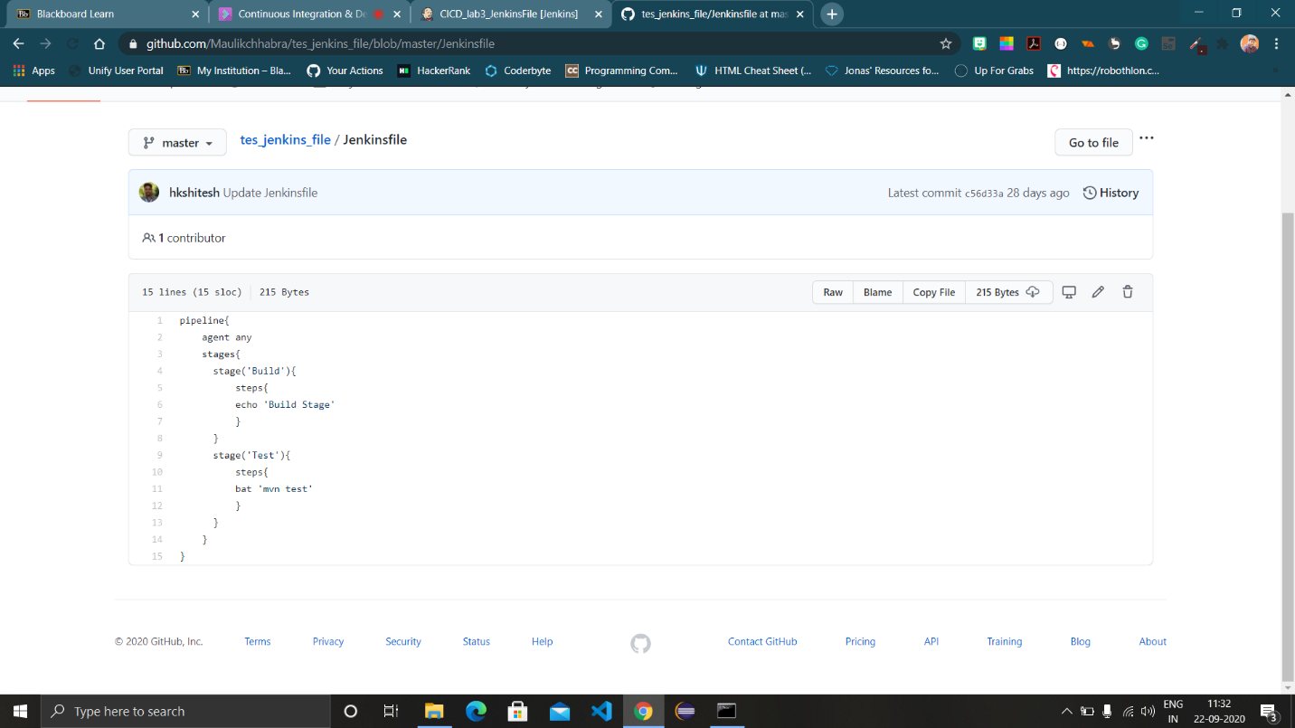

1. Now login to the Jenkins dashboard and click on ‘New item’ and select ‘Pipeline’ and name it.
2. Configure the pipeline with the repository link by clicking ‘pipeline script from SCM’ and providing link and the type of script file used.

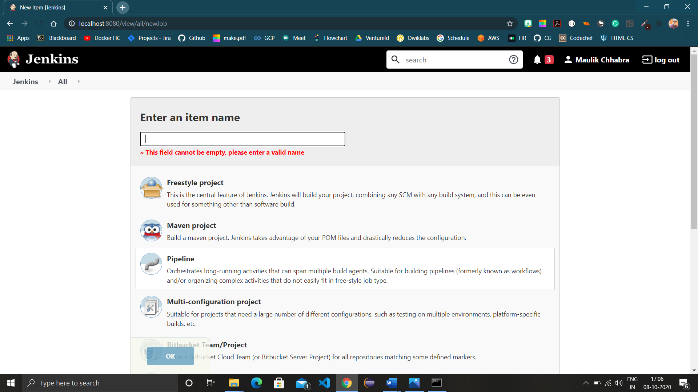

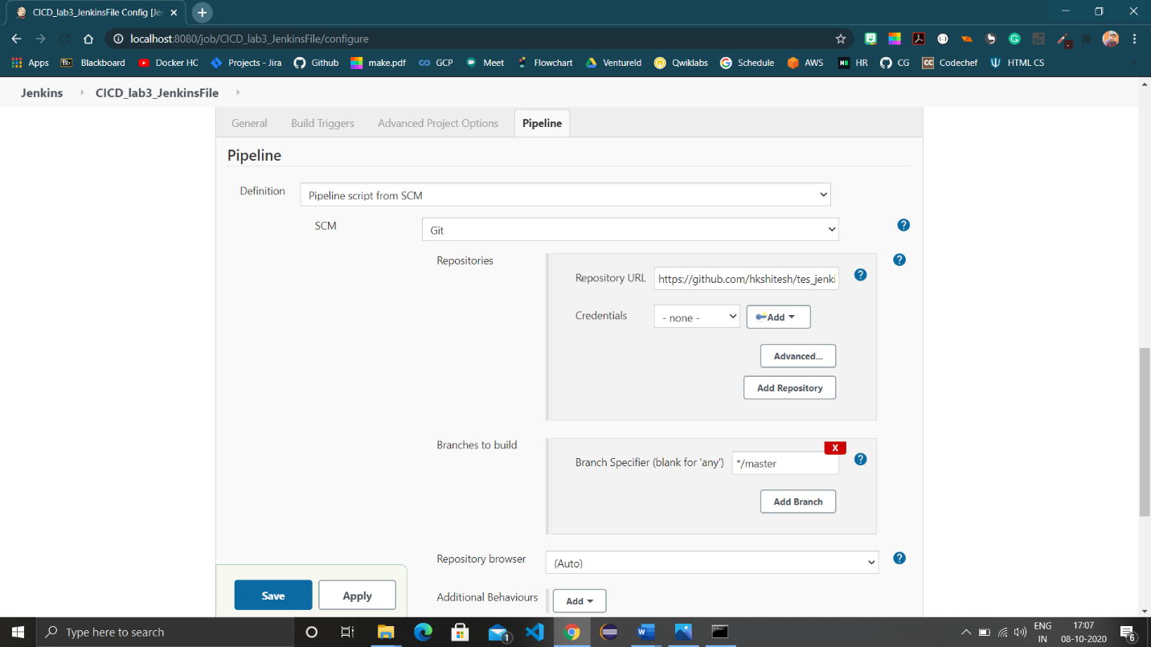

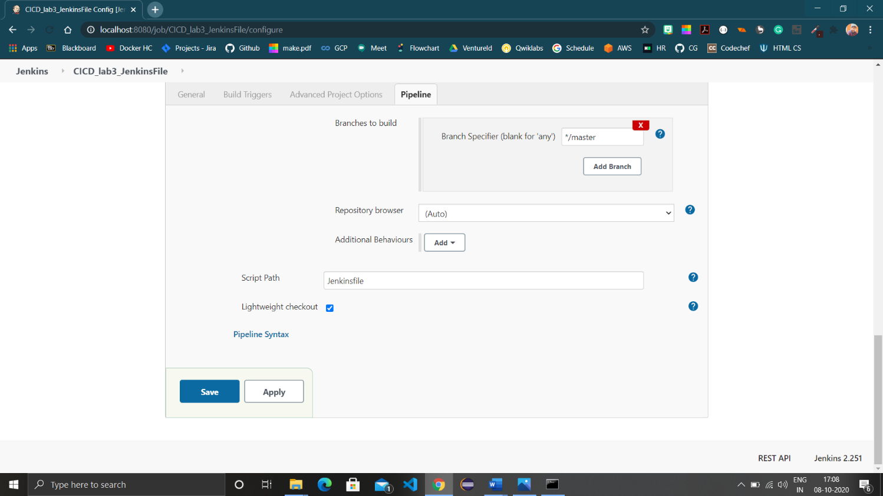

1. After saving the configuration, click ‘Build now’ and the pipeline would be created for the project.

