Experiment 7 (Blue Ocean GUI in Jenkins)

Blue Ocean is used to enhance the GUI effect of pipeline creation.

1. First install the plugin of blue ocean required to run blue ocean on Jenkins by visiting Manage plugins tab. After installing move back to dashboard and click on ‘Open Blue Ocean’.

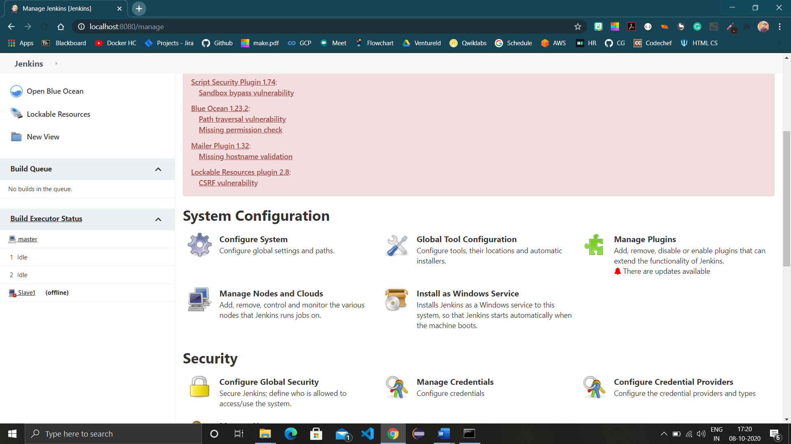

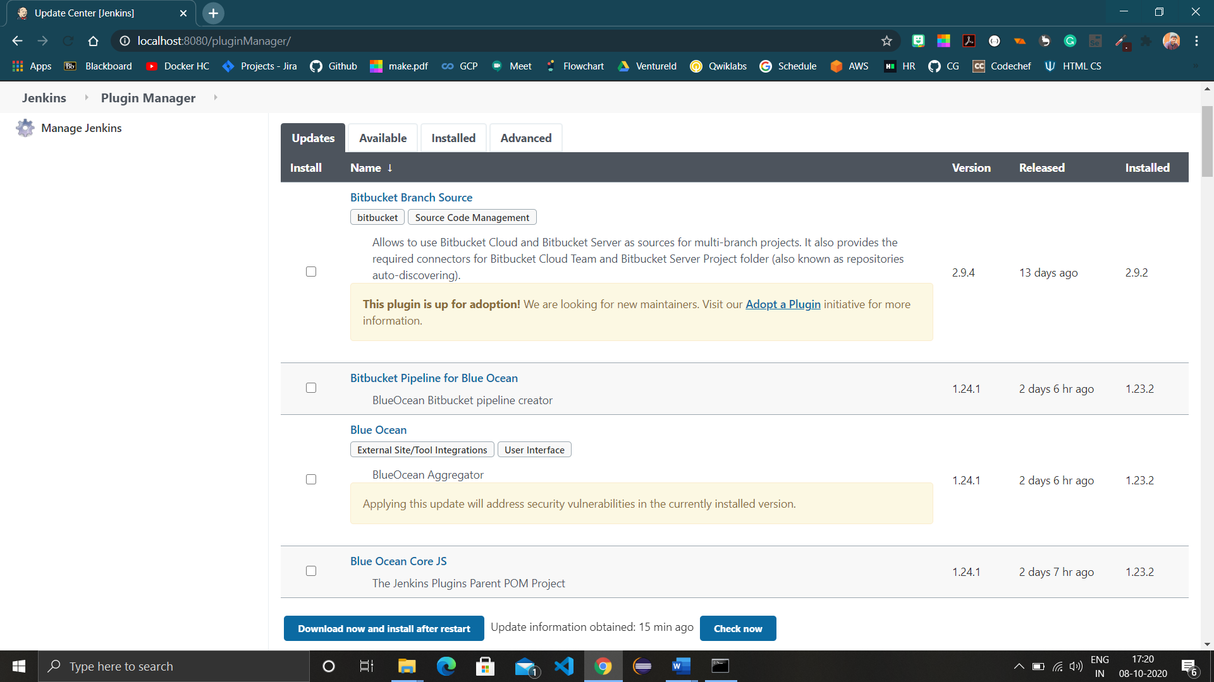

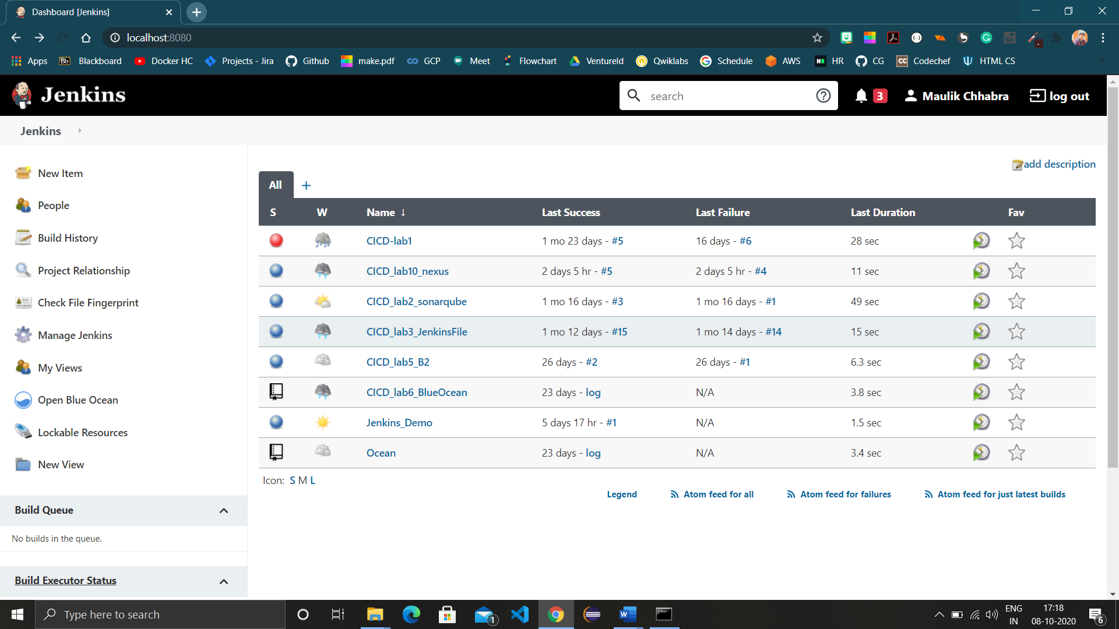

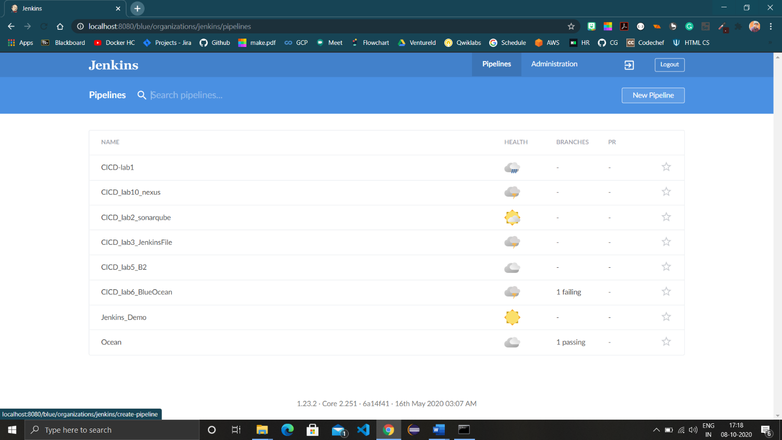

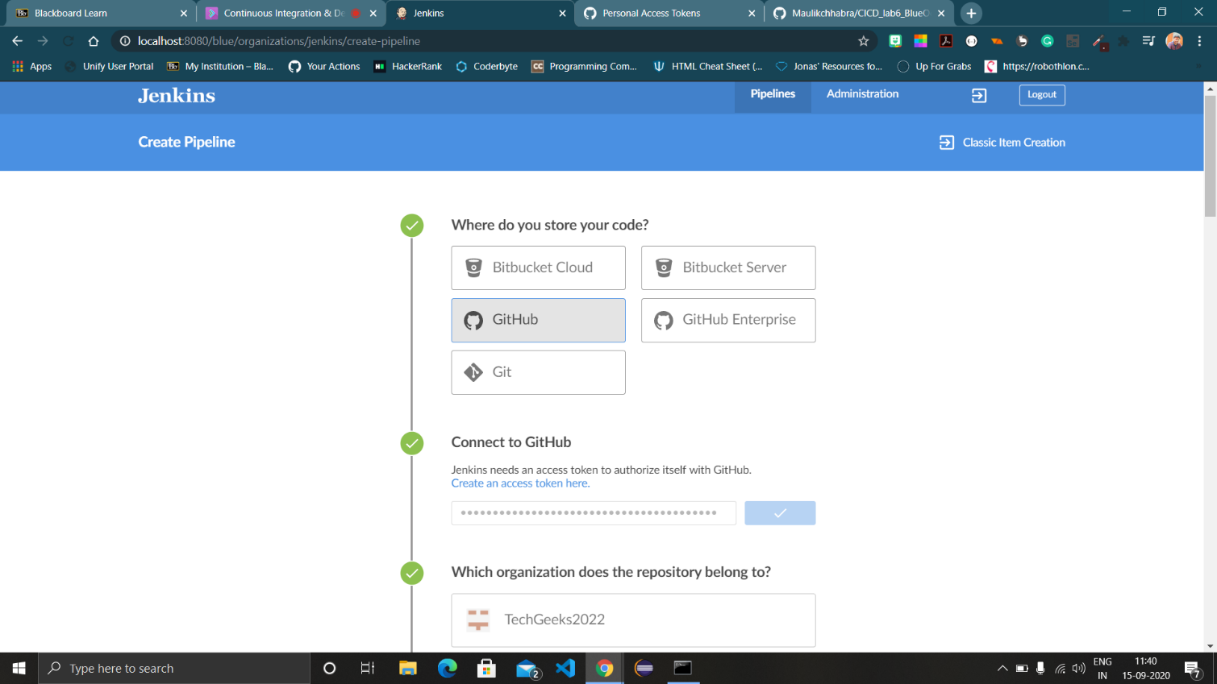

1. Open Blue Ocean and choose SCM tool, select your account and the repository for which you want to create pipeline. The repository should contain a Jenkinsfile for pipeline creation.

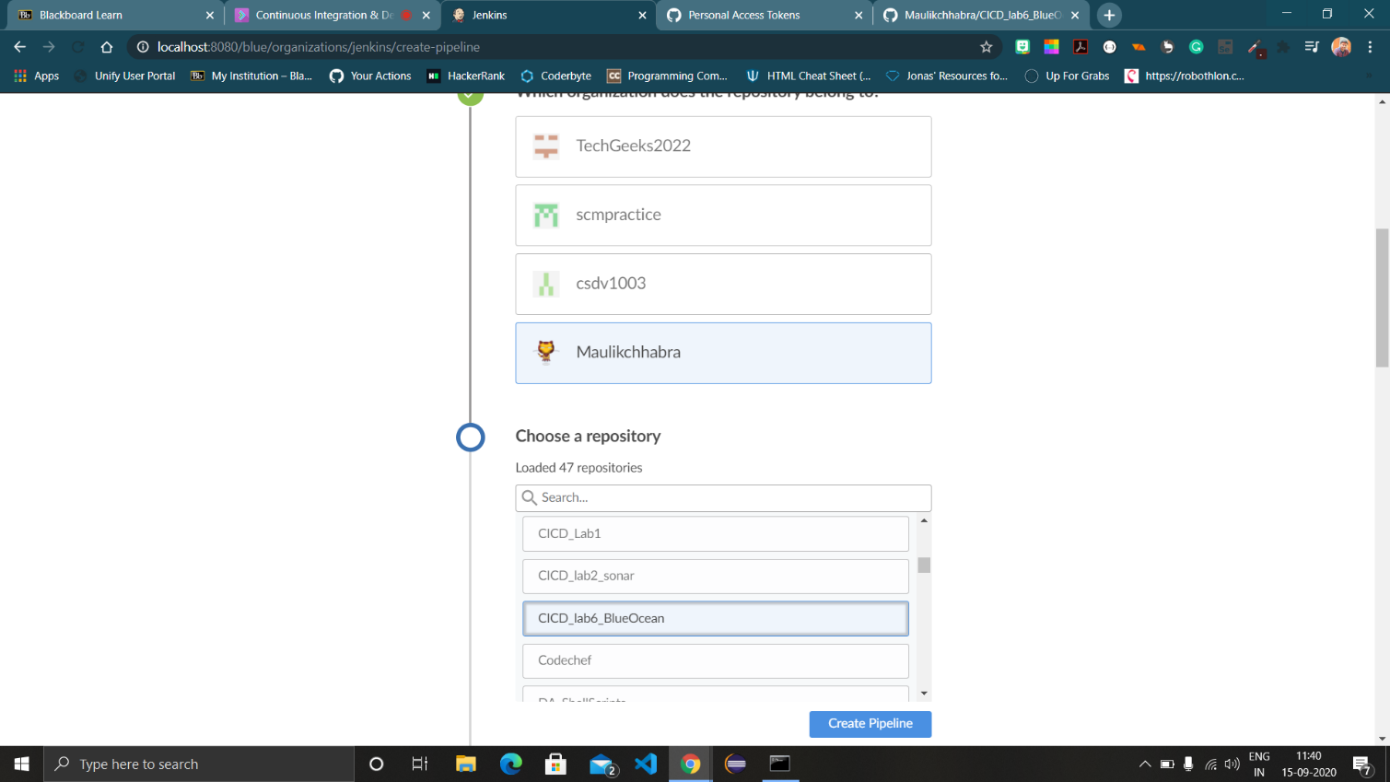

1. Click on create pipeline and wait for the pipeline construction to complete.

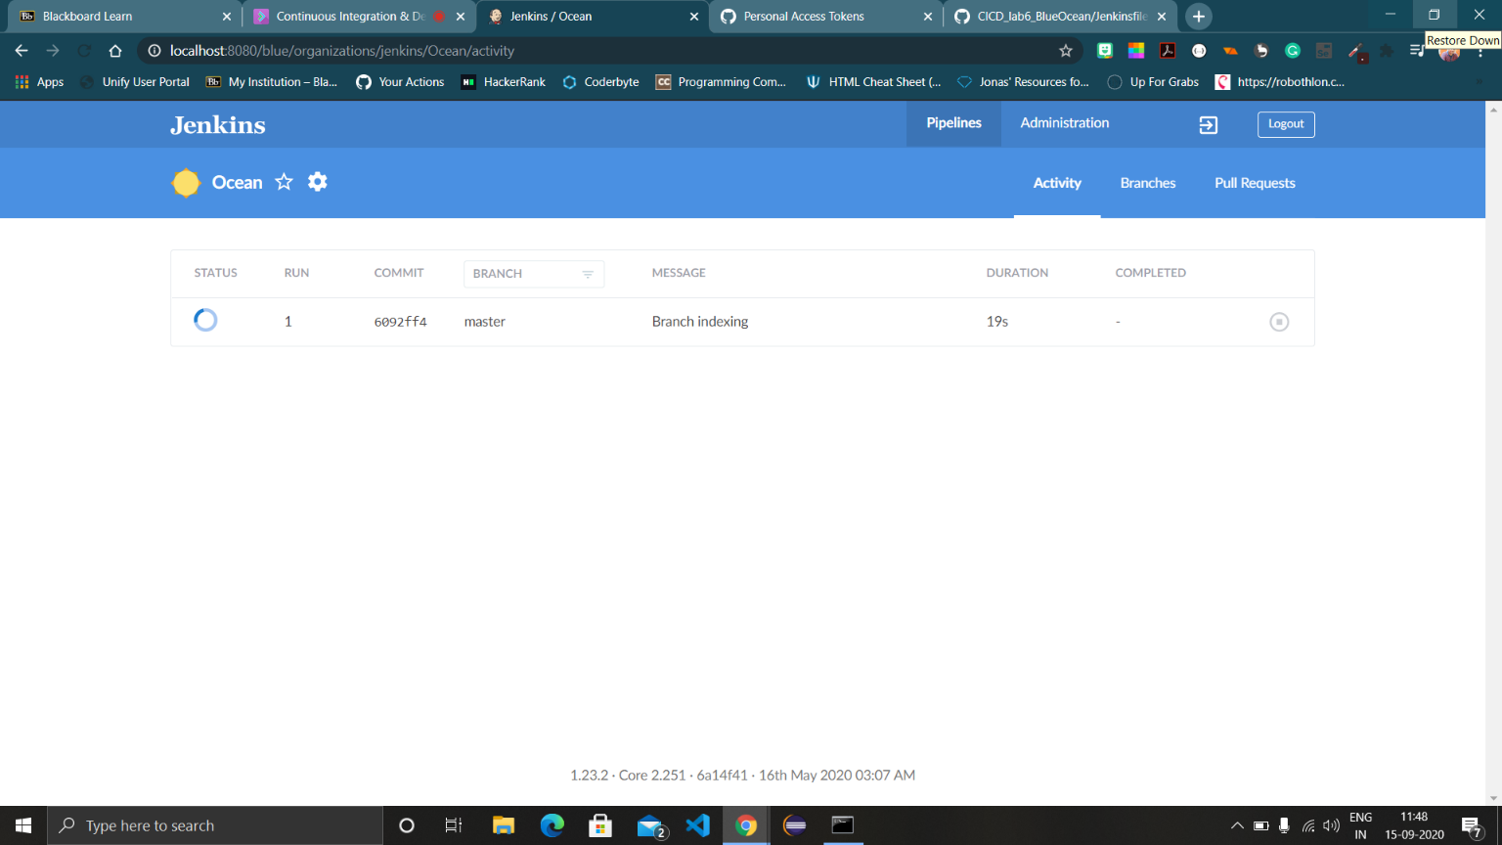

1. After successful pipeline creation, the pipeline will look like this.

