Experiment 8 (Jenkins Master Slave Architecture)

1. Login to Jenkins dashboard and click on ‘Manage Jenkins’ and choose ‘Global Tool Configuration’ and choose ‘random’ in Agents.

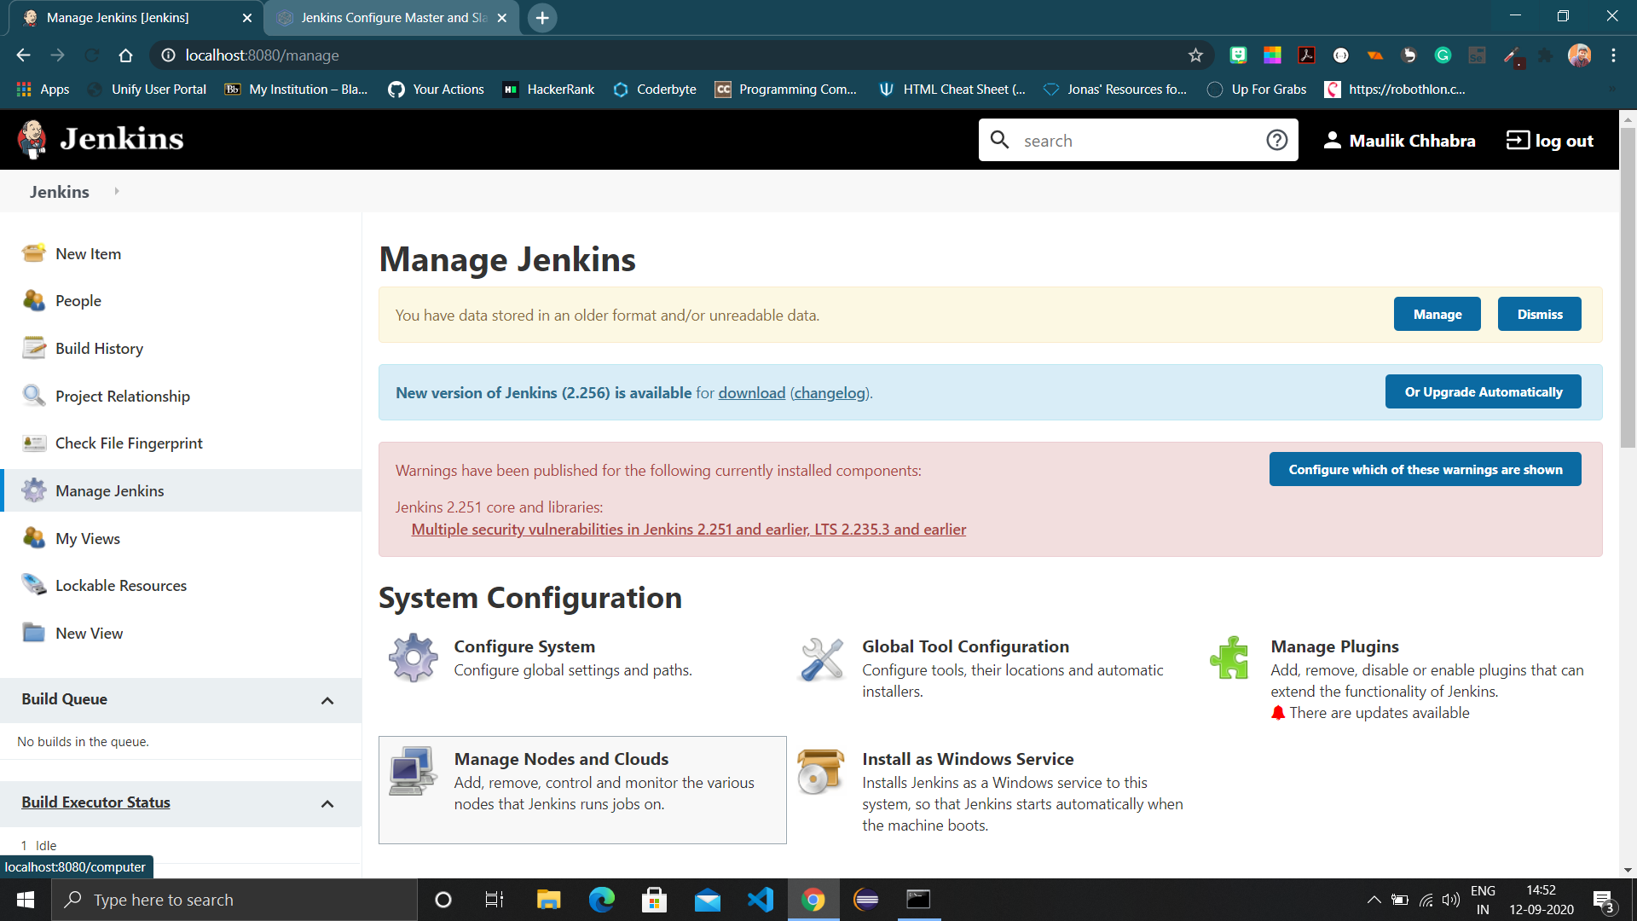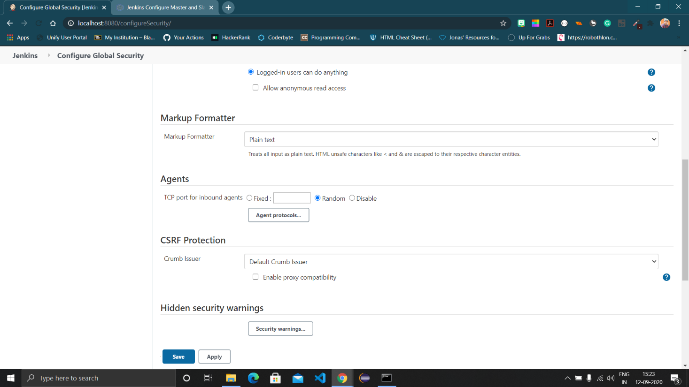

1. Now head back to Manage Jenkins and choose ‘Manage Nodes and Cloud’, you will see a master there. On the left pane click on ‘New Node’.

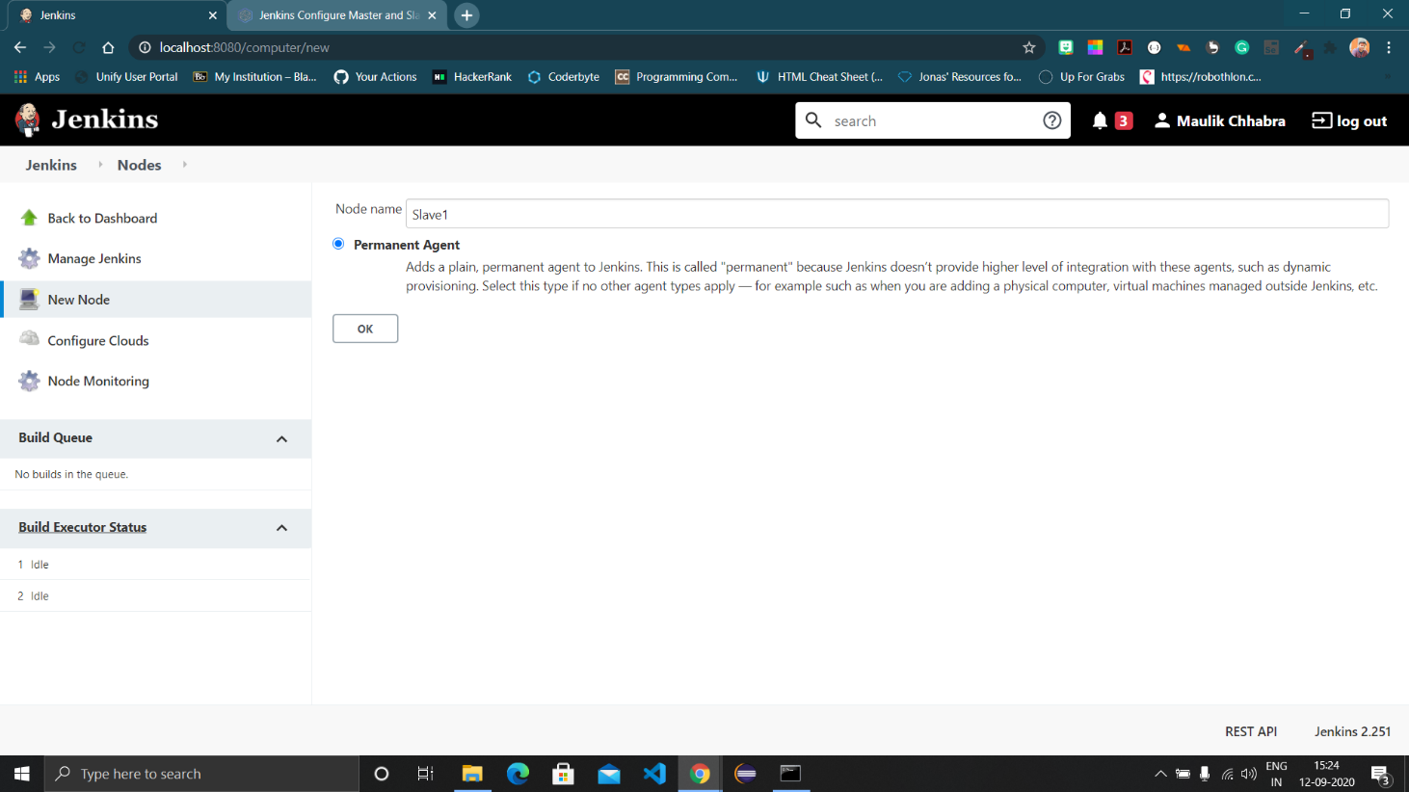

1. Enter the name and the configuration settings, also the path where you want files of slave to reside.

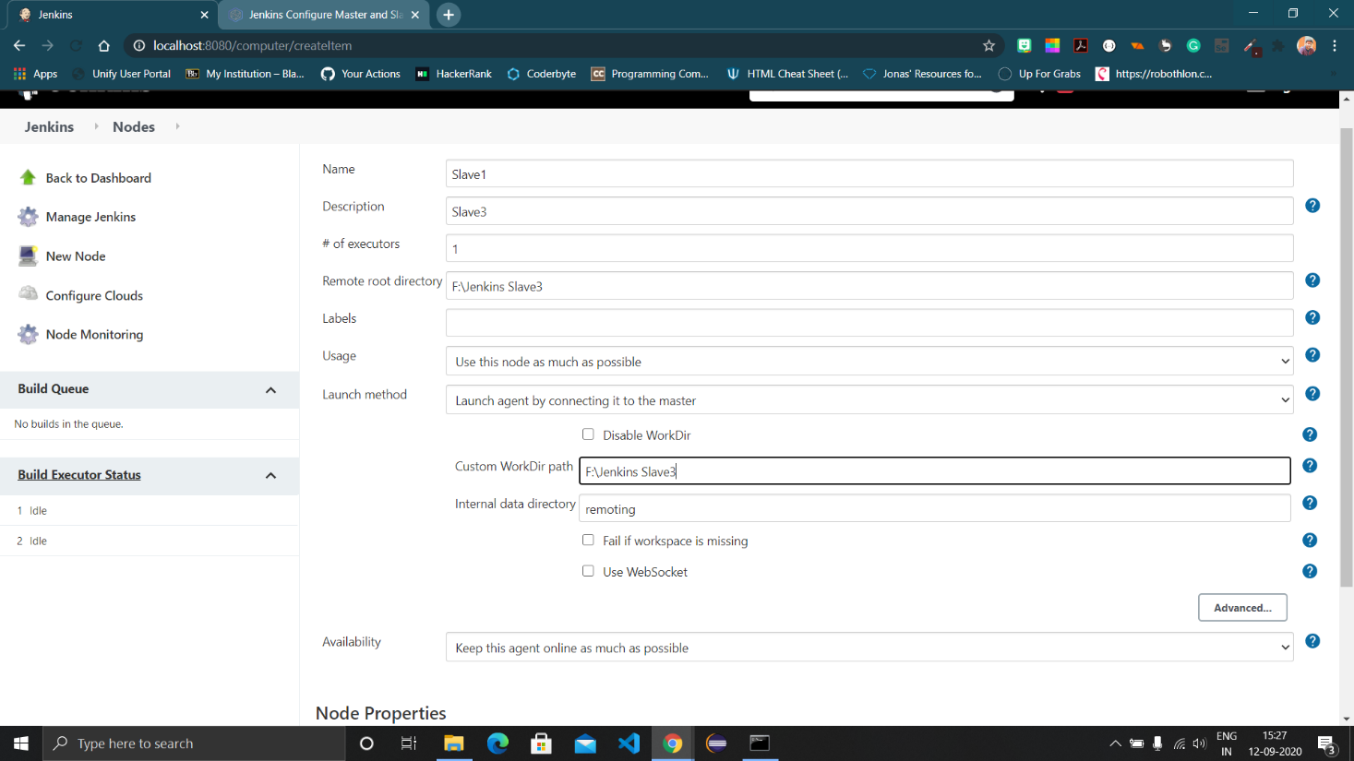

1. Now this screen will appear, click on the agent.jar and it will download and put it in desired location.

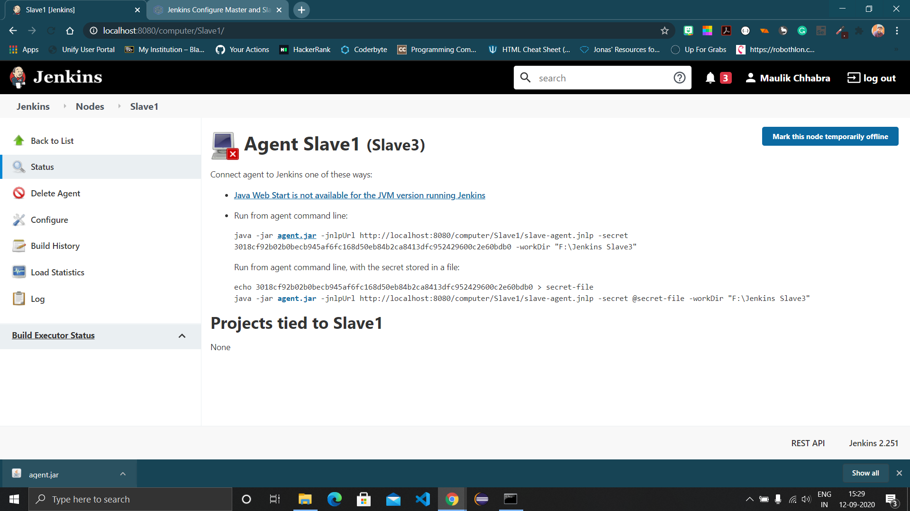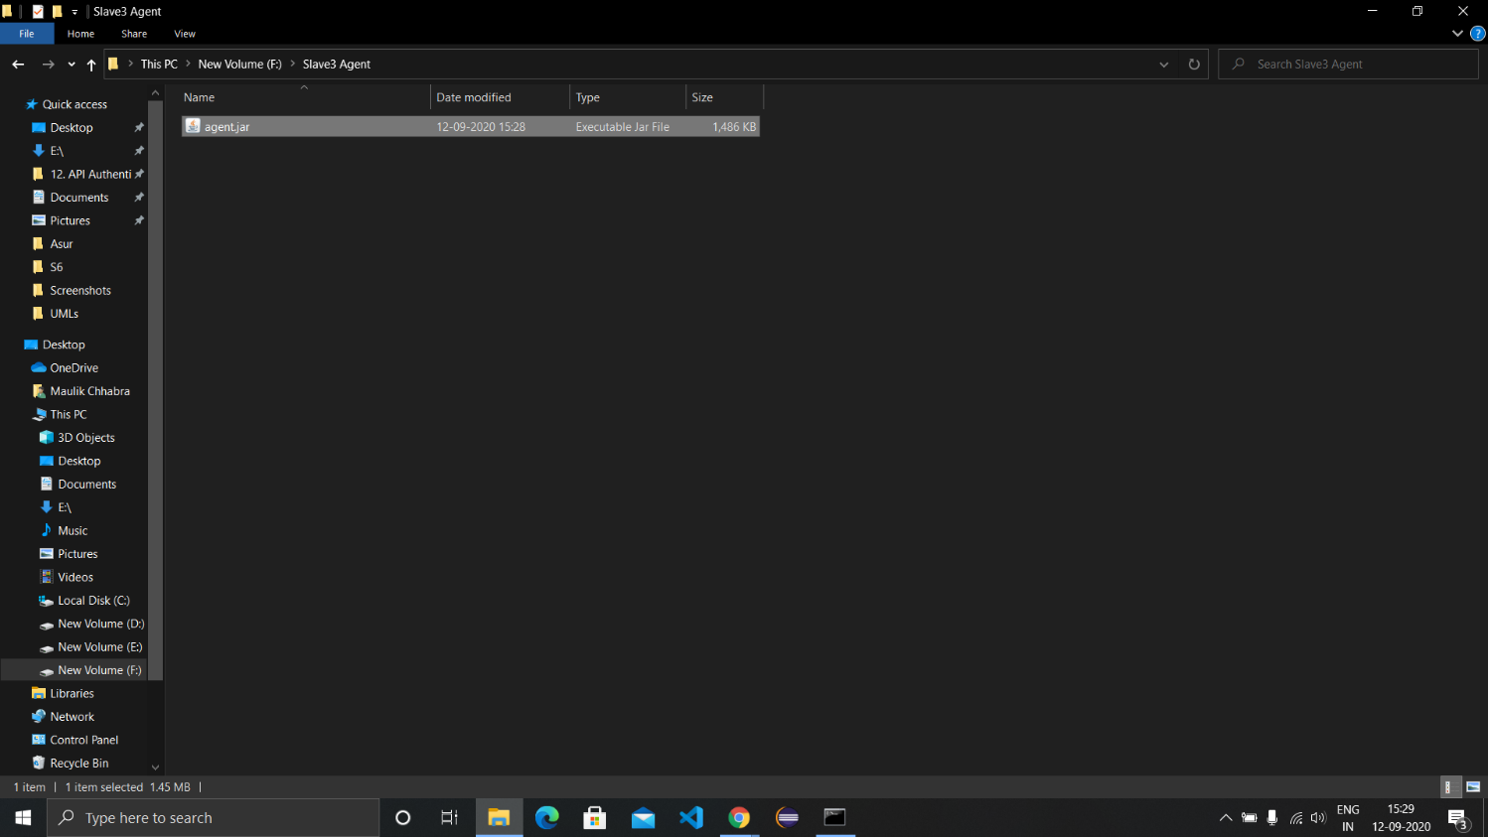

1. Open cmd and run the command

‘java -jar F:\Slave3 Agent\agent.jar -jnlpUrl http://localhost:8080/computer/Slave1/slave-agent.jnlp -secret 3018cf92b02b0becb945af6fc168d50eb84b2ca8413dfc952429600c2e60bdb0 -workDir "F:\Jenkins Slave3"’

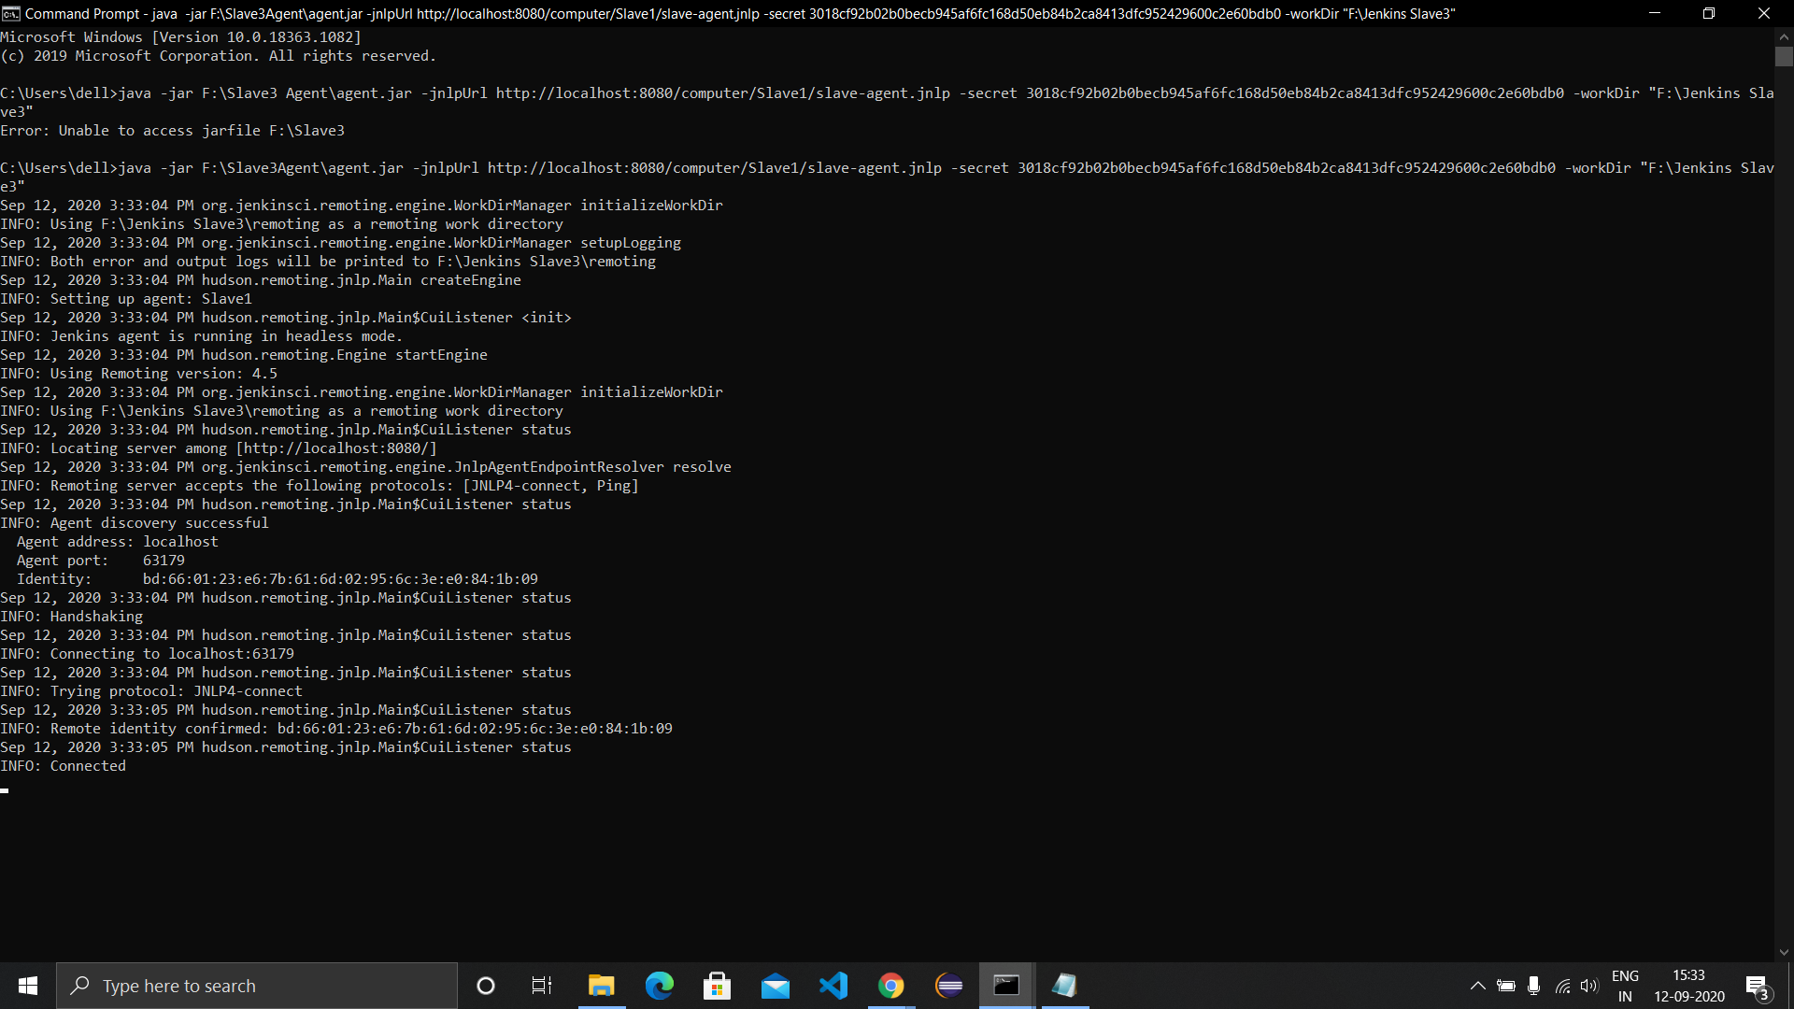

1. The slave would be online after successful execution. Now create a maven project in Jenkins and provide it with a url of github having the project and destination of Pom.xml along with the goal to run.

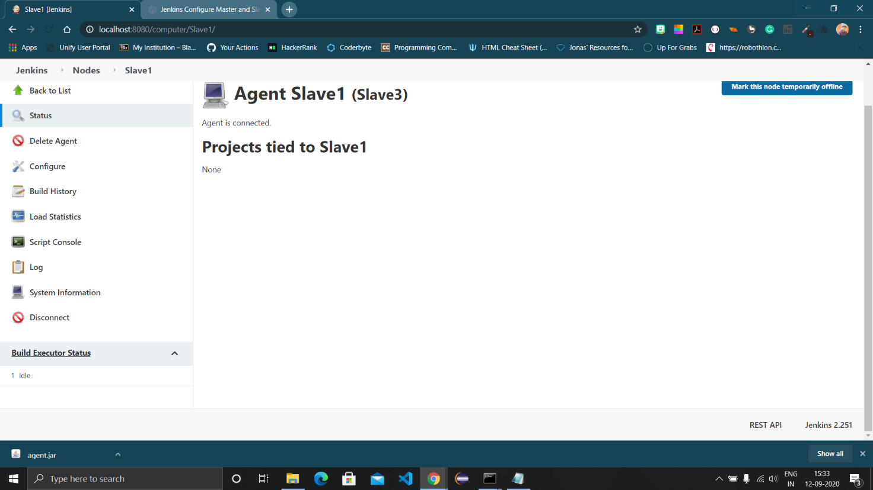

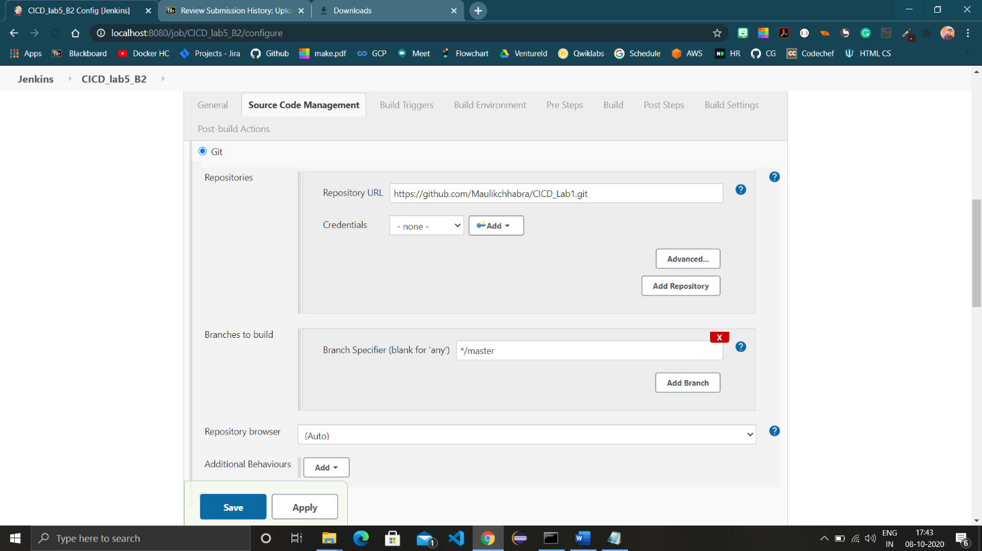

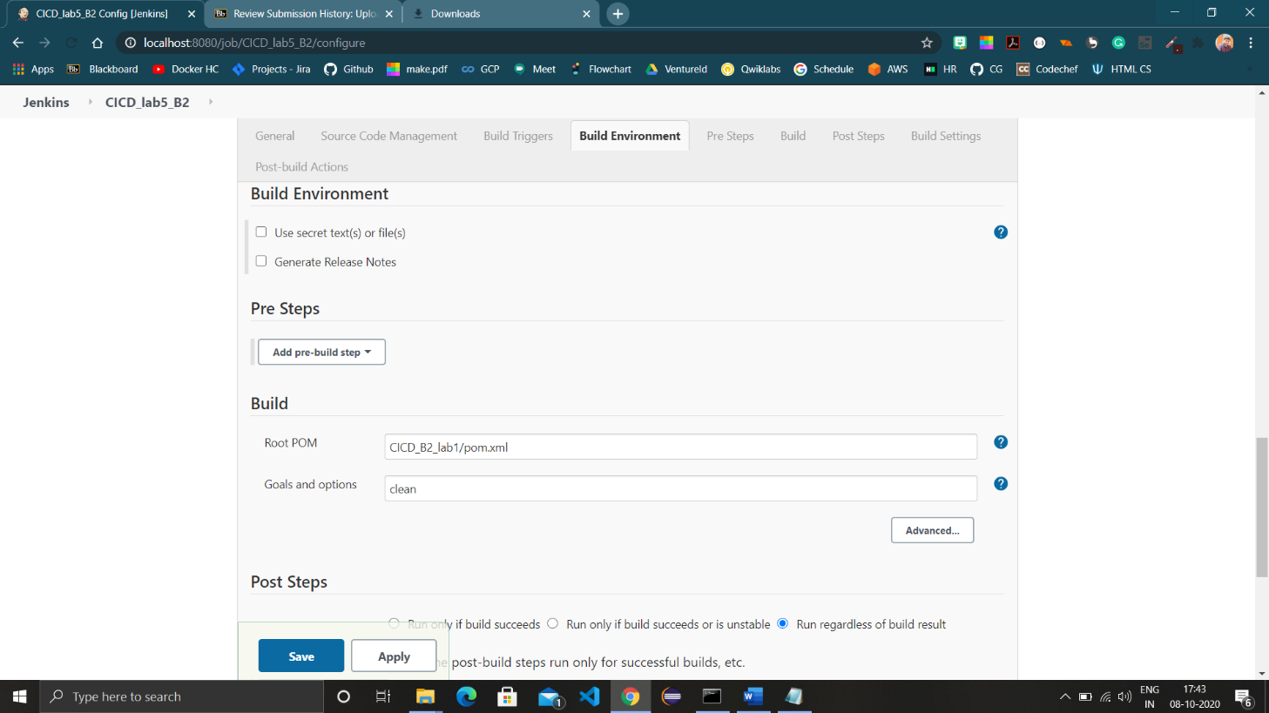

1. Build the project using slave and its workspace would be downloaded to the slave workspace in your computer.

