Exp 9 (Nexus Repository Manager)

1. Create a repository on nexus.

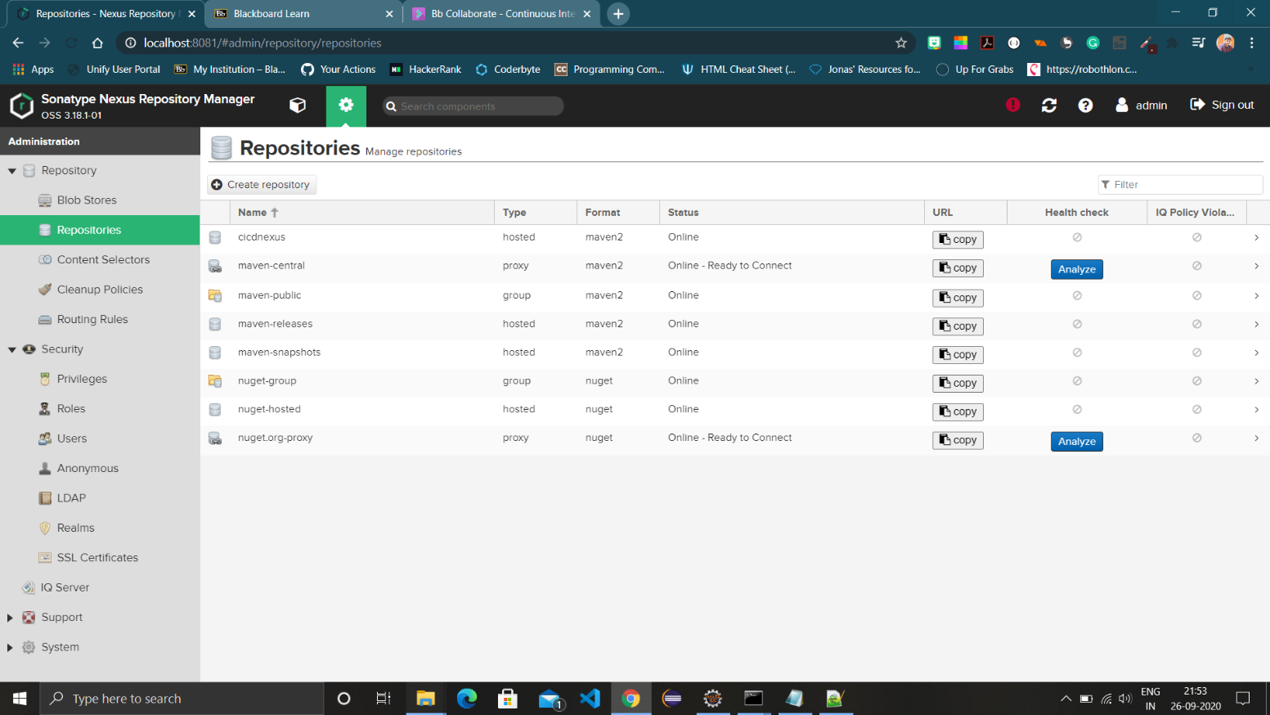

1. Add server tag in settings.xml in current maven folder and use nexus credentials.

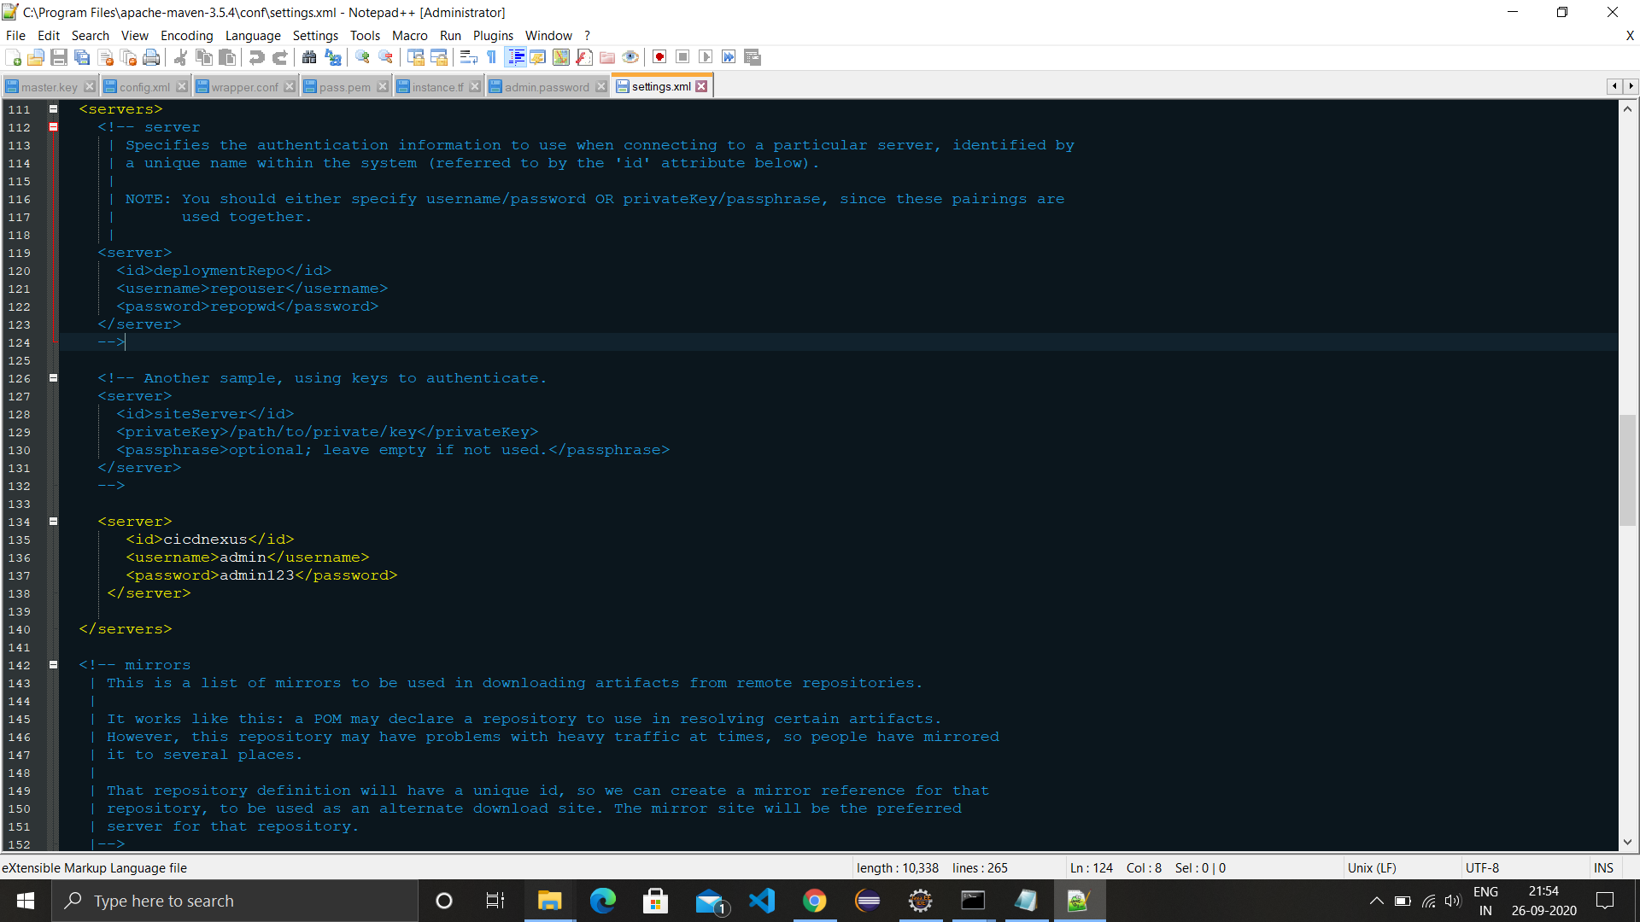

1. Add distributionManagement tag in pom.xml of a maven project and provide link of nexus repo.

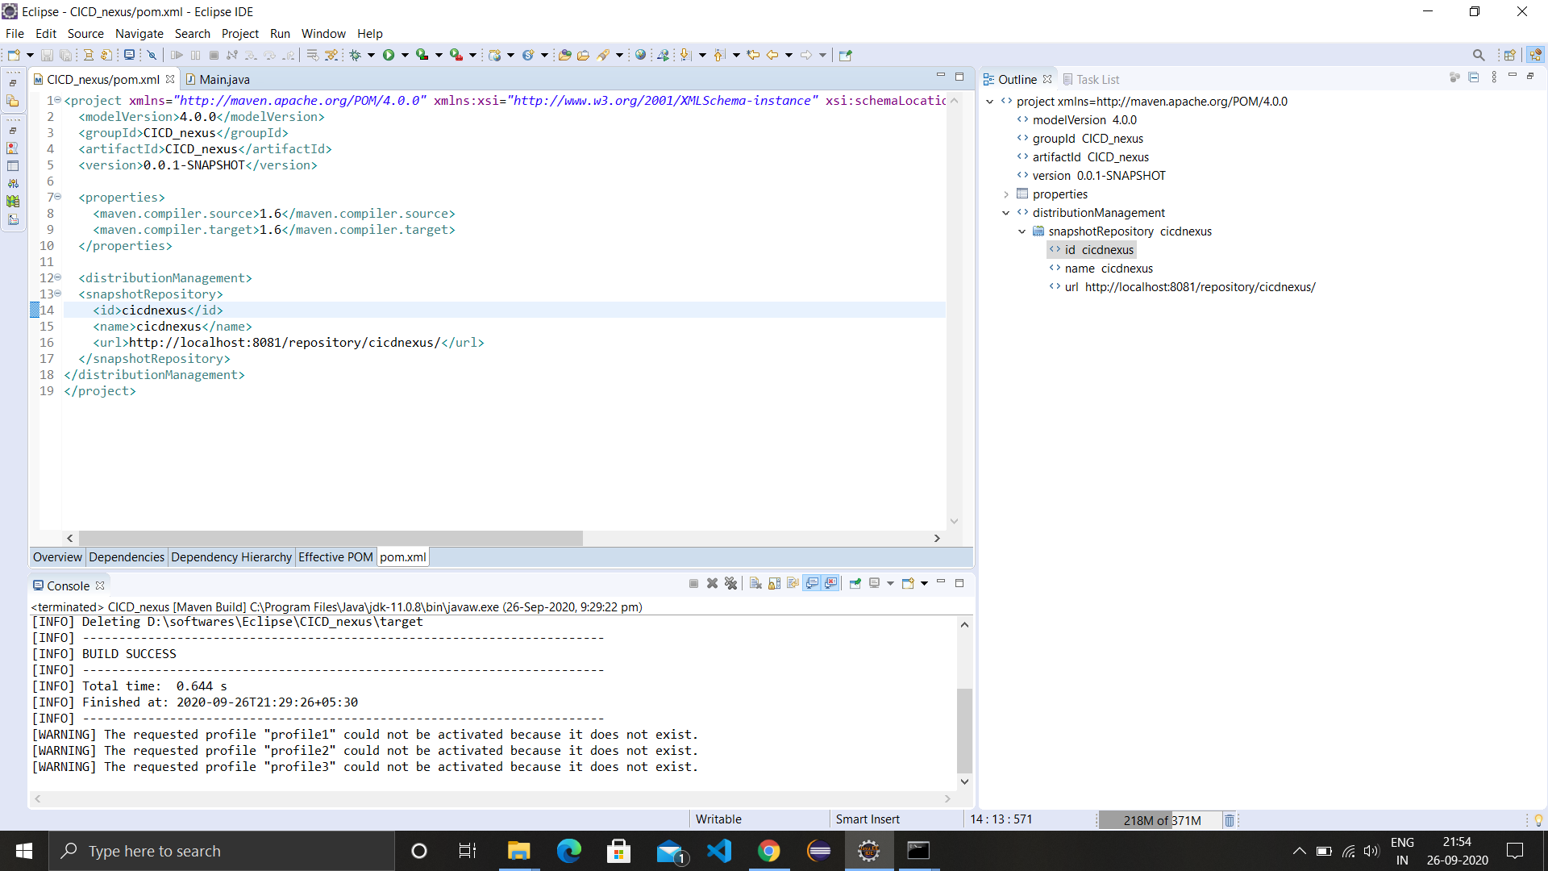

1. Run mvn deploy on cmd in the maven project folder.

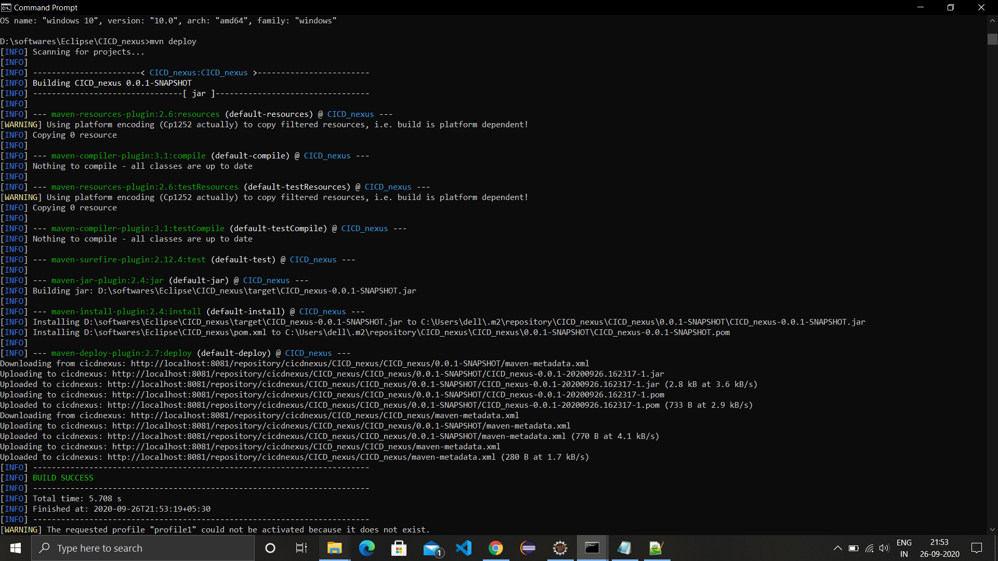

1. Go to browse and select repository and you will get the build of the maven repository.

