**EXP 1: Installation of Jenkins and Execution of Simple Job in Jenkins**

**Step 1: Go to the folder Where U Have Installed Jenkins**

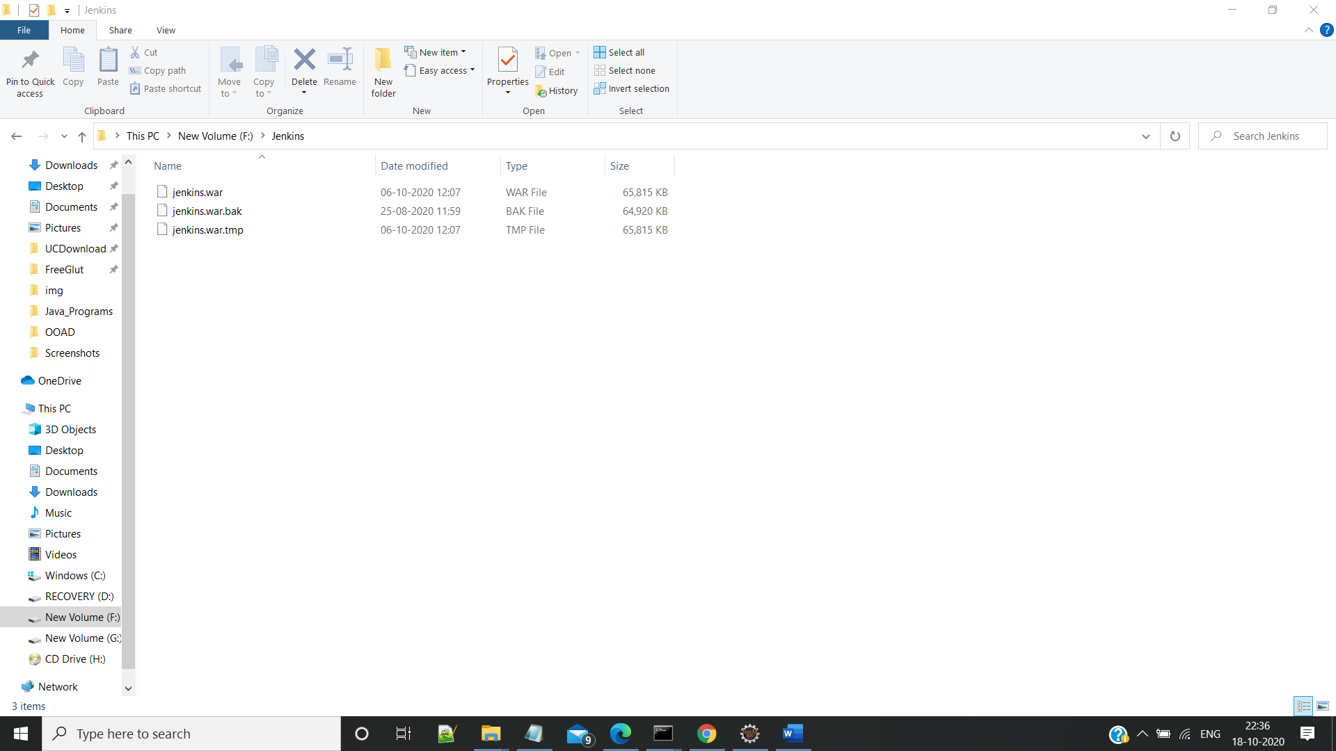

**Step 2:Run java -jar jenkins.war from cmd**

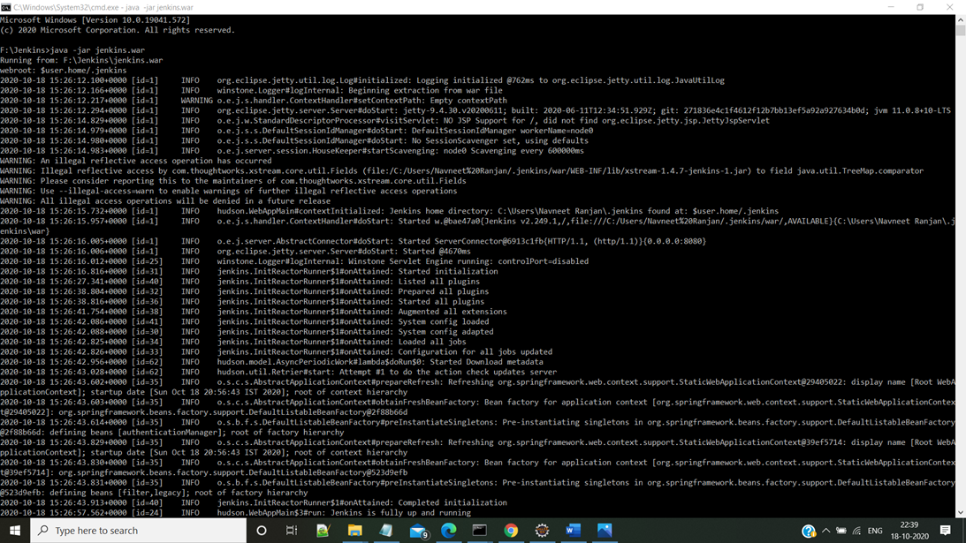

**Step 3: Go to the Url** [**http://localhost:8080**](http://localhost:8080) **Which is the default port for Jenkins You will be redirected to Jenkins**

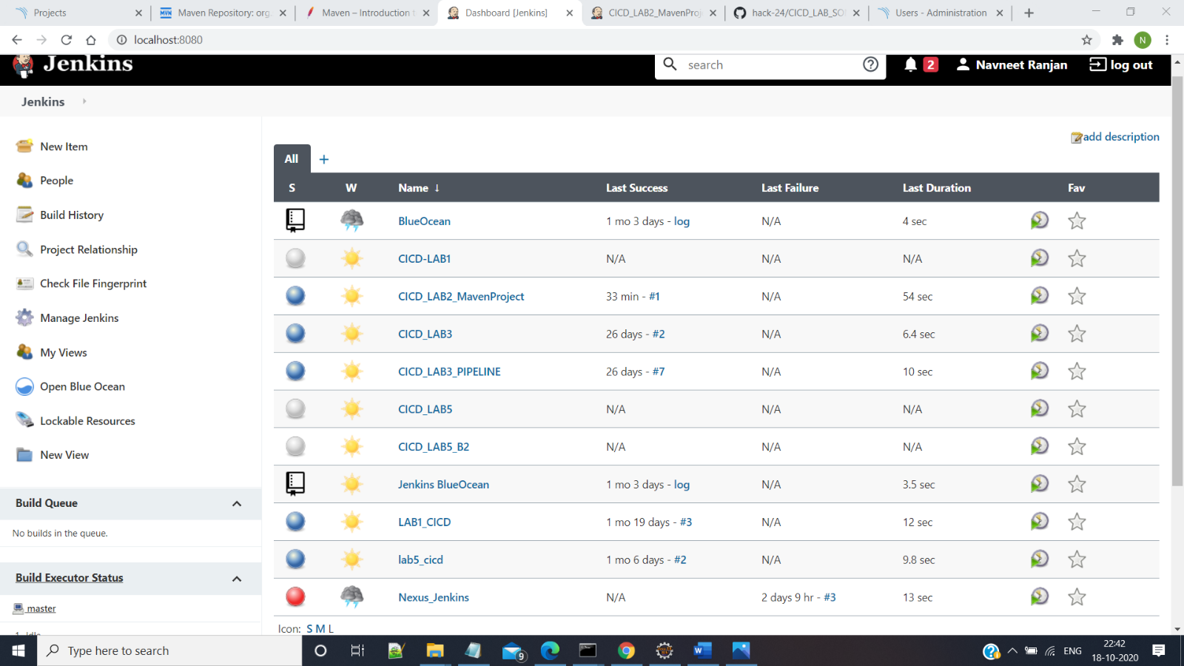

**Step 4: Go To new Item >Maven Project and do the Required Settings**

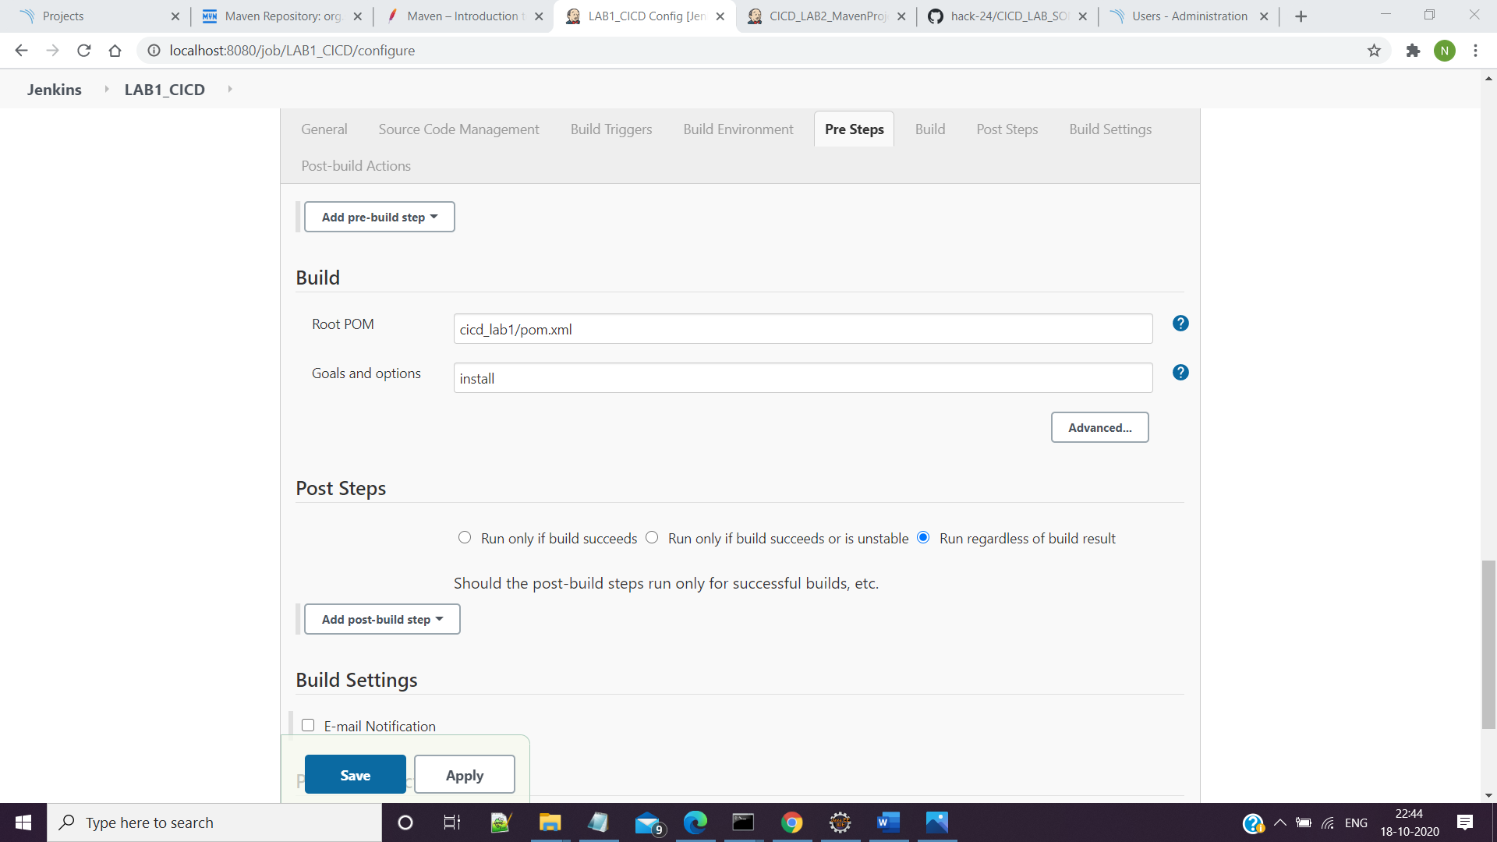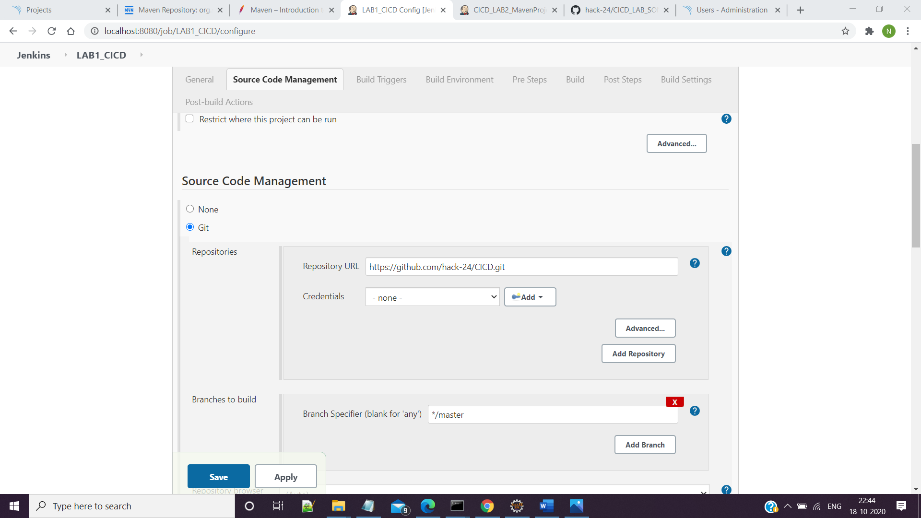

**Step 5 – Save and Build the Project and View The Console Output**

