**Experiment 10:Nexus Integration With Jenkins**

**Step 1:Create a Maven Project**

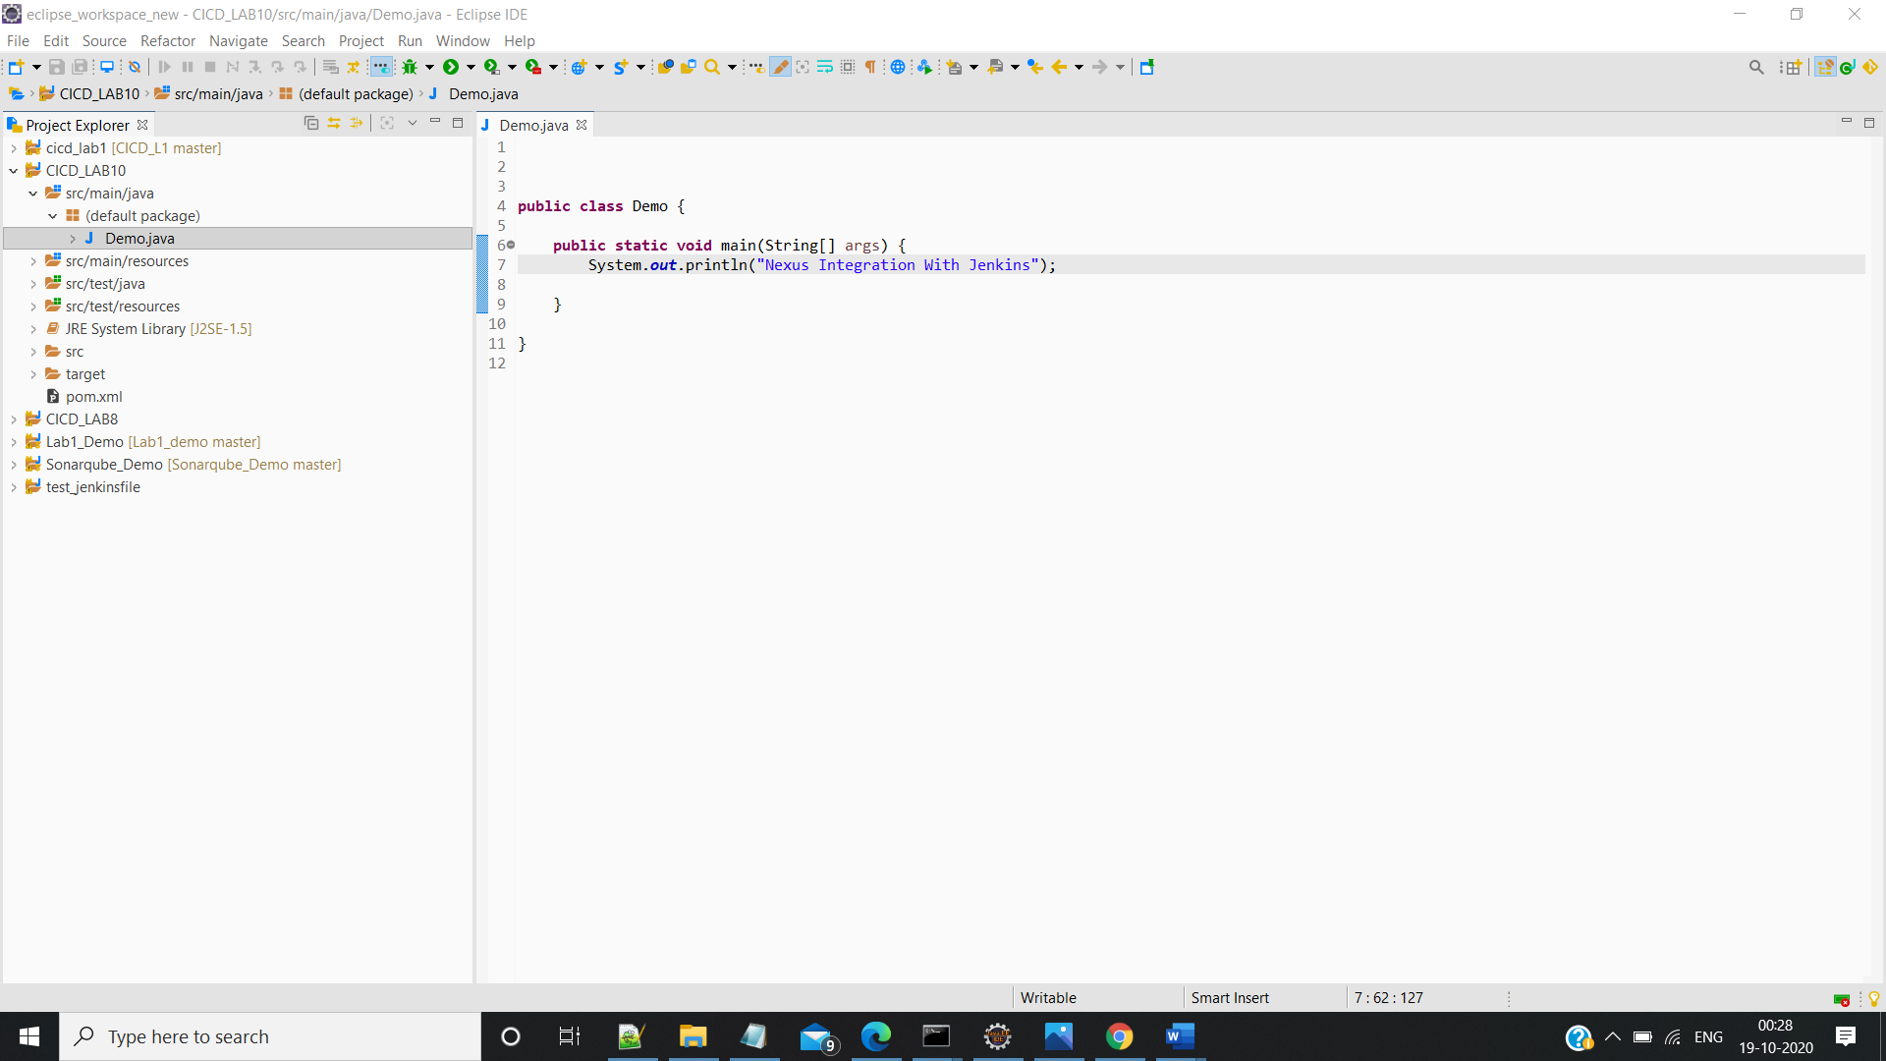

**Step 2: Push the Maven Project to the Github Repo**

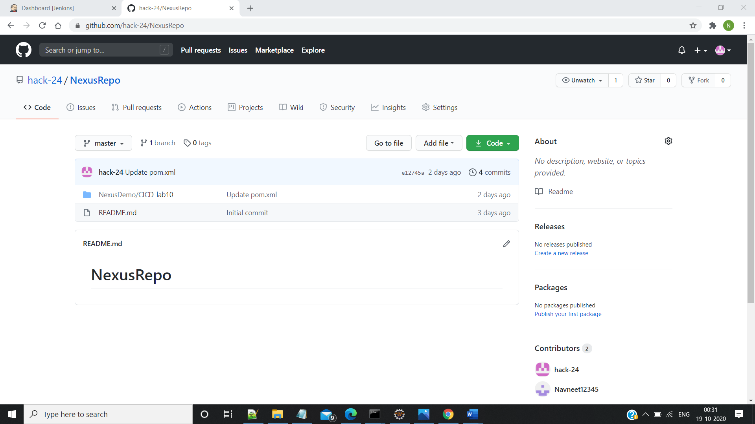

**Step 3: Configure the pom.xml**

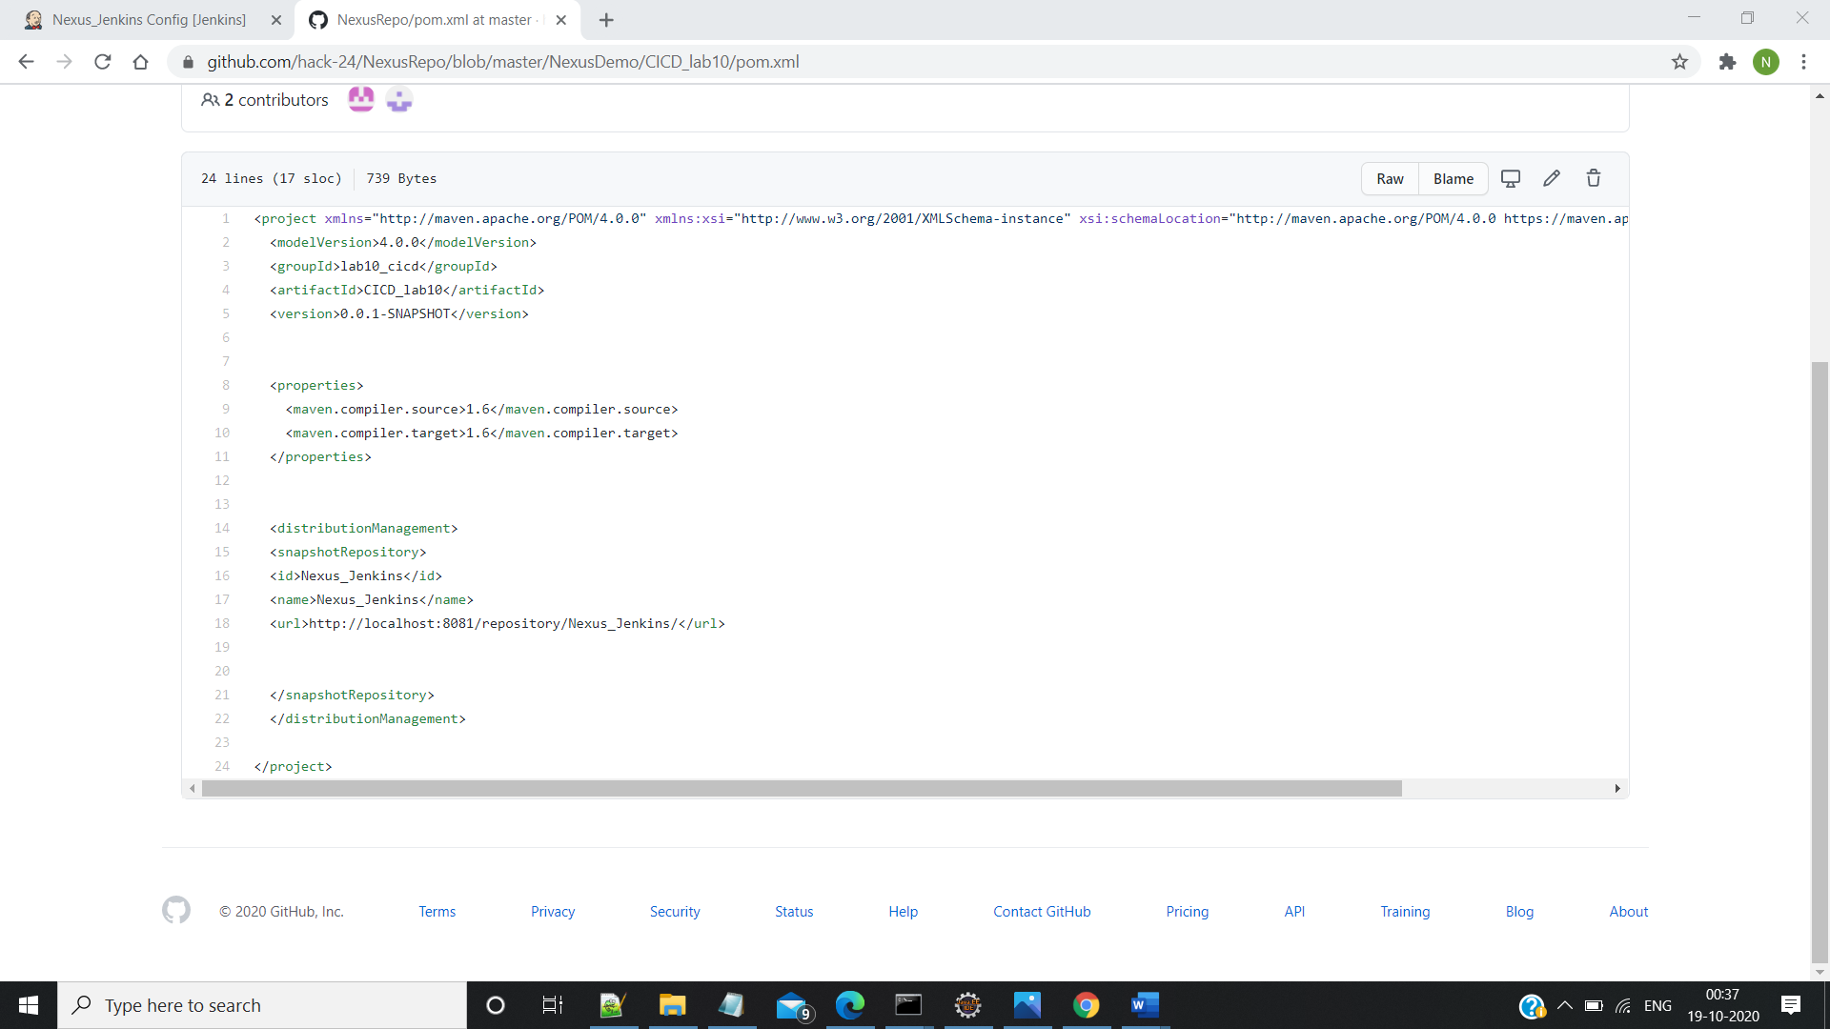

**Step 4:Add the Nexus Server**

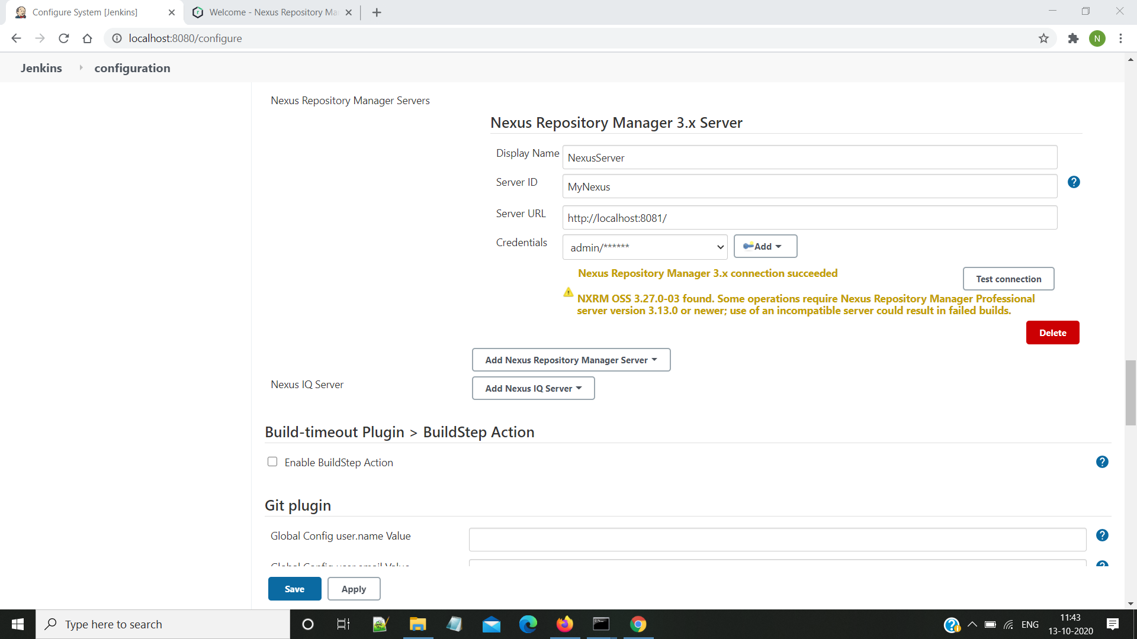

**Step 5:Create a new Item and Do the Configuration Settings**

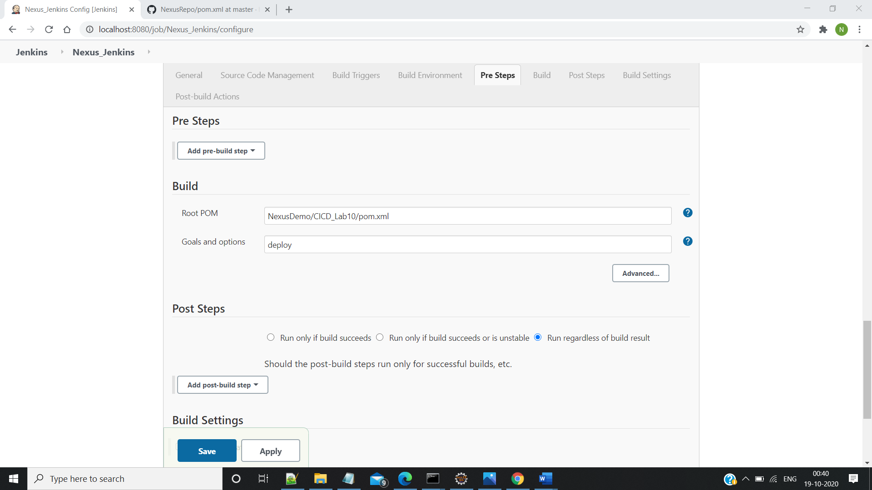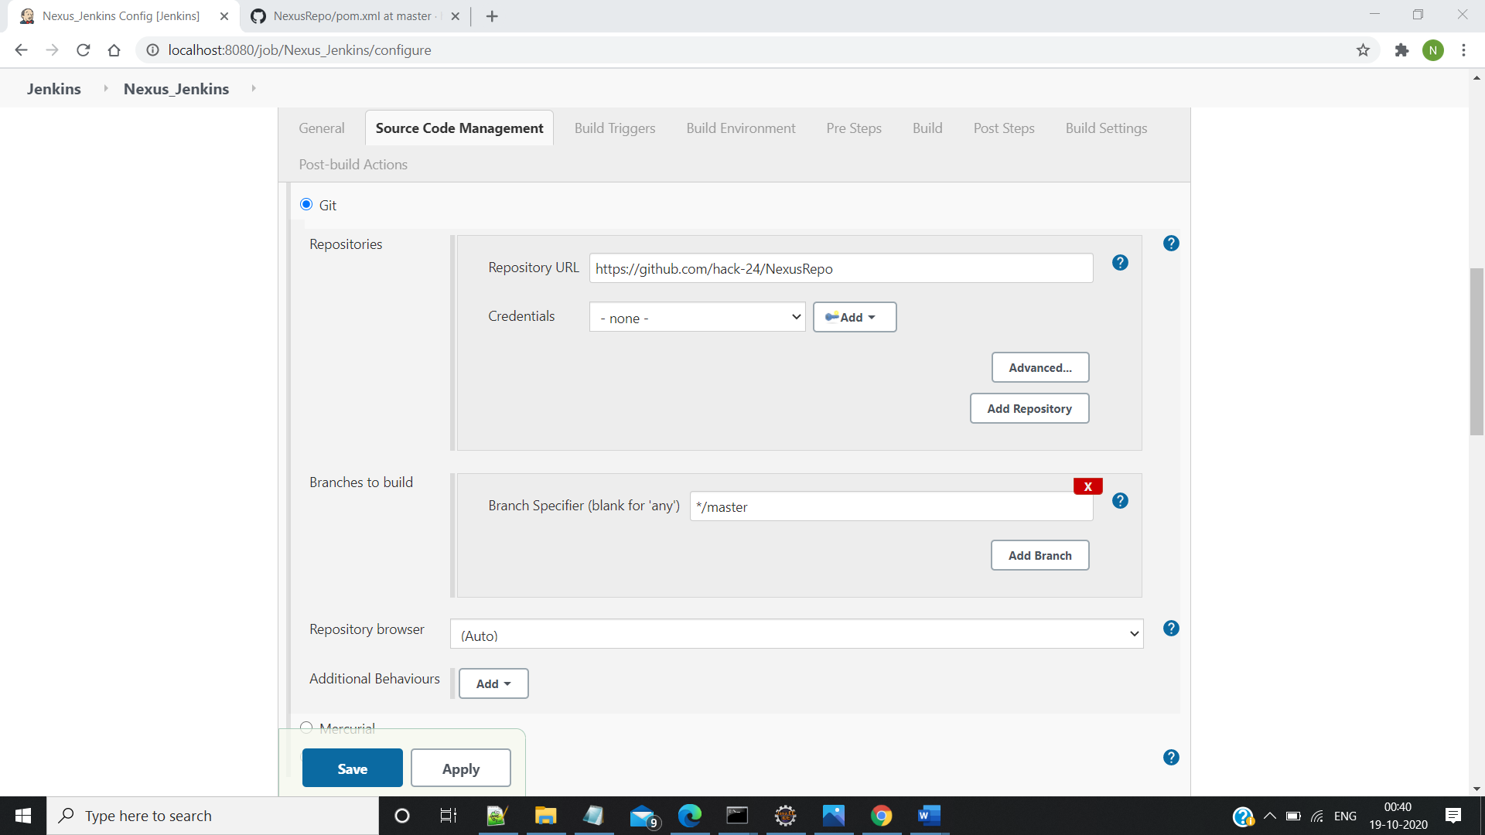

**Step 6:Save and Build the Project:**

