**Exp 2:Jenkins Integration With Github**

**Step 1> Create a Maven Project**

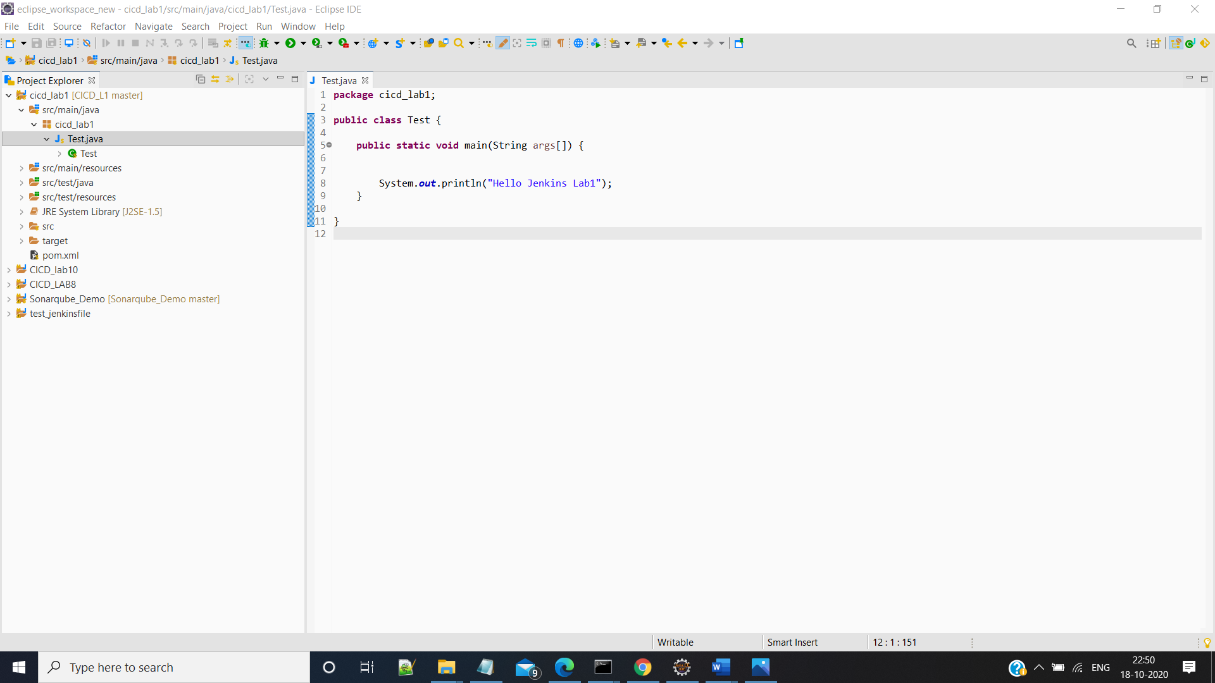

**Step 2: Push the Project on to Github Right Click project then go to Team >Share Project and Create a local git Repository for your Project**

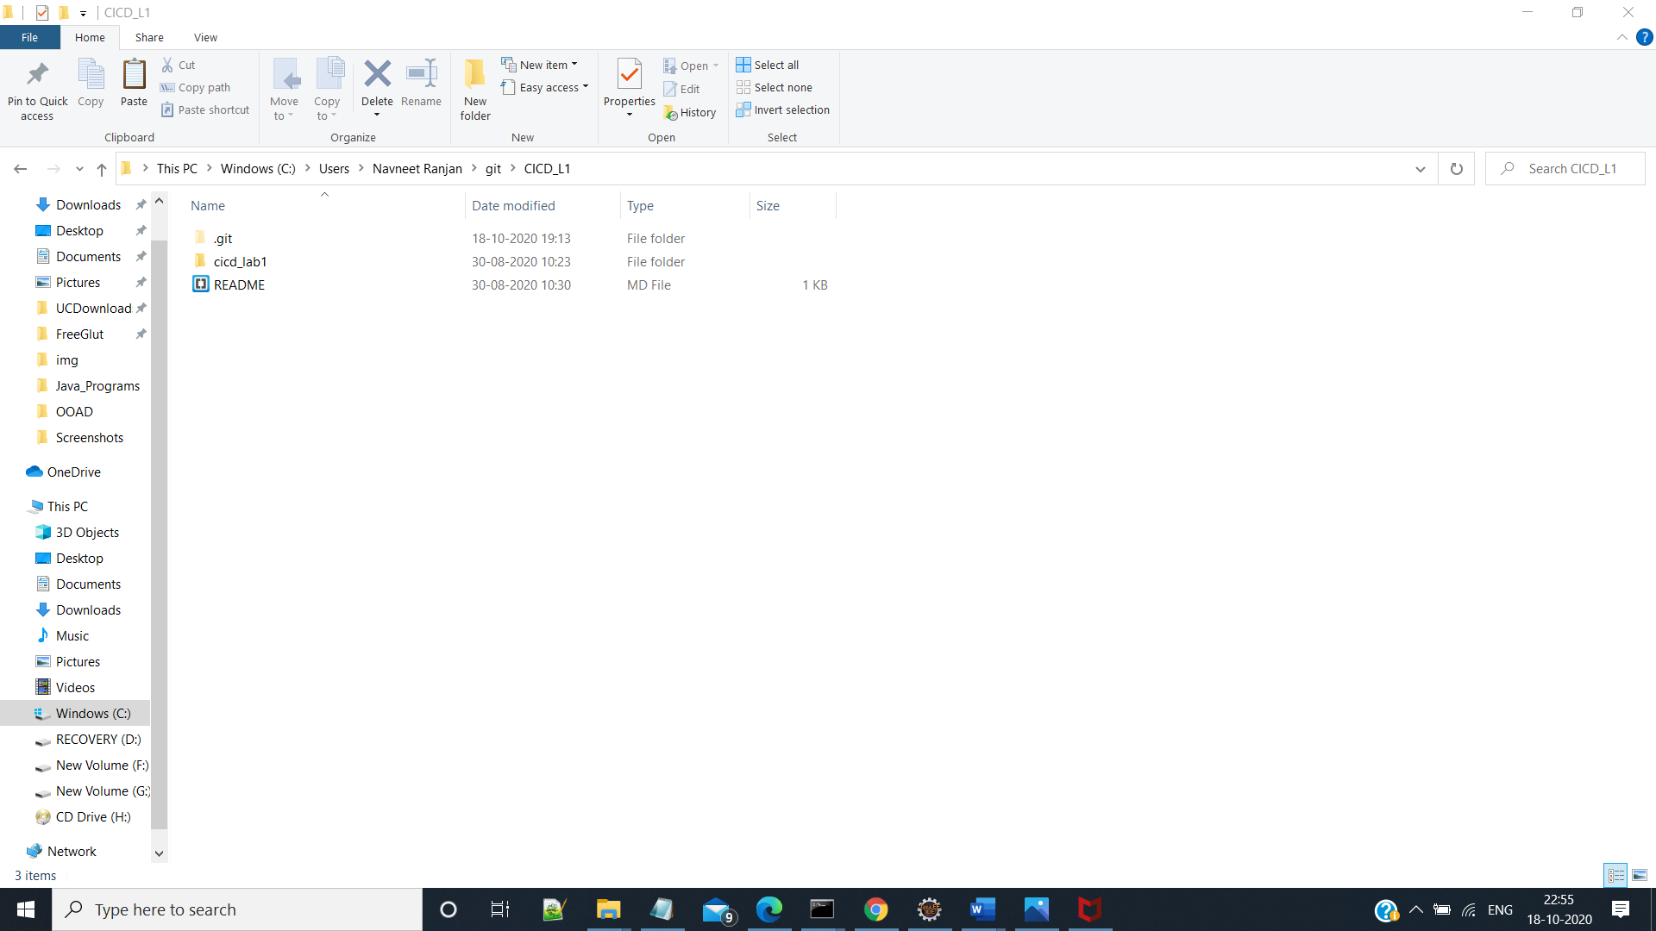

**Step 3: Right Click your Project go to Team > Commit then add All the Unstaged files to Commit area and then Select Commit and Push**

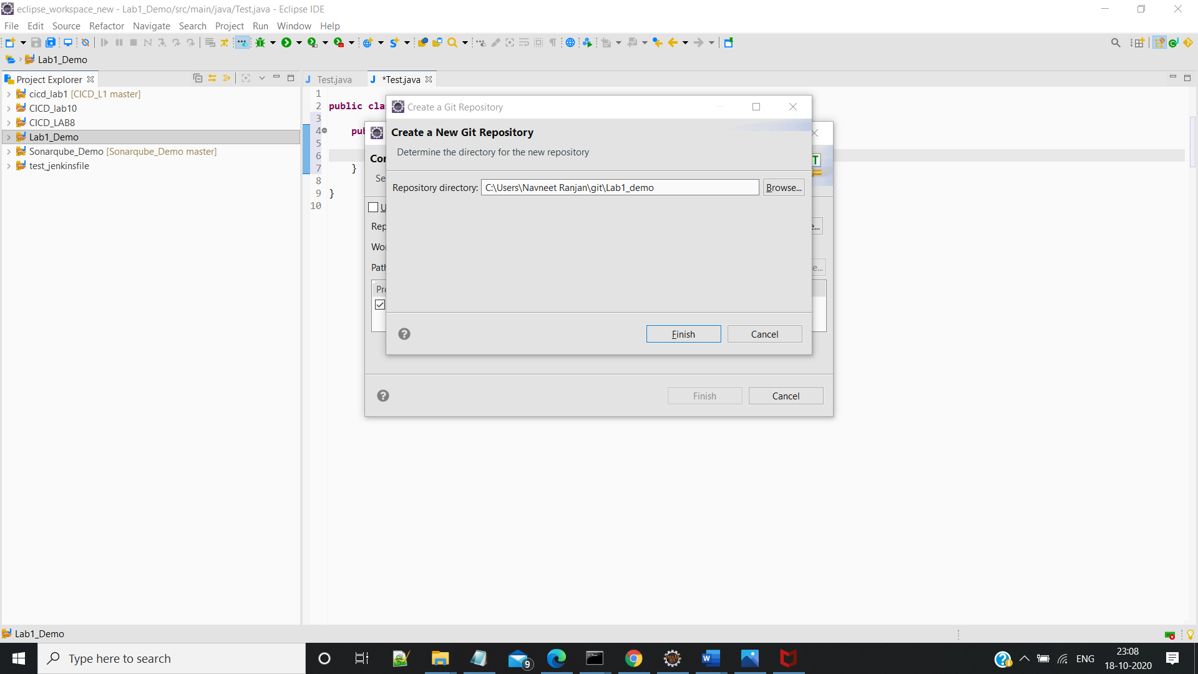

**Step 4:Provide the Credentials to the github**

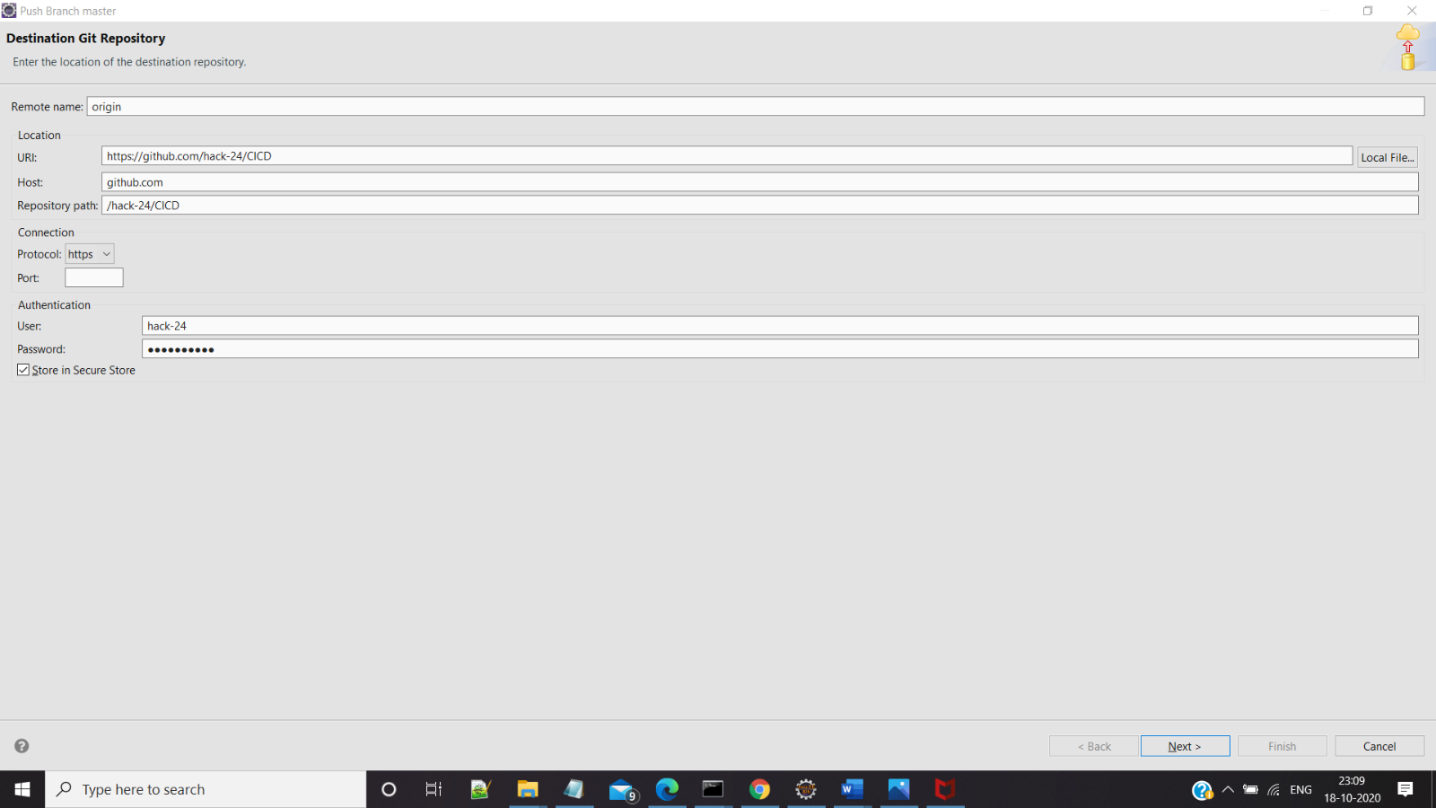

**Step 5:Push the Maven Project to the Repository**

