**Experiment 5: Jenkins Integration with Sonarqube**

**Step 1> Push the Maven Project on Github**

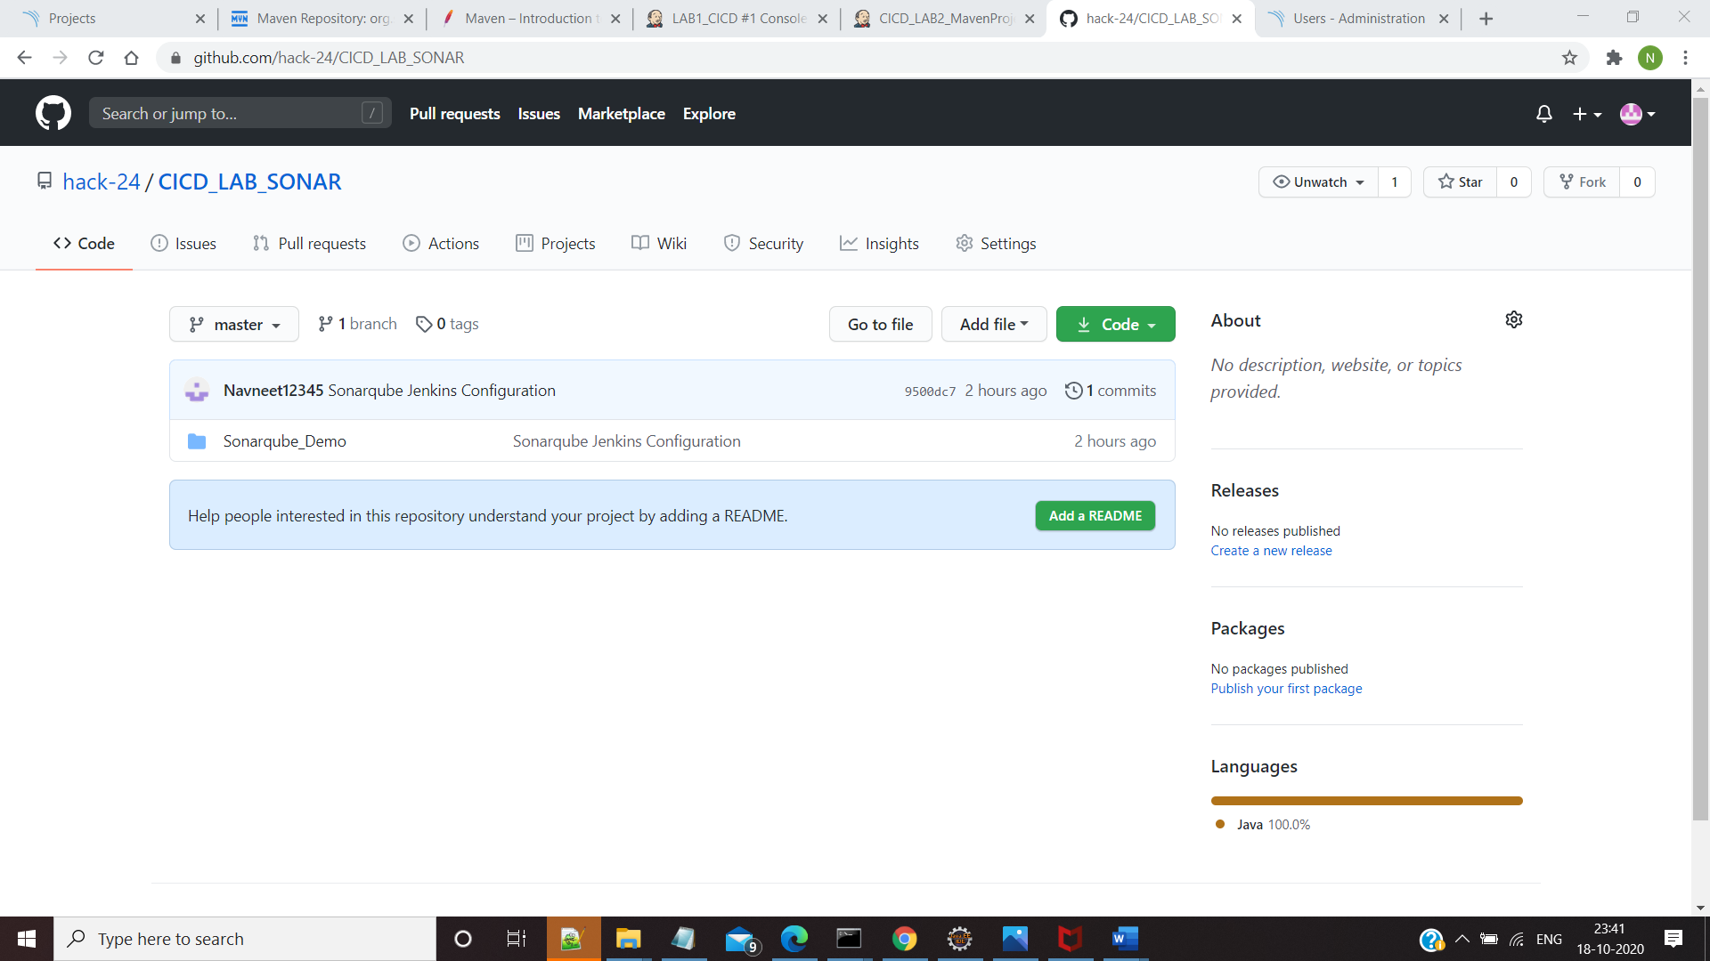

**Step 2: Go to Jenkins and Follow these Steps Manage Jenkins >Manage Plugins and Install SonarQube Scanner**

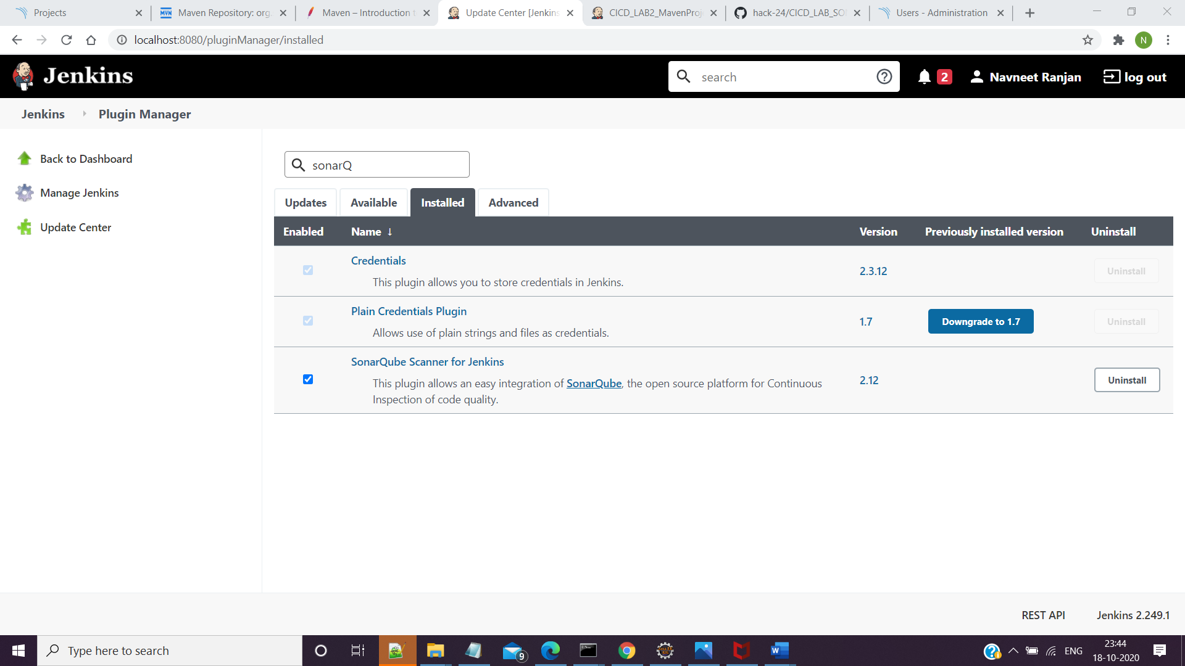

**Step 3: Go to Manage Jenkins > Configure System and Add Sonartype Server**

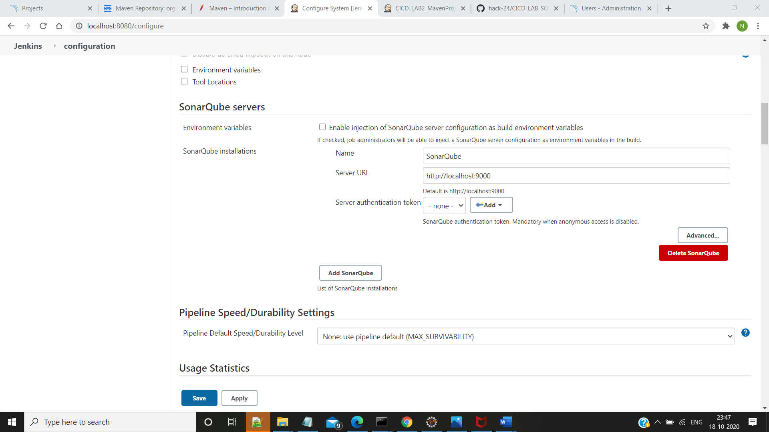

**Step 4:Create a new Maven Item and do the Required Settings**

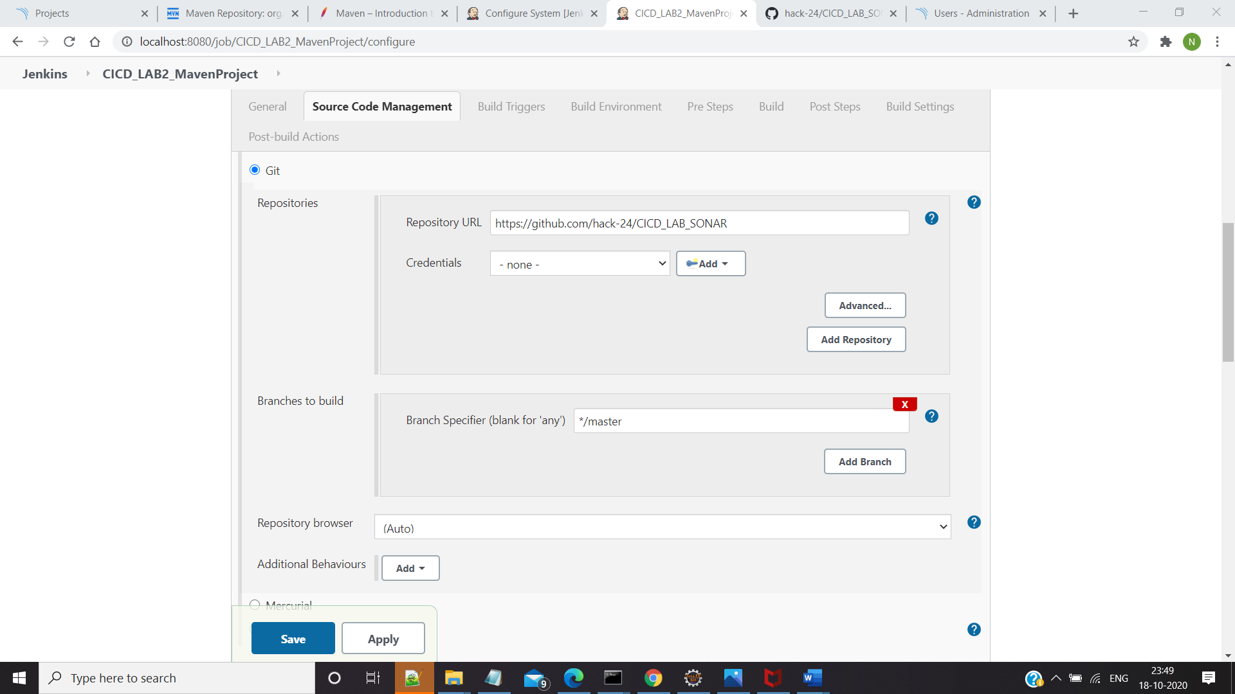

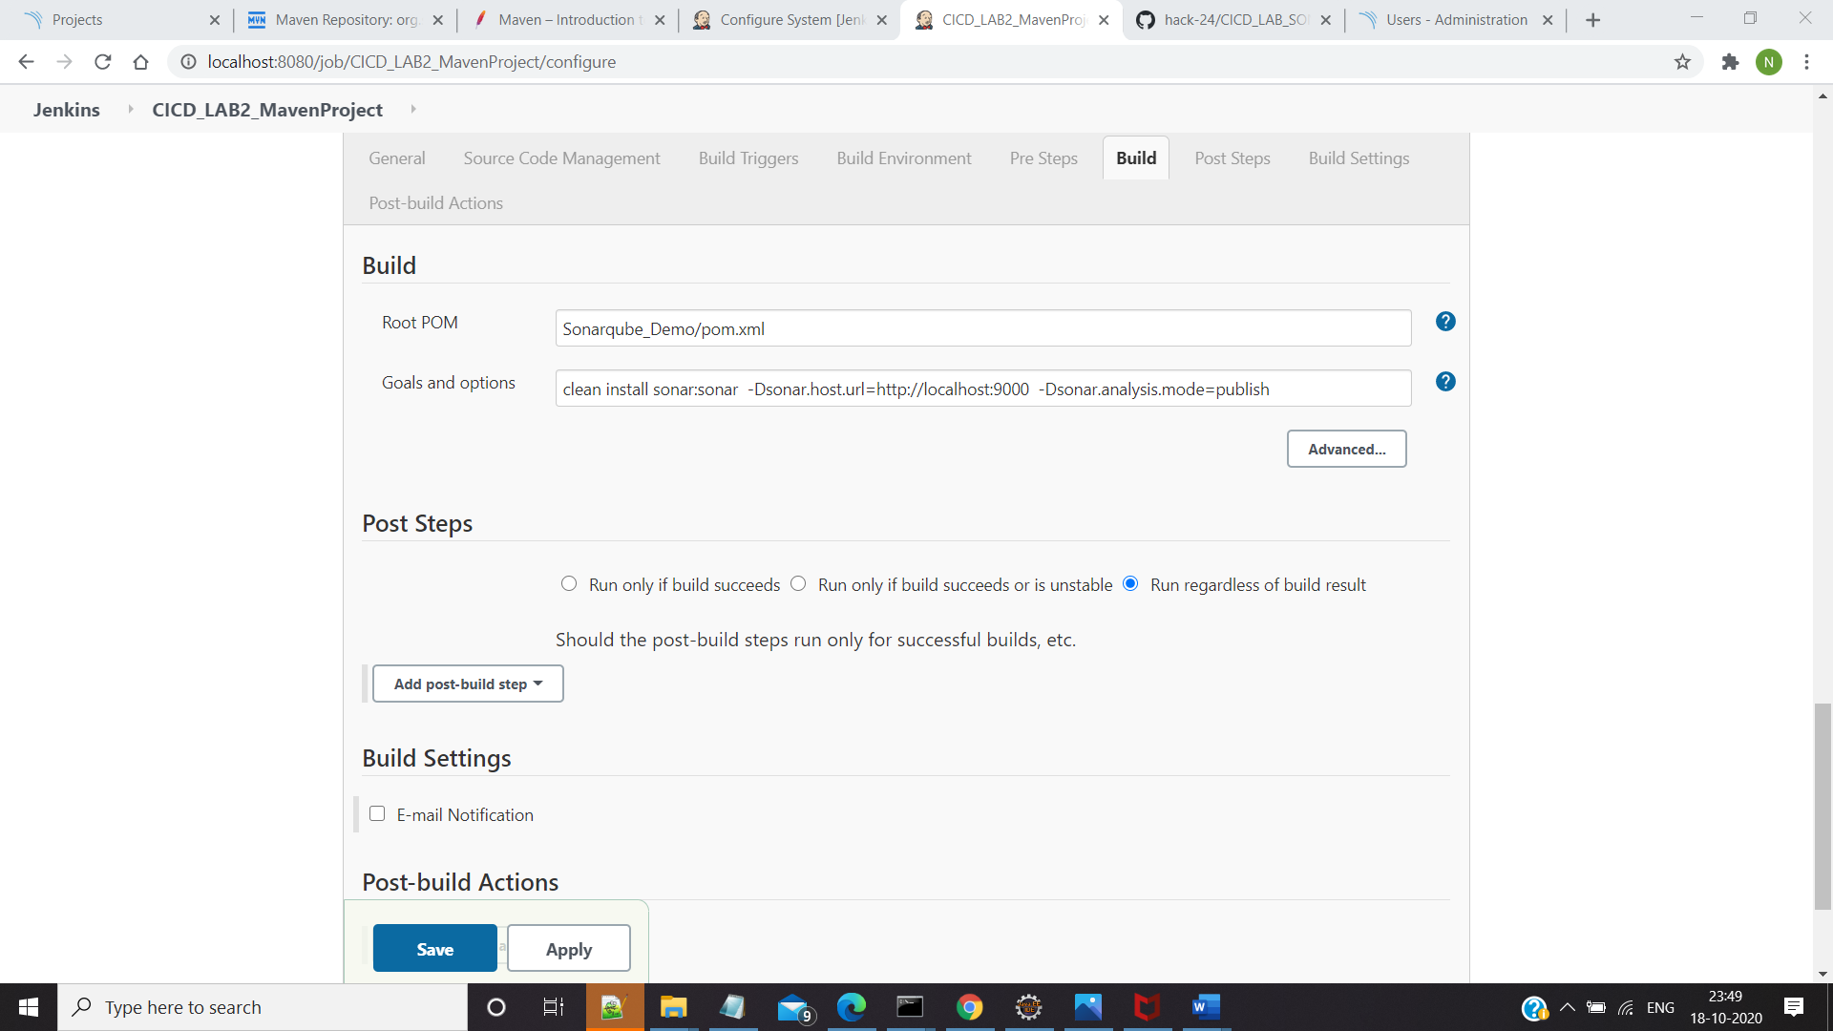

**Step 6:Save and Build the Maven Project and View the Console Output**

