**EXP 6: Create PipeLine Using Jenkins**

**Step 1> Create a Maven Project and Push it to Github**

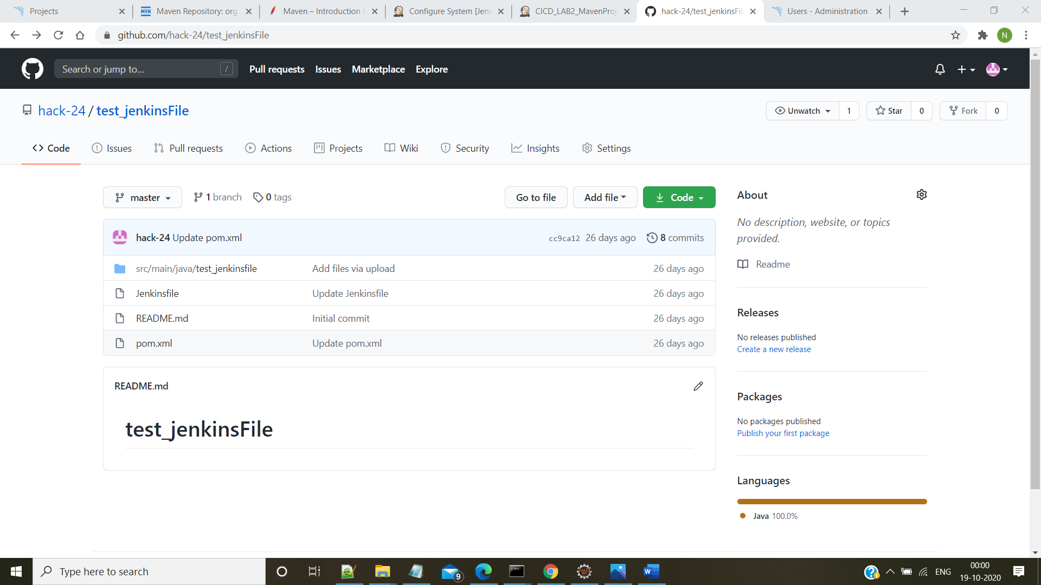

**Step 2>Add a jenkinsFile to the Project**

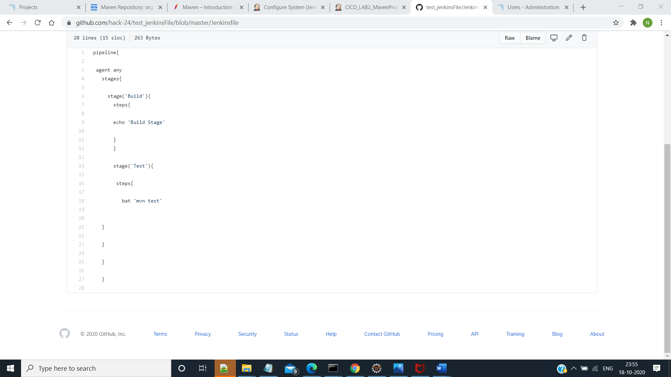

**Step 3> Go to Jenkins and Create a New Pipeline Item and Configure it as Follow:**

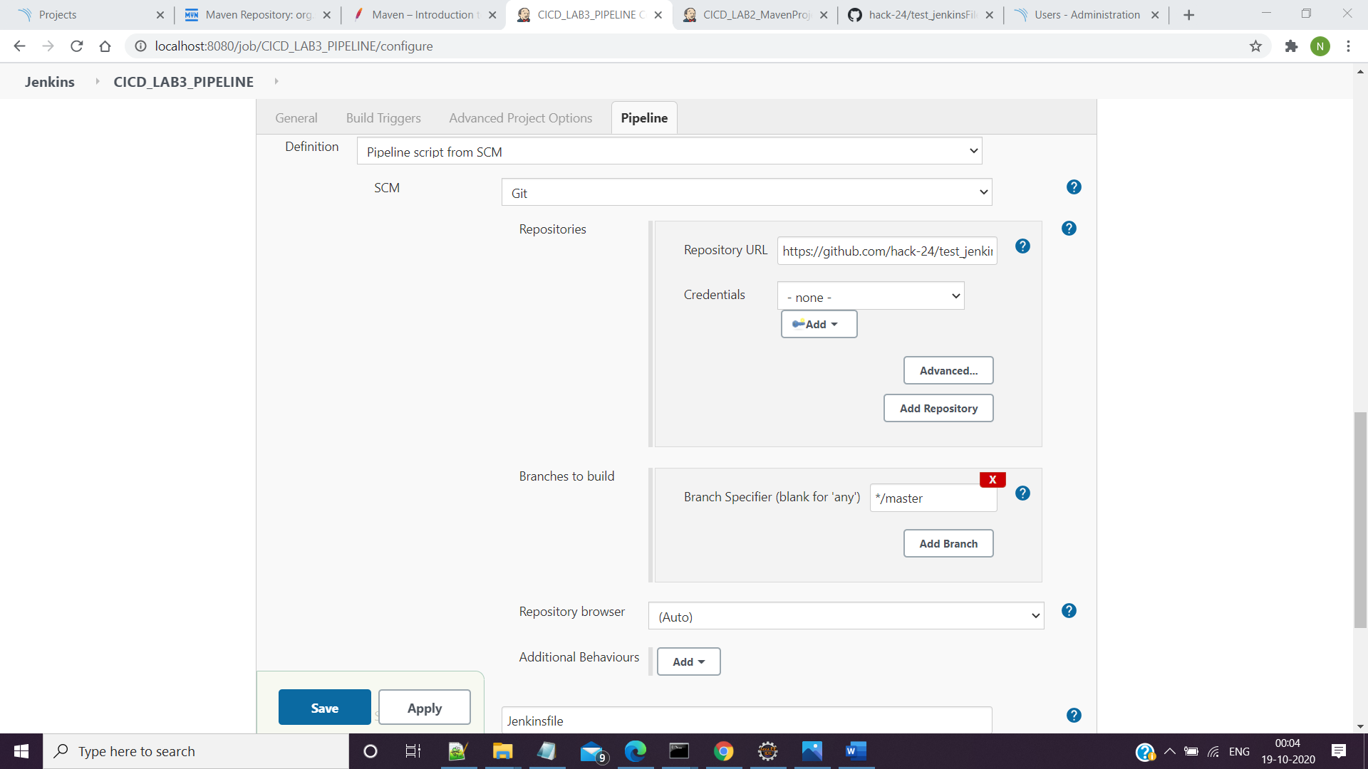

**Step 4> Save and Build the Project and View The Console Output**

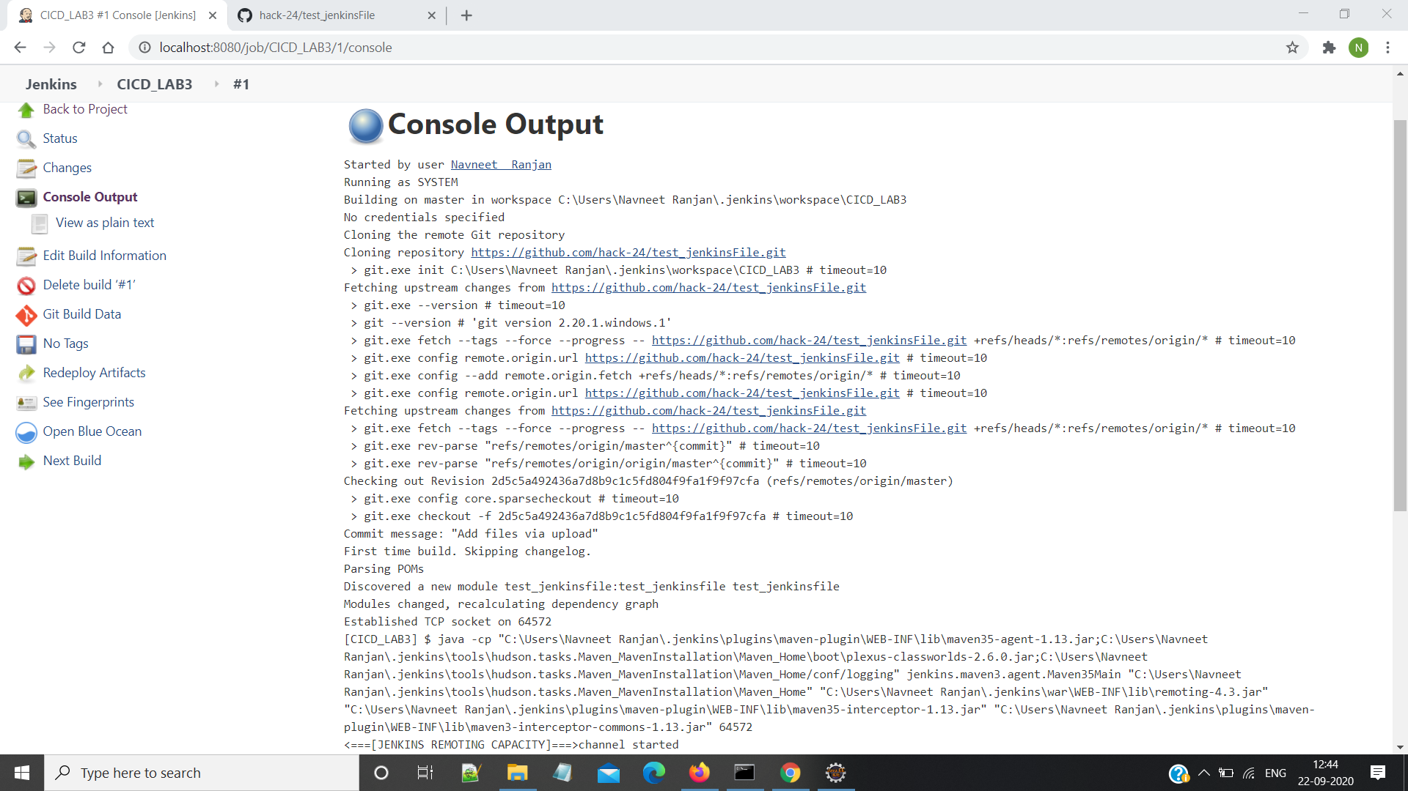

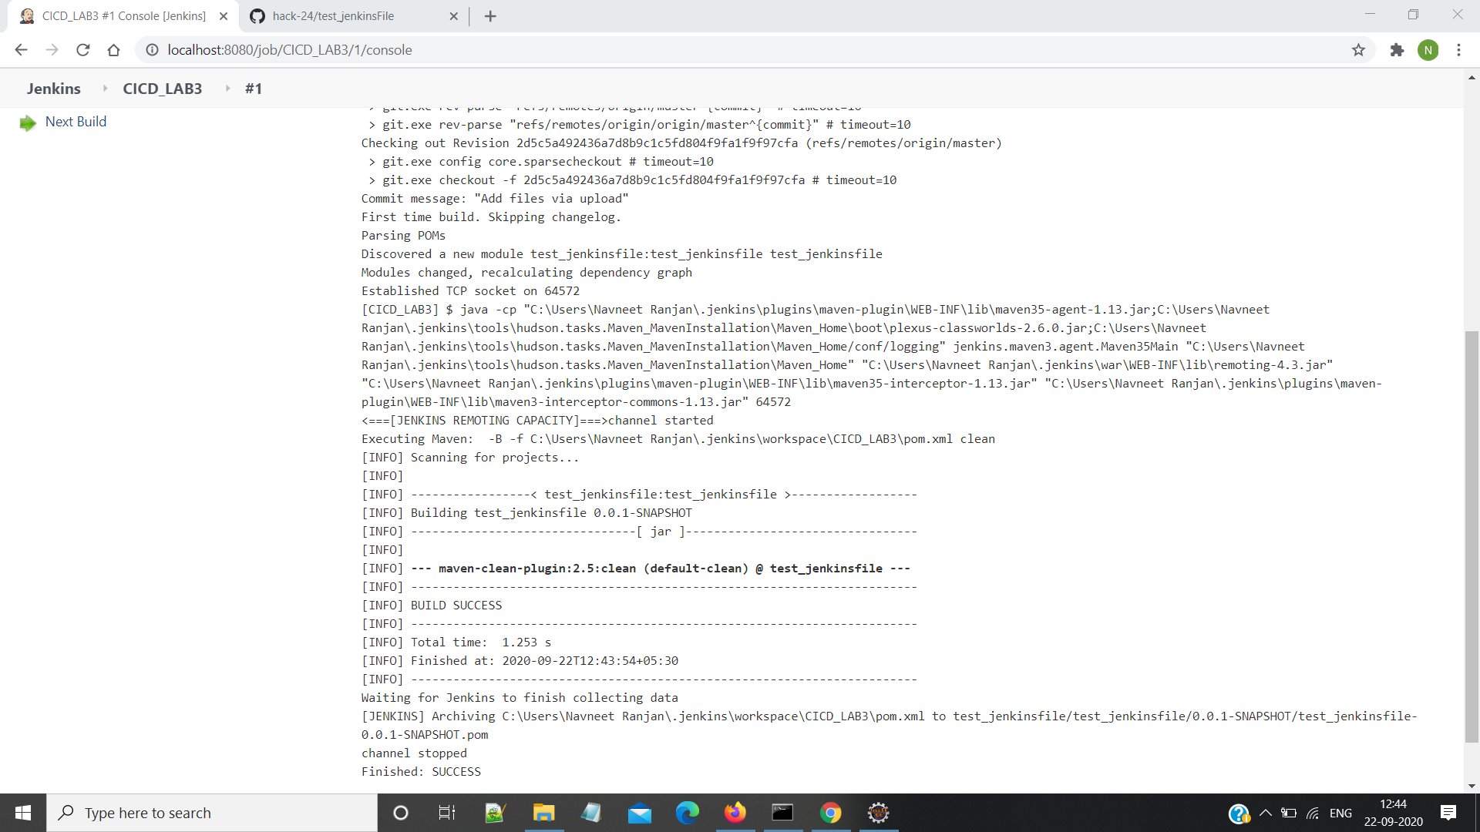

**Step 5> See the Pipeline**

