**1.Run nexus.exe/run**

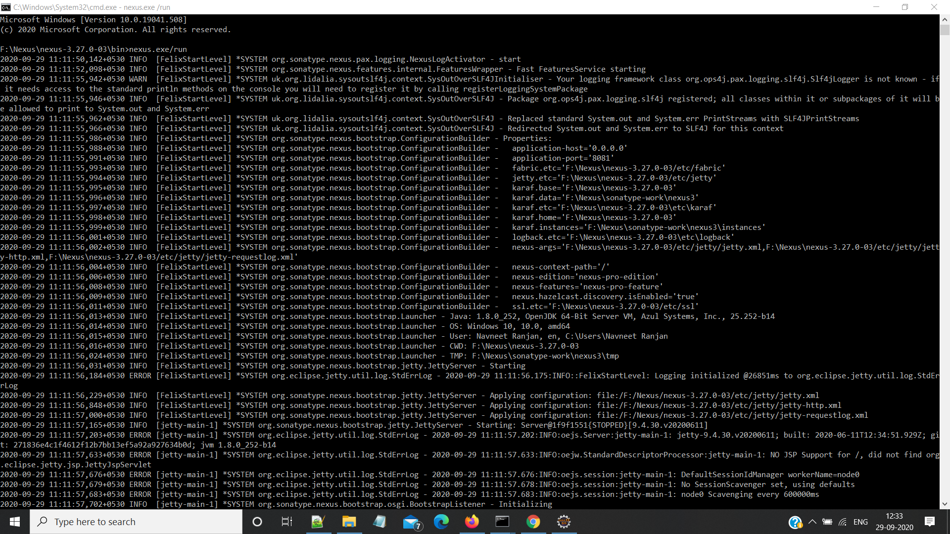

**2.Create a Nexus Repo**

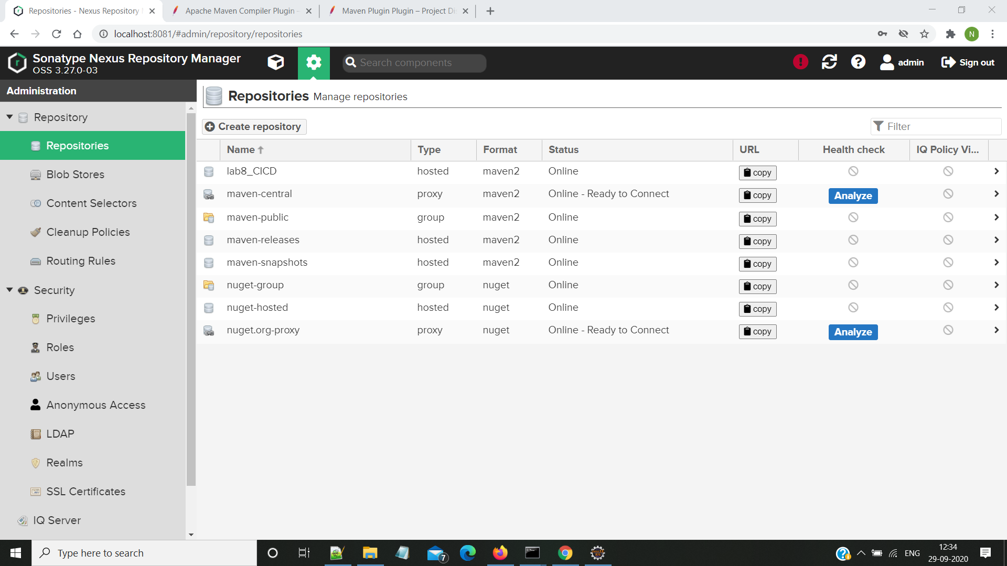

**3.Configure the apache-maven config>settings.xml file**

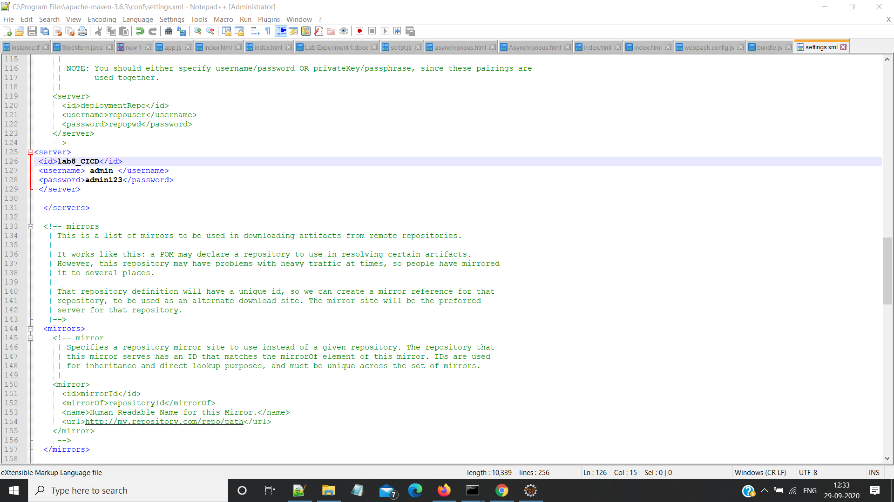

**4.Configure pom.xml of your Maven project to be hosted on Nexus Repository**

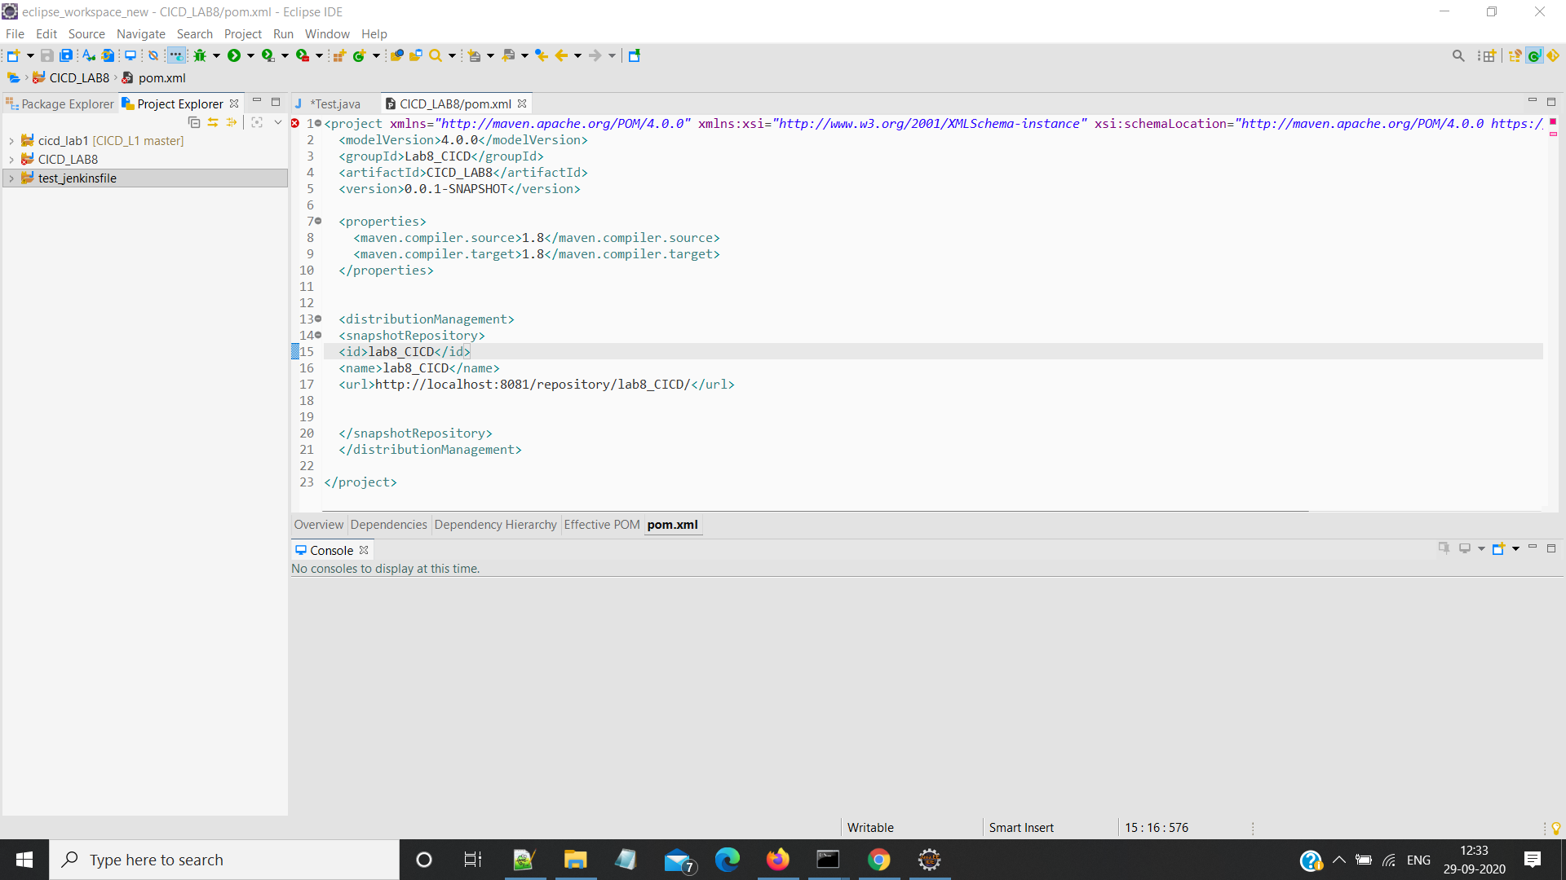

**5 :Run goals**

**i>mvn clean**

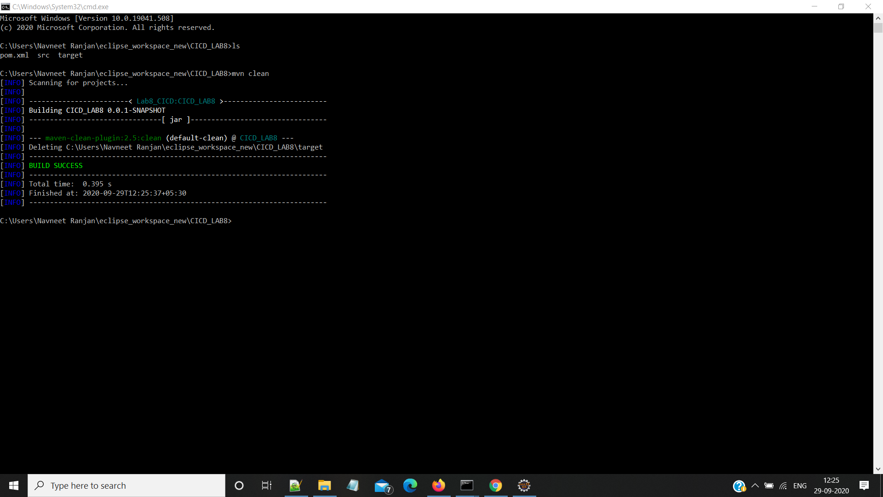

**ii> mvn install**

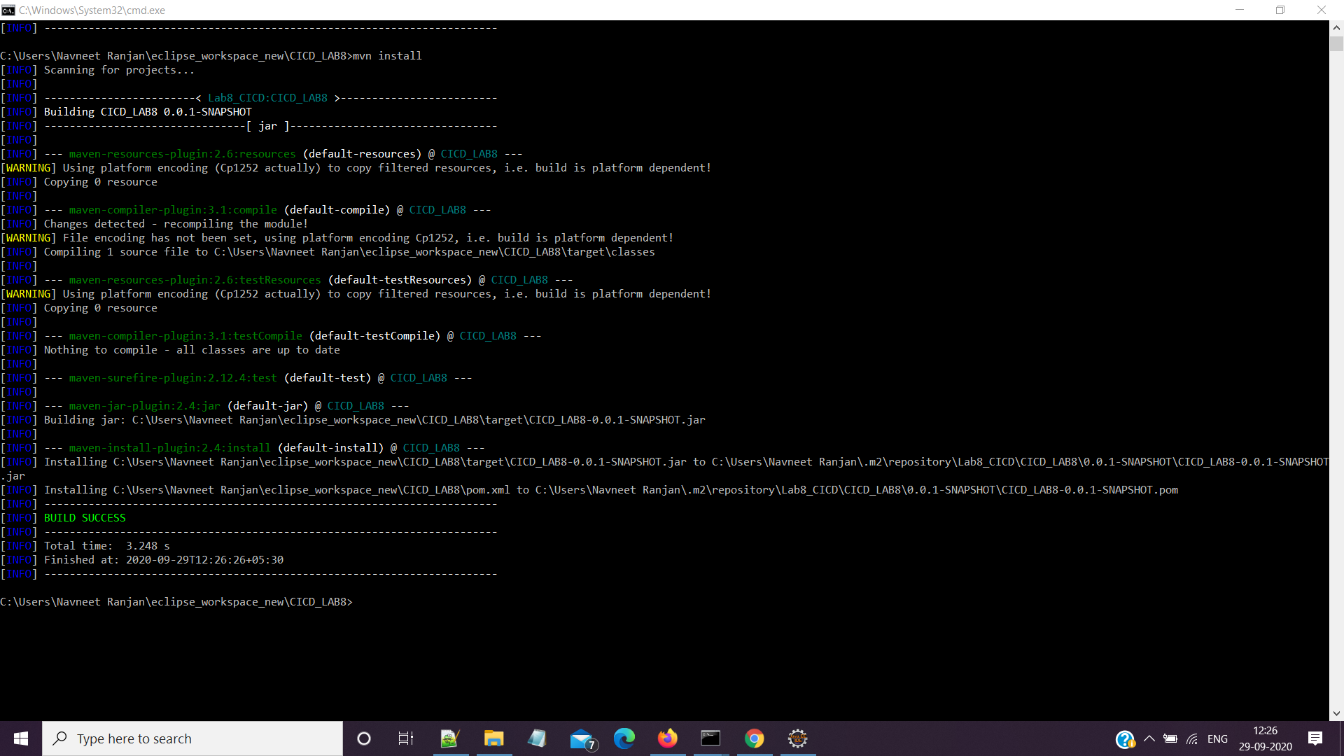

**iii> mvn deploy**

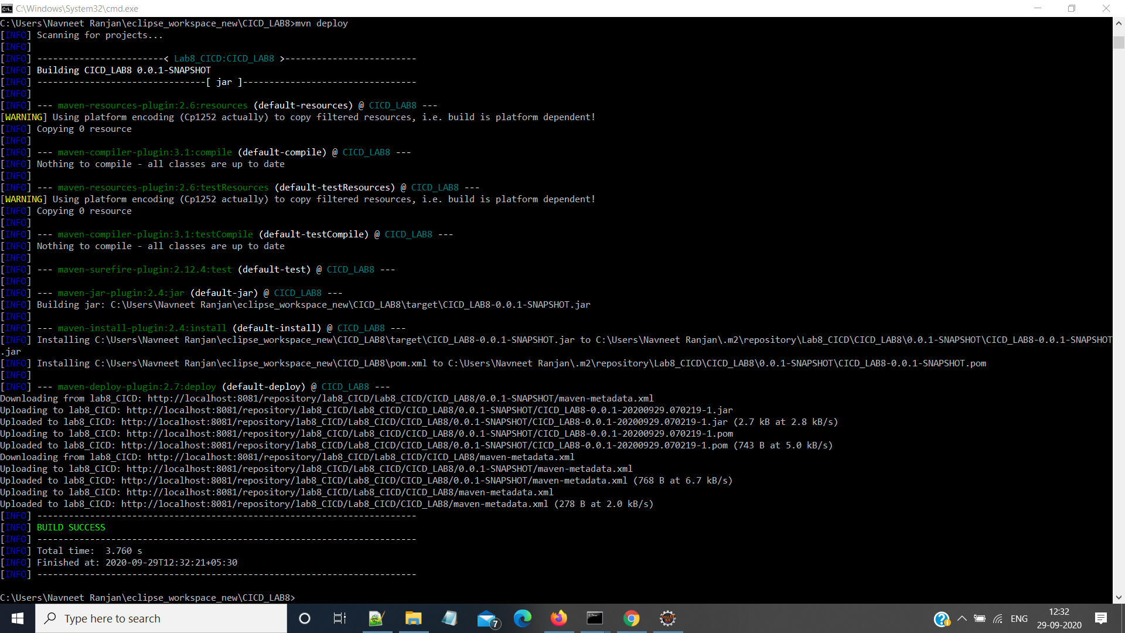

**6:Browse you Nexus Repo**

