**EXPERIMENT-11**

**VAGRANT TOOL**

Step 1:Install the Vagrant tool

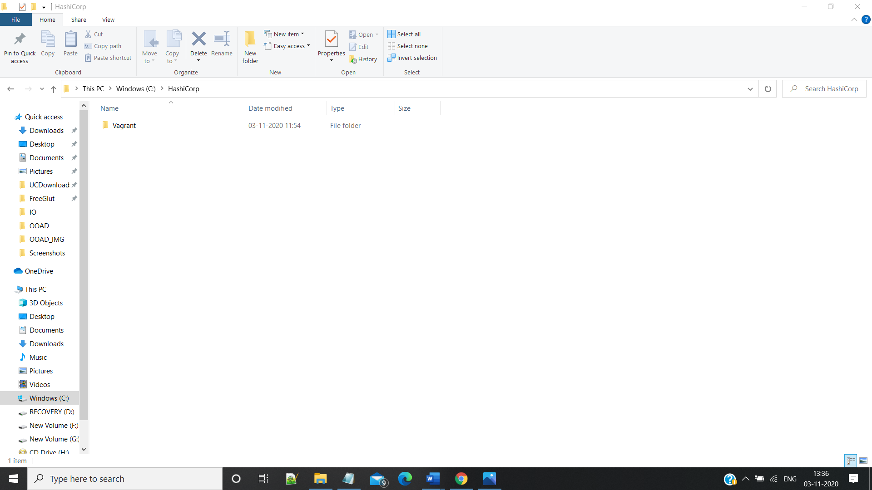

Step 2: Check the Version of Vagrant by Running vagrant --version from command prompt

and Create a directory VM2 and run vagrant init from VM2 folder

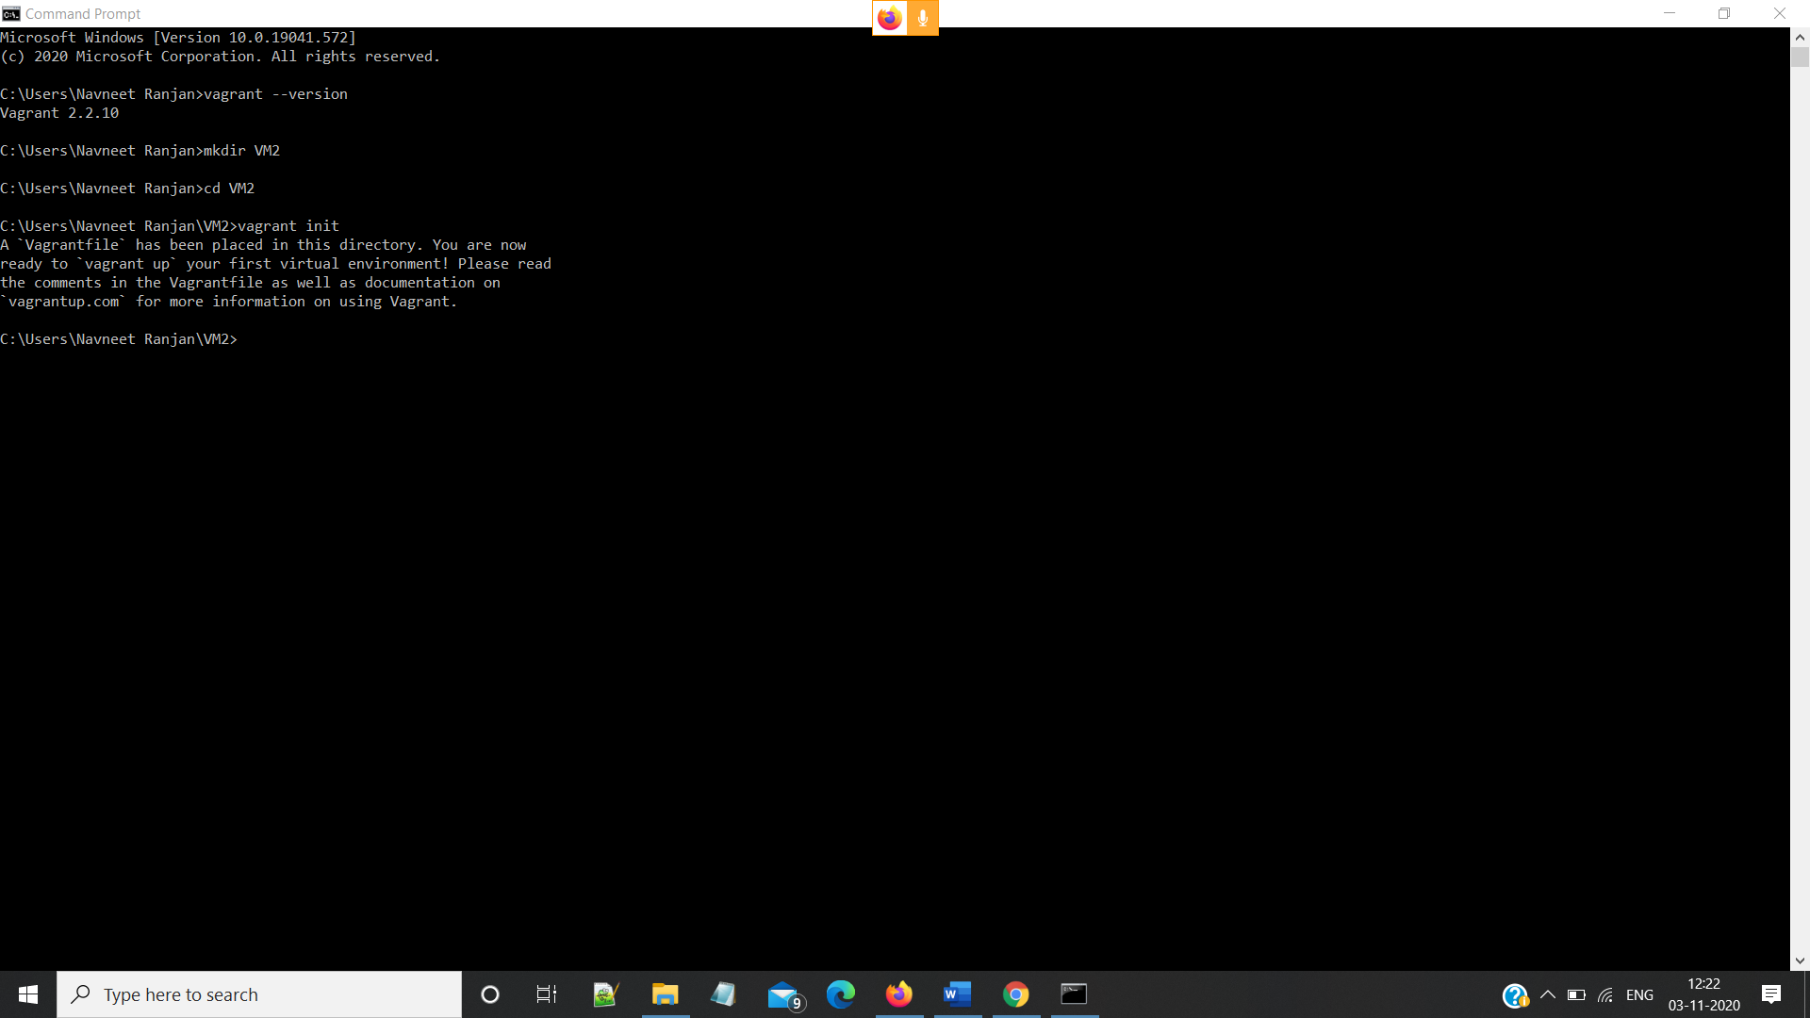

Step 3: Configure the Vagrant File Created in VM2 folder

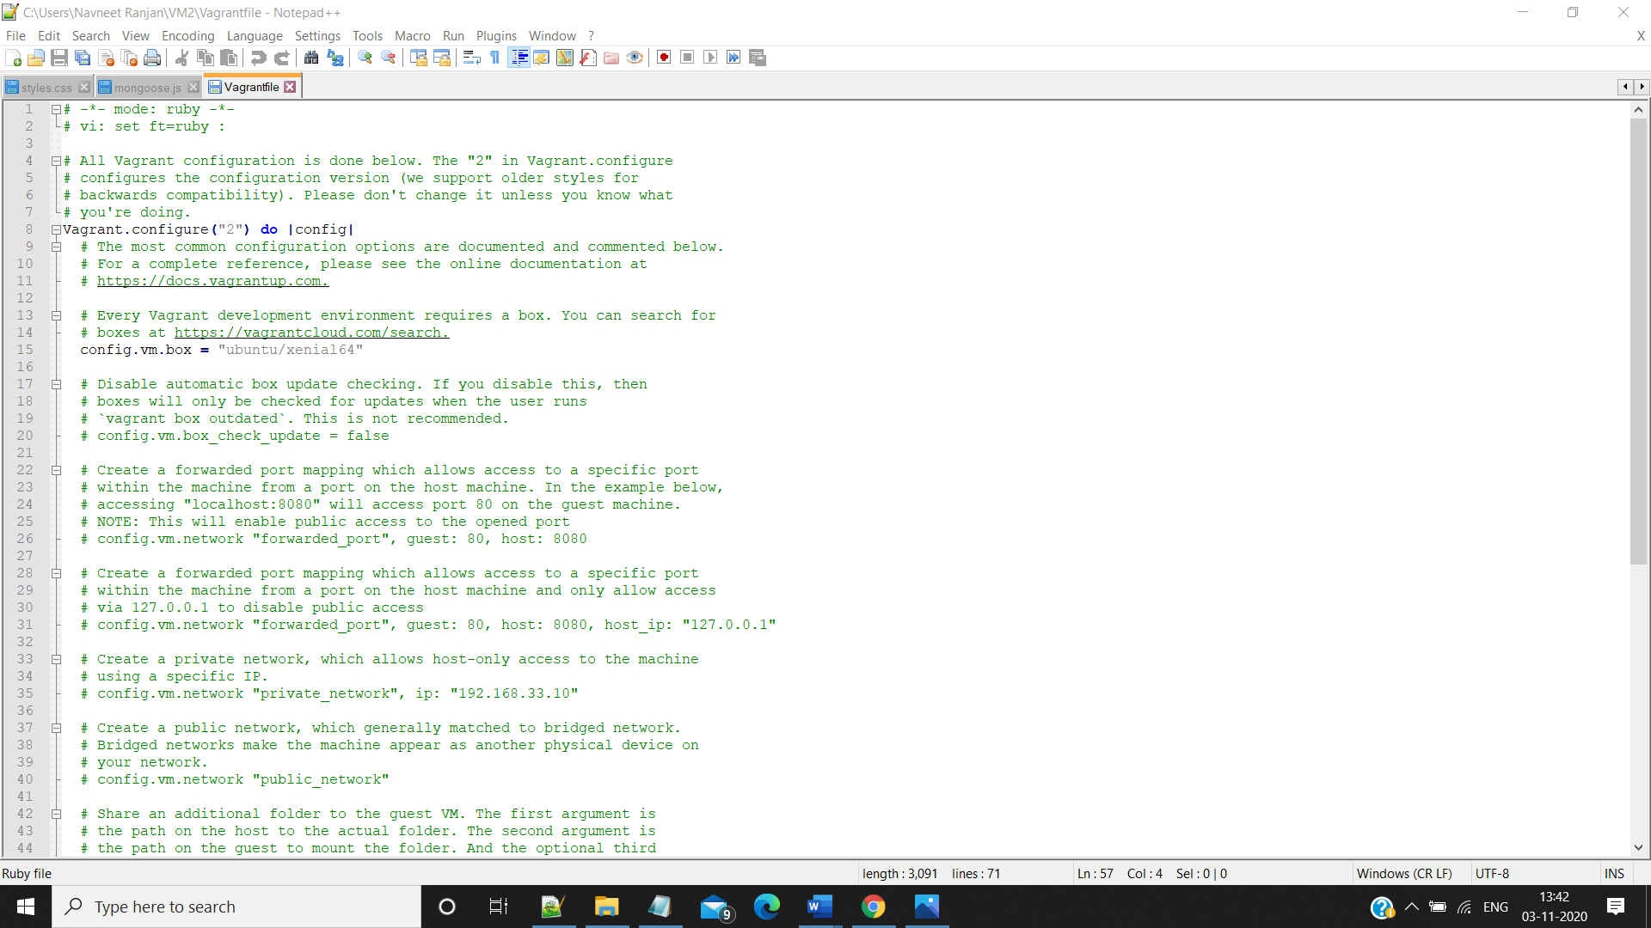

Step 4: Run vagrant up Command

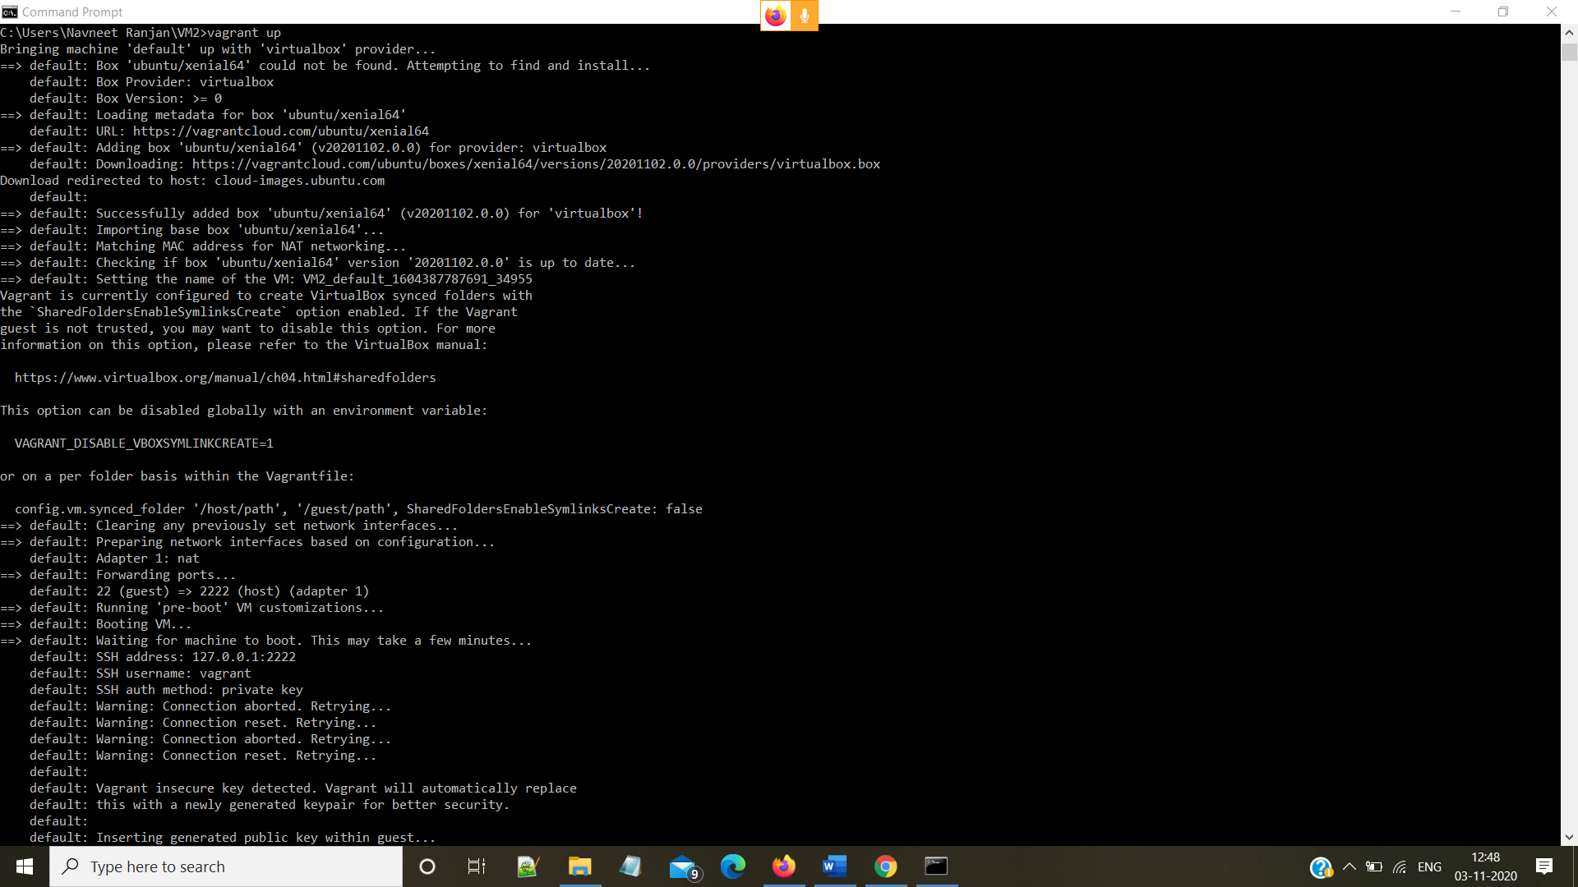

Step 5: Run the vagrant ssh Command you will now have the access to vagrant

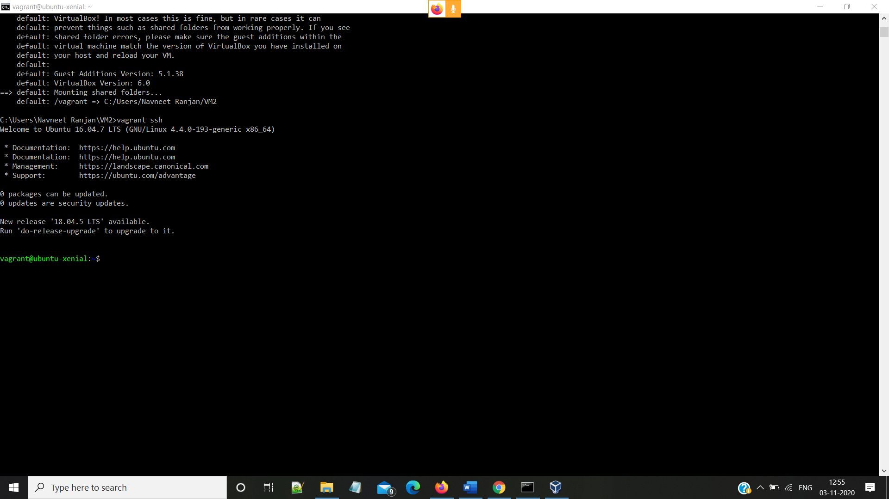

Step 6: Create a test Directory by using mkdir test Command and then ls to view the directory

