**EXPERIMENT-12**

**Configuring Docker With Vagrant**

Step 1: First, in order to ensure the downloads are valid, add the GPG key for the official Docker repository to your system:

$ curl -fsSL https://download.docker.com/linux/ubuntu/gpg | sudo apt-key add -  
  
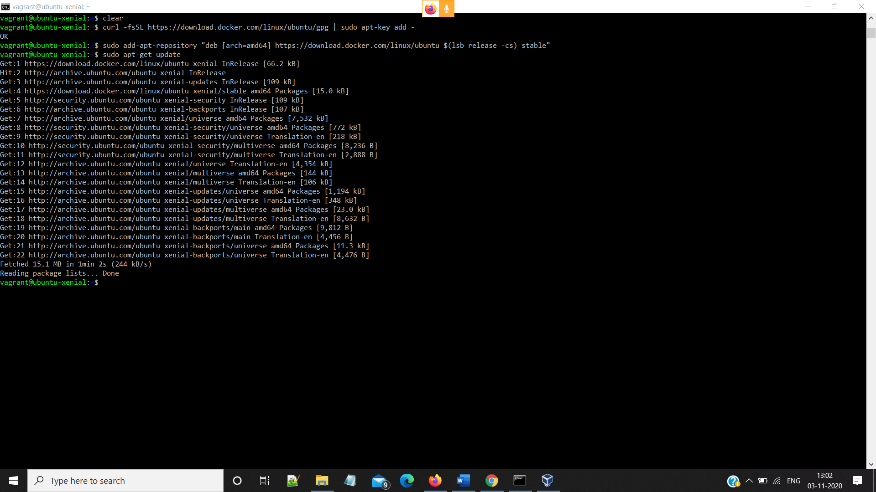

Step 2:

i>Add the Docker repository to APT sources

$ sudo add-apt-repository "deb [arch=amd64] https://download.docker.com/linux/ubuntu $(lsb_release -cs) stable"

ii>Next, update the package database with the Docker packages from the newly added repo:

$ sudo apt-get update

iii>Make sure you are about to install from the Docker repo instead of the default Ubuntu 16.04 repo:

$ apt-cache policy docker-ce



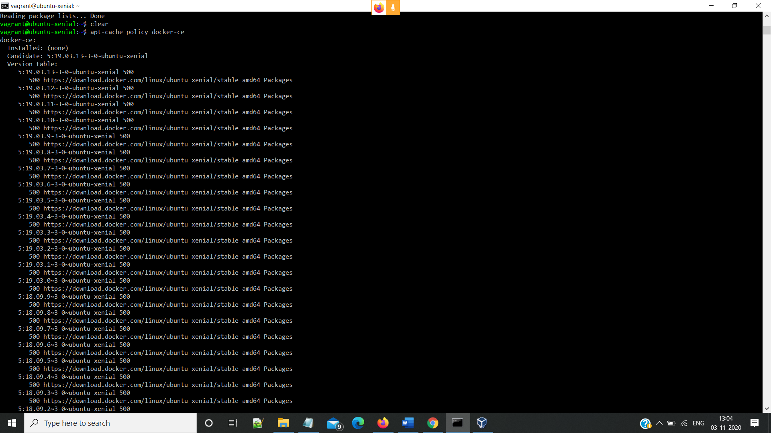

Step 3:Install Docker

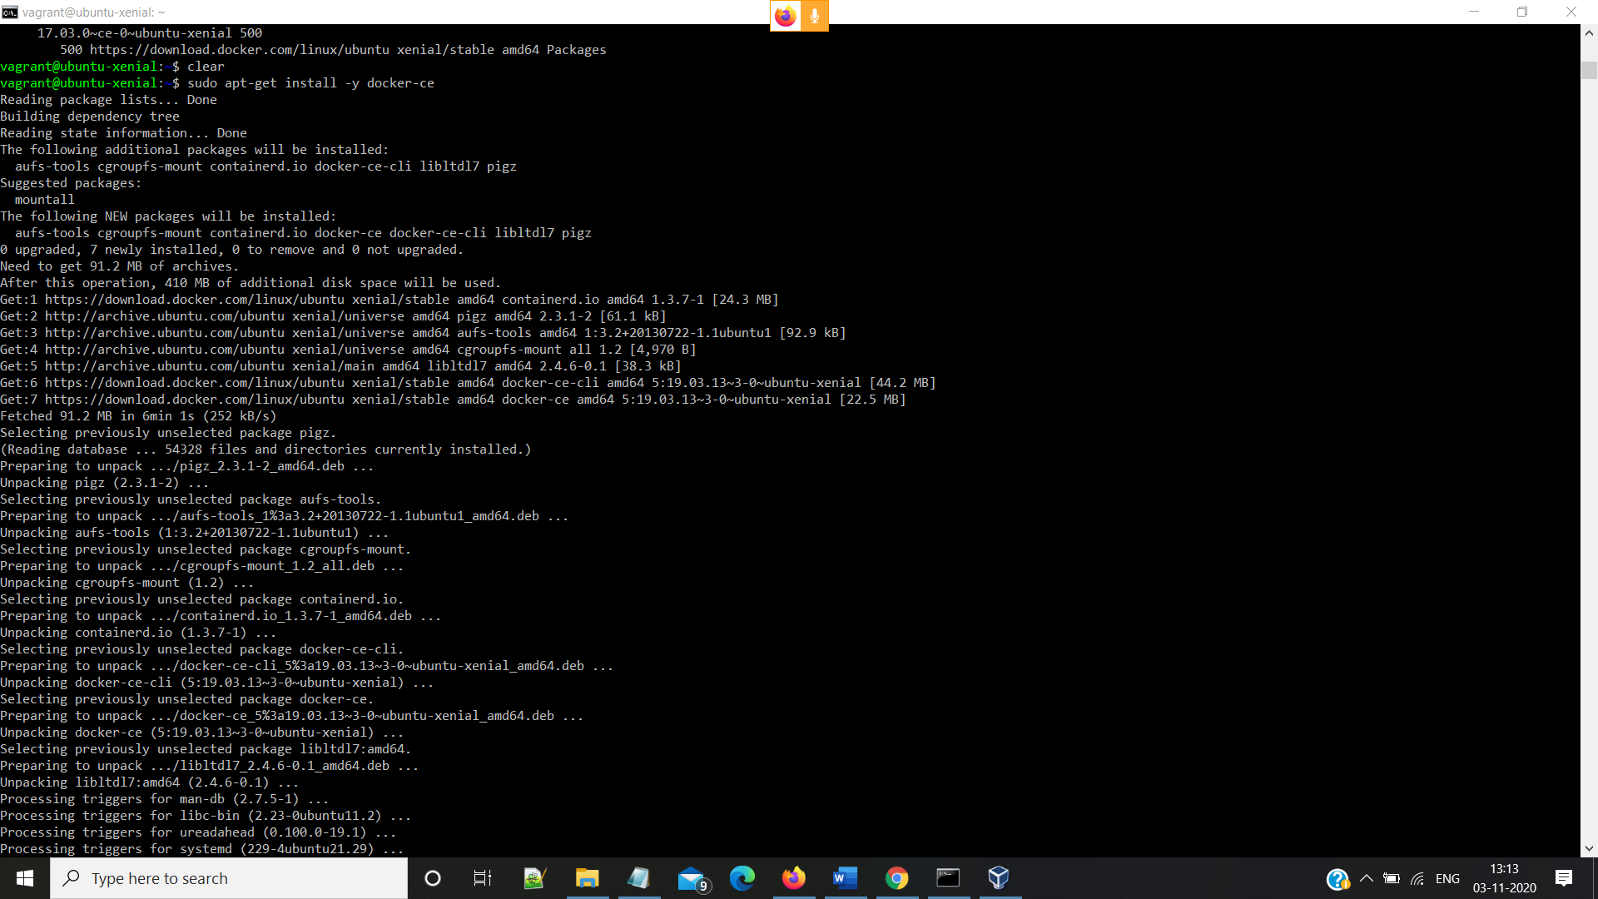

Step 4:Create User Group

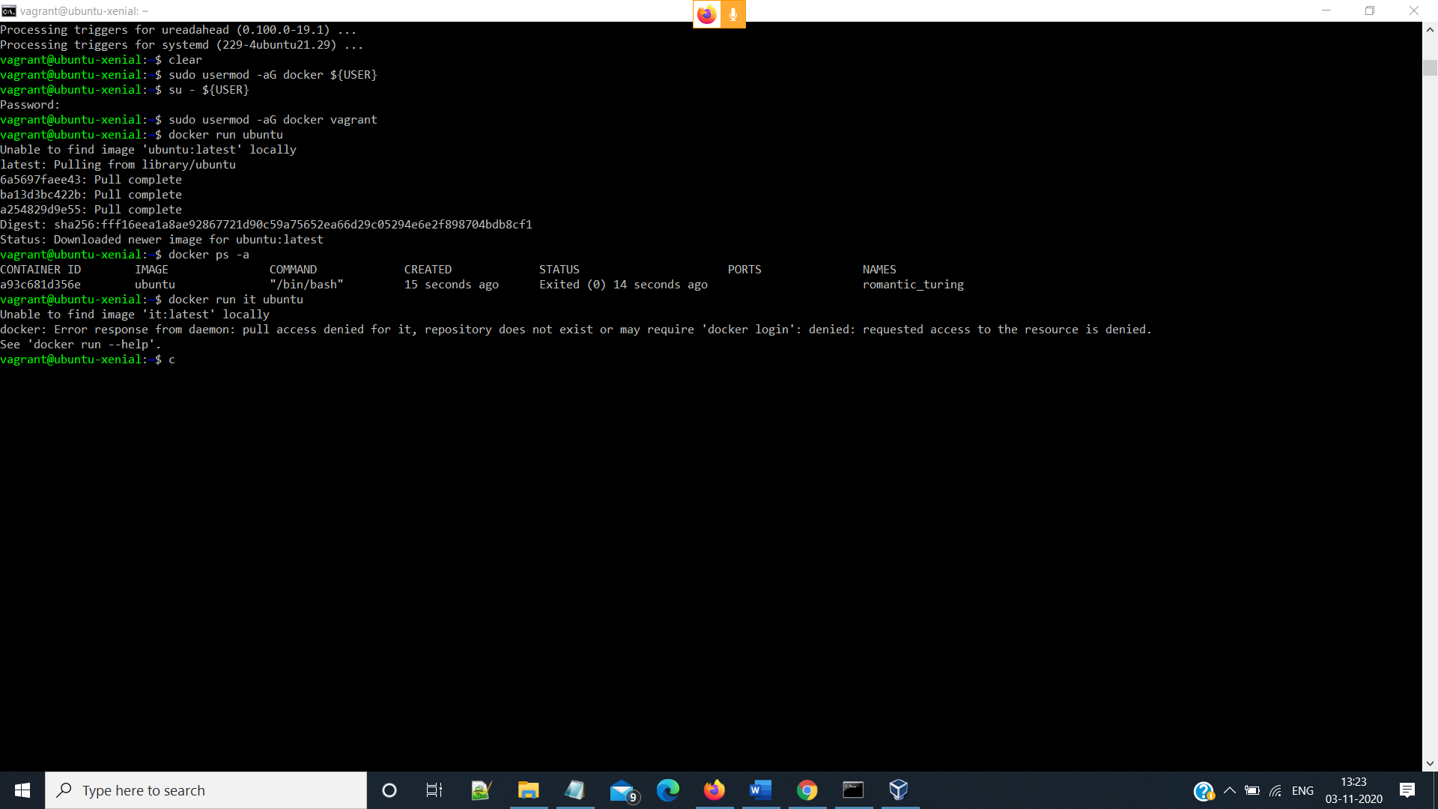

Step 5: Run docker ps -a command and docker run Ubuntu Command



Step 6: Run Dokcer run -it ubuntu Make a test directory and a demo file to test

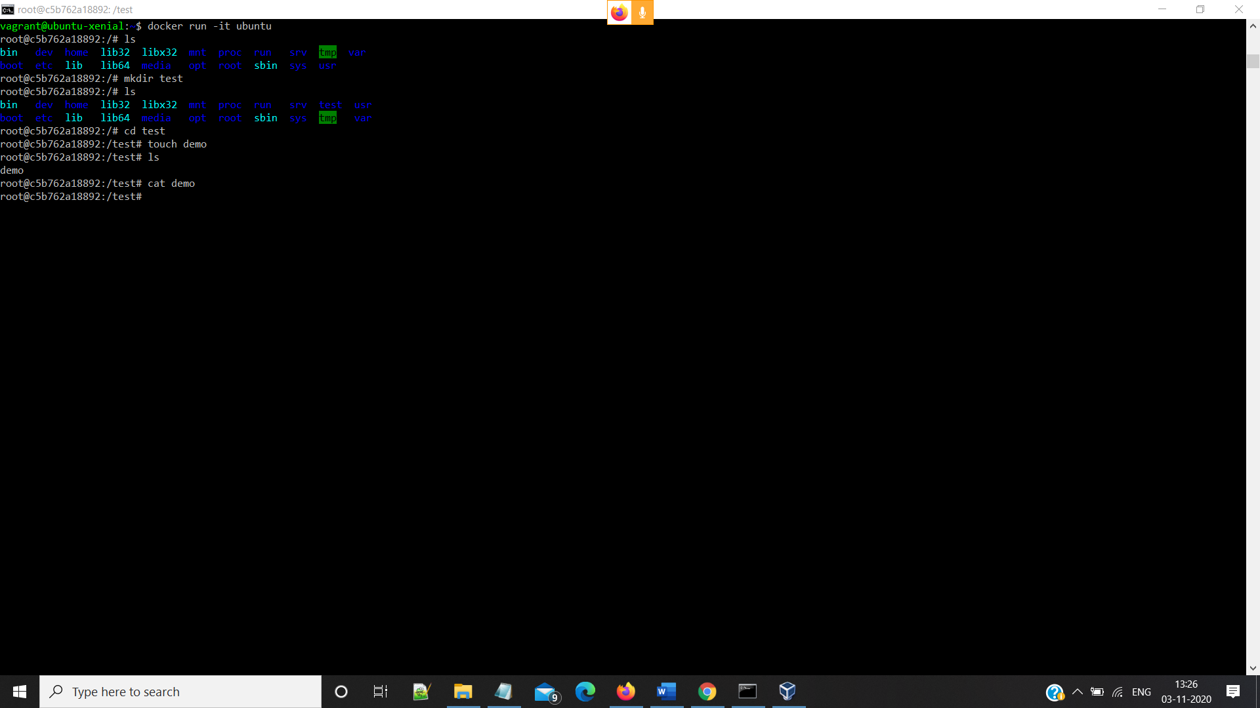

Step 7: run exit command twice to exit vagrant

