**Name: Piyush Vishnoi**

**Roll no: 71**

**Sap id: 500067083**

**Experiment – 12**

**Lab Experiment - 12**

**(Docker installation using Vagrant VM machine)**

1. Check if the virtual machine is compitable to installation of docker using the command “curl -fsSL https://download.docker.com/linux/ubuntu/gpg | sudo apt-key add -”.
2. Now add the docker repository to the APT sources as we will be downloading docker from docker repo and not default apt repo. This will be done by using the command “sudo add-apt-repository "deb [arch=amd64] https://download.docker.com/linux/ubuntu $(lsb_release -cs) stable"”.
3. Now, update the the system packages using “sudo apt-get update”.

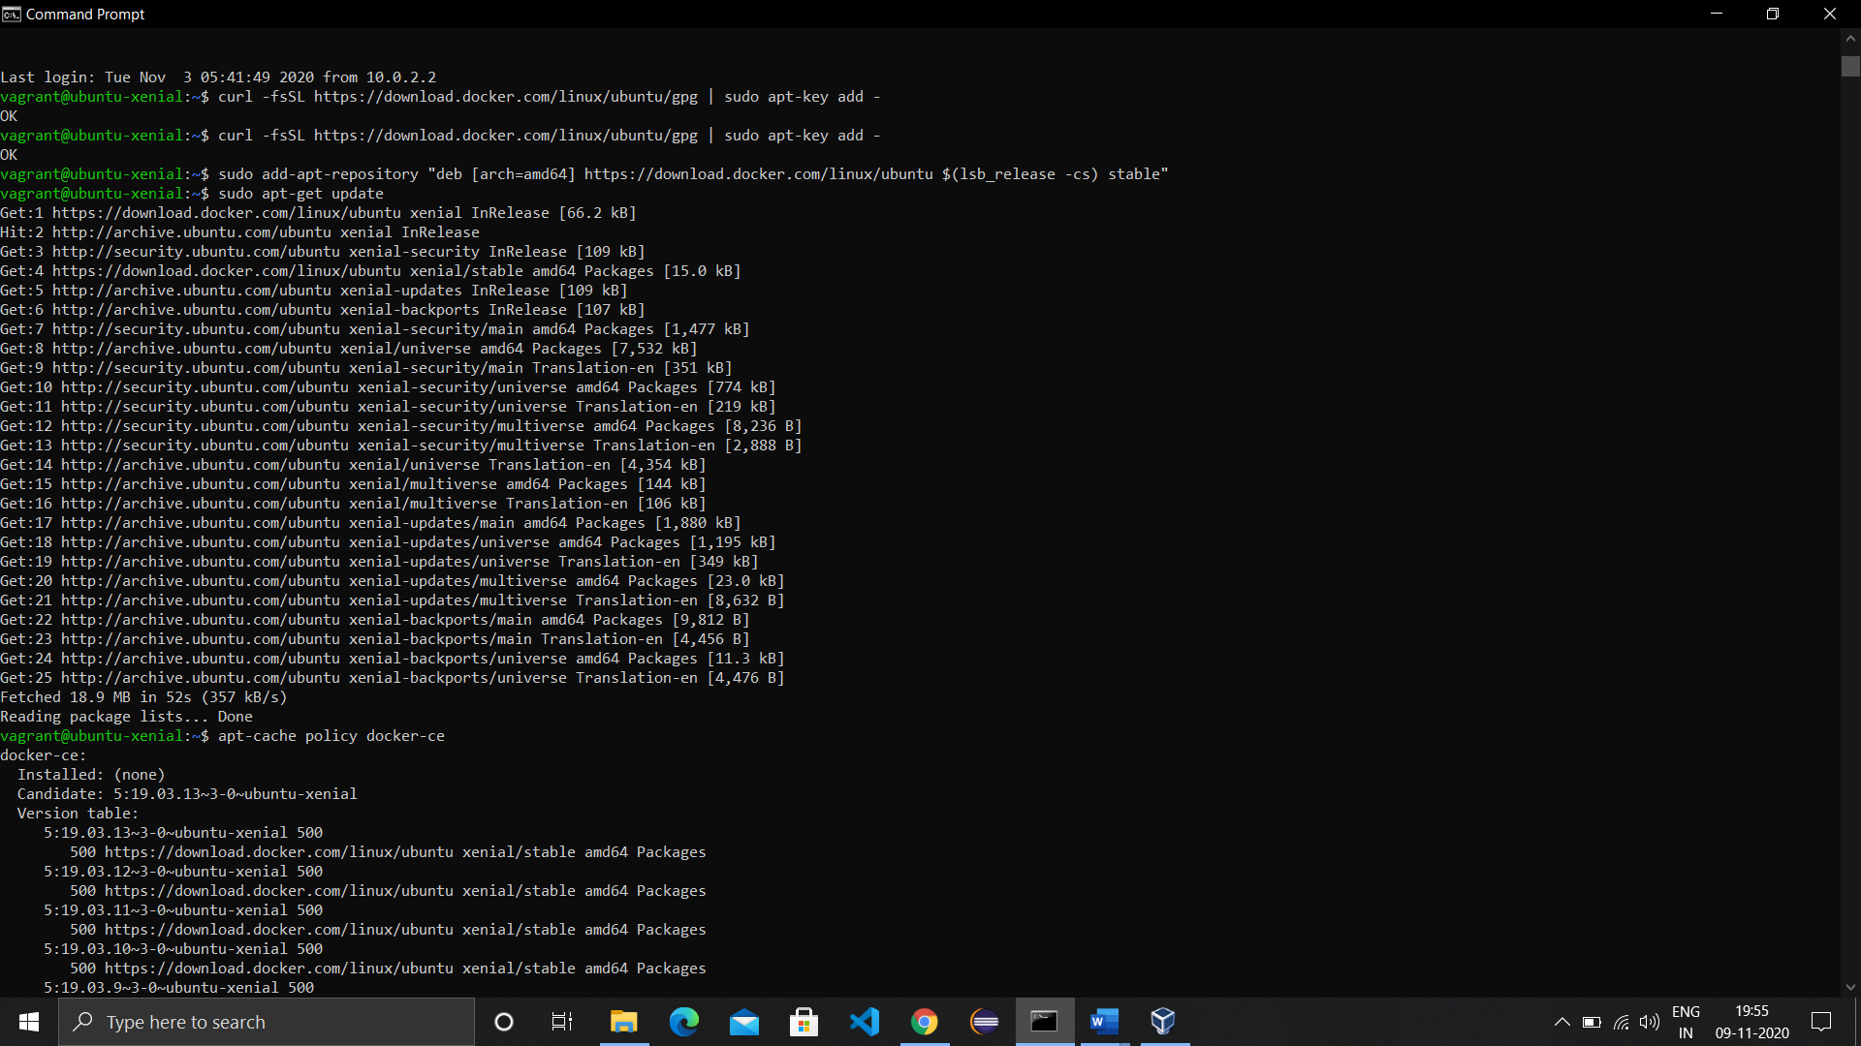

1. Make sure to install Docker repo instead of default repo and install Docker using “sudo apt-get install -y docker-ce”.

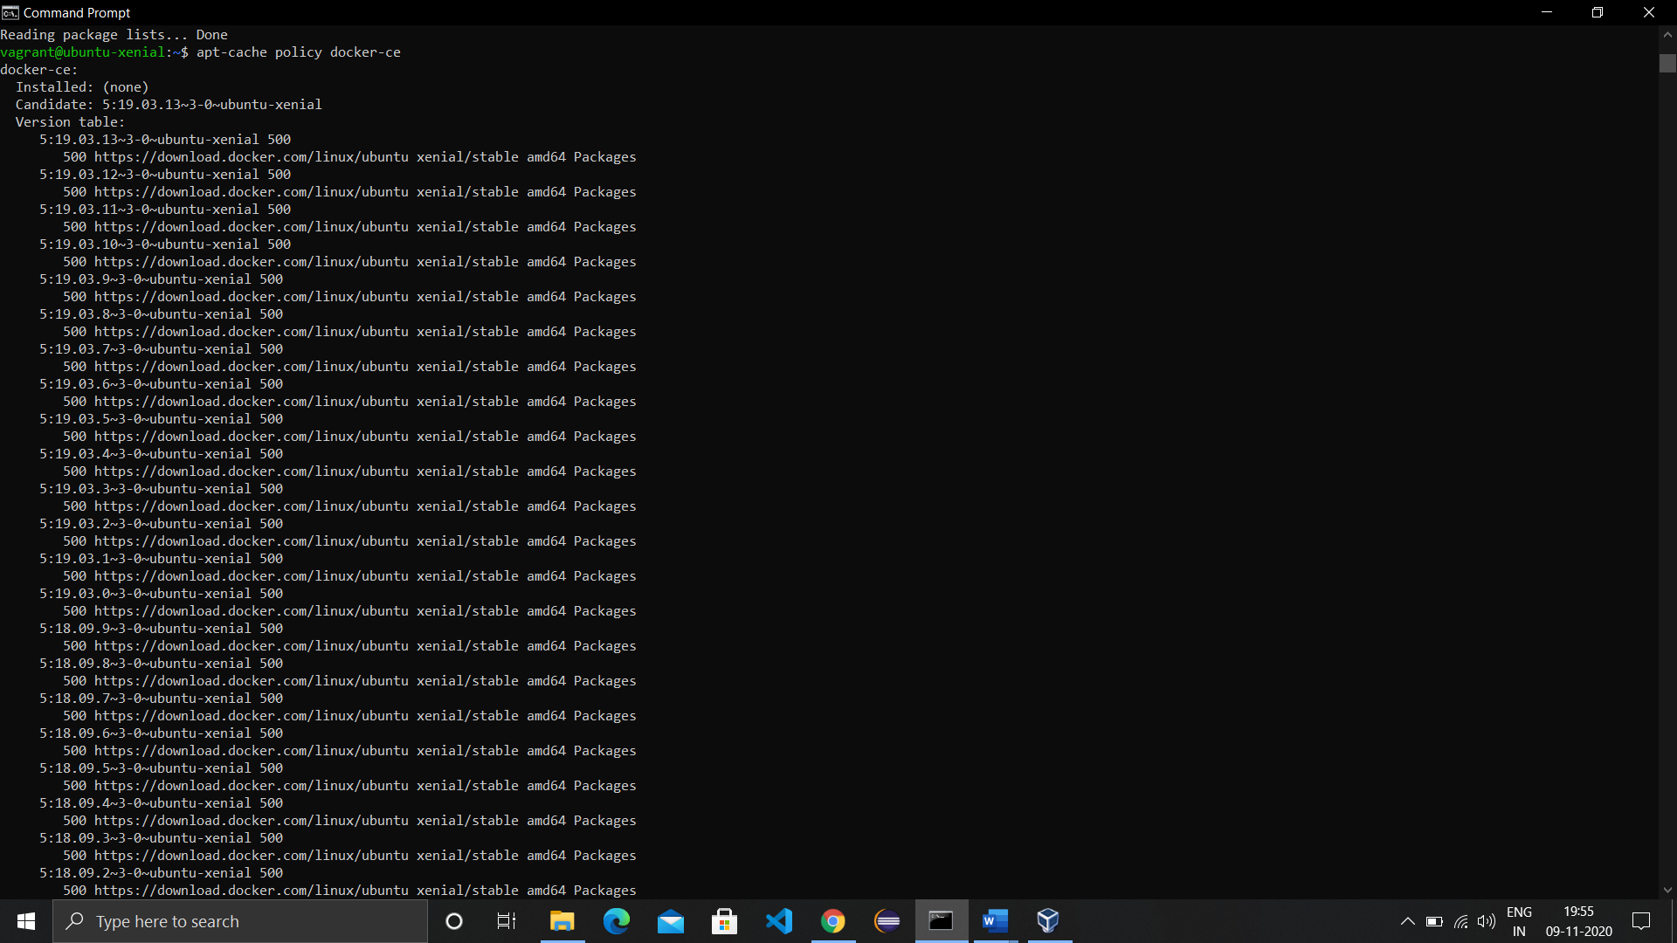

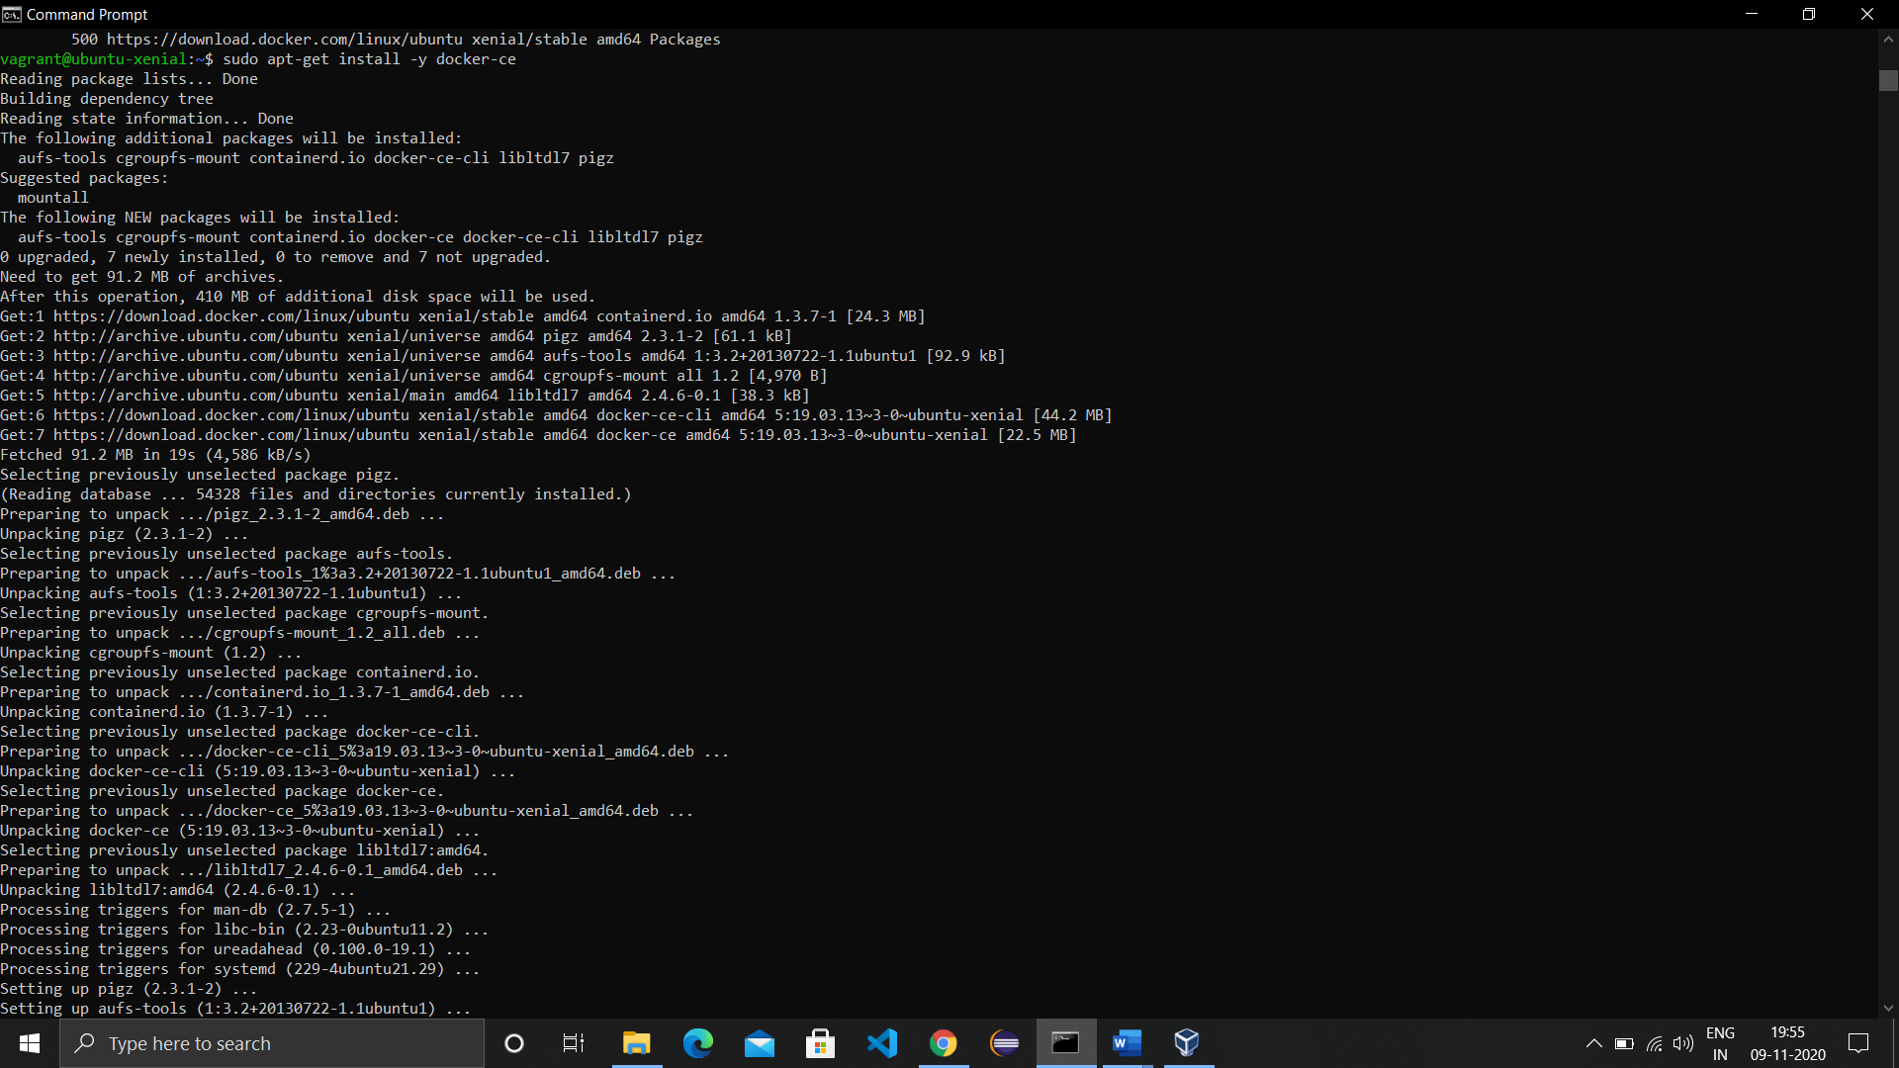

1. Check the version installed and running of Docker using “docker --version”.
2. Now add a docker image of ubuntu using the command ‘docker run ubuntu’ It will take the image locally and now run it using ‘docker run -it ubuntu’. The ubuntu image will load in the cmd only now create a directory using mkdir and get into the directory using cd command.

