**Name: Piyush Vishnoi**

**Roll Number: 71**

**SAP ID: 500067083**

**Lab: 4**

**LAB EXP-4**

**Static Code Analysis using SonarQube**

**Solution:**

Go to sonarqube.org/download to download Sonarqube

Download the community edition

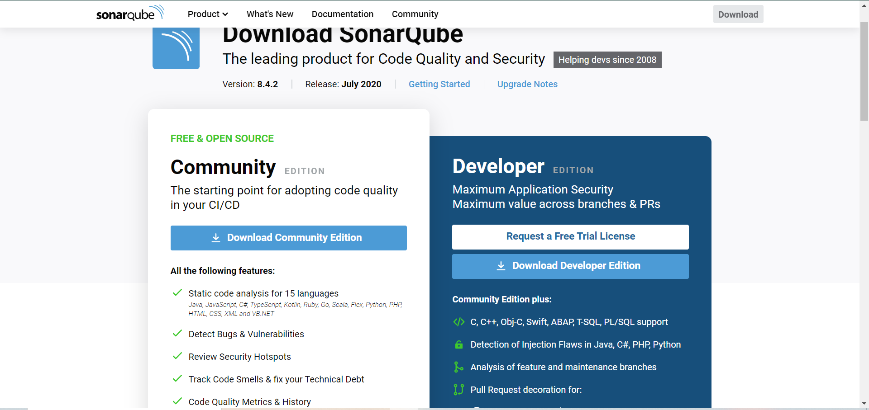

The download is a zipped folder.

Extract the zipped folder

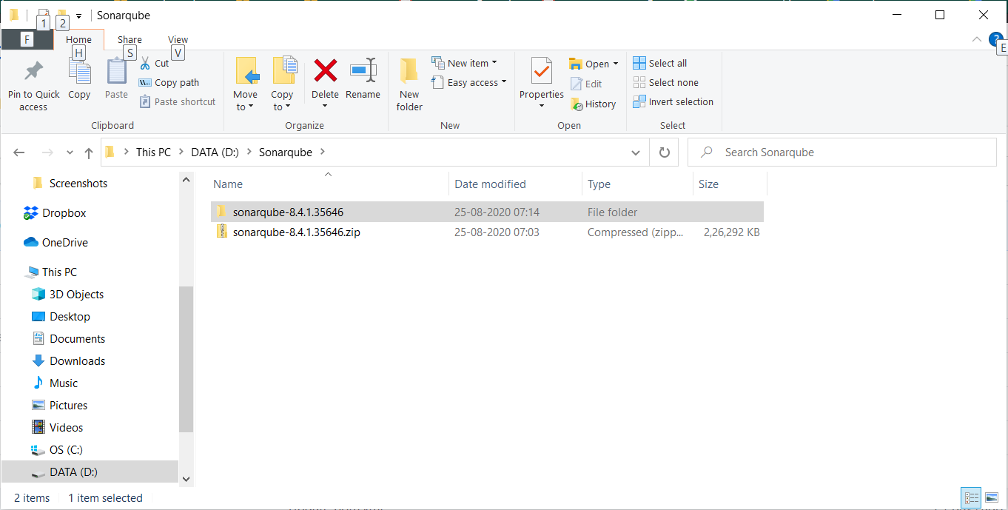

In the extracted folder go to bin, and them to Windows-x86-64 (assuming Windows OS) to find a file named StartSonar.bat

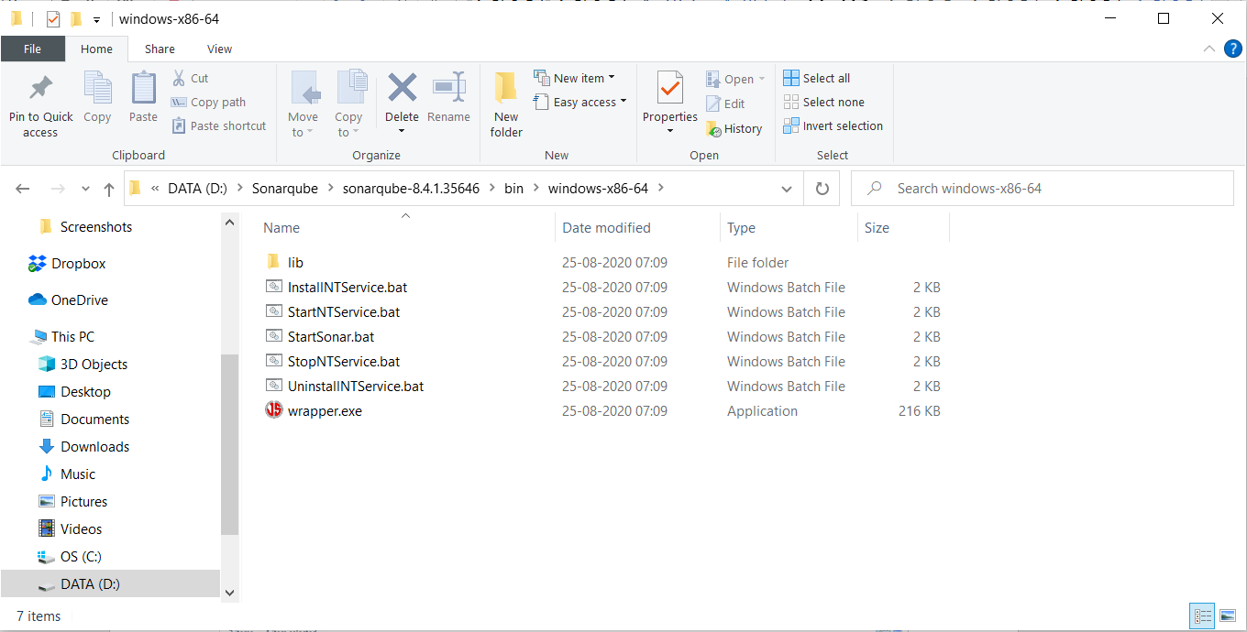

Open command prompt and move to the folder where the StartSonar.bat file is stored.

Run the command: StartSonar.bat

It takes some minutes to run

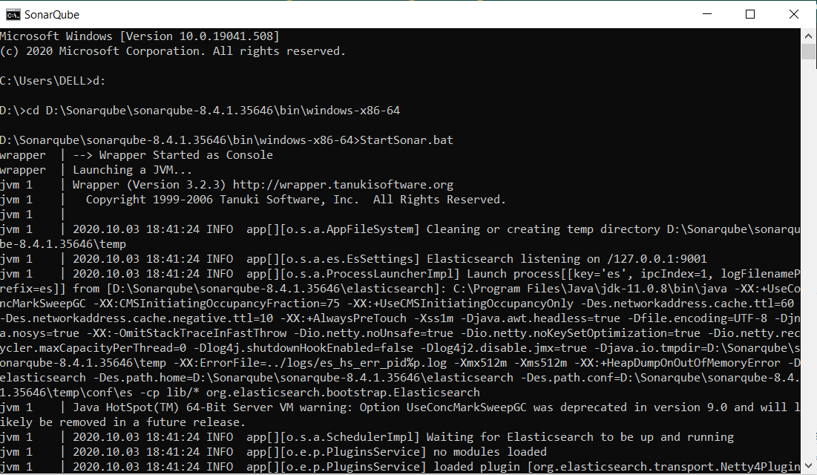

Once the command successfully runs, go to localhost:9000 (9000 is the port where sonarqube runs)

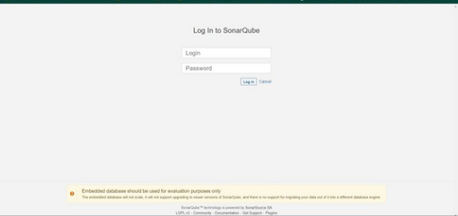

Traverse in the command line to the Maven project whose quality is to be assessed.

Run the following command:

mvn clean install sonar:sonar -Dsonar.host.url=http://localhost:9000 -Dsonar.analysis.mode=publish

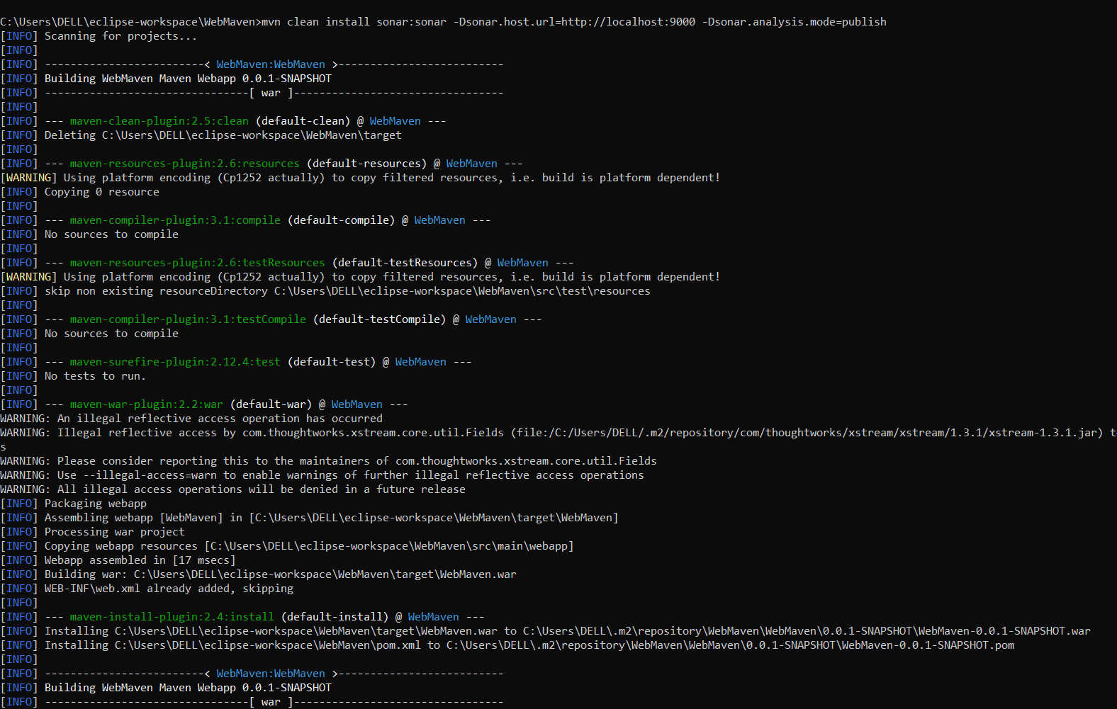

The command should run and download the required dependencies and build successfully

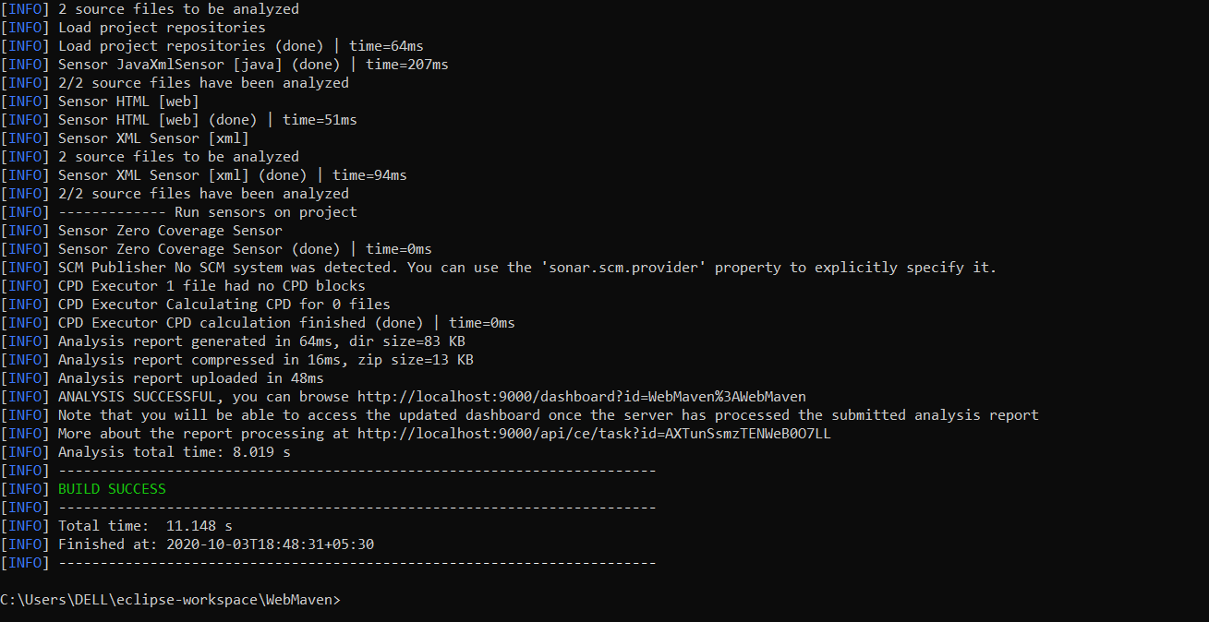

On the location: localhost:9000/projects you will find your maven project being published and the vulnerabilities being assessed

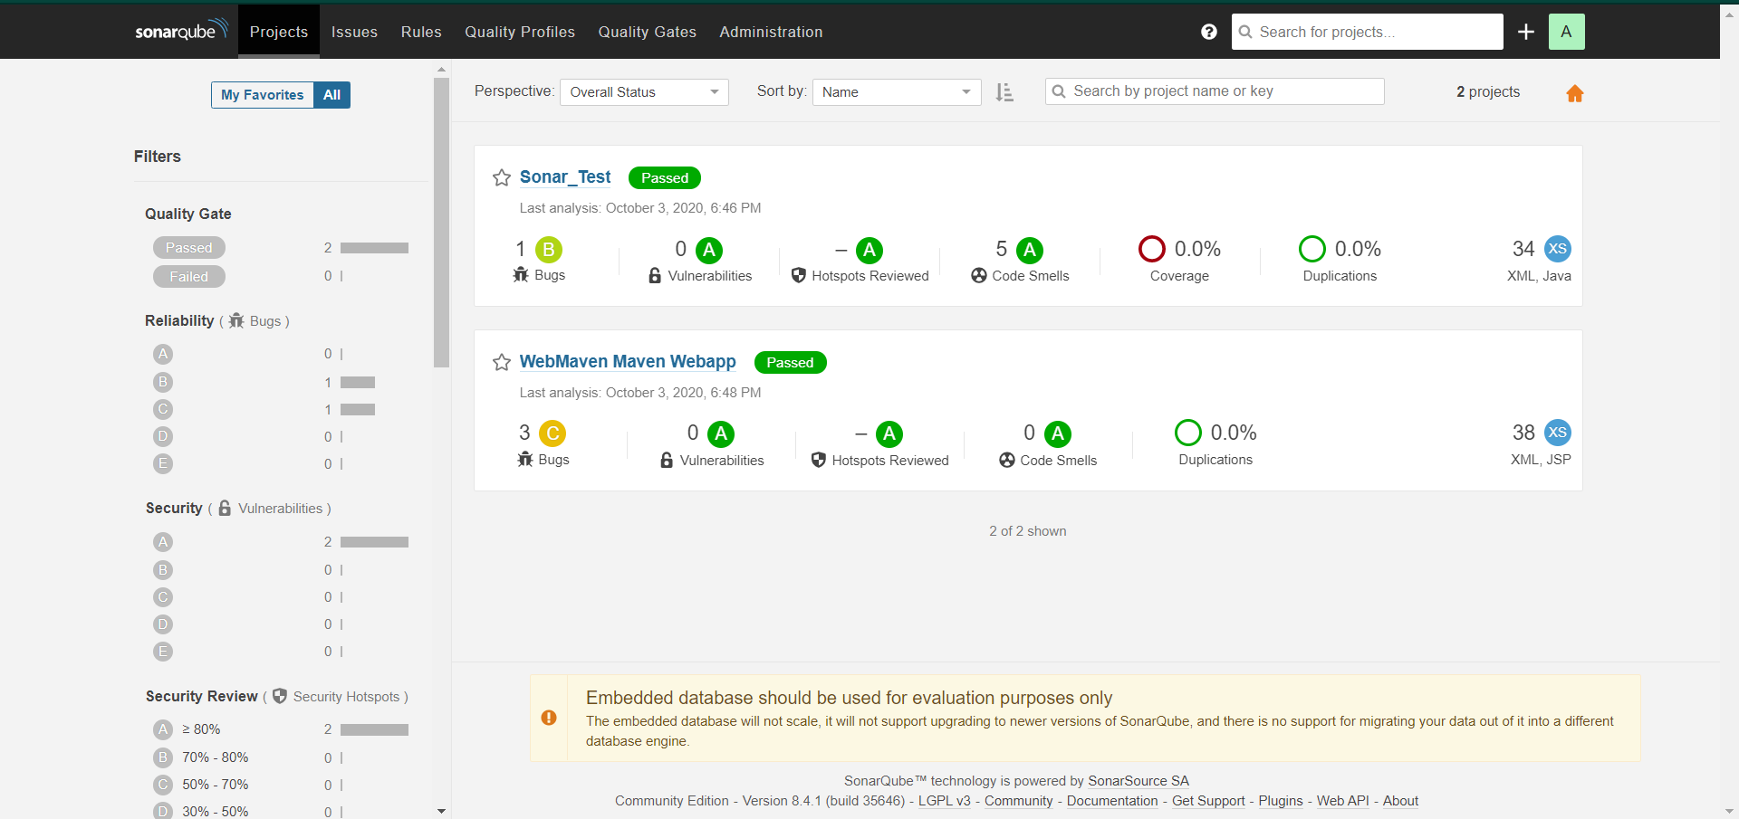

Additionally, you can further inspect the project published, by clicking directly on the project

