**Name: Prashasti Gupta**

**Roll Number: R171218077**

**SAP ID: 500068493**

**Exp: 01 Installation of Jenkins and Execution of a simple job in Jenkins**

To download Jenkins, go to <https://www.jenkins.io/download/>

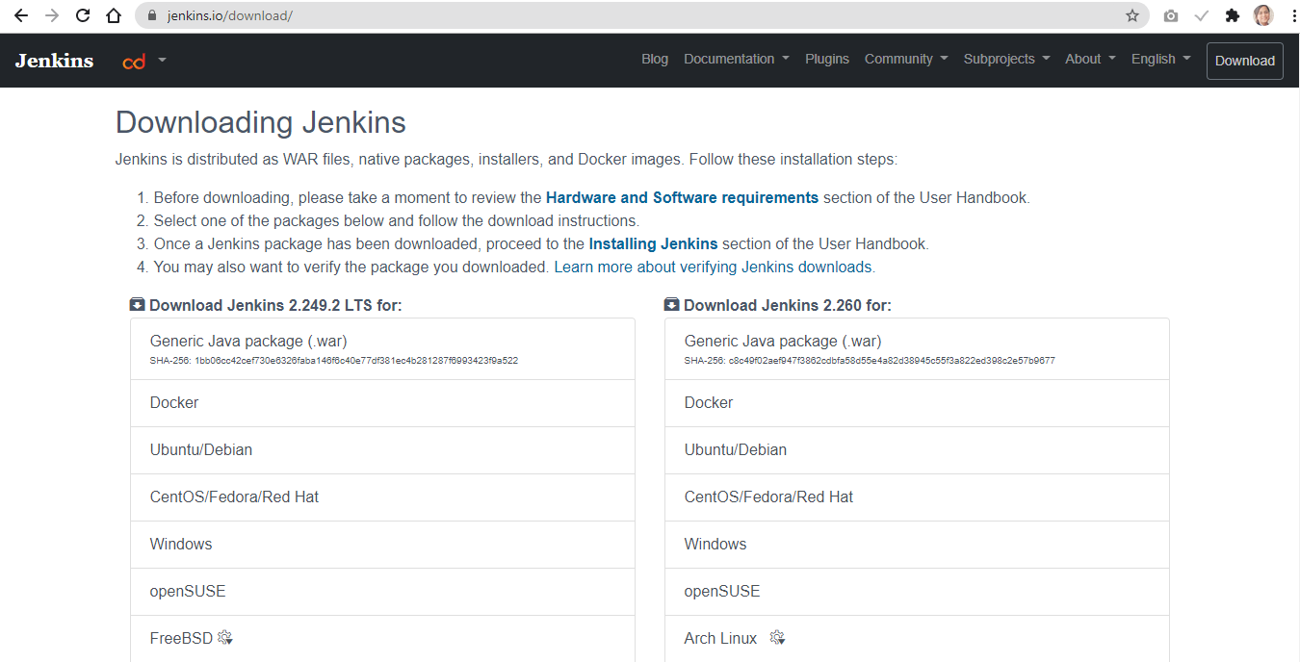

After downloading, complete the installation process to start using Jenkins.

Now, open Command Prompt and move to the directory where you have the stored the Jenkins files.

Type the command: **java –jar Jenkins.war**

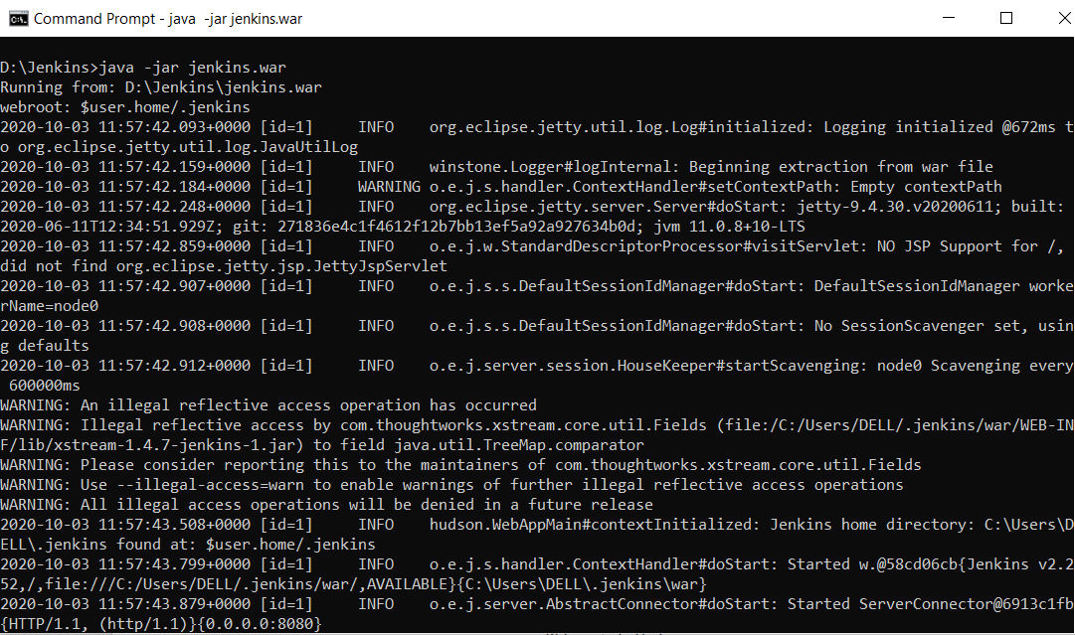

Open the browser and go to **localhost: 8080**

If opening for the first time, it would prompt you to enter the **key**. Copy it from command prompt window and paste it.

It will ask you to install some plugins. Install all of them.

Set the username and password for Jenkins. Finally, Jenkins dashboard will appear.

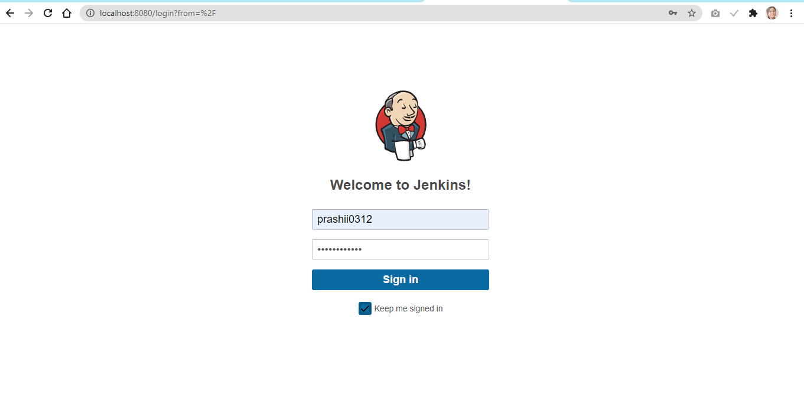

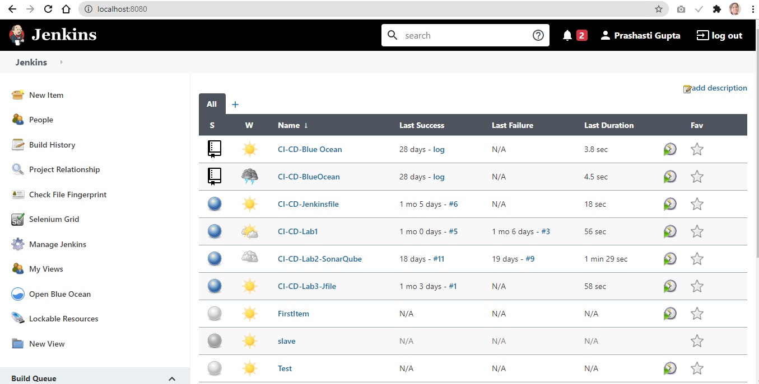

Go to **Manage Jenkins** option and then select **Global Tool Configuration.**

Under the **Maven** Section, in the **Name** field, provide the MAVEN_HOME location.

The version should be same as that of the maven in your system. If not choose the correct version.

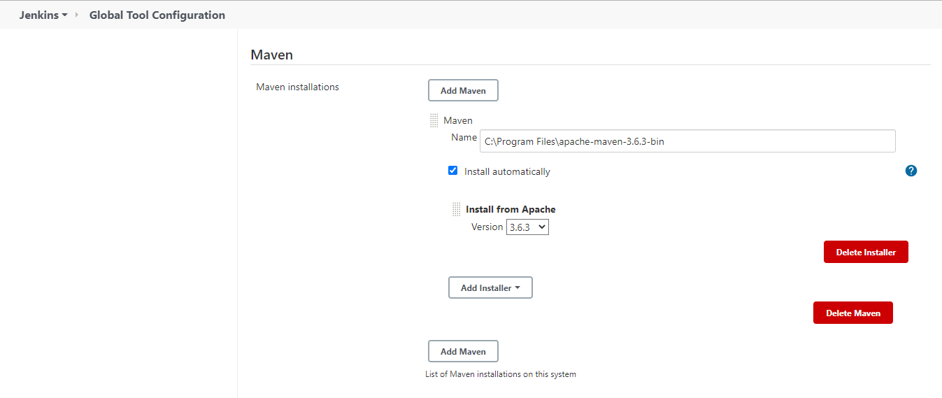

Finally, click on Save.

Go to **Manage Jenkins** again and then select **Manage Plugins.**

Search for Maven Integration under **Available** Plugins column and install it.

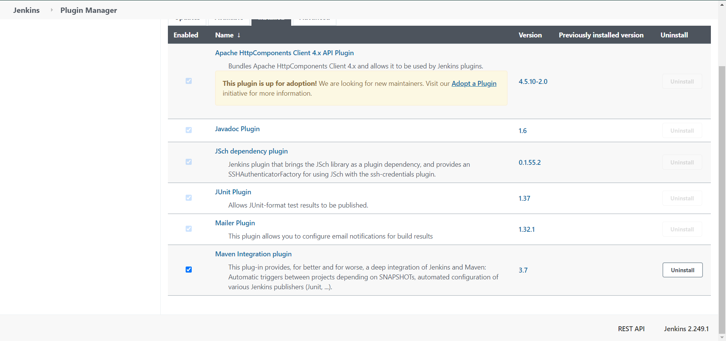

We’re all set to create a Jenkins job now.

On the Jenkins dashboard, select **New item**.

Enter a name for your job and check the **Maven Project** option.

Click **Ok.**

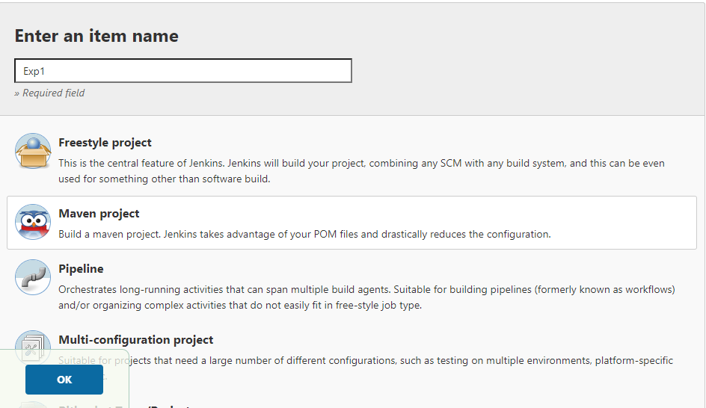

On the screen you see now, specify a maven project.

Specify the path of pom.xml and provide a maven goal under **Build** section.

Save the changes.

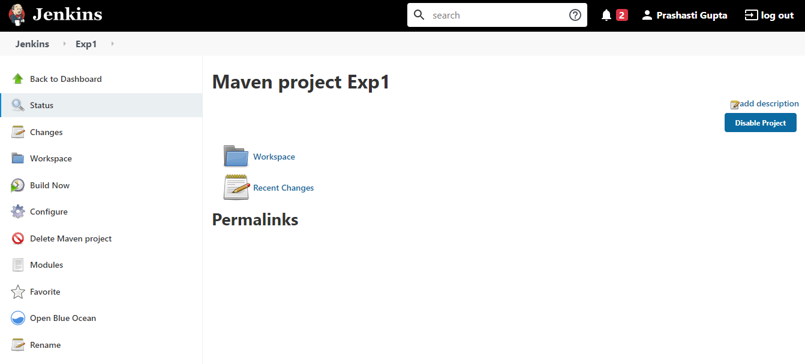

Click on **Build now** and check the console output for the project.

On the successful completion of build, you will get a **Finished: SUCCESS** message.

