**Name: Prashasti Gupta**

**Roll Number: R171218077**

**SAP ID: 500068493**

**Exp: 02 -- Jenkins integration with Github**

Open Command prompt and type **java –jar jenkins.war** to start Jenkins.

Go to the Jenkins dashboard at localhost:8080

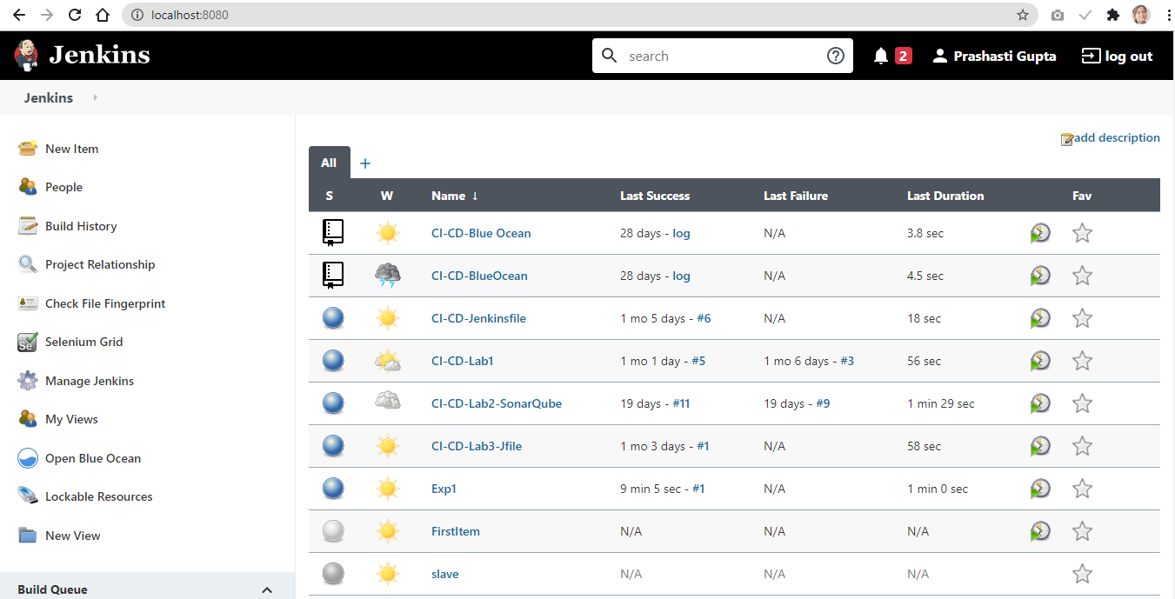

Click on the **New Item**. Give a name to the job and then choose **Freestyle Project**.

Click Ok.

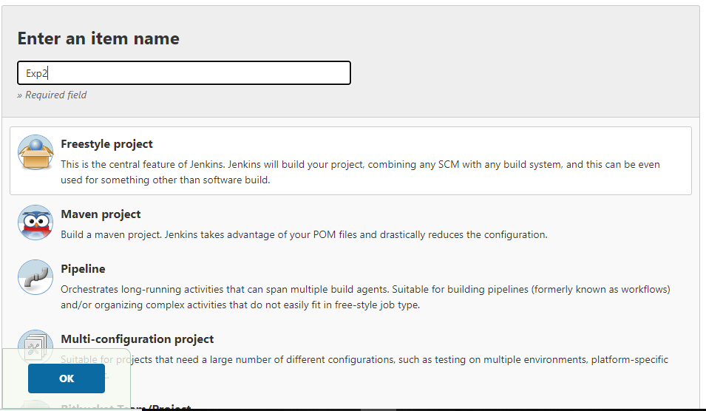

You will be redirected to a page. Scroll down to **Source Code Management** section to add your GitHub repository.

Select **Git** and then specify the URL of your github repository.

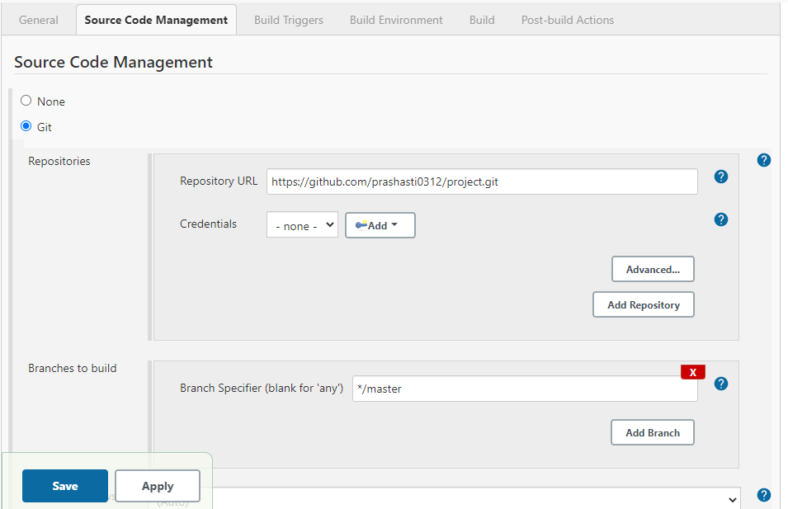

Click on Save.

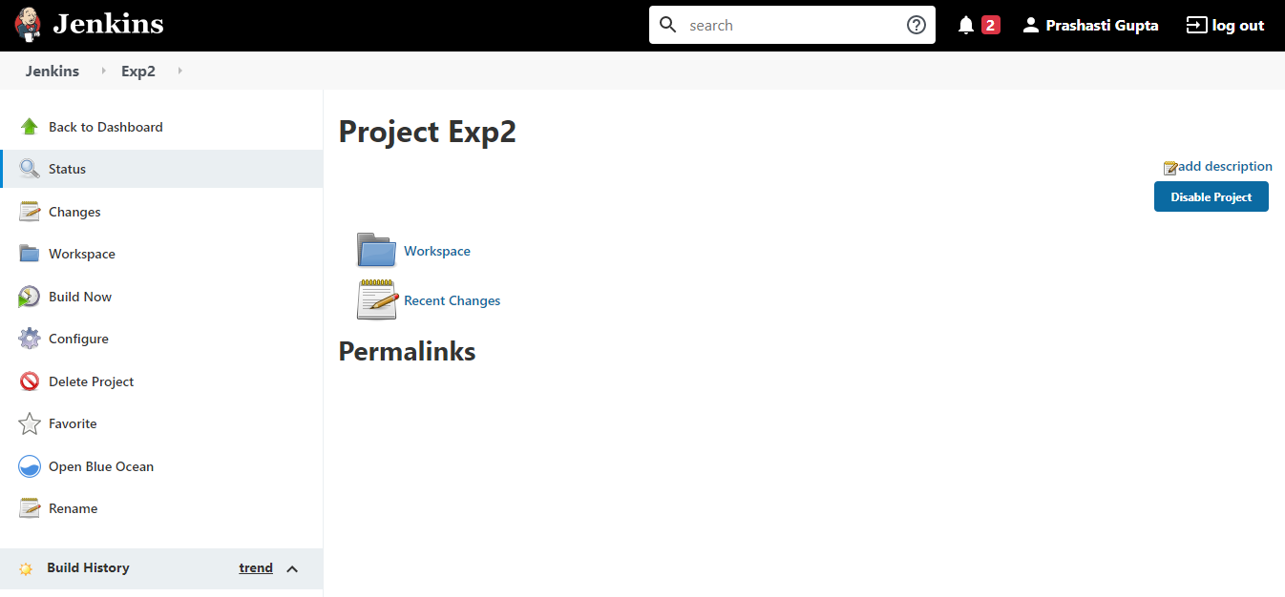

Jenkins has been successfully integrated with GitHub.