**Name: Prashasti Gupta**

**Roll Number: R171218077**

**SAP ID: 500068493**

**Exp: 03 -- Jenkins integration with Github And Maven**

Start Jenkins using the **java -jar jenkins.war** command in the command prompt.

Go to the Jenkins dashboard at localhost:8080

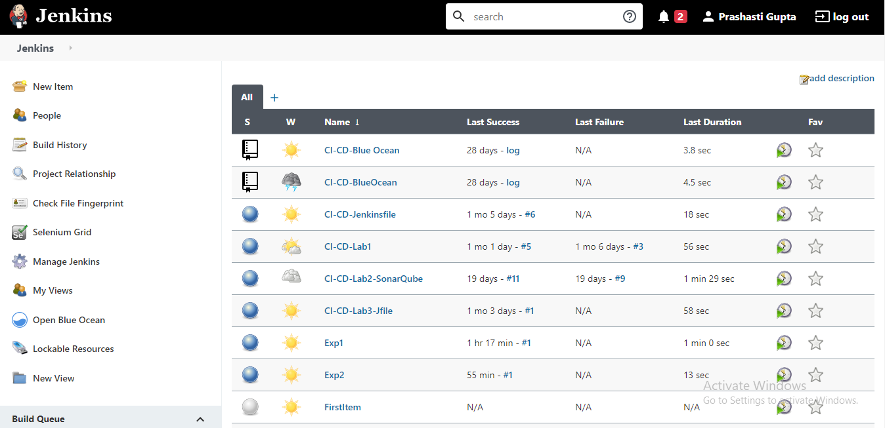

On the Jenkins Dashboard, click on **New Item**.

Give a name and select **Maven Project**.

Click Ok.

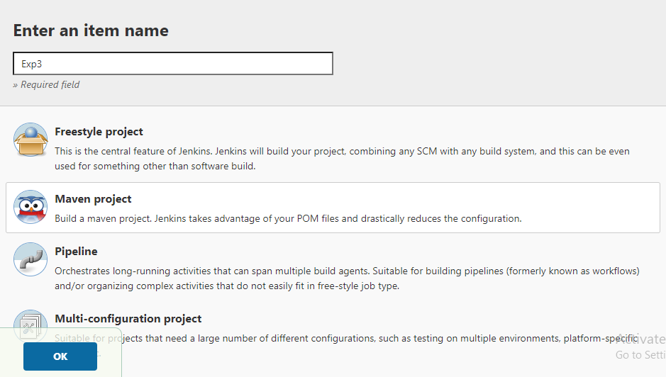

You will be directed to a page similar to this.

Click on the **Source Code Management** tab to add the github repository.

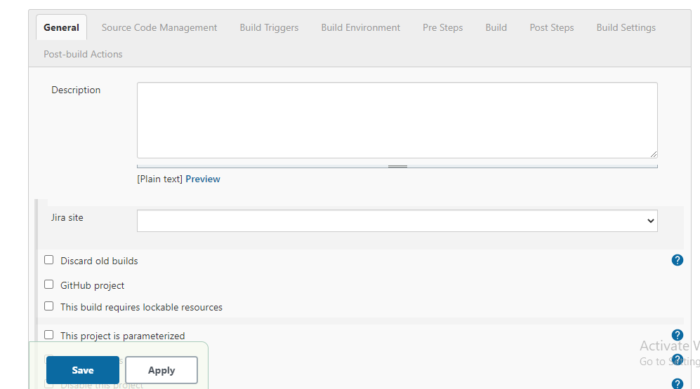

Visit the github repository where you saved your maven project and copy the location of this github repository.

In the Source Code Management Section select **Git.**

Give the repository location in the specified placeholder.

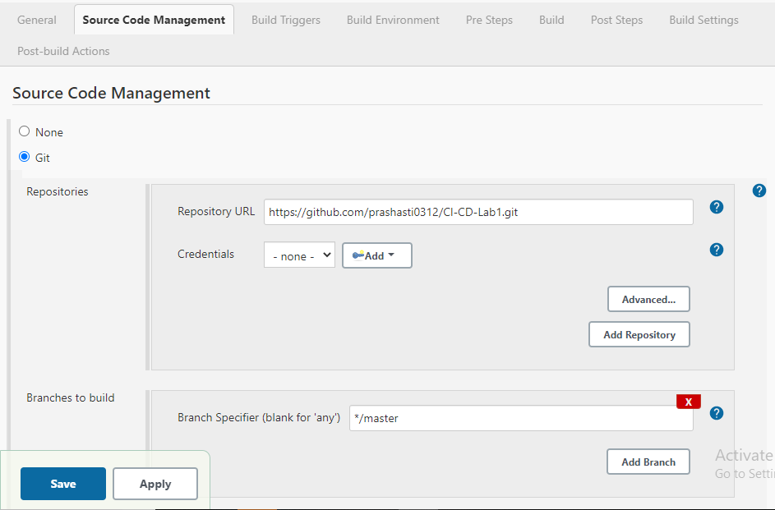

Go down to the **Build** Section.

Add the exact location to the pom.xml file.

If it is inside some folder, specify it as {folder_name}/pom.xml

In the goals specify the maven goals.

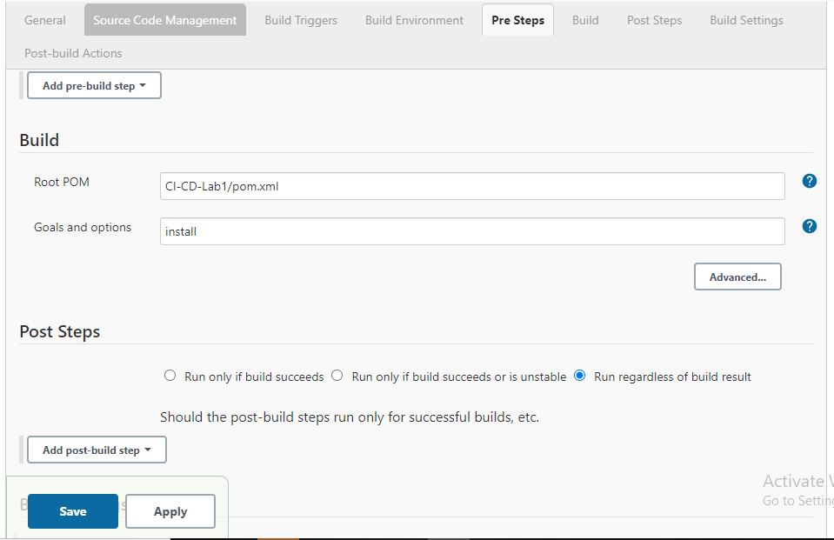

Click on **Save**.

You would be redirected to a dashboard which looks like this.

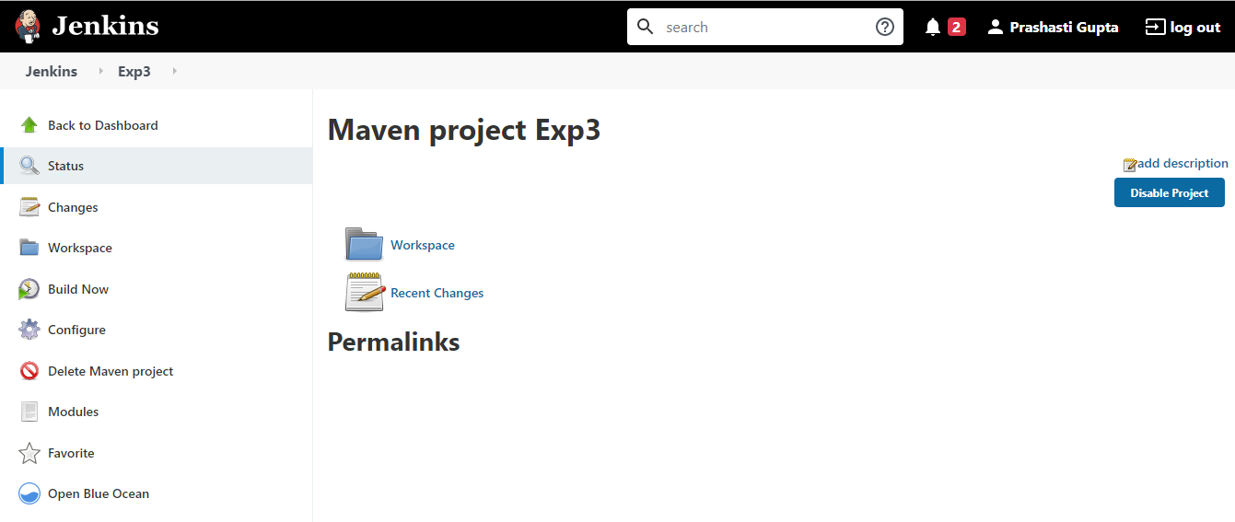

Click on **Build Now** option to build the project.

Choose the **Console Output** option to check the status of the build.

If the build is successful, it would return “**Finished: SUCCESS**”. It would return failure in case of any errors in the project.

