**Name: Prashasti Gupta**

**Roll Number: R171218077**

**SAP ID: 500068493**

**Exp: 04 -- Static Code Analysis using SonarQube**

Go to <https://www.sonarqube.org/downloads/> to download Sonarqube and download the Community edition.

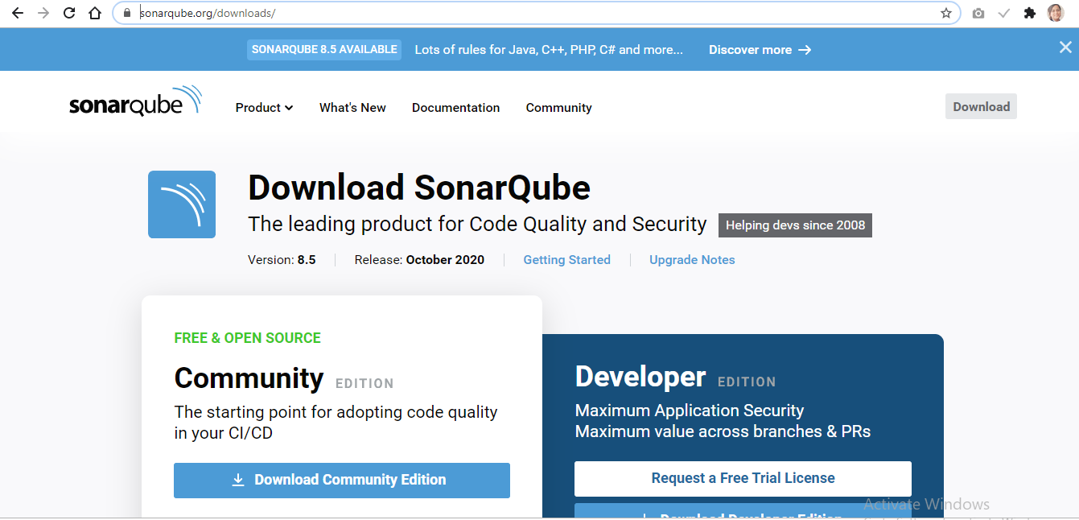

Open command prompt and move to the Sonarqube folder. Go inside bin and then inside the windows-x86-64 folder.

Run the command: **StartSonar.bat**

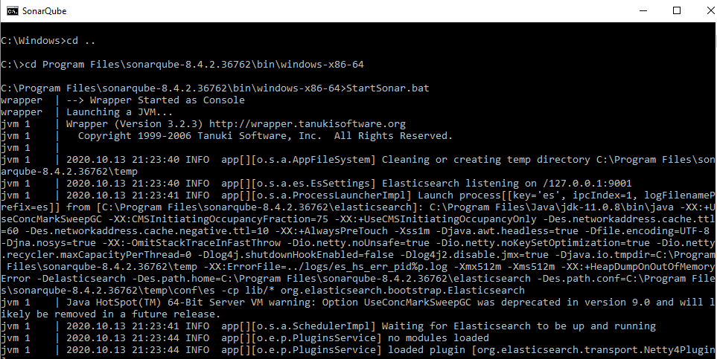

Open the browser and go to **localhost:9000**.

SonarQube dashboard will appear. By default, the username and password is admin.

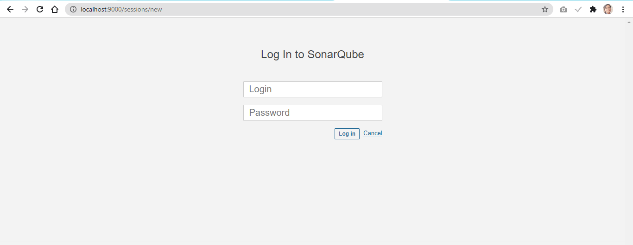

On the command prompt, move to the Maven project whose quality is to be assessed.

Run the following command:

**mvn clean install sonar:sonar -Dsonar.host.url=http://localhost:9000 -Dsonar.analysis.mode=publish**

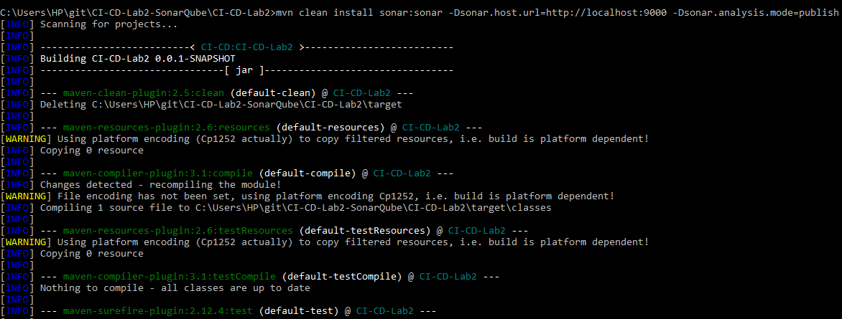

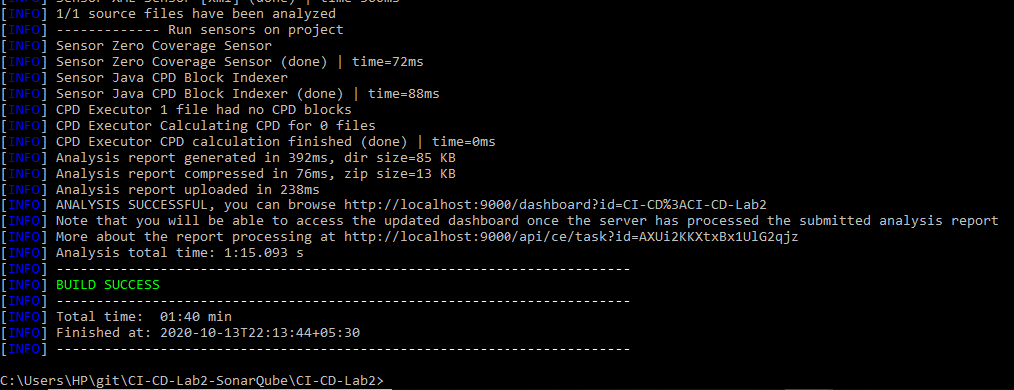

The build was successful.

Now, go to the sonarqube dashboard and click on Projects. Our project will be visible and its analysis report can be seen. We can click on it to check the details of the code analysis performed by sonarqube.

