**Name: Prashasti Gupta**

**Roll Number: R171218077**

**SAP ID: 500068493**

**Exp: 05 -- Jenkins integration with SonarQube**

On the Jenkins Dashboard, click on **New Item.**

Enter the name for the project

Select project type as **Maven Project**

Click on **OK.**

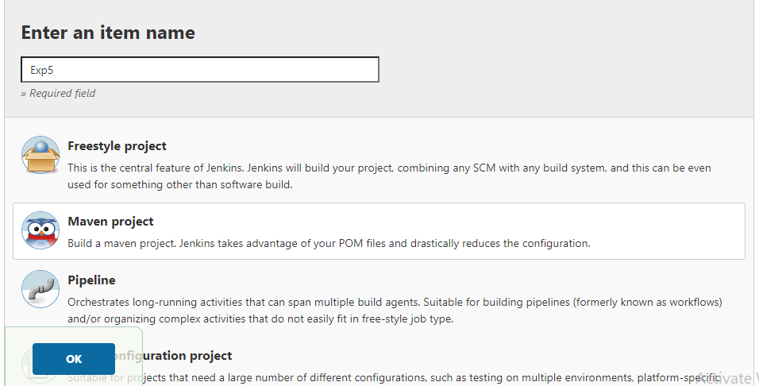

On the screen you see now, scroll down to **Source Code Management** and provide the location of the github repository that hold the project.

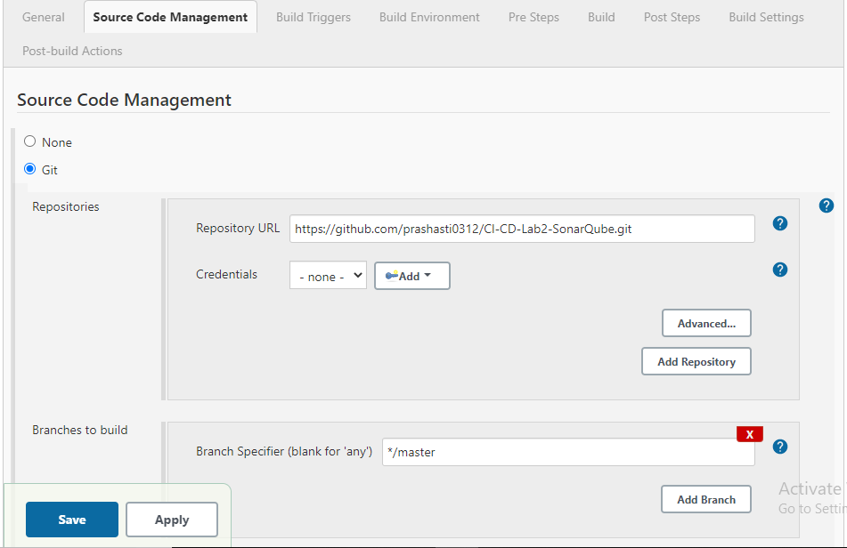

Move down to the **Build** section and provide the complete path of the pom.xml file.

In the **Goals and options** field, specify **clean install sonar:sonar -Dsonar.host.url=http://localhost:9000 -Dsonar.analysis.mode=publish**

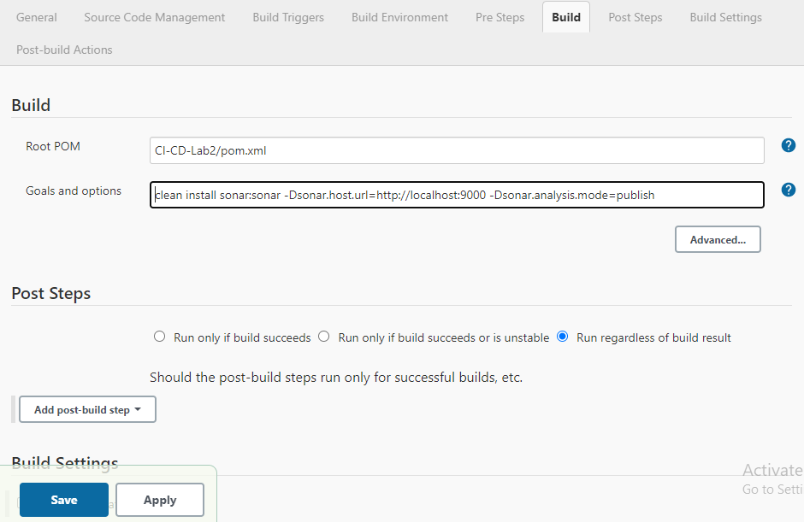

Click on Save.

Finally, Click on **Build Now.**

Click the option of **Console Output** to check the build process.

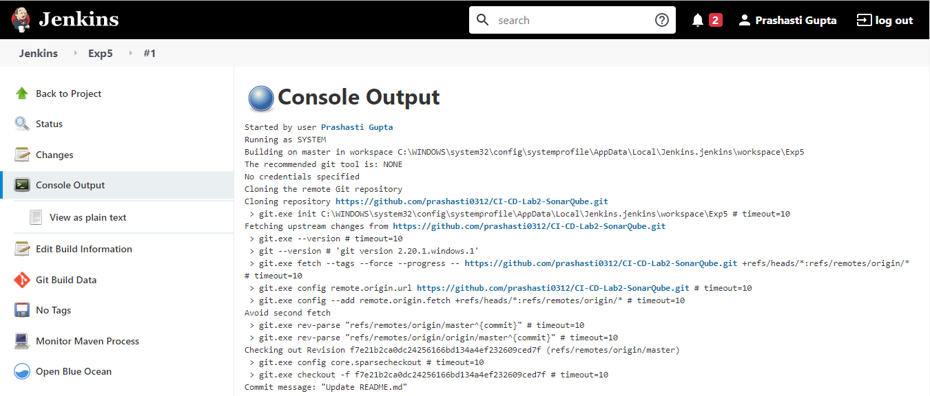

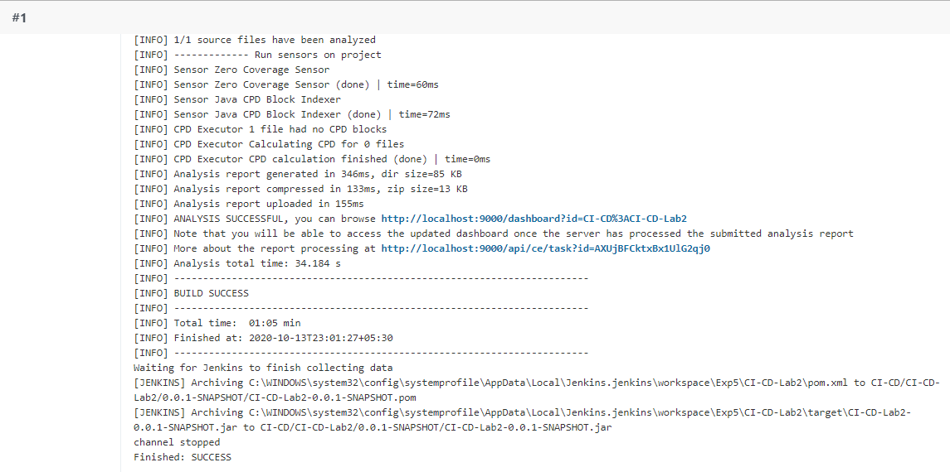

As it can be seen, the build is successful and the sonarqube test reports will be published at localhost:9000.

